|  |  |  |  |  |
| --- | --- | --- | --- | --- |
| **REPORT TITLE** |  | Population Pharmacokinetics Analysis of Cemiplimab (PD-1) in Patients with Advanced Malignancies | | |
|  |  |  | | |
| **STUDY SPONSOR:** |  | Regeneron Pharmaceuticals, Inc. | | |
|  |  |  | | |
| **PROTOCOL NUMBER:** |  | R2810-ONC-1423/ R2810-ONC-1540 | | |
|  |  |  | | |
| **ANALYTICAL FACILITY:** |  | Regeneron Pharmaceuticals, Inc. 777 Old Saw Mill River Road Tarrytown, NY 10591-6707 | | |
|  |  | |  |  | |
|  |  | |  |  | |
|  |  | |  |  | |
| **AUTHOR:** |  | |  |  |
|  |  | |  |  | |
|  | | |  |  | |
| Feng Yang, PhD, MS Fellow, Quantitative Pharmacology | | |  | Date | |
| **APPROVED BY:** |  | |  |  | |
|  |  | |  |  | |
|  | | |  |  | |
| Ronda Rippley, PhD Senior Director, Quantitative Pharmacology | | |  | Date | |

Study Administrative Structure

|  |  |  |
| --- | --- | --- |
| **Author**: | Name: | Feng Yang, PhD |
| Title: | Fellow, Quantitative Pharmacology |
| Telephone: | (914) 847-7674 |
| E-mail: | feng.yang@regeneron.com |
|  |  |  |
| **Management**: | Name: | Ronda Rippley, PhD |
| Title: | Senior Director, Quantitative Pharmacology |
| Telephone: | (914) 847-1478 |
| E-mail: | ronda.rippley@regeneron.com |
|  |  |
| Name: | John Davis, PhD |
| Title: | Senior Director, Clinical Pharmacology |
| Telephone: | (914) 847-7980 |
| E-mail: | john.davis@regeneron.com |
|  |  |
| Name: | A. Thomas DiCioccio PhD |
| Title: | VP, Pharmacometrics |
| Telephone: | (914) 847-5437 |
| E-mail: | thomas.dicioccio@regeneron.com |
|  |  |  |
| **Statistical Programmer(s)**: | Name: | Hong Yan |
| Title: | Director, Statistical Programming, Pharmacometrics |
|  |  |
| Name: | Xianzhang Meng |
| Title: | Senior Statistical Programmer, Pharmacometrics |
|  |  |

Report Synopsis

* 1. Objectives

The primary objectives of this analysis were to:

1. Develop a population pharmacokinetic (Pop PK) model to estimate the population and individual predicted PK parameters of cemiplimab in patients with a range of solid tumors including CSCC;
2. Identify and characterize the clinically relevant sources of variability in PK parameters;
3. Characterize the post-hoc estimates of exposure and the variance from the patients in the overall solid tumor population and in the patients with CSCC, as well as the descriptive statistics of exposure for these patients;
4. Simulate concentration-time profiles and calculate the corresponding exposure metrics at 350 mg Q3W, and compare these results to those simulated at 3 mg/kg Q2W in the same patient population.
   1. Data

The population PK analysis was based on the combined data sets from Study 1423 and Study 1540; the final Analysis Set contained cemiplimab concentration data from 505 patients with solid tumors, including 135 patients with CSCC (26 from study 1423 and 109 from study 1540 [groups 1 and 2]). The final population PK Analysis Set included concentration data from 75 patients with mCSCC and 60 patients with laCSCC.

A pooled NONMEM (version 7.4, ICON Development Solutions, Ellicott City, Maryland) ready dataset (“nm.xpt”) was constructed using SAS (Version 9.2), and the final NONMEM dataset (“nmdat.xpt”) was prepared using R (version 3.3.0 or above, <http://www.r-project.org>). All dataset creation and methods of this analysis followed the guidelines suggested by the Food and Drug Administration for the analysis of population PK data (<https://www.fda.gov/downloads/drugs/guidances/UCM072137.pdf>).

After the Analysis Set for this Pop PK analysis has been locked, a final dataset (‘nmdatfnl.xpt’) was derived with some minor changes. The Appendix G was used to evaluate the potential impacts of substituting the final dataset (‘nmdatfnl.xpt’) with Analysis Set (‘nmdat.xpt’).

* 1. Methods

The population PK model was developed in 3 stages, consisting of the base model, full covariate model, and final covariate model. First, a base model was developed to describe the PK of cemiplimab without consideration of covariate effects. Second, a full covariate model was developed by incorporating the effect of all pre-specified covariate parameter relationships. In the third stage, the final population PK model was developed by retaining covariates that improved a goodness-of-fit statistic (MOFV). During model development various base-model structures were evaluated including a standard 2-compartment population PK models with linear elimination only, as well as a parallel linear and nonlinear (Michaelis-Menten, MM) elimination. In addition, an empirical nonlinear function that allowed clearance to monotonically decline over time was evaluated, to assess its ability to improve the description of the pharmacokinetics of cemiplimab. Sensitivity analyses were used to assess the impact of including or excluding outliers in the base model development. The parameterization of the model was chosen to reduce correlations between parameters and minimize over-parameterization. As it is well established that body-weight is an important and statistically significant covariate of clearance and volume of distribution for monoclonal antibodies (mAbs), body-weight was included as a covariate in all models developed. The effects of additional covariates to include but not limited to: age, sex, race, body-weight, baseline albumin, AST, ALT, ALP, and tumor type on pertinent PK parameters were evaluated. Following covariate selection, the final model was evaluated using the bootstrap method and visual predictive checks (VPC).

The analyses were performed using nonlinear mixed effects modeling methodology as implemented in the computer program, NONMEM. Pre- and post-processing of data from each modeling step was conducted using R software. Standard goodness-of-fit (GOF) and diagnostic plots and VPC were used to assess the predictive performance of the models.

* 1. Results

In general, the population of patients with CSCC was similar to the overall population in terms of age, body weight, race, gender, and lab results. Since only 14 samples (<1% of the total) had concentration values below the limit of quantification (BLQ) and many of them were also identified as outliers, they were flagged and not included in the Pop PK analysis. The level of missing continuous covariate and categorical covariates was limited and did not exceed 10% of the overall population studied.

Model evaluation results indicated that the available data did not support the use of a target-mediated model as the base structural model; no apparent advantage over the linear elimination model was observed. As such, at therapeutic doses (350 mg Q3W or 3 mg/kg Q2W), saturation of the target-mediated pathway is expected and linear elimination models can be used to describe the PK of cemiplimab. A two-compartment model with zero-order IV infusion and first-order elimination was selected as an appropriate and adequate structural model. Inclusion of a function describing a time-varying change in clearance significantly improved the model fit. In the error model, between subject variability (BSV) is expressed as exponential terms on CL/Q and V2/V3, with an off-diagonal correlation between them, and residual error is modeled as additive and proportional residual error. The time-varying change in CL was described using a sigmoid-Emax functional form; T50 was the time for CL to decline by 50% of maximum value. Predictive checks showed that the model adequately characterized the cemiplimab concentration-time profiles following IV administration over the dose range of 1 mg/kg to 10 mg/kg Q2W for up to approximately 48 weeks of treatment.

The final base model was extended to evaluate covariate effects by using 1) full covariate model approach in which all pre-specified covariate-parameter relationships were simultaneously estimated, and 2) the standard procedures of forward addition and backward elimination. Aside from body weight on both clearance parameters (CL/Q) and Vss (V2 and V3) the covariates that were found to statistically significantly improve the model (p<0.01) were baseline albumin, baseline immunoglobulin G and baseline alanine aminotransferase on clearance parameters (CL/Q); baseline BMI on Vss; and race (Black) on T50. The final covariate model was used for subsequent simulations.

Population analysis indicated that cemiplimab exposure increased dose-proportionally over the dose range of cemiplimab 1 mg/kg to 10 mg/kg and interval (14 days) evaluated. Systemic accumulation was evident based on an accumulation index of approximately 2.0-fold in AUC6wk,ss. The simulated results indicated that patients may achieve >90% of steady-state after 16 weeks dosing for the 3 mg/kg dose Q2W regimen and for the 350 mg Q3W regimen. The mean accumulation index upon Q2W dosing is 1.95 and upon Q3W dosing is 1.84. Based on population PK analysis, the total volume of distribution is 5.20 L, similar to the findings for typical monoclonal antibodies.

While the available first-dose cemiplimab concentration data are best described by a 2‑compartment linear model, the population PK analysis did identify a time-dependent component to the clearance of cemiplimab on multiple dosing. In the overall patient population after repeated dosing, the total clearance of cemiplimab appears to decrease over time by about 34.6% over the first 2 months of treatment, ie, from a baseline value of 0.325 L/day down to 0.211 L/day. The individual clearance estimates over the course of treatment in patients with CSCC illustrates the time-varying change in clearance that was accounted for in the population PK model by a sigmoid-Emax function. The change in clearance was larger in patients with CSCC who were considered responders to cemiplimab; the mean was 39.5% in those patients considered responders vs. 33.5% in “all others”.

Based on a population pharmacokinetic analysis, the within dosing interval half-life (post-hoc mean) of cemiplimab at steady-state in patients with solid tumors is 19.2 days. As a result of the noted differing change in clearance between patients considered responders or “all others”, it was observed that patients with CSCC who responded to cemiplimab treatment exhibit longer elimination half-life at steady state than “all others” (mean 22.7 days vs mean 18.7 days).

The final covariate model was used to predict the magnitude of covariate effects on steady state exposure of cemiplimab following IV dosing every two or three weeks. The results show that baseline body weight or BMI, serum albumin level, and IgG level are the most significant covariates impacting the exposure of cemiplimab. In particular, the results of this analysis indicate that when cemiplimab is administered with body weight‑based doses (eg, 3 mg/kg Q2W) patients with higher body weight shows a trend of higher exposure, while for fixed dosing (eg, 350 mg Q3W) the trend is reversed.

Overall, a body weight-adjusted dosing strategy (3 mg/kg Q2W) did not demonstrate a reduction of inter-subject variability over the fixed dose at 350 mg Q3W. Both regimens (350 mg Q3W or 3 mg/kg Q2W) produced not only similar mean exposure, but also similar distribution of concentrations across a wide range of patient’s body weight (30.9-156 kg). The similarities in exposure were observed in both the overall population as well as the CSCC population.

Cemiplimab CL was greater in patients with lower albumin, hence cemiplimab exposures in patients with lower than normal albumin were lower than in patients with normal albumin levels, consistent with the findings for other mAbs. However, the magnitude of increasing/decreasing exposure associated with high/low albumin level is approximately within the range of 75% – 25% relative to the typical exposure at 3 mg/kg Q2W.

In addition, IgG level in patients has a positive impact on clearance (clearance increases with increasing IgG); however, its magnitude of impacts is considered to be small and hence not clinically relevant. Black patients (20 patients) tend to achieve maximum reduction in time-dependent clearance more slowly than white patients. However, no difference in their corresponding steady-state exposures was observed.

The effect of renal impairment on the exposure of cemiplimab was evaluated by a population PK analysis in patients with mild (CLcr 60 to 89 mL/min; n=177), moderate (CLcr 30 to <60 mL/min; n=83), or severe (CLcr <30 mL/min; n=4) renal impairment. No clinically important differences in the exposure of cemiplimab were found between patients with renal impairment and patients with normal renal function.

In patients (n=5) with mild hepatic impairment (total bilirubin greater than 1.0 to 1.5 times the upper limit of normal [ULN] and any AST) and one patients with moderate (>1.5 ULN of total bilirubin) hepatic impairment, no clinically important differences in the exposure of cemiplimab were found between patients with mild/moderate hepatic impairment and patients with normal hepatic function. Cemiplimab has not been studied in patients with severe hepatic impairment*.*

Incidence of positive anti-cemiplimab antibodies was low (<1%, 5/505) and its impacts on exposure was minimal (~10%) compared to the typical patient in the population studied.

Other covariates such as age, sex, lactate dehydrogenase (LDH) level, tumor type, mono-therapy or combination therapy, and corticosteroid use were not considered to be clinically relevant by population analysis.

Table of Contents

Study Administrative Structure 2

Report Synopsis 3

1.1. Objectives 3

1.2. Data 3

1.3. Methods 3

1.4. Results 4

List of Abbreviations and Definitions of Terms 16

1. INTRODUCTION 19

2. OBJECTIVES 20

3. MATERIALS AND METHODS 20

3.1. Overall Study Design 20

3.2. Bioanalytical Assays 21

3.2.1. Functional Cemiplimab Assay 21

3.2.2. Anti-Cemiplimab Antibody Assay 21

3.2.3. Neutralizing Anti-Cemiplimab Antibody Assay 22

3.3. Data Handling 22

3.3.1. Identification of Outliers 22

3.3.2. Missing Data and Imputations 23

3.3.3. Data Exclusions 23

3.3.4. Covariates 24

3.4. Creation of the Input Data File 26

3.5. Computer and Software 26

3.6. Overview of Population Pharmacokinetic Analysis 27

3.6.1. Exploratory Data Analysis 28

3.6.2. Structural Model Development, Rationale, and Strategy 28

3.6.3. Base Model Development 29

3.6.3.1. Sensitivity Analysis 31

3.6.4. Statistical models 31

3.6.4.1. Residual Errors 31

3.6.4.2. Inter-Individual Variability 31

3.6.5. Covariate Model Development 32

3.6.5.1. Forward Selection of Covariates 32

3.6.5.2. Backward Elimination Analysis of Covariates 33

3.6.6. Population Pharmacokinetic Model Evaluation 33

3.6.6.1. Model Validation by Bootstrapping 33

3.6.6.2. Model Validation by Visual Predictive Checks 34

3.6.7. Changes from the Planned Analysis Plan 34

4. RESULTS 35

4.1. PK Population and Samples 35

4.2. Base Model 40

4.2.1. Structural Model 41

4.2.1.1. Linear Elimination Models vs Target-Mediated Elimination Models 41

4.2.1.2. Time-Varying CL vs. fixed CL 42

4.2.2. Inter-Individual Variability and Residual Error Model 42

4.2.2.1. Sensitivity Analysis on the Final Base Model 43

4.3. Full Covariate Model and Covariate Effects 52

4.4. Final Covariate Model 56

4.4.1. Forward Addition 57

4.4.2. Backward Elimination 57

4.4.3. Summary of the Final Model 57

4.5. Model Evaluation 64

4.5.1. Model Stability 64

4.5.2. Model Evaluation 67

4.6. Population PK model Application 71

4.6.1. Post-hoc Exposure Metrics of Cemiplimab 71

4.6.1.1. Absorption and Distribution 71

4.6.1.2. Elimination 71

4.6.1.3. Dose-Proportionality 72

4.6.1.4. Steady-State and Accumulation 72

4.6.2. Covariate Effects on Exposure to Cemiplimab 78

4.6.2.1. Intrinsic Factors 86

4.6.2.2. Extrinsic factors 93

4.6.3. Comparison of Post-hoc Exposure and Simulated Time-Profiles in Two Dose Regimens 94

5. DISCUSSION 97

6. References 98

Appendix A. Monkey Model 100

Appendix B. Base Model 102

Appendix C. Final Model 104

Appendix D. Model Application 113

6.1. Post-Hoc Exposure Metrics of Cemiplimab 113

6.2. Covariate Effects on Cemiplimab Exposure 115

6.2.1. Baseline Body Weight 115

6.2.2. Baseline Albumin 118

6.2.3. Baseline IgG 119

6.3. Additional Simulated Time-profile of Cemiplimab 120

Appendix E. Exploratory PKPD Analyses 122

Appendix F. Control Stream of NONMEM Models 123

Appendix G. Numerical Difference Observed in Analysis Set Used in this PopPK Report and the Final Dataset 133

List of Tables

Table 1: Summary of Studies Included in Pop PK Analysis 21

Table 2: Summary of Baseline Demographic Characteristics and Laboratory Results in All Patients with Solid Tumors in the Analysis Set of Study 1423 and 1540 - Continued 37

Table 3: Summary of Baseline Demographic Characteristics and Laboratory Results in Patients with CSCC in the Analysis Set of Study 1423 and 1540 39

Table 4: List of Key Models in Development of the Linear Elimination Base Models Using Data from Studies 1423 and 1540 44

Table 5: List of Key Models in Development of the Target-mediated Base Models Using Data from Studies 1423 and 1540 45

Table 6: Comparison of Model Parameter Estimate between the Linear Elimination Base Models and the Corresponding Time Dependent Clearance Models, Relative to the Primary Base Model (LN001) 46

Table 7: Comparison of Model Parameter Estimate between the Target-mediated Base Models, and the Corresponding Time Dependent Clearance Models, Relative to the Primary Base Model (LN001) 47

Table 8: Parameter Estimates of the Final Base Model (LN014) 49

Table 9: List of Key Models in Full Covariate Model Development of Using Data from Studies 1423 and 1540 53

Table 10: Pre-selected Covariates and their Effects (Exponent, α*) on Model Parameters, Identified by Two Full Models (LN101 and LN102), Relative to the Parameter Values of a Reference Patient 54

Table 11: Summary of Covariates and their Effects (Exponent, α*) on Model Parameters, Estimated by the Full Model LN103, Relative to the Parameter Values of a Reference Patient 56

Table 12: Summary of Steps in Forward Addition and Backward Elimination of Covariates, Based on the Full Model LN103 60

Table 13: Population PK Parameters of Cemiplimab Obtained from the Final Covariate Model (LN900) 61

Table 14: Summary of Parameter Values after Modelling with Original NONMEM Input Data File or 1,000 Bootstrap Datasets for the Final Model (LN900) 65

Table 15: Summary of Covariates and their Effects (Exponent α*) on Model Parameters, Estimated by the Final Model LN900, Relative to the Parameter Values of a Reference Patient 66

Table 16: Descriptive Statistics of Post-hoc Estimates of Cemiplimab PK Parameters in Patients with Solid Tumors Estimated at 3 mg/kg Q2W and 350 mg Q3W Regimens Using the Final PK Population Model 73

Table 17: Descriptive Statistics for Post-hoc Cemiplimab PK Parameters in CSCC Efficacy Population (Responder and All Others) Using the Final PK Population Model (Estimated at 3 mg/kg Q2W Regimen) 74

Table 18: Descriptive Statistics of Post-hoc Estimates of Pharmacokinetic Parameters of Cemiplimab at Steady-State over a 6-Weeks Dosing Period in Patients with Solid Tumors Using the Final PK Population Model 77

Table 19: Summary Statistics of Post-hoc Steady-State AUC6wk, ss, by Relevant Covariates at 3 mg/kg Q2W 80

Table 20: Summary Statistics of Post-hoc Steady-State Ctrough, by Relevant Covariates at 3 mg/kg Q2W 82

Table 21: Summary (Mean±SD) of Individual Post-Hoc Estimates of Exposure at Steady State (AUC6wk,ss and Ctrough) of Cemiplimab for the 3 mg/kg Q2W and 350 mg Q3WRegimens by Covariate or Other Patient Factors 84

Table 22: Summary Statistics (Mean, SD) of Post-hoc AUC6wk,ss by Responders or All Others and Relevant Covariates at 3 mg/kg Q2W 88

Table 23: Summary Statistics (Mean, SD) of Post-hoc AUC6wk,ss by Quantile of Body Weight and Categorized Body Weight at 3 mg/kg Q2W and Relevant Covariates 89

Table 24: Summary Statistics (Mean, SD) of Post-hoc AUC6wk,ss by Quantile of Body Weight and Categorized Body Weight at 350 mg Q3W and Relevant Covariates 89

Table 25: Summary Statistics (Mean, SD) of Post-hoc AUC6wk,ss Categorized by Creatinine Clearance and Relevant Covariates at 3 mg/kg Q2W 90

Table 26: Summary Statistics (Mean, SD) of Post-hoc AUC6wk,ss Categorized by Total Bilirubin (µmol/L) and Relevant Covariates at 3 mg/kg Q2W 90

Table 27: Summary Statistics (Mean, SD) of Post-hoc AUC6wk,ss Categorized by Albumin (g/L) and Relevant Covariates at 3 mg/kg Q2W 91

Table 28: Summary Statistics (Mean, SD) of Post-hoc AUC6wk,ss Categorized by Quantile of Baseline IgG (g/L) and Relevant Covariates at 3 mg/kg Q2W 92

Table 29: Summary of Preclinical PK Studies Conducted in Cynomolgus Monkeys 100

Table 30: Population Pharmacokinetic Parameters of REGN2810 in Monkey Serum 100

Table 31: Representative Model Fitting of Predicted Concentration-time Profiles vs Observed Profiles in Study 1423 and 1540 [Final Base Model] 103

Table 32: Descriptive Statistics for Post-hoc Cemiplimab PK Parameters in Patients with Solid Tumors Using the Final PK Population Model, Estimated at 3 mg/kg Q2W Regimen 113

Table 33: Descriptive Statistics for Post-hoc Cemiplimab PK Parameters in Patients with Solid Tumors Using the Final PK Population Model, Estimated at 350 mg Q3W Regimen 114

Table 34: Baseline Laboratory Variables of 8* Patients in the Analysis Set (‘nmdat.xpt’) in Study 1423 and 1540 134

Table 35: Baseline Laboratory Variables of 8* Patients in the Final Dataset (‘nmdatfnl.xpt’) in Study 1423 and 1540 134

Table 36: Summary of Baseline Demographic Characteristics, Laboratory and Disease Status Variables in All Patients with Solid Tumors in Study 1423 and 1540 [in the ‘nmdatfnl.xpt’] 135

Table 37: Summary of Baseline Demographic Characteristics, Laboratory and Disease Status Variables in Patients with Advanced CSCC in Study 1423 and 1540 [in the ‘nmdatfnl.xpt’] 136

Table 38: Numerical Difference Observed in Population PK Parameters of Cemiplimab Obtained from the Final Model (LN900) 137

Table 39: Comparison of PsN Output from the Final Model (LN900) Using Analysis Set (nmdat.xpt) and Final Dataset (nmdatfnl.xpt) 138

List of Figures

Figure 1: A General Structural Representation of a Two-compartment Model with Parallel Linear and Michaelis-Menten Elimination for both IV and SC Administration 29

Figure 2: A Flow Diagram Illustrated the Derivation of the Final Analysis Set in Overall Population and CSCC Sub-population, and by Study and Dose Group 36

Figure 3: Post-hoc Individual Clearance Decreases Over the Course of Treatment Duration Using the Final Base Model (LN014) 48

Figure 4: Population Predicted (PRED) versus Observed (DVOR) Cemiplimab Concentration Obtained from the Final Base Model by Dose Groups 50

Figure 5: Individual Predicted (IPRED) versus Observed (DVOR) Cemiplimab Concentration Obtained from the Final Base Model by Dose Groups 51

Figure 6: Goodness-of-Fit Plots for the Final Base Model by Dose Groups During the First Treatment Cycle (Up to Nominal Day 56 Days) in Study 1423 and 1540 52

Figure 7: Forest Plot of Covariates and their Effects (Exponent, α*) on Model Parameters, Estimated by the Full Model LN103, Relative to the Parameter Values of a Reference Patient 55

Figure 8: Population Predicted (PRED) versus Observed (DVOR) Cemiplimab Concentrations by Dose Groups Obtained from the Final Model (LN900) 62

Figure 9: Individual Predicted (IPRED) versus Observed (DVOR) Cemiplimab Concentrations by Dose Groups Obtained from the Final Model (LN900) 63

Figure 10: Goodness-of-Fit Plots for the Final Model (LN900) by Dose Groups in Study 1423 and Study 1540 64

Figure 11: Forest Plot of Covariate Effects (Exponent α*) on Model Parameters, Estimated by the Final Model LN900, Relative to the Parameter Values of a Reference Patient 66

Figure 12: Visual Predictive Check from Final Pop PK Model: Dose-normalized Cemiplimab Concentrations (Log Scale) versus Time in the First Treatment Cycle (up to 56 Nominal Days) with Median and Predicted 95% Confidence Intervals, in the Dose Groups of 1, 3, 10 mg/kg Q2W and 200 mg Q2W 68

Figure 13: Visual Predictive Check from Final Pop PK Model: Dose-normalized Cemiplimab Concentrations (Log Scale) versus Time after Dose in the First Three Treatment Cycle (up to 168 Nominal Days) with Median and Predicted 95% Confidence Intervals in Dose Groups of 1, 3, 10 mg/kg Q2W and 200 mg Q2W 69

Figure 14: Visual Predictive Check from Final Pop PK Model: Cemiplimab Concentrations (Log Scale) versus Time in the First Treatment Cycle (up to 56 Nominal Days) Stratified by Dosage Regimens, with Median and Predicted 95% Confidence Intervals from the Simulation Based on the Final Population Model 70

Figure 15: Tornado Plot of Post-hoc Steady-State AUC6wk,ss, by Relevant Covariates at 3 mg/kg Q2W 79

Figure 16: Tornado Plot of Post-hoc Steady-State Ctrough by Relevant Covariates at 3 mg/kg Q2W 81

Figure 17: Histogram Plots of Post-hoc Steady-state AUC6wk at the Dose Regimens of 3 mg/kg Q2W and 350 mg Q3W 87

Figure 18: Simulated Concentration-Time Profile (Semi-log Scale) of Cemiplimab at 3 mg/kg Q2W (with 95%CI) in Patients with Solid Tumors (2,000 Simulated Patients) 95

Figure 19: Simulated Concentration-Time Profile (Linear Scale) of Cemiplimab at 3 mg/kg Q2W (with 95%CI) in Patients with Solid Tumors (2,000 Simulated Patients) 95

Figure 20: Simulated Concentration-Time Profile of Cemiplimab at 350 mg Q3W (with 95%CI) in Patients with Solid Tumors (2,000 Simulated Patients) 96

Figure 21: Simulated Concentration-Time Profile (Linear Scale) of Cemiplimab at 3 mg/kg Q2W (with 95%CI) in Patients with Solid Tumors (2,000 Simulated Patients) 96

Figure 22: Observed Concentration-Time Profiles from Three Preclinical PK/TX Studies (ADA Impacted Samples Removed) 101

Figure 23: Dose-Normalized Concentration vs TAD (Time after the Previous Dose) in Both Studies of 1423 and 1540 102

Figure 24: Goodness of Fit of what for the Samples Collected After 56 Days from Previous Dose (Final Basel Model LN014) 102

Figure 25: Diagnostic Plots from the Final Base Model 103

Figure 26: Diagnostic Plots from the Final Model 104

Figure 27: Representative Model Fitting of Predicted Concentration-time Profiles vs Observed Profiles in Study 1423 and 1540 [Using the Final Model] 104

Figure 28: Age as Covariate Impacting on Model Parameters in the Final Model 105

Figure 29: Baseline Body Weight as Covariate Impacting on Model Parameters in the Final Model 106

Figure 30: Baseline Albumin as Covariate Impacting on Model Parameters in the Final Model 107

Figure 31: Baseline IGG level as Covariate Impacting on Model Parameters in the Final Model 108

Figure 32: Body Weight vs Time in Both Study 1423 and 1540 109

Figure 33: Albumin vs Time in Both Study 1423 and 1540 109

Figure 34: LDH vs Time in Both Study-1423 and Study-1540 110

Figure 35: Histograms of the Minimum Objective Function Values across the 1,000 Bootstrap Runs 110

Figure 36: Histogram of Parameter Estimates (CL) across 1,000 Bootstrap Runs 111

Figure 37: Histogram of Parameter Estimates (V2) across 1,000 Bootstrap Runs 111

Figure 38: Histogram of Parameter Estimates (Emax) across 1,000 Bootstrap Runs 112

Figure 39: Histogram of Parameter Estimates (T50) across 1,000 Bootstrap Runs 112

Figure 40: Scatter Plot of Post-hoc Steady-state AUC6wk vs. Baseline Body Weight at 3 mg/kg Q2W 115

Figure 41: Scatter Plot of Post-hoc Steady-state AUC6wk vs. Baseline Body Weight at 350 mg Q3W 115

Figure 42: Boxplot of Post-hoc Individual Cemiplimab AUC6wk,ss by Quantiles of Baseline Body Weight at 3 mg/kg Q2W 116

Figure 43: Boxplot of Post-hoc Individual Cemiplimab Ctrough by Quantiles of Baseline Body Weight at 3 mg/kg Q2W 116

Figure 44: Boxplot of Post-hoc Individual Cemiplimab AUC6wk,ss by Quantiles of Baseline Body Weight at 350 mg Q3W 117

Figure 45: Boxplot of Post-hoc Individual Cemiplimab Ctrough by Quantiles of Baseline Body Weight at 350 mg Q3W 117

Figure 46: Scatter Plot of Post-hoc Steady-state AUC6wk,ss vs. Baseline Albumin Level (g/L) at 3 mg/kg Q2W 118

Figure 47: Boxplot of Post-hoc Steady-state AUC6wk by Quantiles of Baseline Albumin at 3 mg/kg Q2W 118

Figure 48: Scatter Plot of Post-hoc Steady-state AUC6wk,ss vs. Baseline IgG (g/L) at 3 mg/kg Q2W 119

Figure 49: Boxplot of Post-hoc Steady-state AUC6wk,ss by Quantiles of Baseline IgG at 3 mg/kg Q2W 119

Figure 50: Simulated Time-profile (Semi-log Scale) of Cemiplimab at 3 mg/kg Q2W (with 95%CI) in Patients with Solid Tumors (2,000 Simulated Patients, Weekly Axis) 120

Figure 51: Simulated Time-profile (Linear Scale) of Cemiplimab at 3 mg/kg Q2W (with 95%CI) in Patients with Solid Tumors (2,000 Simulated Patients, Weekly Axis) 120

Figure 52: Simulated Time-profile (Semi-log Scale) of Cemiplimab at 350 mg Q3W (with 95%CI) in Patients with Solid Tumors (2,000 Simulated Patients, Weekly Axis) 121

Figure 53: Simulated Time-profile (Linear Scale) of Cemiplimab at 350 mg Q3W (with 95%CI) in Patients with Solid Tumors (2,000 Simulated Patients, Weekly Axis) 121

Figure 54: Post-hoc Individual Estimates of the Clearance of Cemiplimab Over Time by Treatment Response in Patients with CSCC 122

List of Abbreviations and Definitions of Terms

|  |  |
| --- | --- |
| **Abbreviation** | **Definition** |
| **α** | Exponent on the covariate model |
| θ | Structural model parameter (theta) |
| η | Random effects (between-patient) parameter (eta) |
| ω2 | Between-patient variance estimate (Omega-squared) |
| σ2 | Residual variance estimate (Sigma-squared) |
| ε | Residual effects (intra-patient) parameter (epsilon) |
| ADA | Anti-drug antibodies |
| ALB | Albumin |
| ALP | Alkaline phosphatase |
| ALT | Alanine aminotransferase |
| APEM | Additive and proportional error model |
| AST | Aspartate aminotransferase |
| AUC | Area under the concentration-time curve |
| AUC6wk,ss | Steady state area under the concentration-time curve from time zero to 6 weeks following IV dosing of cemiplimab every two or three weeks |
| BLQ | Below the level of quantification (censored PK data value) |
| BMI | Body mass index |
| BSV | Between patient variability |
| Ceoi | Concentration at the end of infusion |
| CRCON/CCr | Serum creatinine concentration |
| CI | Confidence interval |
| CL | clearance (in serum) |
| CL/F | Apparent clearance |
| CLss | Clearance at steady-state |
| CLCr | Creatinine clearance (or CRCL) |
| Cmax | Peak concentration |
| Cmax,ss | Steady state maximum concentration in serum |
| Ctrough,ss | Steady state minimum concentration in serum |
| CRP | C-reactive protein |
| CSCC | Cutaneous Squamous Cell Carcinoma |
| CV | Coefficient of variation |
| CWRES | Conditional weighted residual |
| DV | Dependent variable |
| ELISA | Enzyme-linked immunosorbent assay |
| Eta (η) | Empirical Bayes prediction of the inter-individual random effect in a PK or PD parameter |
| FDA | Food and Drug Administration |
| FIH | First-in-human |
| FOCEI | First order conditional estimation with interaction |
| FORM | Formulation |
| GOF | Goodness of fit |
| IgG1 | Immunoglobulin G, subtype 1 |
| IIV | Inter-individual variability |
| IM | Intramuscular |
| IMP | Importance sampling method |
| IPRE/IPRED | Individual predicted value based on individual’s etas |
| ITS | Iterative two stage estimation |
| IV | Intravenous |
| IWRES | Individual weighted residual |
| laCSCC | Unresectable locally advanced CSCC |
| LLOQ | Lower limit of quantification (quantitation in SOP) |
| LOESS | Locally weighted smoother |
| LRT | Likelihood ratio test |
| MOFV | Minimum objective function value. |
| mCSCC | Metastatic (nodal or distant) CSCC |
| N | Population size (N for sample size, n for available data) |
| NAb | Neutralizing anti-drug antibody |
| NONMEM® | NONMEM® software program for NONlinear Mixed-Effects Modeling (ICON, Hanover MD) |
| OFV | Objective function value. Equivalent to 2 times the log-likelihood |
| OMEGA | Variance-covariance matrix (Ω) of the inter-individual random effects (η) in the PK or PD parameter |
| PK | Pharmacokinetic, Pharmacokinetics |
| PPK | Population-based Pharmacokinetics Analysis |
| POSTHOC | Posterior conditional estimation |
| PPC | Posterior predictive check |
| PRED | Population or typical individual predicted value obtained from a NONMEM model fit evaluated at eta=0 |
| Q | Inter-compartmental clearance between the central and peripheral compartments |
| QW | Once every week, |
| Q2W | Once every 2 weeks |
| Q3W | Once every 3 weeks |
| RSE | Relative standard error |
| RV | Residual variability |
| SAEM | Stochastic approximation expectation maximization |
| SAS | Statistical Analysis System |
| SC | Subcutaneous |
| SD | Standard deviation |
| SE | Standard error |
| SIGMA | The variance-covariance matrix of the intra-individual random effects (ε) in the measurements |
| V/F | Apparent volume of distribution |
| VCor V2 | Distribution volume of central compartment |
| VP or V3 | Distribution volume of peripheral compartment |
| VPC | Visual predictive check |
| Vss | Volume of distribution |
| WRES | Weighted residual |
| WT | Body Weight |
| Y | Observation, usually concentration |

1. INTRODUCTION

Enhancement of the anti-tumor immune response with cancer immunotherapy agents has emerged as a highly effective and complementary approach to the therapeutic mainstays of surgery, cytotoxic drugs, targeted therapeutics, and radiation. Moreover, induction of durable and extensive tumor regressions suggest that immunotherapy may convert previously fatal diseases into chronic, manageable conditions for some patients.

Blockade of the PD-1/PD-L1 T-cell checkpoint pathway is an effective and well tolerated approach to stimulating the immune response, and has achieved significant objective responses in advanced, melanoma, renal cell cancer (RCC), and NSCLC (Topalian, 2012). However, optimal therapy will likely require combining anti-PD-1 monoclonal antibody (mAb) treatment with conventional therapies and novel immunotherapy approaches.

Cemiplimab (REGN2810) is a high-affinity, hinge-stabilized human IgG4P antibody directed to the PD-1 receptor that potently blocks the interaction of PD-1 with its ligands, PD-L1 and PD-L2. In syngeneic tumor models in immunocompetent mice humanized for PD-1, the antitumor activity of cemiplimab delivered as a monotherapy against a mouse colon adenocarcinoma tumor line is similar to that observed with antibodies generated in-house based on the publicly available genetic sequences of pembrolizumab and nivolumab, anti-PD-1 antibodies approved for several indications.

Cemiplimab is currently undergoing evaluation in a number of clinical studies, including study R2810-ONC-1423 and R2810-ONC-1540 for the evaluation of patients with CSCC and other advanced malignancies. Study R2810-ONC-1423 (referred to as Study 1423) is a phase 1, open-label, multicenter repeat dosing study of cemiplimab, alone and in combination with other anti-cancer therapies in patients with advanced malignancies, and contains both dose escalation and expansion cohorts. The purpose of this ongoing phase 1 study is to assess the safety of cemiplimab, as monotherapy at different dose levels and in combination with selected other anti-tumor agents that may augment the potency and durability of anti-tumor immune response. Study R2810-ONC-1540 (referred to as Study 1540) is a phase 2 study of cemiplimab in patients with advanced cutaneous squamous cell carcinoma. The purpose of this ongoing phase 2 study is to estimate the clinical benefit of cemiplimab monotherapy for patients with metastatic (nodal or distant) advanced cutaneous squamous cell carcinoma (mCSCC), or for patients with unresectable locally advanced CSCC (laCSCC) as measured by overall response rate (ORR) in each group. The marketing application associated with this report is for the treatment of patients with metastatic cutaneous cell squamous carcinoma (mCSCC), or with locally advanced cutaneous squamous cell carcinoma (laCSCC) who are not candidates for surgery.

The pharmacokinetic information collected in the cemiplimab program comprises data from both dense and sparse blood sampling during repeated administration of cemiplimab. The application of population PK analysis methodology is to gain essential integrated information on pharmacokinetics and clinically relevant sources of pharmacokinetic variability.

1. OBJECTIVES

The primary objectives of this analysis were to:

1. Develop a population pharmacokinetic (Pop PK) model to estimate the population and individual predicted PK parameters of cemiplimab across patients with a range of solid tumors including CSCC.
2. Identify and characterize the clinically relevant sources of variability in PK parameters.
3. Characterize the post-hoc estimates of exposure and the variance from the patients in the overall solid tumor population and the patients with CSCC, as well as the descriptive statistics of exposure for these patients;
4. Simulate concentration-time profiles and calculate the corresponding exposure metrics at 350 mg Q3W, and compare these results to those simulated at 3 mg/kg Q2W in the same patient population.
5. MATERIALS AND METHODS
   1. Overall Study Design

The cemiplimab Pop PK model was developed using cemiplimab concentration data collected from patients in two clinical studies, R2810-ONC-1423 and R2810-ONC-1540. Pertinent details regarding the design and pharmacokinetic sampling scheme for each study are provided in Table 1. Henceforth, these studies are identified by the last 4 digits of the study number.

The PK data collected from studies 1423 and 1540 were combined regardless of tumor type (whether patients with CSCC or not) and CSCC classification (mCSCC or laCSCC) to develop the population PK model. The combined population (all patients from 1423 and 1540) is referred to as ‘overall population’ hereafter.

Characterization of the nonlinear portion of elimination (ie, target-mediated elimination) of cemiplimab was limited due to study design (dose levels and dosing frequencies, mostly Q2W), number of samples in the off treatment period, and follow-up duration after the last dose. Relatively densely sampled studies may provide additional information. Therefore, three preclinical studies in cynomolgus monkey (see Appendix A) were considered to inform the general thinking around the model development process, particularly, to estimate parameters governing the nonlinear elimination of cemiplimab in monkey and to explore whether incorporation of a nonlinear elimination component improves estimation of the concentration time-profiles of cemiplimab in patients. These non-human primate data were not integrated with any clinical data and not used in the base model development in patients.

Table : Summary of Studies Included in Pop PK Analysis

|  |  |  |  |
| --- | --- | --- | --- |
| **Study Number** | **Dosing Regimens** | **Study Population** | **PK/ADA Samples** |
| 1423 | Cemiplimab administrated via IV infusion 1, 3, 10 mg/kg, 200 mg Q2W, and 3 mg/kg Q3W  1 mg/kg Q2W (n=27)  3 mg/kg Q2W (n=331)  10 mg/kg Q2W (n=6)  200 mg/kg Q2W (n=20)  3 mg/kg Q3W (n=12)  Total = 396 | Patients with advanced malignancies (solid tumors) that are incurable and have failed to respond to or showed tumor progression despite standard therapy, or patients who are not candidates for standard therapy, or for whom no available therapy is expected to convey clinical benefit, or for whom PD-1 blockade has been shown to be at least equivalent to standard of care.  The last sample was collected on September 6th 2017. | Serial sampling during the first cycle: prior to and at the end of 30 mins infusion, 1, 4, 8, 24, 48, 72 hours post the first infusion, day 8, 15, 29, and day 43;  Sparse sampling at trough and/or the end of infusion at day 1, 15, 29, 43 in cycle 2-6.  Anti-cemiplimab antibody samples collected pre-infusion on day 1 of cycles 1, 2, and 4. |
| 1540 | Cemiplimab administrated via IV infusion 3 mg/kg Q2W (Group 1 and Group 2)  3 mg/kg Q2W (n=109)  Total = 109 | Patients with metastatic CSCC (mCSCC) or with locally advanced CSCC (laCSCC)  The last sample was collected on October 6th 2017. | Sparse sampling at trough and/or the end of infusion at days 1, 15, 29, and 43 of cycle 1, and on day 1 of cycles 2 through 6, 7, 9, and 11. The final PK samples collected either at the end of study visit or at the follow-up visit.  ADA samples collected prior to treatment on day 1 of cycles 1, 3, 5, 7, and 11. |

* 1. Bioanalytical Assays
     1. Functional Cemiplimab Assay

Serum samples were analyzed for functional cemiplimab concentrations (referred to as ‘cemiplimab’ in this report), using a validated enzyme-linked immunosorbent assay (ELISA). The assay utilizes recombinant human PD-1 extracellular domain as the capture reagent. Captured REGN2810 is detected using a biotinylated anti-human IgG4 monoclonal antibody. In this functional assay, cemiplimab with at least one unoccupied binding site is detected. The lower limit of quantification (LLOQ) is 0.078 mg/L of functional cemiplimab in neat human serum. The bioanalytical assay for functional cemiplimab is described in detail in the Bioanalytical Report R2810-ONC-1540-BA-01V1.

* + 1. Anti-Cemiplimab Antibody Assay

Anti-cemiplimab antibodies (anti-drug antibodies; ADA) were assessed in serum samples using a validated electrochemiluminescence bridging immunoassay.

The method involved 3 steps for the evaluation of human serum samples: screening, confirmation, and titer determination. The screening assay identified potentially positive samples. Samples that had a positive response in the screening assay were then analyzed in the confirmation (drug specificity) assay. Samples were considered negative for ADA if either the screening or confirmation tests were negative; samples that exhibited a positive response in the confirmation assay were considered positive for ADA. A titration assay with a minimum dilution of 1:30 was then used to determine the ADA titer. For samples that were confirmed ADA positive (in the confirmatory step), but found to have a titer below the assay titer cut-off at the minimum dilution (ie, <30), a titer value of 30 was imputed.

The assay for anti-cemiplimab antibody is described in detail in the Bioanalytical Report R2810-ONC-1540-BA-01V1.

* + 1. Neutralizing Anti-Cemiplimab Antibody Assay

The presence of neutralizing anti-cemiplimab antibodies (NAb) was evaluated in ADA-positive serum samples using a validated competitive ligand-binding assay. The assay procedure employed a mouse anti‑cemiplimab monoclonal antibody as the positive control, biotinylated cemiplimab as the capture reagent, ruthenium-labeled PD-1 receptor as the detection reagent, and a human anti‑PD‑1 receptor monoclonal antibody to mitigate ligand interference.

The assay for neutralizing anti-cemiplimab antibody is described in detail in the Bioanalytical Report R2810-ONC-1540-BA-01V1.

* 1. Data Handling

All cemiplimab concentration measurements after the first dose, including values below the limit of quantitation (BLQ) and outliers that were identified in the model development process, were included in the “master dataset” (nm.xpt) and flagged accordingly. However, any patients who had dosing records but without post-dose concentration measurements were excluded from the “master dataset”. Note, given only two studies were available, a single “Analysis Set” (nmdat.xpt) was constructed of the clinical data and used in all model development processes.

After the Analysis Set for this Pop PK analysis has been locked, a final dataset (‘nmdatfnl.xpt’) was derived with some minor changes. The Appendix G was used to evaluate the potential impacts of substituting the final dataset (‘nmdatfnl.xpt’) with Analysis Set (‘nmdat.xpt’).

* + 1. Identification of Outliers

Outliers were identified by initial visual inspection of raw data, followed by inspection of the outputs from the base model, and inspection of diagnostic plots. Data were classified as outliers using the population conditional weighted residuals (CWRES) and individual weighted residuals (IWRES). Observations with |CWRES|>5 or |IWRES|>5 were considered potential outliers.

All outliers were included but not analyzed in the final Pop PK dataset; rather, they were flagged and the reasons for exclusion were specified (Figure 2). In addition, a sensitivity analysis was performed to evaluate the influence of these outliers by comparing estimates of the key model parameters (i.e., CL and V2) from the base model fits on data with and without the outliers, see details in Section 3.6.3.1.

* + 1. Missing Data and Imputations

Concentration data

In general, cemiplimab concentration data associated with unknown or missing sampling date/time, dosing date/time, dosing amounts, or dosing intervals were excluded from this Pop PK analysis. However, when sampling was sparse or dosing interval was large, certain imputation was applied and the reason for imputation was provided in the dataset. For instance, if sampling date/time is missing in the clinical records, but is available from the sample-labeling, then sampling date/time recorded on the sample label was used. If sampling date is missing, but visit date is available, visit date is used. If a dose is given and a dosing date is missing, dosing date was imputed manually based on evaluation of PK and remaining dosing records for a patient.

Covariate data

Missing covariate data were handled depending on whether data were completely or partially missing for a patient. Partially missing covariate data were imputed using backward propagation for baseline observations and last observation carried forward (LOCF) for all other observations. If appropriate, missing baseline covariates were replaced with screening values. For continuous covariates, missing covariate data at both screening and baseline were imputed using the median value of the covariate across patients. For categorical covariates, the value of the most frequent category was used. If a substantial portion of vales for a covariate is missing (eg, >50%), then the covariate was excluded from analysis.

* + 1. Data Exclusions

The following rules were used to exclude patients or data from the Pop PK analyses:

* Concentration data that occurred prior to the first dose were excluded;
* Any patient for whom all post-baseline drug concentrations were BLQ;
* Outlier values defined in Section 3.3.1 or identified during the model development process were excluded from the analysis;
* If a missing covariate could not be imputed, patients were excluded from the covariate model for this specific covariate.

Since the prevalence of BLQ samples was low (less than 1%) and no impact on model parameters was observed, these data were flagged and excluded from Pop PK modeling analysis. The covariate analysis was used to assess their impacts on the exposure of cemiplimab. A complete list of reasons for data exclusion is provided in Section 4.1.

In addition, since the presence of ADA was low and did not appear to notably impact associated cemiplimab concentrations, these concentration data were retained in the Analysis Set.

* + 1. Covariates

The following covariates were assessed in the Pop PK analysis. Note, the covariates represent the baseline status unless it is explicitly stated otherwise:

* Baseline Demographics
  + Baseline and time-variant body weight, i.e. WGT at each visit
  + Gender (SEX, 1 for male, 2 for female),
  + Age (AGE, year),
  + Race:
* RACEN=1, White,
* RACEN=2, Black or African American,
* RACEN=3, Asian,
* Otherwise, classified as “Others”
* BMI (body mass index):

- BMI (kg/m2) = weight (kg) / height2 (m2)

* BSA (body surface area, m2)
* Ethnicity:

- ETHNICN = 1, Not Hispanic or Latino,

- ETHNICN = 2, Hispanic or Latino,

* Country
* Baseline Laboratory parameters:
  + Creatinine Concentration (CRCON) ,
  + Creatinine Clearance (CRCL, or ),
* Creatinine clearance () was calculated using the method of Crockcroft and Gault (Cockcroft, 1976):

in males

in females

where CCr is the serum creatinine concentration. For patients with very high calculated creatinine clearance values (CLCr >150 mL/min), the creatinine clearance was set to 150 mL/min. Actual CLCr determined over 24 hours was used when available. Calculations of CLCr were adjusted for patients who are overweight. For patients whose actual body weight is >20% above ideal body weight, the calculation was made using 120% of ideal body weight, where ideal body weight is calculated as

Males: 50 kg + 2.3 kg for every inch over 5 feet.

Females: 45 kg + 2.3 kg for every inch over 5 feet.

* Normal creatinine clearance is 88–128 mL/min for healthy women and 97–137 mL/min for healthy men.
  + severe renal impairment (CLCr 15 to 29 mL/min)
  + moderate renal impairment (CLCr 30 to 59 mL/min)
  + mild renal impairment (CLCr 60 to 89 mL/min)
  + Albumin (ALB, g/L),
    - Baseline and time-variant albumin level, i.e. albumin at each visit
    - Typically the range for normal albumin is reported between 35 to 55 g/L.
  + Alanine amino transferase (ALT, IU/L),
    - Typically the range for normal ALT is reported between 7 to 56 IU/L.
  + Aspartate amino transferase (AST, IU/L),
    - Typically the range for normal AST is reported between 10 to 40 IU/L.
  + Alkaline phosphatase (ALP, IU/L),
    - Typically the range for normal ALP is reported between 20 to 140 IU/L.
  + Total Bilirubin (BILI, μmol/L),
    - Normal Total Bilirubin : 3-25 μmol/L
    - Mild hepatic impairment: bilirubin greater than 1.0 to 1.5 times ULN
    - Moderate hepatic impairment: bilirubin greater than 1.5 to 3.0 times ULN
    - Severe hepatic impairment: bilirubin greater than 3.0 times ULN
* Tumor type
  + CSCC, NSCLC, and Others
  + CSCC (mCSCC vs laCSCC), NSCLC, and Others
* Disease characteristics
  + Baseline metastatic vs locally advanced,
  + Baseline Eastern Cooperative Oncology Group (ECOG, 0, 1 or 2),
  + Baseline lactate dehydrogenase (LDH), or time-variant LDH at each visit.
* Monotherapy and combination therapy (yes or no)
* Dose escalation cohort vs. expansion cohort (escalation, expansion, or not applicable)
* Concomitant medications (yes or no)
  + cyclophosphamide
* Biomarkers:
  + Baseline immunoglobulin G (IgG)
* Anti-drug antibody (ADA):
  + Negative, including pre-existing ADA positive
  + Positive, treatment-emergent or treatment-boosted

The covariates were summarized by study and for both studies combined. All patients presented in the primary covariate dataset were summarized. Summaries of continuous variables included the number of patients, mean, standard deviation, standard error, median (min and max). Summaries of categorical variables included the numbers of patients and percentages.

* 1. Creation of the Input Data File

A NONMEM formatted data file was created from the clinical and bioanalytical databases. Typical variables include: study number; patient ID; visit number; demographic variables including gender, race, age, weight, height, and BMI; dosing time, amount and route of administration; actual and nominal sampling time; cemiplimab concentrations; relevant clinical laboratory measurements, etc. For patients with missing observations, a null value '.' was assigned.

* 1. Computer and Software

The population PK of cemiplimab was characterized by nonlinear mixed-effects modeling using NONMEM® (7.4, ICON Development Solutions, Ellicott City, Maryland). NONMEM® was accessed through PsN (4.6.0, Uppsala University, Sweden) and run on a Linux high performance cluster. Figures were prepared with R version 3.3.1 or above (http://www.r-project.org). PsN 4.6.0, Xpose 4.5.3 (Uppsala University, Sweden) were utilized as supportive software for NONMEM. In addition, R packages of ‘margsolve’(0.8.0 or above, Metrum Research Group LLC, CT) was used for simulation.

* 1. Overview of Population Pharmacokinetic Analysis

Data from two studies of 1423 and 1540 were used to build a population model for cemiplimab. Model selection was based on physiological and pharmacological rationale and the principle of parsimony – simpler models were chosen over more complex models when statistically justified.

Predictive Check

Adequate

Base Structural Model

Covariate Selection

Random Effects Model (IIV and Error model)

Preliminary Final Model

Full Covariate Model

Final Covariate Model

The Pop PK model was developed in three stages, consisting of the base model, full covariate, and final covariate models. First, a base model was developed to describe the PK of cemiplimab without consideration of covariate effects. Second, a full covariate model was developed by incorporating the effect of all pre-specified covariate parameter relationships. In the third stage, the final Pop PK model was developed by retaining covariates that improved a goodness-of-fit statistic (MOFV). More specifically, the population PK analyses were conducted in the sequence shown in the left panel.

Model development was based on the following criteria:

* Successful minimization and completion of covariance steps in NONMEM;
* Assessment of standard goodness-of-fit and other diagnostic plots;
* Reductions in NONMEM minimum objective function value (MOFV) for hierarchical models; and
* Overall predictive performance.

In addition, the stability of the models throughout the model development process was monitored. To avoid ill-conditioning, inspection of the covariance matrix of estimates at every stage of model development was performed in order to verify that extreme pairwise correlations (ρ > 0.95) of the parameters was not encountered. The condition number of the correlation matrix of the parameter estimates (ie, the ratio of the largest to smallest eigenvalues) was also assessed to ensure values less than 1000. Values greater than 1000 are indicative of a severely ill-conditioned model. If during the course of model development convergence or covariance estimation problems occurred, ad hoc NONMEM runs were performed to evaluate the nature of the ill-conditioning.

* + 1. Exploratory Data Analysis

An exploratory data analysis was first undertaken to visualize the data and evaluate assumptions and appropriateness regarding models to be developed. A series of graphs and tables summarizing the data were generated to examine the basic structure of the concentration-time data, covariate data, outliers, potential identification of trends in the data, and possible errors in data. To help identify functional relationships, concentration-time profile plots of all data were generated with a non-parametric locally weighted smoother (LOESS) line. Observations discordant with the bulk of the data within the same time interval and dose group were identified as outliers.

* + 1. Structural Model Development, Rationale, and Strategy

The first step of the Pop PK analysis is base model development, which consists of the development of a structural model, a residual error model, and inter-individual variability (IIV) model.

There is a body of evidence that suggests the pharmacokinetics of anti-PD1 antibodies including cemiplimab are governed in part by target-mediated processes, thus exhibiting parallel linear and non-linear (target-mediated) elimination. Support for this assertion derives from the known physiological and anatomical distribution of the target antibody target: soluble PD-1 functionally blocks the regulatory effect of membrane-bound PD-1 on T cell activation, thus attenuating the PD-1 pathway and worsening of the disease (Okazaki, 2007). Additionally, though apparently linear in the clinical dose range (2-10 mg/kg Q2W or Q3W) the non-linear and target-mediated behavior of pembrolizumab disposition becomes increasingly dominant in the overall concentration profile at doses below 0.3 mg/kg Q3W (Elassaiss-Schaap, 2017). Of note, the pharmacokinetics of cemiplimab, when studied across a range of doses and duration in nonhuman primates, was also characterized as non-linear with parallel linear and target-mediated elimination. A population PK model was built on monkey serum concentrations collected in studies shown in Table 29 (Appendix A). Target-mediated clearance was represented by a Michaelis-Menten model; its parameters were estimated to be 0.00965 μg/mL and 0.446 μg/kg/h, for Km and Vmax respectively (see preclinical pharmacokinetics scaling report, (REGN2810-MX-14136-SR-01V1).

Over the course of the FIH/Phase 1 study and in further clinical development of cemiplimab, targeted dosing regimens aimed to maintain saturation of the target-mediated pathway over a dosing interval, since dosing regimens that do not achieve this are likely to be sub-optimal, based on observations for other mAbs with similar mechanism of action. Accordingly, clinical trials of cemiplimab were conducted at doses ranging from 1 mg/kg to 10 mg/kg (mostly Q2W); it was anticipated that at the exposures expected for these doses, cemiplimab would exhibit linear kinetics and nonlinear elimination may not be evident due to limited availability of data following cessation of treatment.

To identify the most appropriate Pop PK model (linear vs. nonlinear), parallel linear and non-linear elimination processes were incorporated to assess whether the additional non-linear term on CL could improve the model based on the goodness-of-fit plots and the reduction of objective function values, relative to the model with linear clearance.

If such evaluation did not support the inclusion of a concentration-dependent, nonlinear elimination component (ie, target-mediated elimination) in the Pop PK model for cemiplimab, linear elimination would be used as an approximation of the target-mediated elimination of cemiplimab. In other words, the simpler model that adequately describes the data and is physiologically and pharmacologically rationale would be chosen over more complex models. However, should data become available in the future to support the use of a concentration dependent non-linear model, the target-mediated model may be re-considered.

* + 1. Base Model Development

Based on the aforementioned considerations, as well as known limitations of clinical study design, a two-compartment model with parallel linear and nonlinear (Michaelis-Menten) elimination was selected as a starting model structure. Figure 1 provides a schematic for the initial two-compartment structural PK model with parallel linear and nonlinear (Michaelis-Menten) elimination.

Figure : A General Structural Representation of a Two-Compartment Model with Parallel Linear and Michaelis-Menten Elimination for both IV and SC Administration

Vmax, km

ke

F1, ka

Peripheral

Central

IV

SC

k32

k23

Depot (A1)

V2

(A2)

V3

(A3)

Note: the grayed diagram of SC administration is not applicable to cemiplimab clinical development at this time or indication. However, actual model codes were structured flexibly to accommodate possible route changes in future. SC = subcutaneous; IV = intravenous; F1 = F = bioavailability; ka = absorption rate constant; V2 = Vc = volume of distribution (central compartment); V3 = Vp = volume of distribution (peripheral compartment); Q = inter-compartmental clearance between the central and peripheral compartments; k23, k32 – inter-compartmental rate constants; ke – elimination rate constant; Vm – maximum target-mediated rate of elimination; km – Michaelis-Menten constant. CL is plasma clearance, derived from ke*V2. A1 is the amount of cemiplimab dosed via SC route and patient to bioavailability F, A2is the amount of cemiplimab in the central compartment with a volume V2, A3 is the amount of cemiplimab in the peripheral compartment with a volume V3.

This structural model was parameterized in terms of clearance (*CL*), central volume of distribution (*V2*), peripheral volume of distribution (*V3*), inter-compartmental clearance (*Q*), with log-normal random effect distributions. In the model with both parallel linear and nonlinear elimination, Vmax (maximum rate in nonlinear elimination) and Km (Michaelis-Menten constant) were introduced. The absolute bioavailability (*F*1) was set to a typical value, 0.7, and first-order absorption rate constant (*Ka*) was set to 0.4.

This diagram representation can be mathematically expressed as the following ODE equations:

where A1 A2A3, ka, ke, k23, k32, Vmax, and km are explained in the footnote of Figure 1.

Structural model development also included the assessment of temporal changes in CL (Hongshan, 2017)(Bajaj, 2017), which consisted of the selection of the functional form of the temporal effect in comparison to the model with time-invariant CL. In addition to the model with constant CL, two alternative functional forms describing time-dependent CL (hyperbolic-Emax and sigmoid-Emax, see below) were tested in relation to the base model with constant CL,

Equation 1 Hyperbolic- Emax:

Equation 2 Sigmoid- Emax:

The and T50 parameters of patient *i* is given by the following expression:

Equation 3

Equation 4

where represents the population (typical value) estimate of the maximal change in CL; and ~N(0, ) is a normally distributed random variable, with mean 0, and variance , that represents the inter-individual variability in *Emax*. The T50 parameter represent the time at which the change in CL is 50% of , and represents the sigmoidicity of the relationship with time. In addition, Equation 1 and Equation 2 were applied to Vmax (instead of CL) in the MM-nonlinear elimination.

Moreover, considering the nature of the elimination mechanism (non-specific reticulo-endothelial system-mediated) of monoclonal antibodies (Mould, 2010)(Keizer, 2010) and conventional practice, body weight scaling on clearance and volume parameters was included as a covariate during base model development, ie,

*P* = *P ref*  ⋅*,*

where *P* indicates the model parameters for CL/Q, and V2/V3, WGT is body weight, and α is estimated effect of covariate WGT on PK parameter. is the typical value of the PK parameter (CL/Q, and V2/V3), and is the reference value of the covariate .

* + - 1. Sensitivity Analysis

All outliers were included but not analyzed in the final Pop PK dataset; they were flagged and the reasons were specified. In addition, a sensitivity analysis was performed to evaluate the influence of these outliers by comparing estimates of the key model parameters (i.e., CL and V2) from the base model fits on data with and without the outliers.

* + 1. Statistical models
       1. Residual Errors

Residual variability, a composite measure of assay error, dose/sample time collection errors, model misspecification, and any other unexplained variability within a patient, was described using the following error models and the model with the best fit was selected:

* Additive: Y = F + ERR(1)
* Proportional: Y = F + F × ERR(1)
* Combined: Y = F + F × ERR(1) + ERR(2)

where *Y* denotes the observed concentration, *F* denotes the corresponding predicted concentration based on the PK model and *ERR* denotes the residual random variable, which is assumed to have a normal distribution with a zero mean and variance *σ2*. Log-transformation of the error model was typically applied.

Other residual error models were explored if patterns were observed in the |IWRES| versus IPRED plot. Standard goodness-of-fit and diagnostic plots were used to assess lack-of-fit. Different structural models were considered if the initial model did not adequately describe the cemiplimab concentration-time data.

* + - 1. Inter-Individual Variability

The variation among individuals was modeled through the individual parameters or covariates. For the basic PK parameters an initial assumption of log-normal distribution was made and evaluated graphically. The inter-individual variability was modeled using a log-normal model as described below:



where *θi* is the individual value of the parameter (e.g., CL), *θTV* is the typical value model parameter, and *ηi* denotes the inter-individual random effect accounting for the *ith* individual’s deviation from the typical value. The *ηi*s are assumed to have a normal distribution with a zero mean and variance *ω2*.

In addition to the graphical approach, the arithmetic means of  estimates were computed and compared to zero (using the p value provided by NONMEM) to confirm the selection of the inter-individual variability error model.

The full non diagonal matrix ( -block) and the different combinations of  correlation and  fixed at zero were evaluated. The selection of a ω-block, if any, was guided by the inspection of correlation plot of s and the decrease of MOFV. An objective of the Pop PK analysis is the estimation of the individual cemiplimab exposure and hence the extent of the Bayesian shrinkage was evaluated for each PK parameter in the final model. Large values of shrinkage are associated with generally poor individual estimates of that parameter. The appropriateness of the base structure model and variance model was assessed throughout the development process and refined as necessary.

* + 1. Covariate Model Development

After the selection of an appropriate base structural model, Pop PK covariate model development was undertaken using the full model approach in which all pre-specified covariate-parameter relationships were simultaneously estimated. An effect threshold (absolute effect size > 0.1) relative to a reference value was used to filter the potential covariates listed in Section 3.3.4. The resulting model was considered as the full multivariate model in this analysis, and this model was further processed by standard procedures of forward addition and backward elimination.

Covariate screening was also conducted graphically using univariate plots of PK parameters versus covariates. Additionally, any parameter-covariate relationships that were visually apparent or considered to be of mechanistic or clinical relevance were tested statistically using methods described below.

* + - 1. Forward Selection of Covariates

A univariate analysis of each patient covariate with an observable trend was performed using NONMEM. The relationships between continuous covariates or categorical covariates (CAT, 0 or 1) and the relevant PK parameters were evaluated using the following functions:

= x ( COV/Median COV )α for continuous covariates

= x CAT(0,1) α for categorical covariates (CAT, 0 or 1)

where is the typical value of a PK parameter *i*, is the covariate-adjusted typical value, and COV is a continuous covariate and CAT(0,1)is a categorical covariate (either 0 or 1). The exponent of α on normalized COV and CAT(0,1) represents the covariate effects on PK parameter *i*, and the magnitude of α referred to as “effect size” of corresponding covariate. For instance, if a covariate has an effect of 1.1 on clearance this indicates that doubling of such a covariate will result in 10% increase in clearance, i.e., an effect size of 10%. In general, an effect size of <25% is considered to be insignificant on the model parameters.

Covariates contributing at least a 6.63 unit change in the minimum objective function value (MOFV) (α = 0.01, one degree of freedom) were considered statistically significant during forward selection. After the initial univariate analyses were completed, the covariate contributing the most significant change in the MOFV (smallest p value) was included in the next base covariate model. This process was repeated until there were no further covariates that produced significant changes in the MOFV. The appropriateness of structure and statistical models was assessed throughout and refined as necessary.

* + - 1. Backward Elimination Analysis of Covariates

If forward addition procedure produced more than two covariates, backward elimination was then employed. In this process, each covariate was removed from the parameter equation separately. A covariate was considered significant if it contributed to at least a 10.83 change in the MOFV value (α = 0.001, one degree of freedom) when removed from the model. The most non-significant covariate (the highest p-value greater than 0.001) was removed from the model and this reduced model then served as the next base multivariate model. The backward elimination procedure was repeated until all remaining covariates were statistically significant (p < 0.001).

* + 1. Population Pharmacokinetic Model Evaluation

During model development, the following criteria were generally used for evaluation of the candidate Pop PK models:

* Graphical examination of standard diagnostic and population analysis goodness-of-fit plots;
* Graphical examination of the agreement between the observed and individual post-hoc predicted concentration-time data;
* Reduction in both residual variability and IIV (ω2); and
* Comparison of MOFV for nested models.

In addition to these evaluation criteria, model selection was based upon physiological and pharmacological rationale as well as principle of parsimony–simpler model was chosen over complex models when statistically justified.

* + - 1. Model Validation by Bootstrapping

Once a final PK model was identified, the robustness of the model and the accuracy of parameter estimates (indicated by 95% confidence interval) were assessed using a bootstrap method. The main steps of bootstrap execution were as follows: 1) multiple (1,000) bootstrap datasets were generated by resampling with replacement from the original model development dataset by study and dose groups; 2) population PK parameters were estimated for each bootstrap dataset, and the corresponding mean, median, standard deviation, and 2.5th / 97.5th percentiles were estimated for each PK parameter generated from bootstrapping; and 3) the point estimate of each parameter obtained in the final model of the original dataset was compared with the mean parameters from bootstraps to assess the robustness of the final model. If the majority (greater than 60%) of the results from bootstrap datasets converged successfully, with reasonable conditional numbers (less than 1,000), and the difference in parameter estimates between the original NONMEM® input dataset and the bootstrapped datasets was less than 10%, good stability of the final model was generally considered to be achieved.

* + - 1. Model Validation by Visual Predictive Checks

Visual predicted checks (VPC) for selected studies or stratified by dose groups were conducted as model validation for verifying the predictive adequacy of the final model within specific subgroups. The main process for constructing VPC is briefly described below: 1) patients in the studied population were randomly sampled and a simulated population was constructed as well as the dosing records for specified dosing regimens; 2) the corresponding concentration-time profiles of cemiplimab were simulated by using ‘mrgsolve’ simulation engine based upon the final Pop PK model; and 3) the distribution of the simulated observations was compared with observed data to verify the appropriateness of final Pop PK model.

* + 1. Changes from the Planned Analysis Plan

1. In the population analysis plan (PAP), it was indicated that the model with parallel linear and MM elimination model would be used as a starting point for model development. In this Pop PK analysis, both linear elimination models and target-mediated elimination models were simultaneously considered.
2. No data from efficacy endpoint (responder vs all others) was discussed in the PAP. In this analysis report, exploratory PK-PD analyses were performed.
   1. The responder refers to patients who achieved best overall response of CR/PR determined by independent central review (variable of ‘BORIND’ in the ‘nm.xpt’ data file); the rest patients in efficacy population with CSCC are not considered as responder.
3. The main process for constructing VPC was updated slightly as described below: 1) patients in the studied population were randomly sampled and a simulated population was constructed as well as the dosing records for specified dosing regimens; 2) the corresponding concentration-time profiles of cemiplimab were simulated by using ‘mrgsolve’ simulation engine based upon the final Pop PK model; and 3) the distribution of the simulated observations was compared with observed data to verify the appropriateness of final Pop PK model.
4. The following covariates were slightly modified:

* Updated tumor types:
  + - CSCC, NSCLC, and Others
    - mCSCC vs. laCSCC, NSCLC, and Others
* No disease characteristics or corresponding time-variant behavior was assessed.
* Limited PD-L1 expression data (less than 1% of overall population) were available in both Study 1423 and -1540. No analysis was performed.
* The dataset for baseline tumor size and its time-dependent measurements was not available for this Pop PK analysis, hence no analysis was performed.

1. RESULTS
   1. PK Population and Samples

The master dataset comprised 506 patients and 11,629 samples from two clinical studies (Study 1423 and 1540) with the planned cut-off dates. One patient (R2810-ONC-1423-724004-020) was classified as outlier and excluded from the Pop PK analysis. In addition, a total of 694 samples were excluded based on the criteria discussed in Section 3.3.1. The specific reasons for removing these concentrations and patients and derivation of the final dataset are illustrated in Figure 2. The resulting dataset is referred to as ‘Analysis Set’ hereafter, and all present analyses were restricted to the ‘Analysis Set’. Note only 14 samples (<1%) had their concentrations below the limit of quantification (BLQ), many of which were also identified as outliers. Therefore, they were flagged and not included in the Pop PK analysis.

The ‘Analysis Set’ comprised 505 patients and 10,935 cemiplimab serum concentration with the last samples collected on September 6th 2017 and October 6th 2017, for Study 1423 and 1540, respectively. Figure 2 also indicates the number of included patients and the corresponding serum samples by study, dose group, and overall in the ‘Analysis Set’, for overall population and CSCC-specific patient population. Patients in Study 1423 received biweekly IV doses of cemiplimab at 1, 3, and 10 mg/kg, and 200 mg, as well as 3 mg/kg every three weeks; patients in study 1540 received 3 mg/kg IV Q2W (Groups 1 and 2). Except for one patient (R2810-ONC-1423-840004-003) who received cemiplimab 1 mg/kg Q2W, all other patients with CSCC received cemiplimab 3 mg/kg Q2W.

The demographic and baseline values for relevant covariates are summarized in Table 2 and Table 3, for overall population and CSCC sub-population, respectively. In general, the population of patients with CSCC was similar to the overall population in term of age, body weight, race, gender, and laboratory results. The level of missing continuous covariate and categorical covariates was limited and did not exceed 10% of the overall population studied.

Figure : A Flow Diagram Illustrated the Derivation of the Final Analysis Set in Overall Population and CSCC Sub-population, and by Study and Dose Group

**Subset of Master Data**

**(in patients with CSCC only)**

**Master Data**

**(All data and patients)**

By studies and groups

By studies and groups

Analysis set:

2,023 post-dose PK samples in 135 CSCC patients

Filter1: predose samples

Filter2: outliers/BLQ

Reasons # of Obs # of Subj Impacted

Inversion 32 12

Outliers 13 12

Postdose BLQ 5 3

Total samples removed: 32+13+5=50

Total patients removed: 0

Reasons # of Obs # of Subj Impacted

Inversion 120 51

Inversion+Outliers 1 1

Outliers 57 39

Postdose BLQ 14 12

Total samples removed: 120+1+57+14=192

Total patients removed: 1*

Reasons # of Obs # of Subj Impacted

Predose >BLQ 2 2

Predose Samples 131 131

Total samples removed: 131+2=133

Total patients removed: 0

Filter2: outliers/BLQ

11,127 post-dose PK samples in 506 patients

Reasons # of Obs # of Subj Impacted

Predose >BLQ 25 25

Predose Samples 477 477

Total samples removed: 477+25 = 502

Total patients removed: 0

2,073 post-dose PK samples in 135 CSCC patients

A total of 11,629 PK samples in 506 patients

Analysis set:

10,935 post-dose PK samples in 505* patients

A total of 2,206 PK samples in 135 CSCC patients

Filter1: predose samples

# of Observation # of Patient

Study 1423

1 mg/kg Q2W 54 1

3 mg/kg Q2W 734 25

Study 1540

3 mg/kg Q2W 1,235 109

Total 2,023 135

# of Observation # of Patient

Study 1423

1 mg/kg Q2W 894 27

3 mg/kg Q2W 7,710 331

10 mg/kg Q2W 188 6

200 mg Q2W 672 20

3 mg/kg Q3W 236 12

Study 1540

3 mg/kg Q2W 1,235 109

Total 10,935 505*

Note: inversion predose concentration is higher than the corresponding end of infusion concentration, ie, Ctrough >> Ceoi; Concentration outliers = concentrations that exceeded 5-times the average concentrations in those specific patients, or identified during the modeling development as shown in Section 4.2. *One patient (R2810-ONC-1423-724004-020) was classified as “outlier” since inclusion of their volatile drug concentration data caused instability of the population PK model (see Section 3.3.1) and excluded in the Analysis Set. Note this patient was from expansion cohort 3 at 3 mg/kg Q2W [+XRT(9Gyx3)+CTX+GM-CSF].

Table 2: Summary of Baseline Demographic Characteristics and Laboratory Results in All Patients with Solid Tumors in the Analysis Set of Study 1423 and 1540 - Continued

| **Covariate** | **Statistics** | **Study 1423** | **Study 1540** | **Overall** |
| --- | --- | --- | --- | --- |
| Age (year) | N | 396 | 109 | 505 |
| Mean | 61.1 | 71.3 | 63.3 |
| SD | 12.1 | 10.9 | 12.6 |
| SE | 0.607 | 1.05 | 0.559 |
| Median(range) | 62.0(27.0-88.0) | 72.0(38.0-96.0) | 65.0(27.0-96.0) |
| Weight  (kg) | N | 396 | 109 | 505 |
| Mean | 77.1 | 81.6 | 78.1 |
| SD | 18.8 | 16.2 | 18.4 |
| SE | 0.946 | 1.56 | 0.818 |
| Median(range) | 75.4(30.9-156) | 81.1(46.4-135) | 76.1(30.9-156) |
| Height (cm) | N | 396 | 109 | 505 |
| Mean | 168 | 173 | 169 |
| SD | 10.1 | 8.09 | 9.85 |
| SE | 0.508 | 0.775 | 0.438 |
| Median(range) | 167(142-199) | 174(140-190) | 169(140-199) |
| BMI (kg/m2) | N | 396 | 109 | 505 |
| Mean | 27.1 | 27.3 | 27.1 |
| SD | 5.77 | 4.62 | 5.54 |
| SE | 0.290 | 0.442 | 0.246 |
| Median(range) | 26.4(14.8-56.3) | 27.1(17.2-44.2) | 26.5(14.8-56.3) |
| Creatinine Conc. (μmol/L) | N | 396 | 109 | 505 |
| Mean | 78.2 | 87.6 | 80.2 |
| SD | 23.9 | 25.1 | 24.5 |
| SE | 1.20 | 2.40 | 1.09 |
| Median(range) | 73.4(33.6-186) | 80.0(46.0-201) | 76.0(33.6-201) |
| Creatinine  Clearance (mL/min) | N | 396 | 109 | 505 |
| Mean | 95.8 | 82.3 | 92.9 |
| SD | 40.2 | 30.0 | 38.6 |
| SE | 2.02 | 2.87 | 1.72 |
| Median(range) | 91.1(24.9-420) | 76.0(29.7-177) | 87.4(24.9-420) |
| ALT (IU/L) | N | 396 | 109 | 505 |
| Mean | 28.0 | 20.3 | 26.3 |
| SD | 24.5 | 14.6 | 23.0 |
| SE | 1.23 | 1.40 | 1.02 |
| Median(range) | 22.0(5.00-196) | 16.0(6.00-92.0) | 21.0(5.00-196) |
| AST (IU/L) | N | 396 | 109 | 505 |
| Mean | 32.0 | 22.8 | 30.1 |
| SD | 25.5 | 10.6 | 23.4 |
| SE | 1.28 | 1.02 | 1.04 |
| Median(range) | 24.0(6.00-179) | 20.0(9.00-69.0) | 23.0(6.00-179) |
| Total Bilirubin (µmol/L) | N | 396 | 109 | 505 |
| Mean | 9.02 | 8.90 | 9.00 |
| SD | 5.07 | 4.15 | 4.88 |
| SE | 0.255 | 0.397 | 0.217 |

Table 2: Summary of Baseline Demographic Characteristics and Laboratory Results in All Patients with Solid Tumors in the Analysis Set of Study 1423 and 1540 - Continued

| **Covariate** | **Statistics** | **Study 1423** | **Study 1540** | **Overall** |
| --- | --- | --- | --- | --- |
|  | Median(range) | 8.21(0.350-44.5) | 8.00(1.71-20.5) | 8.21(0.350-44.5) |
| Albumin (g/L) | N | 396 | 109 | 505 |
| Mean | 36.8 | 39.5 | 37.4 |
| SD | 4.50 | 4.32 | 4.60 |
| SE | 0.226 | 0.414 | 0.205 |
| Median(range) | 37.0(22.0-48.0) | 40.0(28.0-48.0) | 38.0(22.0-48.0) |
| IgG (g/L) | N | 396 | 109 | 505 |
| Mean | 10.3 | 10.4 | 10.3 |
| SD | 3.96 | 3.24 | 3.81 |
| SE | 0.199 | 0.310 | 0.170 |
| Median(range) | 9.57(1.29-27.9) | 10.3(4.13-21.6) | 9.63(1.29-27.9) |
| LDH (IU/L) | N | 396 | 109 | 505 |
| Mean | 382 | 226 | 349 |
| SD | 345 | 110 | 317 |
| SE | 17.4 | 10.6 | 14.1 |
| Median(range) | 285(80.0-3120) | 192(89.0-635) | 239(80.0-3120) |
| ALP (IU/L) | N | 396 | 109 | 505 |
| Mean | 116 | 92.8 | 111 |
| SD | 83.1 | 48.9 | 77.6 |
| SE | 4.18 | 4.69 | 3.45 |
| Median(range) | 90.0(32.0-673) | 83.0(46.0-485) | 89.0(32.0-673) |
| CSCCP2F  (CSCC flag, 1540) | N | 370(93.4%) | 0 | 370 |
| Y | 26(6.57%) | 109(100%) | 135 |
| Ethnicity | Hispanic/Latino | 35(8.84%) | 3(2.75%) | 38 |
| Not Hispanic/Latino | 346(87.4%) | 105(96.3%) | 451 |
| Not Reported | 15(3.79%) | 1(0.917%) | 16 |
| Race | Asian | 7(1.77%) | 1(0.917%) | 8 |
| Black | 19(4.80%) | 1(0.917%) | 20 |
| Others | 20(5.05%) | 1(0.917%) | 21 |
| White | 350(88.4%) | 106(97.2%) | 456 |
| Sex | F | 193(48.7%) | 16(14.7%) | 209 |
| M | 203(51.3%) | 93(85.3%) | 296 |

Note: For categorical variables, the values indicated the number of the patients and the corresponding percentage in each study and overall. BMI: body mass index, BSA: body surface area, ALB: albumin level (g/L), ALP: alkaline phosphatase (IU/L), ALT: alanine aminotransferase (IU/L), AST: Aspartate Aminotransferase(IU/L), BILI: Total Bilirubin(µmol/L), CRCL: Creatinine Clearance (mL/min), CREAT: creatinine concentration (µmol/L), IgG: immunoglobulin G (g/L), LDH: lactate dehydrogenase (IU/L).

Table 3: Summary of Baseline Demographic Characteristics and Laboratory Results in Patients with CSCC in the Analysis Set of Study 1423 and 1540

| **Covariate** | **Statistics** | **Study 1423** | **Study 1540** | **Overall** |
| --- | --- | --- | --- | --- |
| Age (year) | N | 26 | 109 | 135 |
| Mean | 71.9 | 71.3 | 71.4 |
| SD | 10.6 | 10.9 | 10.8 |
| SE | 2.07 | 1.05 | 0.931 |
| Median(range) | 72.5(52.0-88.0) | 72.0(38.0-96.0) | 72.0(38.0-96.0) |
| Weight  (kg) | N | 26 | 109 | 135 |
| Mean | 78.0 | 81.6 | 80.9 |
| SD | 16.9 | 16.2 | 16.4 |
| SE | 3.31 | 1.56 | 1.41 |
| Median(range) | 76.2(52.0-114) | 81.1(46.4-135) | 79.2(46.4-135) |
| Height (cm) | N | 26 | 109 | 135 |
| Mean | 172 | 173 | 172 |
| SD | 11.5 | 8.09 | 8.80 |
| SE | 2.26 | 0.775 | 0.758 |
| Median(range) | 172(144-190) | 174(140-190) | 174(140-190) |
| BMI (kg/m2) | N | 26 | 109 | 135 |
| Mean | 26.2 | 27.3 | 27.1 |
| SD | 3.85 | 4.62 | 4.49 |
| SE | 0.756 | 0.442 | 0.386 |
| Median(range) | 25.7(19.4-36.1) | 27.1(17.2-44.2) | 26.8(17.2-44.2) |
| Creatinine conc. (µmol/L) | N | 26 | 109 | 135 |
| Mean | 83.3 | 87.6 | 86.8 |
| SD | 21.1 | 25.1 | 24.3 |
| SE | 4.13 | 2.40 | 2.09 |
| Median(range) | 78.2(52.2-130) | 80.0(46.0-201) | 79.6(46.0-201) |
| Creatinine  Clearance (mL/min) | N | 26 | 109 | 135 |
| Mean | 81.3 | 82.3 | 82.1 |
| SD | 32.1 | 30.0 | 30.3 |
| SE | 6.29 | 2.87 | 2.60 |
| Median(range) | 76.5(27.7-180) | 76.0(29.7-177) | 76.0(27.7-180) |
| ALT (IU/L) | N | 26 | 109 | 135 |
| Mean | 19.1 | 20.3 | 20.1 |
| SD | 8.33 | 14.6 | 13.6 |
| SE | 1.63 | 1.40 | 1.17 |
| Median(range) | 17.0(8.00-38.0) | 16.0(6.00-92.0) | 17.0(6.00-92.0) |
| AST (IU/L) | N | 26 | 109 | 135 |
| Mean | 21.4 | 22.8 | 22.5 |
| SD | 9.20 | 10.6 | 10.4 |
| SE | 1.80 | 1.02 | 0.892 |
| Median(range) | 19.5(7.00-50.0) | 20.0(9.00-69.0) | 20.0(7.00-69.0) |
| Total Bilirubin (µmol/L) | N | 26 | 109 | 135 |
| Mean | 8.85 | 8.90 | 8.89 |
| SD | 3.74 | 4.15 | 4.06 |
| SE | 0.733 | 0.397 | 0.349 |
| Median(range) | 8.55(1.71-17.1) | 8.00(1.71-20.5) | 8.55(1.71-20.5) |

Table 3: Summary of Baseline Demographic Characteristics and Laboratory Results in Patients with CSCC in the Analysis Set of Study 1423 and 1540 - Continued

| **Covariate** | **Statistics** | **Study 1423** | **Study 1540** | **Overall** |
| --- | --- | --- | --- | --- |
| Albumin (g/L) | N | 26 | 109 | 135 |
| Mean | 36.4 | 39.5 | 38.9 |
| SD | 2.89 | 4.32 | 4.25 |
| SE | 0.566 | 0.414 | 0.366 |
| Median(range) | 36.5(30.0-42.0) | 40.0(28.0-48.0) | 39.0(28.0-48.0) |
| IGG (g/L) | N | 26 | 109 | 135 |
| Mean | 9.70 | 10.4 | 10.2 |
| SD | 2.89 | 3.24 | 3.18 |
| SE | 0.567 | 0.310 | 0.273 |
| Median(range) | 9.65(3.50-16.2) | 10.3(4.13-21.6) | 10.2(3.50-21.6) |
| LDH (IU/L) | N | 26 | 109 | 135 |
| Mean | 273 | 226 | 235 |
| SD | 203 | 110 | 134 |
| SE | 39.8 | 10.6 | 11.5 |
| Median(range) | 178(80.0-805) | 192(89.0-635) | 189(80.0-805) |
| ALP (IU/L) | N | 26 | 109 | 135 |
| Mean | 82.8 | 92.8 | 90.9 |
| SD | 32.5 | 48.9 | 46.3 |
| SE | 6.37 | 4.69 | 3.98 |
| Median(range) | 70.5(40.0-158) | 83.0(46.0-485) | 82.0(40.0-485) |
| CSCCP2F  (CSCC flag, 1540) | Y | 26(100%) | 109(100%) | 135 |
| Ethnicity | Hispanic/Latino | 1(3.85%) | 3(2.75%) | 4 |
| Not Hispanic/Latino | 23(88.5%) | 105(96.3%) | 128 |
| Not Reported | 2(7.69%) | 1(0.917%) | 3 |
| Race | Asian |  | 1(0.917%) | 1 |
| Black |  | 1(0.917%) | 1 |
| Others | 2(7.69%) | 1(0.917%) | 3 |
| White | 24(92.3%) | 106(97.2%) | 130 |
| Sex | F | 5(19.2%) | 16(14.7%) | 21 |
| M | 21(80.8%) | 93(85.3%) | 114 |

Note: For categorical variables, the values indicated the number of the patients and the corresponding percentage in each study and overall. BMI: body mass index, BSA: body surface area, ALB: albumin level (g/L), ALP: alkaline phosphatase (IU/L), ALT: alanine aminotransferase (IU/L), AST: Aspartate Aminotransferase(IU/L), BILI: Total Bilirubin(µmol/L), CRCL: Creatinine Clearance (mL/min), CREAT: creatinine concentration (µmol/L), IgG: immunoglobulin G (g/L), LDH: lactate dehydrogenase (IU/L)

* 1. Base Model

Base model development consists of the development of a structural model, an inter-individual variability (IIV) model, and a residual error model. The goal of this step is to develop a stable and parsimonious model to describe cemiplimab serum concentration–time data in patients with advanced malignancies, without considering covariate effects. The overall strategy for base model development is previously described in Section 3.6.2.

As shown in Figure 22 in Appendix A, the pharmacokinetics of cemiplimab in cynomolgus monkeys can be characterized as non-linear with parallel linear and target-mediated elimination, especially in the low dose ranges (1 mg/kg). This result supported the appropriateness of using the concentration-dependent, target-mediated clearance model as one of the structural models.

Key steps in base model development on clinical data (Study 1423 and 1540) are presented in Table 4 and Table 5, for linear elimination-based models (LN001-LN004, LN011-LN014, referred to as ‘LN-xxx’) and target mediated elimination models (MM001-MM003, MM011-MM015, referred to as ‘MM-xxx’), respectively. Nonlinear time-varying clearance (sigmoid-Emax functional form) was incorporated into both linear elimination-based models (LN-xxx) and target-mediated elimination models (MM-xxx). In particular, model LN001 is the primary base model; models LN001, LN002, LN003 and LN004 are linear models without time-varying clearance; models LN011, LN012, LN013, and LN014 are linear elimination models with time-varying clearance. Similarly, models MM001, MM002 and M003 are target-mediated elimination models without time-varying clearance; MM011, MM012, MM013, MM014 and MM015 are target-mediated elimination models with time-varying clearance. The differences among these models were presented in details in Table 4 and Table 5. The parameter estimates and MOFV of all related models were compared relative to the primary base model (LN001), and the results were presented in Table 6 and Table 7, for all LN-xxx models and MM-xxx models, respectively.

* + 1. Structural Model

As discussed in the Method Section 3.6.2, a two-compartment model with zero-order IV infusion, parallel linear and nonlinear (Michaelis-Menten) elimination was chosen as one of the population PK structural model, and its schematic illustration and the corresponding parameterization is presented in Figure 1. The key steps were to determine whether there were adequate clinical data to estimate the model parameters of the target-mediated elimination of cemiplimab, and assess the impacts of the time-varying clearance in cemiplimab PK.

* + - 1. Linear Elimination Models vs Target-Mediated Elimination Models

The target-mediated elimination models (MM-xxx) were compared to linear elimination models (LN-xxx) with the goal of answering whether the additional model parameters (Vmax and Km) could improve the model-fitting based on the goodness-of-fit plots and the reduction of objective function values, relative to the primary base model (LN001).

The results indicated that models incorporating a Michaelis–Menten elimination term did not improve the goodness of fit compared to the corresponding linear models (see Table 6 and Table 7). For instance, the reduction of objective function values (-638.40 and -644.16) of LN014 and MM014 were comparable relative to the primary base model (LN001), indicating no improvement in model-fitting. In addition, the condition numbers associated with MM-based models were large (>1,000), indicating lack of relevant data to estimate the parameters of Vmax and Km. Note, applying a time-varying sigmoid-Emax function on Vmax in a MM-based nonlinear model (MM015) did not show much improvement on the reduction of objective function values. Instead, large Km (>1,000 mg/L) was observed and essentially, the model (MM015) could be interpreted as a linear model.

Notably, due to study design and need for continued treatment (where appropriate) there were insufficient drug concentration data to characterize the PK in the off-treatment period, as shown in Figure 23.

To further support the adequacy of the linear model approximation, Figure 24 shows that the linear elimination model (LN014) did not over-predict the concentrations observed after 56 days after previous dosing as might be expected if target-mediated elimination was playing an important role in cemiplimab clearance at the clinical doses. On the contrary, values of observed data are higher than those predicted using the linear elimination model (LN014) at various times, suggesting the insignificant contribution of the target-mediated elimination pathway based on existing data.

In summary, existing data did not support the use of a target-mediated component of elimination in the base structural model; no apparent advantage over the linear elimination model was observed. As such, at therapeutic doses (350 mg Q3W or 3 mg/kg Q2W), linear elimination models can be used to describe the PK of cemiplimab. However, as the program is continuing to investigate cemiplimab in other malignancies, should additional data become available that support the use of a concentration dependent clearance, a model incorporating target-mediated elimination may be re-considered.

* + - 1. Time-Varying CL vs. fixed CL

The inclusion of a time-varying change on clearance (models LN011 to LN014) significantly improved the model fit and resulted in a reduction of the minimum objective function value (MOFV) greater than 300 points relative to the model with constant clearance (LN001), as shown in Table 6. In particular, the MOFV value for the sigmoid-Emax based model (LN014) was markedly lower than the one with constant CL (LN001, by 638 points) and hyperbolic (Emax) effect on CL (LN013, by 91 points). Therefore, time-varying CL with sigmoid-Emax functional form (shown in Section 3.6.3) was selected for subsequent model development. Figure 3, a plot of normalized individual clearance over the course of treatment duration, illustrates the changes of clearance over time. The results show that on average clearance decreases by more than 30% over time compared to the baseline clearance, i.e. from ~0.30 L/day to ~0.20 L/day within 16 weeks of treatment. The half-life (T50) of time-varying clearance was estimated to be ~30 days in a typical patient.

* + 1. Inter-Individual Variability and Residual Error Model

Various combinations of exponential between-patient variability (BSV) on CL, Q, V2 and V3, with or without off-diagonal correlation were used. Testing of inter-individual variability on PK parameters led to the estimation of a shared inter-individual variability on clearance (CL) and inter-compartmental clearance (Q) and a shared inter-individual variability on central and peripheral volumes of distribution (V2 and V3, respectively), as well as the covariance between these two. This covariance structure reduced the over-parameterization and effectively characterized apparent correlations between the parameters with limited impact on MOFV. It is also consistent with the principle of allometric scaling.

Subsequently, exploration of various residual variability models led to the selection of the additive and proportional residual error on the log-scale model, since it was observed that a 266.5 unit increase of MOFV in the model with proportional residual error only, LN004, in relation to the one with both additive and proportional residual error, LN001.

Following evaluation of all two-compartment models and based upon the MOFVs, GOF plots, parameter estimates, precision of parameter estimates, BSV and residual error, model LN014 (two-compartment model with zero-order IV infusion, first-order elimination, BSV expressed as exponential terms on CL/Q, V2/V3, with an off-diagonal correlation between them, residual error modeled as additive and proportional residual error) was selected as an appropriate and adequate model. Note this model was implemented with time-varying CL with sigmoid-Emax functional form.

The PK parameter estimates (RSE%) of cemiplimab obtained from the final base model are presented in Table 8 The estimated model parameters were relatively precise, as indicated by small magnitudes of the RSE, and consistent with typical PK parameters for a monoclonal antibody and with those of marketed PD1 inhibitors (Elassaiss-Schaap, 2017), (Bajaj, 2017), and (Feng, 2014). Variance parameter estimates were also indicative of the typical magnitude of unexplained inter-individual variability (~30%) observed for mAbs. Following intravenous (IV) administration, cemiplimab undergoes biphasic elimination consisting of a rapid distribution phase with a distribution half-life (t1/2, α) of ~1 days and a slow elimination phase with a elimination half-life (t1/2, β) of ~18 days at steady state when time-varying clearance reaches plateau. However, this estimate of the half-life was based on data within the dosing interval and not during the washout period, when target-mediated elimination would be expected to play a significant role.

Goodness-of-fit plots including dependent variable (DV) versus population predicted value (PRED) and DV versus individually predicted value (IPRED) by dose group are given in Figure 4 and Figure 5, respectively. Individual predicted (IPRED), population predicted (PRED) and observed cemiplimab concentrations versus time by dose group are presented in Figure 6. Inspection of the goodness-of-fit plots suggested good agreement between observed geometric mean data and model predictions for most conditions.

* + - 1. Sensitivity Analysis on the Final Base Model

The influence of the excluded samples (192 samples, 1.7%, see Figure 2), was evaluated by comparing the base model run on data with and without the outliers. The results showed that including those excluded samples prevented the run from converging, justifying their exclusion from the Pop PK analyses.

The base model was stable towards perturbation of initial parameter estimates and had a low condition number. Goodness-of-fit plots confirmed the adequacy of the base model to describe both the total population and the individual study populations without bias (See Appendix B). A plot of conditional weighted residuals vs. population-predicted residuals and a plot of conditional weighted residuals vs. time after first dose are shown in Figure 25. The NONMEM control stream along with the diagnostic plots for the final base model is located in Appendix F.

Table : List of Key Models in Development of the Linear Elimination Base Models Using Data from Studies 1423 and 1540

| **Model** | **Description** |
| --- | --- |
| LN001 | Default linear model;  Weight-scaled CLQ (CL+Q) and VSS (V2+V3);  OMEGA block for IIV on CLQ and VSS;  Proportional and additive error |
| LN002 | Weight-scaled CLQ (CL+Q) and VSS (V2+V3);  OMEGA block for IIV on CL AND V2 ONLY, NO IIV ON Q AND V3;  Proportional and additive error |
| LN003 | Weight-scaled CLQ (CL+Q) and VSS (V2+V3);  Diagonal OMEGA for IIV on CLQ and VSS;  Proportional and additive error |
| LN004 | Weight-scaled CLQ (CL+Q) and VSS (V2+V3);  OMEGA block for IIV on CLQ and VSS;  Proportional error |
| LN011 | Weight-scaled CLQ (CL+Q) and VSS (V2+V3);  OMEGA block for IIV on CLQ and VSS;  Proportional and additive error;  Time dependent clearance using hyperbolic Emax model, IIV ON EMAX |
| LN012 | Weight-scaled CLQ (CL+Q) and VSS (V2+V3);  OMEGA block for IIV on CLQ and VSS;  Proportional and additive error;  Time dependent clearance using sigmoid Emax model, IIV ON EMAX |
| LN013 | Weight-scaled CLQ (CL+Q) and VSS (V2+V3);  OMEGA block for IIV on CLQ and VSS;  Proportional and additive error;  Time dependent clearance using hyperbolic Emax model, IIV ON EMAX and T50 |
| LN014 | Weight-scaled CLQ (CL+Q) and VSS (V2+V3);  OMEGA block for IIV on CLQ and VSS;  Proportional and additive error;  Time dependent clearance using sigmoid Emax model, IIV ON EMAX and T50 |

Table : List of Key Models in Development of the Target-mediated Base Models Using Data from Studies 1423 and 1540

| **Model** | **Description** |
| --- | --- |
| MM001 | Weight-scaled CLQ (CL+Q) and VSS (V2+V3);  OMEGA block for IIV on CLQ and VSS;  Proportional and additive error |
| MM002 | Weight-scaled CLQ (CL+Q) and VSS (V2+V3);  OMEGA block for IIV on CL AND V2 ONLY, NO IIV ON Q AND V3;  Proportional and additive error |
| MM003 | Weight-scaled CLQ (CL+Q) and VSS (V2+V3);  Diagonal OMEGA for IIV on CLQ and VSS;  Proportional and additive error |
| MM011 | Weight-scaled CLQ (CL+Q) and VSS (V2+V3);  OMEGA block for IIV on CLQ and VSS;  Proportional and additive error;  Time dependent clearance using hyperbolic Emax model on CL, IIV ON EMAX |
| MM012 | Weight-scaled CLQ (CL+Q) and VSS (V2+V3);  OMEGA block for IIV on CLQ and VSS;  Proportional and additive error;  Time dependent clearance using sigmoid Emax model on CL, IIV ON EMAX |
| MM013 | Weight-scaled CLQ (CL+Q) and VSS (V2+V3);  OMEGA block for IIV on CLQ and VSS;  Proportional and additive error;  Time dependent clearance using hyperbolic Emax model on CL, IIV ON EMAX AND T50 |
| MM014 | Weight-scaled CLQ (CL+Q) and VSS (V2+V3);  OMEGA block for IIV on CLQ and VSS;  Proportional and additive error;  Time dependent clearance using sigmoid Emax model on CL, IIV ON EMAX AND T50 |
| MM015 | Weight-scaled CLQ (CL+Q) and VSS (V2+V3);  OMEGA block for IIV on CLQ and VSS;  Proportional and additive error;  Time dependent clearance using sigmoid Emax model on Vmax, IIV ON EMAX AND T50 |

Table : Comparison of Model Parameter Estimate between the Linear Elimination Base Models and the Corresponding Time Dependent Clearance Models, Relative to the Primary Base Model (LN001)

| **Parameters** | **LN001** | **LN002** | **LN003** | **LN004** | **LN011** | **LN012** | **LN013** | **LN014** |
| --- | --- | --- | --- | --- | --- | --- | --- | --- |
| ofv | -21986 | -21605 | -21927 | -21719 | -22374 | -22434 | -22532 | -22624 |
| diff_ofv | 0 | 381.20 | 58.830 | 266.51 | -388.33 | -448.28 | -546.56 | -638.40 |
| minimization_successful | 1 | 1 | 1 | 1 | 1 | 1 | 1 | 1 |
| covariance_step_successful | 1 | 1 | 1 | 1 | 1 | 1 | 0 | 1 |
| condition_number | 12.9178 | 12.371 | 11.7503 | 15.0594 | 25.5709 | 28.1924 | --- | 32.8076 |
| TVCL | 0.212 | 0.210 | 0.211 | 0.216 | 0.283 | 0.270 | 0.380 | 0.302 |
| TVV2 | 3.38 | 3.40 | 3.39 | 3.37 | 3.35 | 3.35 | 3.35 | 3.35 |
| TVQ | 0.590 | 0.523 | 0.593 | 0.620 | 0.635 | 0.672 | 0.529 | 0.643 |
| TVV3 | 2.91 | 2.86 | 2.93 | 2.82 | 1.94 | 1.89 | 1.73 | 1.68 |
| RUVCV | 0.186 | 0.187 | 0.186 | 0.198 | 0.183 | 0.183 | 0.181 | 0.179 |
| RUVSD | 2.31 | 2.78 | 2.3 | --- | 1.54 | 1.51 | 1.6 | 1.39 |
| EMAX | --- | --- | --- | --- | -0.393 | -0.278 | -0.730 | -0.424 |
| T50 | --- | --- | --- | --- | 45.0 | 42.2 | 12.1 | 29.6 |
| HILL | --- | --- | --- | --- | --- | 2.35 | --- | 2.84 |
| WGT_ON_CLQ | 0.361 | 0.365 | 0.380 | 0.460 | 0.410 | 0.429 | 0.415 | 0.437 |
| WGT_ON_VSS | 0.528 | 0.543 | 0.546 | 0.545 | 0.528 | 0.528 | 0.533 | 0.525 |
| IIV_CLQ | 0.1624 | 0.1579 | 0.1651 | 0.1604 | 0.1518 | 0.1421 | 0.1005 | 0.1187 |
| IIV_VSS | 0.0493 | 0.0554 | 0.0507 | 0.0500 | 0.0454 | 0.0460 | 0.0446 | 0.0459 |
| IIV_EMAX | --- | --- | --- | --- | 5.82e-01 | 6.03e-01 | 1.09e-01 | 2.23e-01 |
| IIV_T50 | --- | --- | --- | --- | --- | --- | 3.682 | 0.808 |
| OMEGA.2.1. | 0.0349 | 0.0484 | --- | 0.0359 | 0.0469 | 0.0451 | 0.0493 | 0.0480 |

Note: models of LN001, LN002, LN003 and LN004 are linear elimination models without time-varying clearance; models of LN011, LN012, LN013, and LN014 are linear elimination models with time-varying clearance. The differences between these models are described in details in Table 4. The description of the model parameters were given in Table 8. ofv: objective function value, diff_ofv: difference in ofv relative to the primary base model LN001.

Table : Comparison of Model Parameter Estimate between the Target-mediated Base Models, and the Corresponding Time Dependent Clearance Models, Relative to the Primary Base Model (LN001)

| **Parameters** | **LN001** | **MM001** | **MM002** | **MM003** | **MM011** | **MM012** | **MM013** | **MM014** | **MM015** |
| --- | --- | --- | --- | --- | --- | --- | --- | --- | --- |
| ofv | -21986 | -22066 | -22122 | -22100 | -22417 | -22460 | -22556 | -22630 | -22652 |
| diff_ofv | 0 | -79.957 | -136.24 | -114.59 | -430.95 | -474.46 | -570.21 | -644.16 | -666.49 |
| minimization_successful | 1 | 1 | 1 | 1 | 1 | 1 | 1 | 1 | 1 |
| covariance_step_successful | 1 | 1 | 1 | 1 | 1 | 1 | 1 | 0 | 1 |
| condition_number | 12.9178 | 19.0556 | 52.0116 | 73.7929 | 40945600 | 62.2374 | 18253600 | --- | 5554650 |
| TVCL | 0.212 | 0.172 | 0.159 | 0.163 | 0.267 | 0.229 | 0.342 | 0.285 | 0.191 |
| TVV2 | 3.38 | 3.37 | 3.37 | 3.37 | 3.36 | 3.36 | 3.35 | 3.35 | 3.35 |
| TVQ | 0.590 | 0.615 | 0.627 | 0.625 | 0.626 | 0.660 | 0.558 | 0.637 | 0.638 |
| TVV3 | 2.91 | 2.81 | 2.74 | 2.75 | 2.11 | 2.14 | 1.83 | 1.76 | 1.67 |
| TVVMAX | --- | 6.62e-01 | 1.42e+00 | 1.20e+00 | 1.82e-02 | 3.32e-01 | 1.89e-02 | 1.20e-01 | 1.20e+04 |
| TVKSS | --- | 1.50e+01 | 4.13e+01 | 3.54e+01 | 1.18e+01 | 2.84e+01 | 7.85e+00 | 3.31e+01 | 3.87e+05 |
| RUVCV | 0.186 | 0.193 | 0.192 | 0.192 | 0.182 | 0.183 | 0.180 | 0.178 | 0.179 |
| RUVSD | 2.31 | 7.48e-06 | 7.81e-07 | 3e-06 | 1.65 | 1.47 | 1.56 | 1.45 | 1.35 |
| EMAX | --- | --- | --- | --- | -0.340 | -0.192 | -0.636 | -0.412 | -209.463 |
| T50 | --- | --- | --- | --- | 44.9 | 50.1 | 16.7 | 32.0 | 995.1 |
| HILL | --- | --- | --- | --- | --- | 3.21 | --- | 3.11 | 1.65 |
| WGT_ON_CLQ | 0.361 | 0.570 | 0.568 | 0.558 | 0.504 | 0.524 | 0.447 | 0.467 | 0.457 |
| WGT_ON_VSS | 0.528 | 0.550 | 0.548 | 0.549 | 0.534 | 0.526 | 0.527 | 0.513 | 0.525 |
| IIV_CLQ | 0.1624 | 0.1082 | 0.1160 | 0.1206 | 0.1312 | 0.1118 | 0.1065 | 0.0969 | 0.1158 |
| IIV_VSS | 0.0493 | 0.0509 | 0.0507 | 0.0508 | 0.0452 | 0.0468 | 0.0506 | 0.0462 | 0.0473 |
| IIV_EMAX | --- | --- | --- | --- | 6.66e-01 | 9.51e-01 | 1.66e-01 | 2.28e-01 | 1.69e-13 |
| IIV_T50 | --- | --- | --- | --- | --- | --- | 3.096 | 0.902 | 0.784 |
| IIV_VMAX | --- | 0.6865 | 0.1723 | 0.0701 | 10.0265 | 1.6997 | 9.1153 | 4.0794 | 0.3468 |
| IIV_KSS | --- | --- | 1.80 | 1.44 | --- | --- | --- | --- | --- |
| OMEGA.2.1. | 0.0349 | 0.0252 | 0.0230 | 0.0229 | 0.0480 | 0.0416 | 0.0552 | 0.0502 | 0.0400 |

Note: model LN001 is the primary base model without time-varying clearance; models of MM011, MM012, MM013, MM014 and MM015 are MM-based nonlinear models with time-varying clearance. The differences between these models are described in details in Table 5. The description of the model parameters were given in Table 8. ofv: objective function value, diff_ofv: difference in ofv relative to the primary base model LN001.

Figure : Post-hoc Individual Clearance Decreases Over the Course of Treatment Duration Using the Final Base Model (LN014)

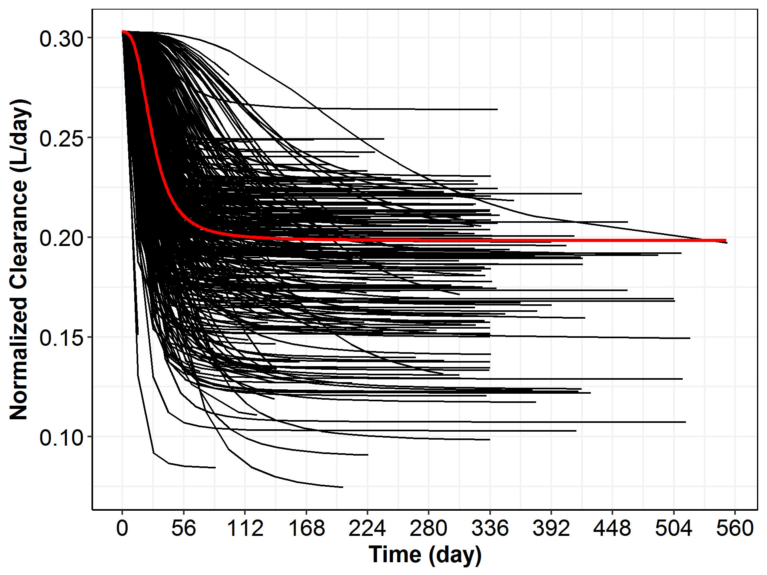

Note: Each black line represents normalized clearance-time profiles relative to population mean clearance (0.302 L/day); the red line represents the overall time-course of population mean clearance.

Table : Parameter Estimates of the Final Base Model (LN014)

| **Name** | **Description** | **Unit** | **Estimate(RSE)** |
| --- | --- | --- | --- |
| TVCL | Typical clearance | L/day | 0.302(2.32%) |
| TVV2 | Typical central volume of distribution | L | 3.35(1.14%) |
| TVQ | Typical inter-compartmental clearance | L/day | 0.642(4.60%) |
| TVV3 | Typical peripheral volume of distribution | L | 1.68(3.10%) |
| RUVCV | proportional error |  | 0.179(0.360%) |
| RUVSD | additive error | mg/L | 1.41(4.74%) |
| EMAX | Typical maximum effect in sigmoid model |  | -0.424(5.47%) |
| T50 | Typical half-life to achieve  half of the maximum effect | day | 29.6(6.89%) |
| HILL | hill exponent in Sigmoid-Emax model |  | 2.84(8.50%) |
| WGT_ON_CLQ | Weight on CLQ (CL and Q) |  | 0.435(14.7%) |
| WGT_ON_VSS | Weight on Vss (V2 and V3) |  | 0.523(8.42%) |
| IIV_CLQ | IIV on CL/Q |  | 0.119(6.16%) |
| IIV_VSS | IIV of Vss |  | 0.0459(6.49%) |
| IIV_EMAX | IIV of Emax |  | 0.223(15.1%) |
| IIV_T50 | IIV on T50 |  | 0.809(15.5%) |
| OMEGA.2.1. | IIV between CLQ and VSS |  | 0.0480(8.17%) |

Figure : Population Predicted (PRED) versus Observed (DVOR) Cemiplimab Concentration Obtained from the Final Base Model by Dose Groups

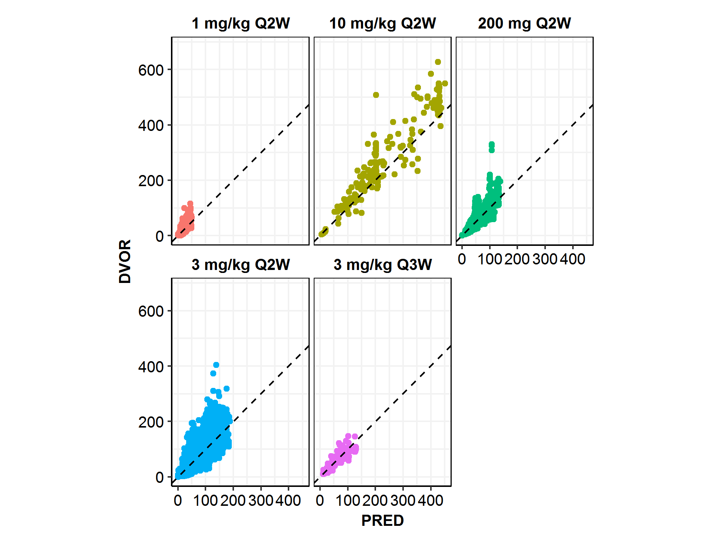

Note: the dashed line is the unity line. There are only 6 patients in the dose group of 10 mg/kg Q2W.

Figure : Individual Predicted (IPRED) versus Observed (DVOR) Cemiplimab Concentration Obtained from the Final Base Model by Dose Groups

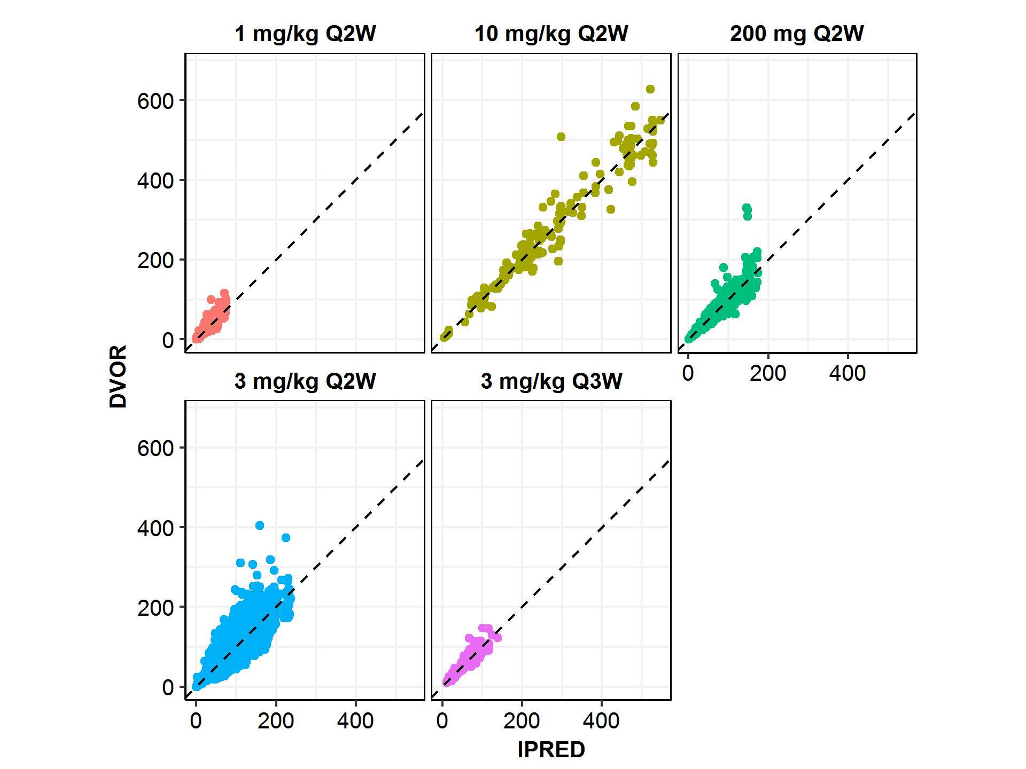

Note: the dashed line is the unity line. There are only 6 patients in the dose group of 10 mg/kg Q2W.

Figure : Goodness-of-Fit Plots for the Final Base Model by Dose Groups During the First Treatment Cycle (Up to Nominal Day 56 Days) in Study 1423 and 1540

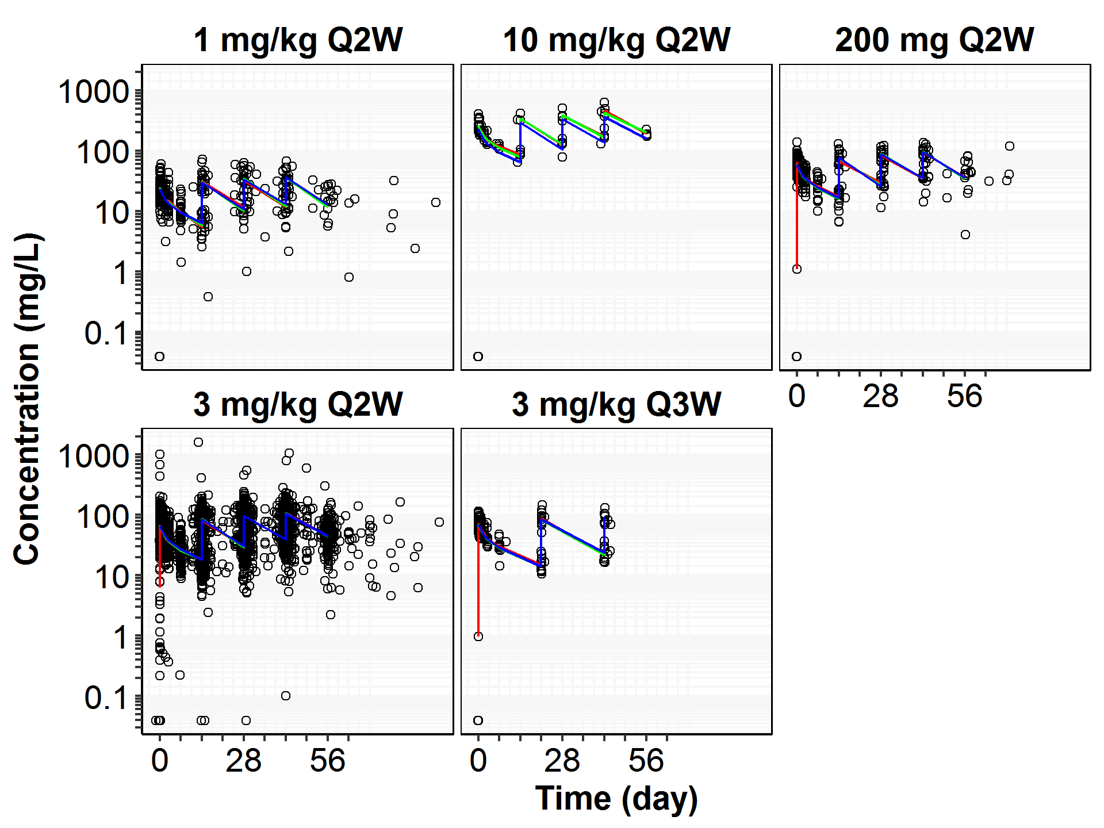

Note:

1. Black open circles correspond to individually observed concentrations, black solid lines, green and blue lines correspond to geometric mean observed concentrations, geometric mean individually predicted concentrations (IPRED) and geometric mean typical predicted concentrations (PRED), respectively.
2. In the dose group of 10 mg/kg Q2W in study 1423, one patient (R2810-ONC-1423-840-004-006) who received the wrong dose (1 mg/kg) on Day 1 was excluded in this plot.
   1. Full Covariate Model and Covariate Effects

The final base model (LN014) identified in Section 4.2 was extended to evaluate the covariate effects in three full models─LN101, LN102 and LN103 (see Table 9), in which all pre-specified covariate-parameter relationships were simultaneously estimated.

Table : List of Key Models in Full Covariate Model Development of Using Data from Studies 1423 and 1540

| **Model** | **Description** |
| --- | --- |
| LN101 | Covariates of baseline weight, age, BMI, BSA, height, sex, race, mono-therapy or not, patient with CSCC or not, creatinine, creatinine clearance, ALT, AST, bilirubin, ALB, IGG, LDH and ALP were applied to both CL/Q, and V2/V3. A total of 42 pairs of covariate-parameters were used. |
| LN102 | Covariates of baseline weight, age, BMI, BSA, height, sex, race, mono-therapy or not, patient with CSCC or not, creatinine, creatinine clearance, ALT, AST, bilirubin, ALB, IGG, LDH and ALP were applied to both Emax and T50. A total of 42 pairs of covariate-parameters were used. |
| LN103 | Derived from the results of LN101 and LN102.  A total of 35 covariate-parameters were used, as shown in Table 10. |

To achieve unbiased estimation of covariate effects, two full models (LN101 and LN102) were used to pre-select the potential pairs of covariate-parameter. In particular, LN101 was used to select covariates that may have an impact on clearance parameters (CL and Q), and a total of 42 pairs of covariate-parameter were to be filtered. Model LN102 was used for selecting covariates that may have an impact on Emax and T50 in the sigmoid Emax term and a total of 42 pairs of covariate-parameter were to be filtered. An effect threshold (exponent α in covariate model described in Section 3.6.5.1) of 0.1 relative to a typical patient was used to filter these 84 (42+42) pairs of covariate-parameter into a list of 35 pairs, which have been listed in Table 10.

Table 10 shows the covariates identified by the full models LN101 and LN102, in order of the absolute effect size. Not surprisingly, body weight and baseline albumin are the most influential covariates based on the magnitude of their effect sizes on cemiplimab clearance. A number of covariates were found to be associated with Emax and T50 in the sigmoid Emax model for the time-varying clearance. A total of 35 pairs of covariate-parameter including WGT_ON_CLQ and WGT_ON_VSS, were selected to characterize the covariate-parameter relationship.

Using the listed pairs of covariate-parameter identified in Table 10, a full covariate model, LN103, was constructed to further assess the covariate effects on the key model parameters (CL/Q, Vss, Emax and T50) and the resulting covariate effects (greater than 0.1) are presented in Figure 7 and Table 11. The results confirmed that body weight was one of the most influential covariates on cemiplimab clearance parameters (CL and Q) and on volume of distribution (Vss), and they supported the correctness of incorporating body weight into the base structural model. Results also indicated that albumin was an important covariate on clearance parameters (CL and Q). BMI was identified as an important covariate on Vss. For sigmoid Emax functional form of CL, race (black, Asia and other), immunoglobulin G (IGG), alkaline phosphatase (ALP), creatinine concentration (CREAT), alanine aminotransferase (ALT), and mono-therapy (MONO) were found to have impacts on Emax and T50. Notably, disease status (ECOG or LDH) was not statistically significant in this assessment.

Table : Pre-selected Covariates and their Effects (Exponent, α*) on Model Parameters, Identified by Two Full Models (LN101 and LN102), Relative to the Parameter Values of a Reference Patient

| **Parameters on CLQ/VSS (LN101)** | **Value (LN101)** | **Parameters on EMAX/T50 (LN102)** | **Value (LN102)** |
| --- | --- | --- | --- |
| ALB_ON_CLQ | -1.03 | CREAT_ON_EMAX | 0.587 |
| WGT_ON_CLQ | 0.455 | BMI_ON_EMAX | -0.453 |
| HGT_ON_CLQ | 0.244 | HGT_ON_EMAX | 0.419 |
| ALP_ON_CLQ | 0.118 | IGG_ON_EMAX | -0.414 |
| BSA_ON_CLQ | 0.116 | CRCL_ON_EMAX | 0.320 |
| IGG_ON_CLQ | 0.11 | ASIA_ON_EMAX | -0.259 |
| ALT_ON_CLQ | -0.103 | CSCC_ON_EMAX | 0.229 |
| WGT_ON_VSS | 0.716 | BLK_ON_EMAX | 0.184 |
| BMI_ON_VSS | -0.388 | MONO_ON_EMAX | 0.175 |
| HGT_ON_VSS | 0.323 | SEX_ON_EMAX | -0.172 |
| ALB_ON_VSS | -0.211 | OTHER_ON_EMAX | 0.158 |
| BSA_ON_VSS | 0.114 | ALT_ON_EMAX | 0.157 |
| --- | --- | ALP_ON_EMAX | 0.118 |
| --- | --- | BSA_ON_T50 | 0.613 |
| --- | --- | ASIA_ON_T50 | 0.514 |
| --- | --- | BLK_ON_T50 | 0.419 |
| --- | --- | OTHER_ON_T50 | 0.271 |
| --- | --- | ALT_ON_T50 | -0.267 |
| --- | --- | SEX_ON_T50 | -0.247 |
| --- | --- | CREAT_ON_T50 | 0.206 |
| --- | --- | IGG_ON_T50 | 0.168 |
| --- | --- | ALB_ON_T50 | -0.123 |
| --- | --- | AST_ON_T50 | -0.107 |

Note: * exponent α in the covariate model was described in Section 3.6.5.1. See discussions of covariate effects on exposure metrics such as Ctrough and AUC6wk,ss in Section 4.6.2.

1. ALB: albumin (g/L), ALB: albumin (g/L), ALP: alkaline phosphatase (IU/L), ALT: alanine aminotransferase (IU/L), AST: Aspartate Aminotransferase(IU/L), BMI: body mass index, BSA: body surface area, BILI: Total Bilirubin(µmol/L), CRCL: Creatinine Clearance (mL/min), CREAT: creatinine concentration (µmol/L), IgG: immunoglobulin G (g/L), LDH: lactate dehydrogenase (IU/L)
2. The reference patient is a 60-year-old white male weighing 75 kg with a baseline BMI (BMI) of 26.5 kg/m2, albumin level (ALB) of 38 g/L, lactate dehydrogenase (LDH) of 250 IU/L, alkaline phosphatase (ALP) of 90 IU/L, alanine aminotransferase (ALT) of 21 IU/L, creatinine (CREAT) of 75 umol/L, immunoglobulin G (IGG) of 9.7 g/L and body surface area (BSA) of 1.88 m2.

Figure 7: Forest Plot of Covariates and their Effects (Exponent, α*) on Model Parameters, Estimated by the Full Model LN103, Relative to the Parameter Values of a Reference Patient

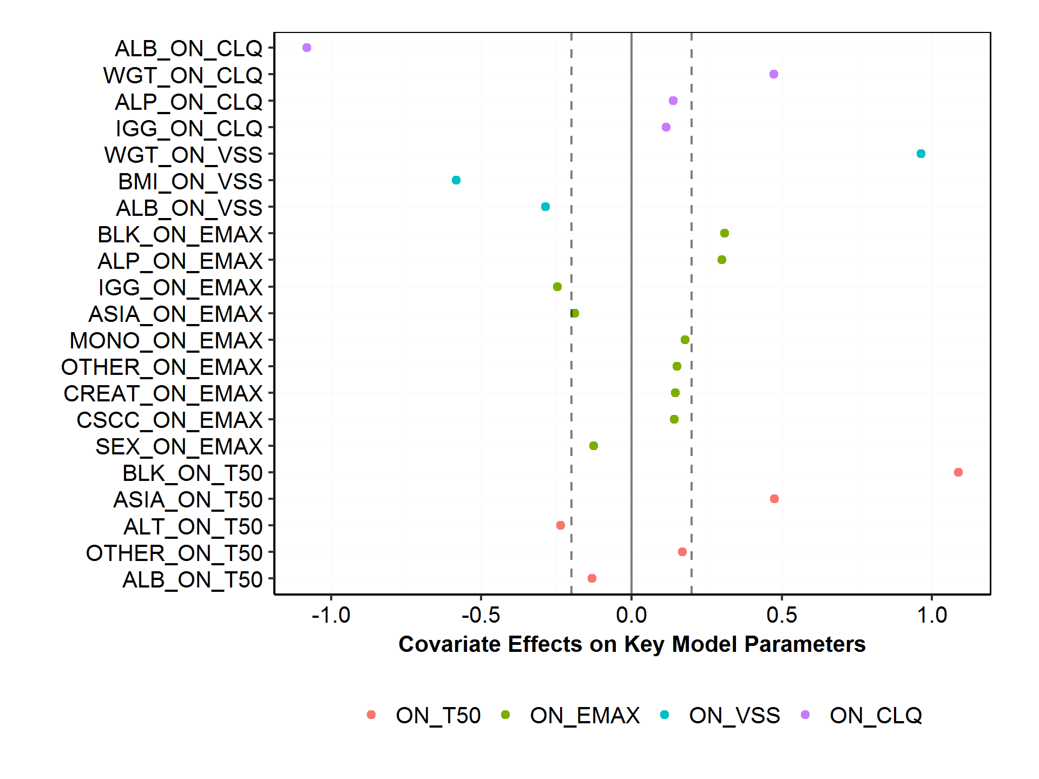

Note**:** * The interpretation of exponent α in the covariate model was described in Section 3.6.5.1. See discussions of covariate effects on exposure metrics such as Ctrough,ss and AUC6wk,ss in Section 4.6.2.

1. Color represents the category of the covariate model parameters (either on CLQ, VSS, Emax or T50); each dot represents the covariate effects (exponent, α) relative to the reference value.
2. ALB: albumin (g/L), ALB: albumin (g/L), ALP: alkaline phosphatase (IU/L), ALT: alanine aminotransferase (IU/L), AST: Aspartate Aminotransferase(IU/L), BMI: body mass index, BSA: body surface area, BILI: Total Bilirubin(µmol/L), CRCL: Creatinine Clearance (mL/min), CREAT: creatinine concentration (µmol/L), IgG: immunoglobulin G (g/L), LDH: lactate dehydrogenase (IU/L).
3. The reference patient is a 60-year-old white male weighing 75 kg with a baseline BMI (BMI) of 26.5 kg/m2, albumin level (ALB) of 38 g/L, lactate dehydrogenase (LDH) of 250 IU/L, alkaline phosphatase (ALP) of 90 IU/L, alanine aminotransferase (ALT) of 21 IU/L, creatinine (CREAT) of 75 umol/L, immunoglobulin G (IGG) of 9.7 g/L and body surface area (BSA) of 1.88 m2.
4. Parameter estimate in the reference patient is considered 0.0% (vertical solid line), and dashed vertical lines are at -20% and 20% of this value.

Table 11: Summary of Covariates and their Effects (Exponent, α*) on Model Parameters, Estimated by the Full Model LN103, Relative to the Parameter Values of a Reference Patient

| **Parameters** | **Covariate Effect**  (exponent α) | **Group** |
| --- | --- | --- |
| ALB_ON_T50 | -0.132 | ON_T50 |
| OTHER_ON_T50 | 0.170 | ON_T50 |
| ALT_ON_T50 | -0.236 | ON_T50 |
| ASIA_ON_T50 | 0.476 | ON_T50 |
| BLK_ON_T50 | 1.087 | ON_T50 |
| SEX_ON_EMAX | -0.126 | ON_EMAX |
| CSCC_ON_EMAX | 0.143 | ON_EMAX |
| CREAT_ON_EMAX | 0.146 | ON_EMAX |
| OTHER_ON_EMAX | 0.152 | ON_EMAX |
| MONO_ON_EMAX | 0.178 | ON_EMAX |
| ASIA_ON_EMAX | -0.189 | ON_EMAX |
| IGG_ON_EMAX | -0.246 | ON_EMAX |
| ALP_ON_EMAX | 0.300 | ON_EMAX |
| BLK_ON_EMAX | 0.310 | ON_EMAX |
| ALB_ON_VSS | -0.286 | ON_VSS |
| BMI_ON_VSS | -0.584 | ON_VSS |
| WGT_ON_VSS | 0.963 | ON_VSS |
| IGG_ON_CLQ | 0.116 | ON_CLQ |
| ALP_ON_CLQ | 0.138 | ON_CLQ |
| WGT_ON_CLQ | 0.473 | ON_CLQ |
| ALB_ON_CLQ | -1.080 | ON_CLQ |

Note: this table corresponds to Figure 7. *The interpretation of exponent α in the covariate model was described in Section 3.6.5.1. See discussions of covariate effects on exposure metrics such as Ctrough,ss and AUC6wk,ss in Section 4.6.2.

ALB: albumin (g/L), ALB: albumin (g/L), ALP: alkaline phosphatase (IU/L), ALT: alanine aminotransferase (IU/L), AST: Aspartate Aminotransferase(IU/L), BMI: body mass index, BSA: body surface area, BILI: Total Bilirubin(µmol/L), CRCL: Creatinine Clearance (mL/min), CREAT: creatinine concentration (µmol/L), IgG: immunoglobulin G (g/L), LDH: lactate dehydrogenase (IU/L).  
The reference patient is a 60-year-old white male weighing 75 kg with a baseline BMI (BMI) of 26.5 kg/m2, albumin level (ALB) of 38 g/L, lactate dehydrogenase (LDH) of 250 IU/L, alkaline phosphatase (ALP) of 90 IU/L, alanine aminotransferase (ALT) of 21 IU/L, creatinine (CREAT) of 75 μmol/L, immunoglobulin G (IGG) of 9.7 g/L and body surface area (BSA) of 1.88 m2.

* 1. Final Covariate Model

The full model (LN103) as described in the previous section identified a list of covariates and their effects on the key model parameters (CL, Vss, Emax and T50). To further remove non-significant covariates and achieve a concise covariate model, the standard procedures of forward addition and backward elimination were used, and the results are presented in Table 12. In particular, five iterations of forward addition and one iteration of backward elimination were conducted.

* + 1. Forward Addition

Through five iterations of forward addition, the covariates that were found to be statistically significant (p<0.01) were baseline albumin, baseline immunoglobulin G and baseline alanine aminotransferase on clearance parameters (CL/Q), baseline BMI on Vss, and race (Black) on T50, as shown in Table 12. All of the remaining effect parameters were considered as statistically insignificant and therefore not considered for further analyses. The final model from the forward addition step is model LN511, which includes ALB_ON_CLQ, BMI_ON_VSS, IGG_ON_CLQ, ALT_ON_CLQ, and BLK_ON_T50 as the covariate-parameters.

* + 1. Backward Elimination

Each of the significant relationships (ie, covariate-parameter) in the model LN511, were deleted sequentially (backward elimination) one at a time. Removal of each covariate led to a significant degradation in the reduced model as indicated by an increase of more than 10.83 points in MOFV relative to reference model (LN511), as shown in Table 12. Therefore, each relationship was considered significant and the model LN511 was considered as the final model; it has been renamed as model LN900 for subsequent simulations.

* + 1. Summary of the Final Model

A summary of the final model (LN900) and the covariate effects are discussed in this section. That is, all covariates that add to the characterization of between-patient variability in cemiplimab pharmacokinetics are described below. The impact of covariates on cemiplimab exposure (Ctrough and AUCss) and relevance, if any, to clinically meaningful exposure changes, are discussed in Section 4.6.

Both clearance (CL) and inter-compartment clearance (Q) were found to depend on body weight according to the principle of allometric scaling, with an exponent of 0.454, whereas the exponent of both central and peripheral volumes was found to be 0.935, a value that suggests volume is approximately linearly proportional to weight. No systematic trend of gain or loss of body weight during the treatment period was observed (see Figure 32), indicating no direct relationship between patient’s body weight changes and the time-varying clearance observed for cemiplimab. The impact of BMI on Vss (an exponent of -0.553) is statistically significant; removal resulted in ~42 unit increase in MOFV and its effect on volume decreased from ~0.9 to ~0.5.

The covariate analyses show that baseline albumin (ALBBL) has a negative linear proportional effect on CL and Q (with a covariate effect of ~-1.0), ie, cemiplimab clearance was greater in patients with lower ALB levels, relative to a typical patient in the overall population. It was also observed that the albumin level in patients did not show systematic trends during the treatment period (See Figure 33), indicating albumin level during treatment did not contribute to the time-varying clearance observed for cemiplimab.

Black or African American (a total of 20 patients) patients were observed to take longer time (~75 days) to achieve maximum change in clearance in the time-varying clearance model, compared to 30 days for a white patient (see Figure 7 and Table 11).

Baseline IgG and ALT are not anticipated to affect the exposure of cemiplimab to a clinically meaningful extent (effect sizes were <20%), although they were identified as significant covariates in the forward addition and backward elimination analyses.

The parameter estimates from the final model are presented in Table 13, and it was observed that the IIV on CL and Q of the final model were reduced by 24.8%, compared with the base model. The estimated IIV on CL/Q and Vss are relatively small (<0.1), and IIV on Emax and T50 are 0.26 and 0.583, respectively. The condition number associated with the final model is small (37.9), indicating the parameter estimates are reliable.

Inspection of the goodness-of-fit plots suggests good agreement between geometric mean observed data and model predictions for most conditions. Goodness-of-fit plots including dependent variable (DV) versus population predicted value (PRED) and DV versus individually predicted value (IPRED) by dose group are given in Figure 8 and Figure 9, respectively. Individual predicted (IPRED), population predicted (PRED) and observed cemiplimab concentrations versus time by dose group are presented in Figure 10. Goodness-of-fit plots IPRED versus conditional weighted residual (CWRES), TIME versus CWRES, patient ID versus CWRES, key covariate variables against etas, and time-dependent body weight, albumin, and lactate dehydrogenase (LDH) against time are presented in Appendix C. The NONMEM® control stream of the final model is also included in Appendix F.

The final model is as follows:

where , , , and are the typical values of CL, Q, V2, V3 and T50. The model parameters of WGTBL_ON_CLQ, ALBBL_ON_CLQ, IGGBL_ON_CLQ, ALTBL_ON_CLQ, WGTBL_ON_VSS, BMIBL_ON_VSS, and BLK_ON_T50 are used to assess the covariate effects of relevant covariates of weight, albumin, IgG, ALT, BMI, and race (Black). The represents the inter-individual variability for each model parameter, represents the estimate of the maximal change of CL over time. The parameter represents the time at which the change in is 50% of , and represents the sigmoidicity (HILL) of the relationship with time. The index of *i* represents patient *i*. The reference values of the covariates were chosen to be close to the median values of the corresponding covariate.

Table : Summary of Steps in Forward Addition and Backward Elimination of Covariates, Based on the Full Model LN103

| **Key step** | **Covariate** | **Difference in MOFV\*** | **Model** |
| --- | --- | --- | --- |
| forward.iter=1 |  |  |  |
|  | +ALB_ON_CLQ | -98.84 | LN112 |
|  | +BMI_ON_VSS | -46.534 | LN115 |
|  | +IGG_ON_CLQ | -33.855 | LN113 |
|  | +ALT_ON_CLQ | -16.073 | LN111 |
|  | +BLK_ON_T50 | -12.083 | LN125 |
|  | +MONO_ON_EMAX | -11.929 | LN120 |
|  | +ALP_ON_CLQ | -10.828 | LN114 |
| forward.iter=2 |  |  |  |
|  | +BMI_ON_VSS | -37.692 | LN211 |
|  | +IGG_ON_CLQ | -33.406 | LN212 |
|  | +BLK_ON_T50 | -13.21 | LN214 |
|  | +ALP_ON_CLQ | -12.369 | LN216 |
|  | +MONO_ON_EMAX | -12.067 | LN215 |
|  | +ALT_ON_CLQ | -9.0924 | LN213 |
| forward.iter=3 |  |  |  |
|  | +IGG_ON_CLQ | -33.771 | LN311 |
|  | +BLK_ON_T50 | -20.335 | LN312 |
|  | +ALT_ON_CLQ | -16.248 | LN315 |
|  | +ALP_ON_CLQ | -12.955 | LN313 |
|  | +MONO_ON_EMAX | -12.027 | LN314 |
| forward.iter=4 |  |  |  |
|  | +BLK_ON_T50 | -14.181 | LN411 |
|  | +ALP_ON_CLQ | -10.029 | LN413 |
| forward.iter=5 |  |  |  |
|  | +ALP_ON_CLQ | -11.967 | LN511 |
| backward.iter=1 |  |  |  |
|  | -ALB_ON_CLQ | 88.378 | LN611 |
|  | -BMI_ON_VSS | 42.284 | LN612 |
|  | -IGG_ON_CLQ | 30.043 | LN613 |
|  | -ALT_ON_CLQ | 16.119 | LN614 |
|  | -BLK_ON_T50 | 11.967 | LN615 |

Note: *change in MOFV relative to the reference model. The positive sign (+) on each covariate indicate adding each covariate one at time to the base model from the previous step; the negative sign (-) on each covariate indicate removing each covariate one at time to the base model from the previous step.

Table : Population PK Parameters of Cemiplimab Obtained from the Final Covariate Model (LN900)

| **Name** | **Description** | **Unit** | **Estimate(RSE)** | **CI95** |
| --- | --- | --- | --- | --- |
| TVCL | Typical clearance | L/day | 0.287(2.15%) | [0.274-0.309] |
| TVV2 | Typical central volume   of distribution | L | 3.34(1.11%) | [3.28-3.40] |
| TVQ | Typical inter-compartmental   clearance | L/day | 0.647(4.50%) | [0.579-0.722] |
| TVV3 | Typical peripheral volume   of distribution | L | 1.69(3.06%) | [1.53-1.85] |
| RUVCV | proportional error |  | 0.180(0.360%) | [0.173-0.187] |
| RUVSD | additive error | mg/L | 1.34(5.25%) | [0.0245-1.95] |
| EMAX | Typical maximum effect   in sigmoid model |  | -0.382(5.53%) | [-0.476--0.324] |
| T50 | Typical half-life to achieve   half of the maximum effect | day | 32.1(6.16%) | [24.0-38.6] |
| HILL | hill exponent   in Sigmoid model |  | 3.17(9.08%) | [2.33-4.13] |
| WGT_ON_CLQ | Weight on CL/Q |  | 0.454(13.3%) | [0.300-0.609] |
| WGT_ON_VSS | Weight on Vss |  | 0.935(8.36%) | [0.779-1.08] |
| ALT_ON_CLQ | ALT on CL/Q |  | -0.0818(25.0%) | [-0.137--0.0240] |
| ALB_ON_CLQ | Albumin on CL/Q |  | -1.00(8.72%) | [-1.23--0.722] |
| IGG_ON_CLQ | IgG on CL/Q |  | 0.182(15.4%) | [0.110-0.270] |
| BMI_ON_VSS | BMI on Vss |  | -0.553(16.1%) | [-0.707--0.378] |
| BLK_ON_T50 | Black on T50 |  | 0.946(30.0%) | [0.417-1.70] |
| IIV_CLQ | IIV on CL/Q |  | 0.0893(5.52%) | [0.0655-0.120] |
| IIV_VSS | IIV of Vss |  | 0.0412(6.38%) | [0.0345-0.0484] |
| IIV_EMAX | IIV of Emax |  | 0.260(15.3%) | [0.159-0.357] |
| IIV_T50 | IIV on T50 |  | 0.583(16.9%) | [0.394-0.970] |
| OMEGA.2.1. | IIV between   CLQ and VSS |  | 0.0403(8.57%) | [0.0323-0.0502] |

Note: the 95% confident interval came from 1,000 bootstrap described in Section 4.5.2.

BMI: body mass index, BSA: body surface area, ALB: albumin (g/L), ALP: alkaline phosphatase (IU/L), ALT: alanine aminotransferase (IU/L), AST: Aspartate Aminotransferase(IU/L), BILI: Total Bilirubin(µmol/L), CRCL: Creatinine Clearance (mL/min), CREAT: creatinine concentration (µmol/L), IgG: immunoglobulin G (g/L), LDH: lactate dehydrogenase (IU/L)

Figure : Population Predicted (PRED) versus Observed (DVOR) Cemiplimab Concentrations by Dose Groups Obtained from the Final Model (LN900)

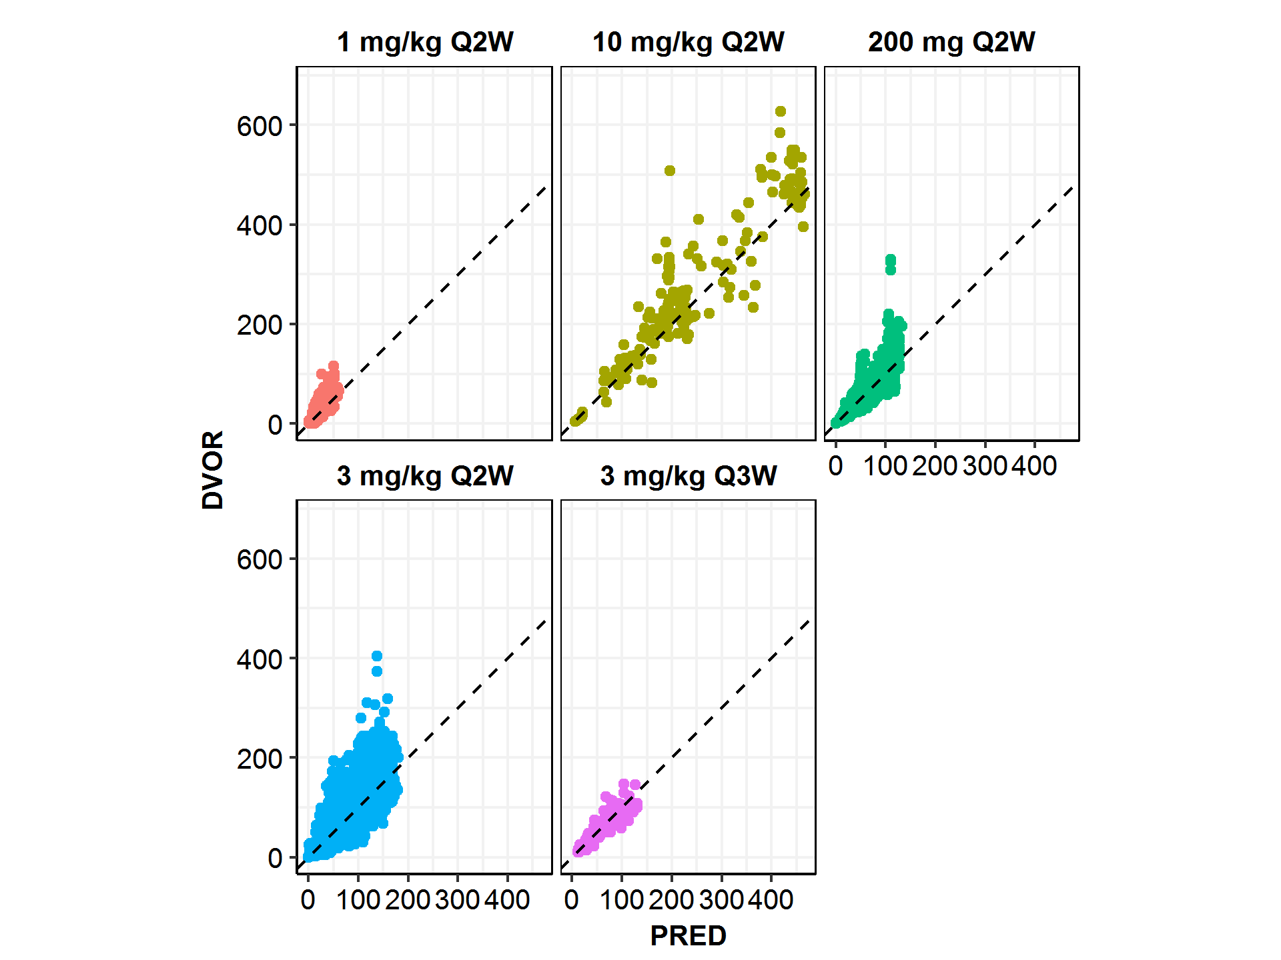

Note: the solid line is the unity line. There are only 6 patients in the dose group of 10 mg/kg Q2W.

Figure : Individual Predicted (IPRED) versus Observed (DVOR) Cemiplimab Concentrations by Dose Groups Obtained from the Final Model (LN900)

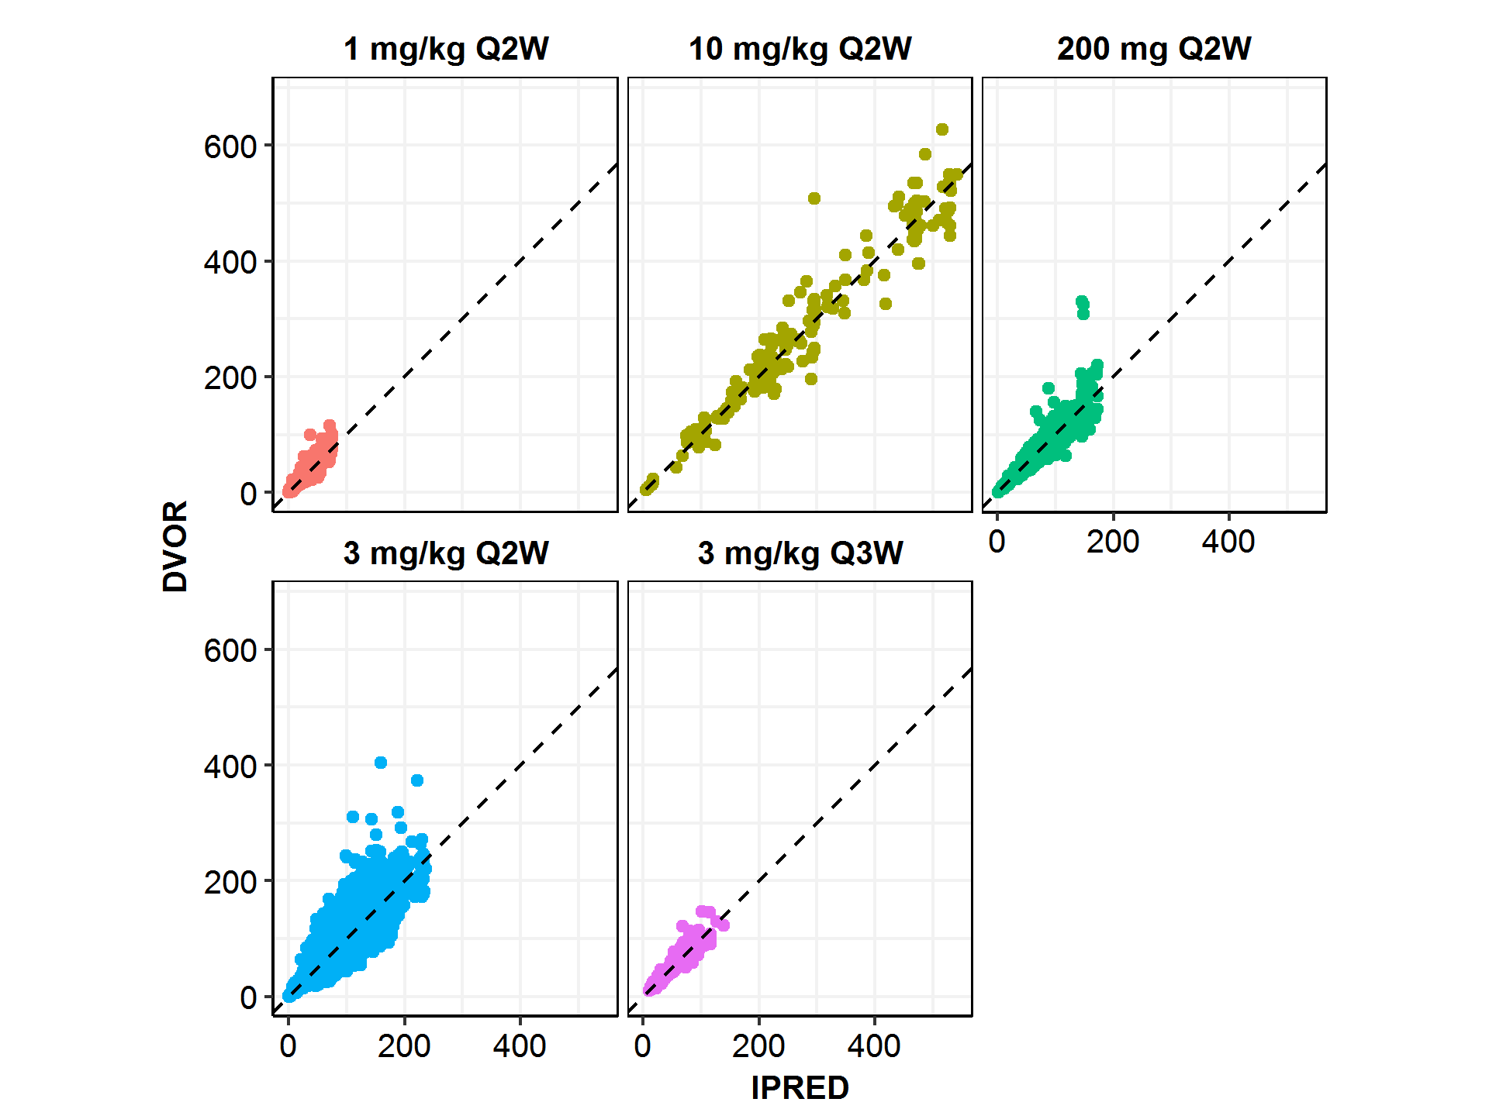

Note: the solid line is the unity line. There are only 6 patients in the dose group of 10 mg/kg Q2W.

Figure : Goodness-of-Fit Plots for the Final Model (LN900) by Dose Groups in Study 1423 and Study 1540

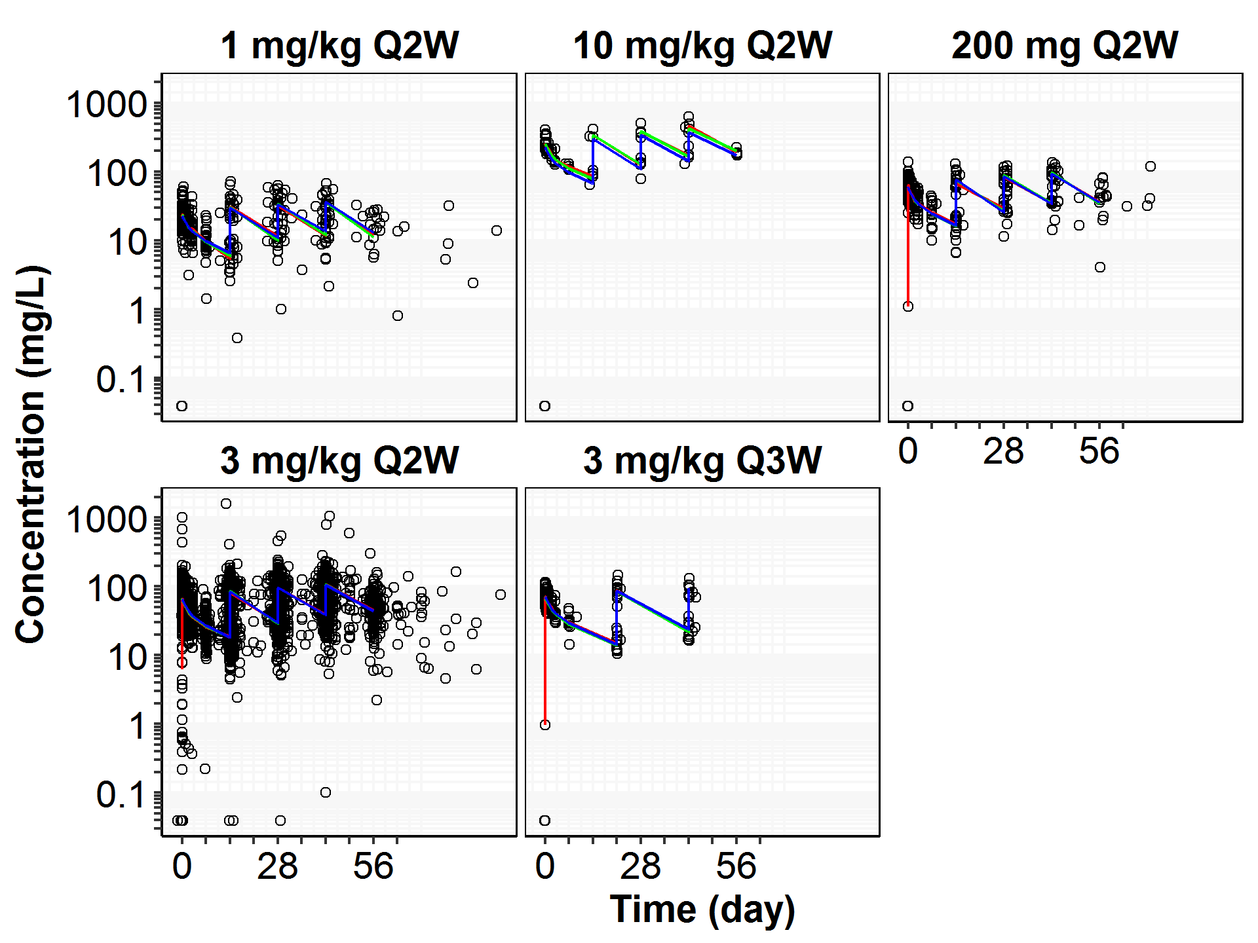

Note:

1. Black open circles correspond to individually observed concentrations, black solid lines, green and blue dashed lines correspond to geometric mean observed concentrations, geometric mean individually predicted concentrations (IPRED) and geometric mean typical predicted concentrations (PRED), respectively.
2. In the dose group of 10 mg/kg Q2W in study 1423, one patient (R2810-ONC-1423-840004-006) who received the wrong dose (1 mg/kg) on Day 1 was excluded in the plot.
   1. Model Evaluation
      1. Model Stability

The final model was fitted to 1,000 bootstrap replicate datasets to evaluate its stability and performance. Nonparametric bootstrap was performed and resulted in 95% CIs for population PK parameter estimates, which are presented in Table 14. The covariate effects are presented in a forest plot, as shown in Figure 11 and its tabular form in Table 15. CIs were based on bootstrap estimates from 1,000 model runs that converged successfully, regardless of $COVARIANCE step success. Among the 1,000 runs, 258 (~25%) failed due to rounding errors; however, reasonable estimation of the parameters were still observed.

Overall, typical structural model parameters, random variance terms, and covariate effects were estimated with good precision and stability, since the difference in parameter estimates between the original NONMEM® input dataset and the bootstrapped datasets were minimal (less than 10%). Histograms of the MOFV and parameter estimates across the 1,000 runs are shown in Appendix C.

Table : Summary of Parameter Values after Modelling with Original NONMEM Input Data File or 1,000 Bootstrap Datasets for the Final Model (LN900)

| **Parameter** | **Estimate from  (Analysis Set)** | **Estimate from  1,000 Bootstrap** | |
| --- | --- | --- | --- |
| **Point Estimate** | **Mean(CV)** | **Median[CI95]** |
| TVCL | 0.287 | 0.290(3.12%) | 0.290[0.274-0.309] |
| TVV2 | 3.34 | 3.34(0.930%) | 3.34[3.28-3.40] |
| TVQ | 0.647 | 0.647(5.69%) | 0.647[0.579-0.722] |
| TVV3 | 1.69 | 1.68(4.65%) | 1.68[1.53-1.85] |
| RUVCV | 0.180 | 0.180(2.06%) | 0.180[0.173-0.187] |
| RUVSD | 1.34 | 1.22(41.7%) | 1.33[0.0245-1.95] |
| EMAX | -0.382 | -0.392(9.44%) | -0.390[-0.476--0.324] |
| T50 | 32.1 | 31.1(11.9%) | 31.0[24.0-38.6] |
| HILL | 3.17 | 3.15(14.3%) | 3.11[2.33-4.13] |
| WGT_ON_CLQ | 0.454 | 0.456(17.2%) | 0.456[0.300-0.609] |
| WGT_ON_VSS | 0.935 | 0.932(8.18%) | 0.936[0.779-1.08] |
| ALT_ON_CLQ | -0.0818 | -0.0817(34.9%) | -0.0823[-0.137--0.0240] |
| ALB_ON_CLQ | -1.00 | -0.976(13.4%) | -0.973[-1.23--0.722] |
| IGG_ON_CLQ | 0.182 | 0.185(22.0%) | 0.183[0.110-0.270] |
| BMI_ON_VSS | -0.553 | -0.545(15.8%) | -0.547[-0.707--0.378] |
| BLK_ON_T50 | 0.946 | 0.998(32.2%) | 0.972[0.417-1.70] |
| IIV_CLQ | 0.0893 | 0.0883(15.5%) | 0.0876[0.0655-0.120] |
| IIV_VSS | 0.0412 | 0.0410(8.47%) | 0.0408[0.0345-0.0484] |
| IIV_EMAX | 0.260 | 0.253(20.4%) | 0.250[0.159-0.357] |

Note: the description of model parameters was provided in Table 13.

Figure 11: Forest Plot of Covariate Effects (Exponent α*) on Model Parameters, Estimated by the Final Model LN900, Relative to the Parameter Values of a Reference Patient

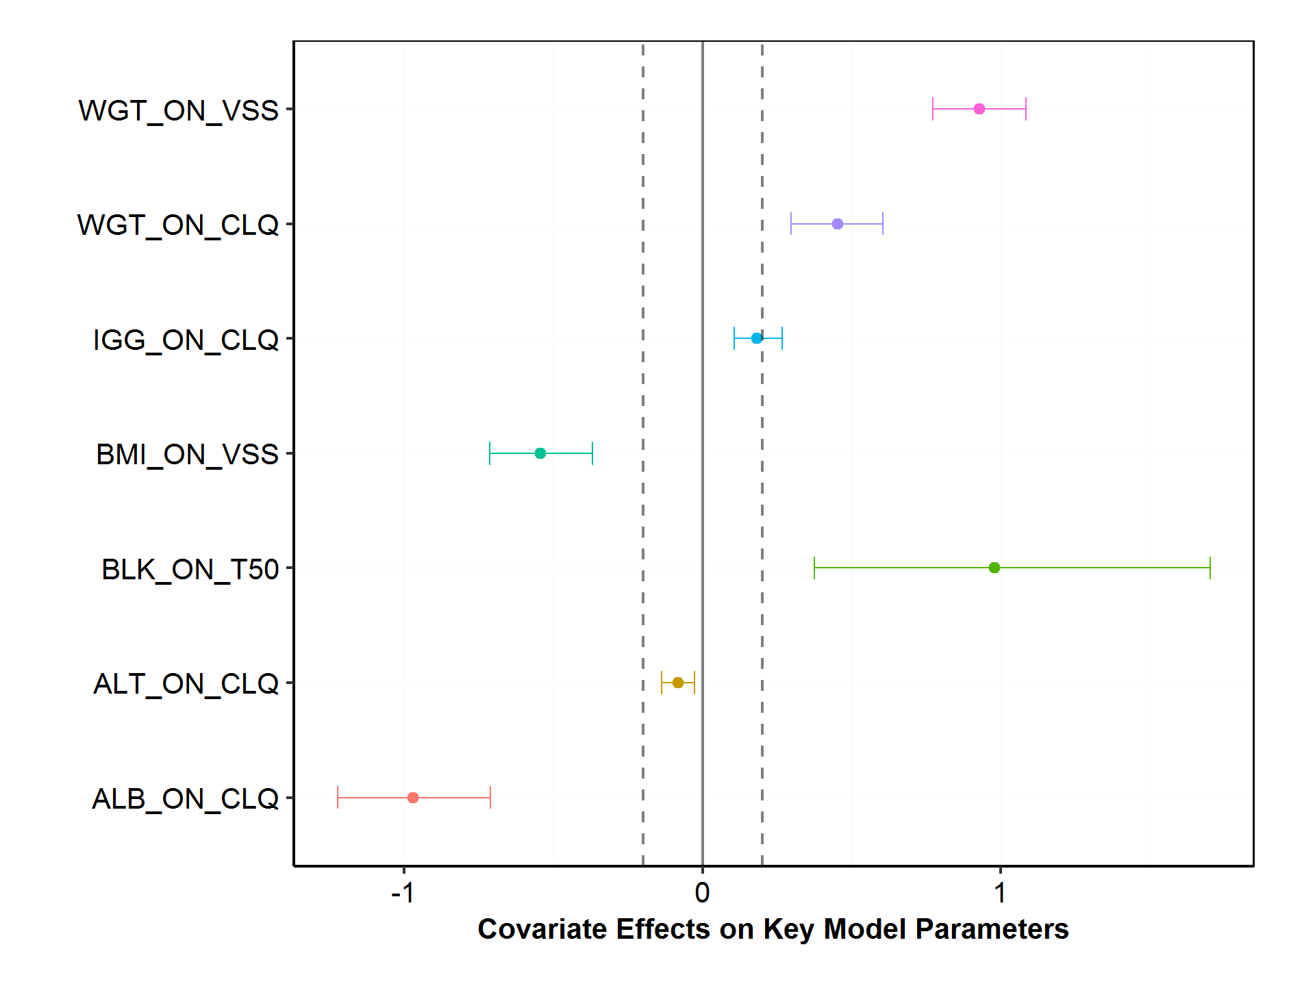

Note: * the interpretation of exponent α in the covariate model was described in Section 3.6.5.1. See discussions of covariate effects on exposure metrics such as Ctrough and AUC6wk,ss in Section 4.6.2. WGT: weight (kg), IgG: immunoglobulin G (g/L), BMI: body mass index, BLK: black, ALT: alanine aminotransferase (IU/L), ALB: albumin (g/L).

Table 15: Summary of Covariates and their Effects (Exponent α*) on Model Parameters, Estimated by the Final Model LN900, Relative to the Parameter Values of a Reference Patient

| **Parameters** | **Median(CI95)** |
| --- | --- |
| ALB_ON_CLQ | -0.970(-1.22,-0.711) |
| ALT_ON_CLQ | -0.0821(-0.137,-0.0258) |
| BLK_ON_T50 | 0.957(0.376,1.70) |
| BMI_ON_VSS | -0.547(-0.714,-0.368) |
| IGG_ON_CLQ | 0.181(0.107,0.268) |
| WGT_ON_CLQ | 0.454(0.297,0.606) |
| WGT_ON_VSS | 0.933(0.774,1.08) |

Note: This table corresponds to Figure 11.

* + 1. Model Evaluation

Visual predictive checks (VPCs) were constructed to evaluate the model predictability. Overall, the model described the observed data well, and illustrated that the assumptions about random variability were reasonably satisfied.

Figure 12 and Figure 13 show representative VPC plots of dose-normalized concentration versus actual time at 1, 3, 10 mg/kg, and 200 mg every two weeks (Q2W), during the first treatment cycle (up to 56 nominal days) and the first three cycles (up to 168 nominal days), respectively. Figure 14 represents observed cemiplimab concentrations stratified for the different dosage regimens in the first treatment cycle.

The plots show that the observed concentration–time course of cemiplimab at the 2.5th, 50th, and 97.5th percentiles fell within their corresponding 95% prediction intervals, indicating that the model adequately predicted the central tendency (median) and extremes (2.5th and 97.5th percentiles) of the concentration–time profile of cemiplimab in the dose range studied. Some evidence of increasing concentrations beyond 8 weeks were visible in the VPC plot at the last portion of the concentration time curves, which was captured by the time-varying CL component of the model.

In summary, the cemiplimab population PK model evaluation results, which include the results of simulation and nonparametric bootstrap, reveal that the final model provides a reliable description of the data with good precision of structural model and variance parameter estimates.

Figure : Visual Predictive Check from Final Pop PK Model: Dose-normalized Cemiplimab Concentrations (Log Scale) versus Time in the First Treatment Cycle (up to 56 Nominal Days) with Median and Predicted 95% Confidence Intervals, in the Dose Groups of 1, 3, 10 mg/kg Q2W and 200 mg Q2W

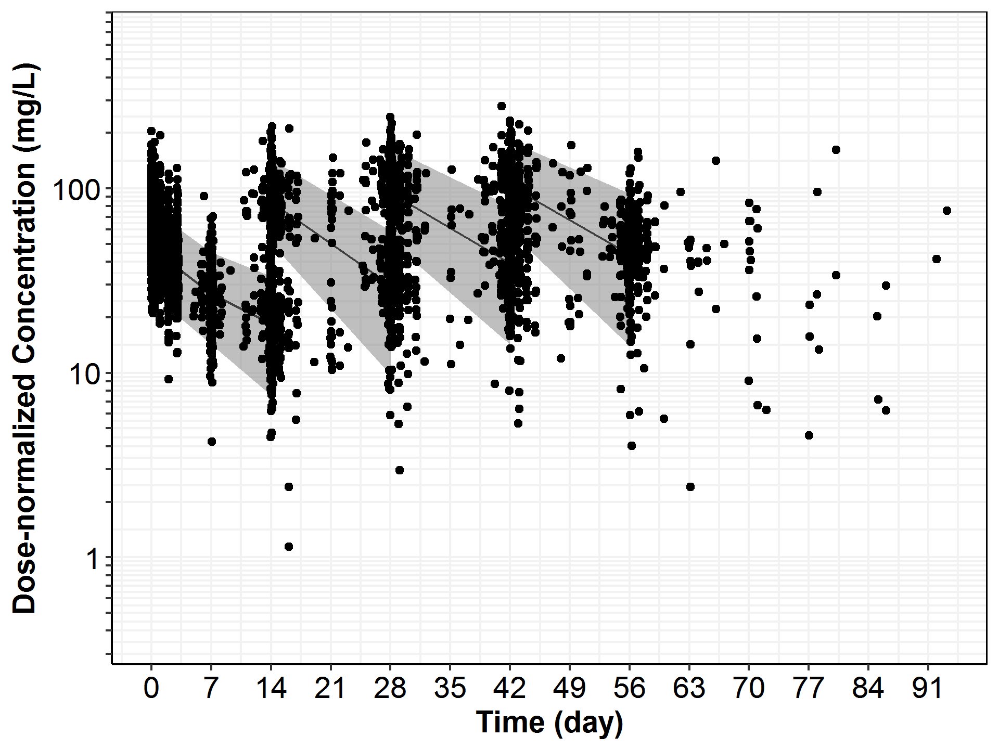

Note:

1. Dots are observed data and the solid lines represent the median of the simulated data, and the shaded areas represent the simulation-based 95% confidence intervals for the 2.5th and 97.5th percentiles of the predicted data. Patient at 3 mg/kg Q3W were not included in this plot.
2. In the dose group of 10 mg/kg Q2W in study 1423, one patient (R2810-ONC-1423-840004-006) who received the wrong dose (1 mg/kg) on Day 1 was excluded in this plot.

Figure 13: Visual Predictive Check from Final Pop PK Model: Dose-normalized Cemiplimab Concentrations (Log Scale) versus Time after Dose in the First Three Treatment Cycle (up to 168 Nominal Days) with Median and Predicted 95% Confidence Intervals in Dose Groups of 1, 3, 10 mg/kg Q2W and 200 mg Q2W

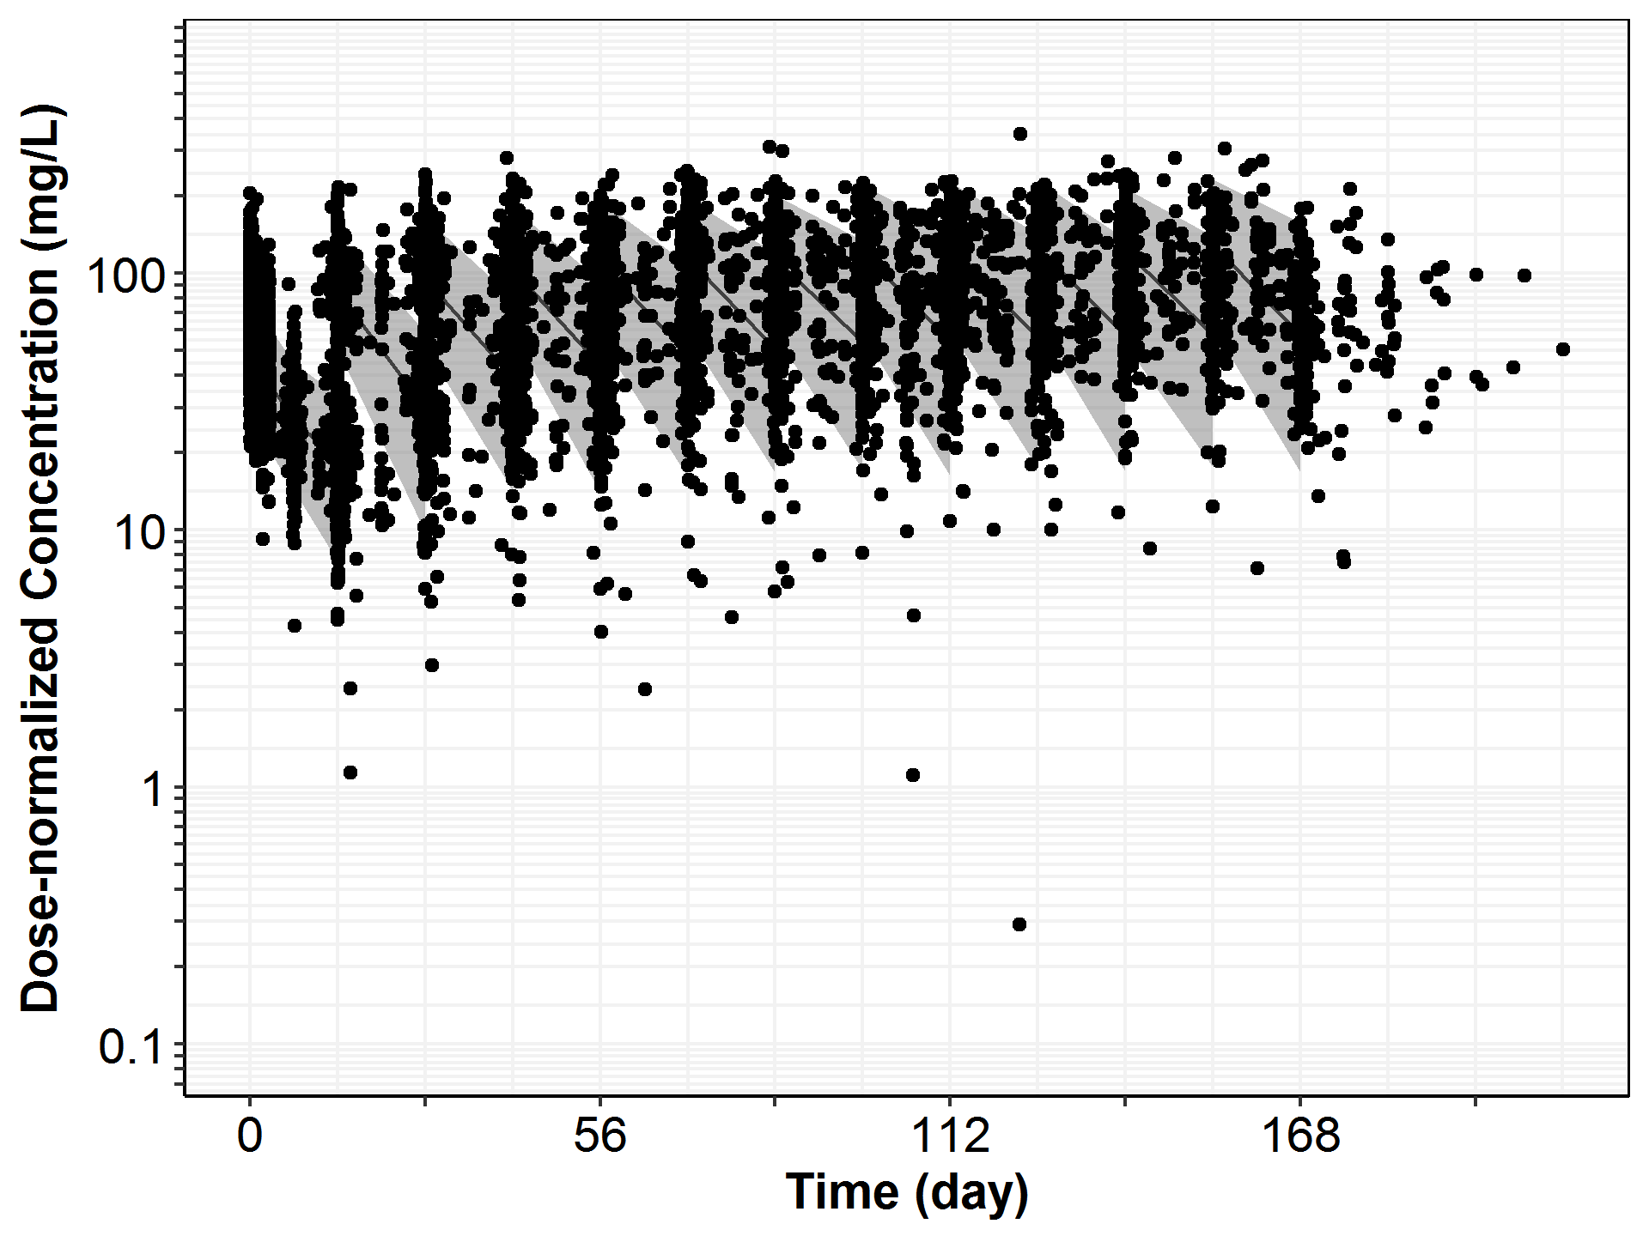

Note:

1. Dots are observed data and the solid lines represent the median of the simulated data, and the shaded areas represent the simulation-based 95% confidence intervals for the 2.5th and 97.5th percentiles of the predicted data. Patients with 3 mg/kg Q3W were not included in this plot.
2. In the dose group of 10 mg/kg Q2W in study 1423, one patient (R2810-ONC-1423-840004-006) who received the wrong dose (1 mg/kg) on Day 1 was excluded in the plot.

Figure : Visual Predictive Check from Final Pop PK Model: Cemiplimab Concentrations (Log Scale) versus Time in the First Treatment Cycle (up to 56 Nominal Days) Stratified by Dosage Regimens, with Median and Predicted 95% Confidence Intervals from the Simulation Based on the Final Population Model

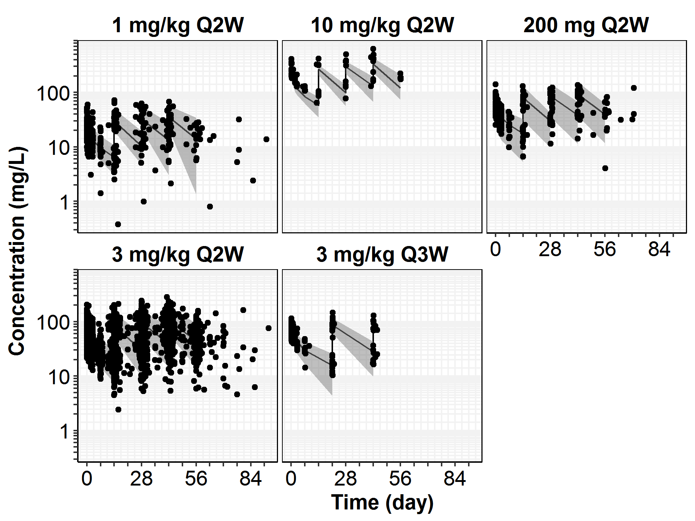

Note:

1. Dots are observed data and the solid lines represent the median of the simulated data, and the shaded areas represent the simulation-based 95% confidence intervals for the 2.5th and 97.5th percentiles of the predicted data. Patients with 3 mg/kg Q3W were not included in this plot.
2. In the dose group of 10 mg/kg Q2W in study 1423, one patient (R2810-ONC-1423-840004-006) who received the wrong dose (1 mg/kg) on Day 1 was excluded in the plot.
   1. Population PK model Application
      1. Post-hoc Exposure Metrics of Cemiplimab

The final Pop PK model (LN900) was used to generate the post-hoc estimates of individual PK parameters and exposure metrics for each patient. As would be expected, the model-predicted steady-state Ctrough,ss, Cmax,ss, Cavg,ss, AUCss, were highly correlated (Pearson correlation coefficient > 0.9); Ctrough,ss and AUCss over six-week of dosing period (AUC6wk,ss) were intentionally selected to describe exposure over a same observation period for the 2 dosing regimen and thus comprised 3 doses of 3 mg/kg Q2W doses and 2 doses of 350 mg Q3W.

As cemiplimab is a monoclonal antibody directed against PD-1, a cell membrane target, there is a body of data, including the PK observed in the non-human primate (see Appendix A), suggesting an underlying saturable, target-mediated elimination pathway may be the predominant route of elimination at low doses/concentrations, leading to non-linear pharmacokinetics. However, in Study 1423 and 1540, over the dose range, 1 mg/kg to 10 mg/kg, and dosing intervals (Q2W and Q3W) linear and dose-proportional kinetics were observed.

The pharmacokinetics of cemiplimab were evaluated in the overall patient population, which included patients with various solid tumor types, including CSCC, who received cemiplimab as monotherapy or in combination with other anti-cancer treatments (Study 1423). The pharmacokinetics were also evaluated in patients with CSCC who received cemiplimab 3 mg/kg Q2W as monotherapy using a sparse sampling schedule (Study 1423 and Study 1540).

Pharmacokinetic parameters obtained from the population PK analysis are presented in the following sections, to describe the PK of cemiplimab.

* + - 1. Absorption and Distribution

Cemiplimab was administered IV as a 30-minute infusion and hence bioavailability is complete. Peak concentrations are typically reached at the end-of-infusion, ie, at 0.5 hours. Based on population PK analysis, the mean Cmax after the first dose was 69.5 mg/L for 3 mg/kg Q2W regimen (Table 16). As is typical for monoclonal antibodies, cemiplimab is primarily distributed in the vascular system. Based on population PK analysis, the total volume of distribution is 5.20 L (Table 16), similar to the findings for typical monoclonal antibodies.

* + - 1. Elimination

Following a single dose, the clearance of cemiplimab was observed to be independent of dose for the regimens studied (1 mg/kg to 10 mg/kg Q2W). Due to study design and the need for continued treatment (where appropriate) there were insufficient drug concentration data to fully characterize cemiplimab PK in the off-treatment period.

While the available the first-dose cemiplimab concentration data are best described by a 2‑compartment linear model, the population PK analysis did identify a time-dependent component to the clearance of cemiplimab on multiple dosing. In the overall patient population after repeated dosing, the total clearance of cemiplimab appears to decrease over time by about 34.6% over the first 2 months of treatment, ie, from a baseline value of 0.325 L/day down to 0.211 L/day (Table 16). The individual clearance estimates over the course of treatment in patients with CSCC illustrates the time-varying change in clearance that was accounted for in the population PK model by a sigmoid-Emax function (Figure 3 and Figure 54). The change in clearance was larger in patients with CSCC who were considered responders to cemiplimab; the mean was 39.5% in those patients considered responders vs. 33.5% in “all others” (Table 17). However, this decrease in CL is not considered clinically relevant.

Based on a population pharmacokinetic analysis, the within dosing interval half-life (post-hoc mean) of cemiplimab at steady-state in patients with solid tumors is 19.2 days (Table 16). As a result of the noted differing change in clearance between patients considered responders or “all others”, it was observed that patients with CSCC who responded to cemiplimab treatment exhibit longer elimination half-life at steady state than “all others” (mean 22.7 days vs mean 18.7 days), as shown in Table 17. Post-hoc individual estimates of the clearance of cemiplimab over time by treatment response in patients with CSCC are presented in Appendix E (exploratory PKPD analyses).

* + - 1. Dose-Proportionality

Following a single dose of cemiplimab, mean exposure generally increased in a dose proportional manner over the dose range of cemiplimab studied (1 mg/kg to 10 mg/kg Q2W, Table 18). These observations are consistent with the results in the base model development, in which a linear-elimination model was considered to adequately describe the PK of cemiplimab.

* + - 1. Steady-State and Accumulation

Systemic accumulation was evident based on an accumulation index of approximately 2.0-fold in AUC6wk,ss.  The simulated results indicated that patients may achieve >90% of steady-state after 16 weeks dosing for the 3 mg/kg dose Q2W regimen and for the 350 mg Q3W regimen (Table 16). The mean accumulation index upon Q2W dosing is 1.95 and upon Q3W dosing is 1.84.

Table : Descriptive Statistics of Post-hoc Estimates of Cemiplimab PK Parameters in Patients with Solid Tumors Estimated at 3 mg/kg Q2W and 350 mg Q3W Regimens Using the Final PK Population Model

| **3 mg/kg Q2W** | | | **350 mg Q3W** | | |
| --- | --- | --- | --- | --- | --- |
| **Parameter** | **Mean(CV)** | **SD** | **Parameter** | **Mean(CV)** | **SD** |
| t1/2,beta,2wk  (day) | 12.5 (22.4%) | 2.79 | t1/2,beta,3wk  (day) | 12.5(22.4%) | 2.79 |
| t1/2,beta,ss  (day) | 19.2(29.5%) | 5.68 | t1/2,beta,ss  (day) | 19.2(29.5%) | 5.68 |
| Baseline Clearance (L/day) | 0.325(40.0%) | 0.130 | Baseline Clearance (L/day) | 0.325(40.0%) | 0.130 |
| Clearance at ss (L/day) | 0.211(39.5%) | 0.0832 | Clearance at ss (L/day) | 0.211(39.5%) | 0.0832 |
| Percent of   reduction in CL | 34.6(28.5%) | 9.87 | Percent of   reduction in CL | 34.6(28.5%) | 9.87 |
| Volume of distribution (L) | 5.20(24.3%) | 1.26 | Volume of distribution (L) | 5.20(24.3%) | 1.26 |
|  |  |  |  |  |  |
| Cmax,2wk  (mg/L) | 69.5(23.2%) | 16.1 | Cmax,3wk  (mg/L) | 107(24.6%) | 26.3 |
| Cmax.ss  (mg/L) | 135(28.4%) | 38.4 | Cmax.ss  (mg/L) | 166(27.8%) | 46.1 |
| Ctrough,2wk (mg/L) | 18.9(30.3%) | 5.73 | Ctrough,3wk (mg/L) | 20.4(37.4%) | 7.61 |
| Ctrough,ss (mg/L) | 65.7(42.8%) | 28.1 | Ctrough,ss (mg/L) | 58.7(47.7%) | 28.0 |
| Cavg0-6wk (mg/L) | 44.9(27.6%) | 12.4 | Cavg0-6wk (mg/L) | 48.8(29.6%) | 14.4 |
| Cavg6wk,ss (mg/L) | 88.4(35.9%) | 31.7 | Cavg6wk,ss (mg/L) | 90.6(37.2%) | 33.7 |
| AUC0-6wk (mg*day/L) | 1880(27.6%) | 520 | AUC0-6wk (mg*day/L) | 2050(29.6%) | 606 |
| AUC6wk,ss (mg*day*/L) | 3710(35.9%) | 1330 | AUC6wk,ss (mg*day*/L) | 3800(37.2%) | 1410 |
| Accumulation Index in AUC6wk,ss | 1.95(20.0%) | 0.391 | Accumulation Index in AUC6wk,ss | 1.84(19.7%) | 0.364 |
| Percentage of SS during (42,56] days | 74.6(13.4%) | 10.0 | Percentage of SS during (42,63] days | 77.0(12.9%) | 9.95 |
| Percentage of SS during (56,70] days | 81.2(11.9%) | 9.71 | Percentage of SS during (63,84] days | 85.2(10.7%) | 9.13 |
| Percentage of SS during (70,84] days | 86.2(10.4%) | 8.97 | Percentage of SSss during (84,105] days | 90.7(8.54%) | 7.74 |
| Percentage of SS during (84,98] days | 89.8(8.94%) | 8.03 | Percentage of SS during (105,126] days | 94.0(6.64%) | 6.24 |
| Percentage of SS during (98,112] days | 92.4(7.59%) | 7.02 | Percentage of SS during (126,147] days | 96.1(5.08%) | 4.89 |

Note: summary statistics for both regimens are presented in Table 32, and Table 33, respectively.

Table : Descriptive Statistics for Post-hoc Cemiplimab PK Parameters in CSCC Efficacy Population (Responder and All Others) Using the Final PK Population Model (Estimated at 3 mg/kg Q2W Regimen)

| **Parameter** | **Responder** | **N** | **Mean(CV)** | **SE** | **SD** | **Median(CI95)** | **GEOmean(SD)** |
| --- | --- | --- | --- | --- | --- | --- | --- |
| t1/2,beta,2wk  (day) | 0 | 56 | 12.4(21.1%) | 0.349 | 2.61 | 12.3(7.19-16.8) | 12.1(9.70-15.1) |
| 1 | 51 | 13.3(17.1%) | 0.318 | 2.27 | 13.2(9.62-18.1) | 13.1(11.0-15.6) |
| NA | 398 | 12.4(23.1%) | 0.143 | 2.86 | 12.4(6.98-17.8) | 12.0(9.39-15.4) |
| t1/2,beta,ss  (day) | 0 | 56 | 18.7(29.2%) | 0.730 | 5.46 | 18.4(10.6-34.0) | 18.0(13.6-23.9) |
| 1 | 51 | 22.7(30.2%) | 0.959 | 6.85 | 21.3(12.6-36.1) | 21.8(16.4-29.0) |
| NA | 398 | 18.8(28.7%) | 0.271 | 5.40 | 18.3(9.50-31.5) | 18.1(13.6-24.1) |
| Baseline Clearance (L/day) | 0 | 56 | 0.318(33.6%) | 0.0143 | 0.107 | 0.296(0.173-0.552) | 0.301(0.216-0.420) |
| 1 | 51 | 0.298(24.9%) | 0.0104 | 0.0742 | 0.287(0.186-0.494) | 0.290(0.228-0.368) |
| NA | 398 | 0.329(41.9%) | 0.00691 | 0.138 | 0.306(0.161-0.647) | 0.307(0.214-0.441) |
| Clearance at ss (L/day) | 0 | 56 | 0.212(35.2%) | 0.00996 | 0.0745 | 0.193(0.0925-0.388) | 0.199(0.138-0.287) |
| 1 | 51 | 0.177(27.1%) | 0.00670 | 0.0479 | 0.169(0.0845-0.284) | 0.170(0.128-0.226) |
| NA | 398 | 0.215(40.5%) | 0.00436 | 0.0870 | 0.202(0.0959-0.433) | 0.200(0.137-0.291) |
| Percent of   reduction in CL | 0 | 56 | 33.5(25.0%) | 1.12 | 8.37 | 31.2(22.7-58.7) | 32.6(25.9-41.0) |
| 1 | 51 | 39.5(33.5%) | 1.85 | 13.2 | 34.4(23.5-68.0) | 37.5(27.3-51.6) |
| NA | 398 | 34.1(27.6%) | 0.471 | 9.40 | 31.8(18.8-56.4) | 32.9(25.2-43.0) |
| Volume of distribution (L) | 0 | 56 | 5.14(26.0%) | 0.179 | 1.34 | 5.18(3.02-7.50) | 4.99(3.89-6.38) |
| 1 | 51 | 5.30(21.7%) | 0.161 | 1.15 | 5.11(3.79-8.38) | 5.19(4.24-6.34) |
| NA | 398 | 5.19(24.4%) | 0.0635 | 1.27 | 5.06(3.04-8.14) | 5.04(3.96-6.43) |
| Cmax 2wk | 0 | 56 | 73.0(23.9%) | 2.33 | 17.4 | 71.2(44.3-113) | 71.1(56.7-89.1) |
| 1 | 51 | 69.5(16.8%) | 1.63 | 11.7 | 68.7(49.7-93.8) | 68.5(57.6-81.4) |
| NA | 398 | 69.0(23.7%) | 0.822 | 16.4 | 66.7(42.0-108) | 67.2(53.1-85.0) |
| Cmax.ss  (mg/L) | 0 | 56 | 138(25.9%) | 4.79 | 35.8 | 134(79.4-233) | 134(105-172) |
| 1 | 51 | 150(25.1%) | 5.27 | 37.6 | 149(97.0-229) | 146(116-183) |
| NA | 398 | 133(28.9%) | 1.93 | 38.4 | 128(66.3-226) | 127(94.8-171) |
| Ctrough,2wk (mg/L) | 0 | 56 | 19.7(28.4%) | 0.747 | 5.59 | 19.2(11.4-35.3) | 18.9(14.3-25.0) |
| 1 | 51 | 19.9(18.7%) | 0.520 | 3.71 | 20.0(12.0-26.9) | 19.5(16.0-23.8) |
| NA | 398 | 18.7(31.9%) | 0.298 | 5.94 | 18.5(7.44-31.4) | 17.6(12.3-25.2) |

Table 17: Descriptive Statistics for Post-hoc Cemiplimab PK Parameters in CSCC Efficacy Population (Responder and All Others) Using the Final PK Population Model (Estimated at 3 mg/kg Q2W Regimen) - Continued

| **Parameter** | **Responder** | **N** | **Mean(CV)** | **SE** | **SD** | **Median(CI95)** | **GEOmean(SD)** |
| --- | --- | --- | --- | --- | --- | --- | --- |
| Ctrough,ss (mg/L) | 0 | 56 | 65.5(39.4%) | 3.45 | 25.8 | 61.4(30.6-128) | 61.0(41.6-89.5) |
| 1 | 51 | 80.6(41.5%) | 4.68 | 33.4 | 76.6(33.7-153) | 75.3(52.3-108) |
| NA | 398 | 63.8(42.5%) | 1.36 | 27.1 | 60.1(18.9-133) | 57.9(36.5-91.8) |
| Cavg0-6wk (mg/L) | 0 | 56 | 46.7(26.3%) | 1.64 | 12.3 | 45.3(27.1-79.3) | 45.2(35.0-58.5) |
| 1 | 51 | 46.8(16.9%) | 1.10 | 7.89 | 47.3(30.3-62.6) | 46.1(38.6-55.1) |
| NA | 398 | 44.4(28.9%) | 0.642 | 12.8 | 43.3(21.4-72.1) | 42.4(31.3-57.6) |
| Cavg6wk,ss (mg/L) | 0 | 56 | 89.3(32.7%) | 3.90 | 29.2 | 82.5(47.7-161) | 85.0(62.0-116) |
| 1 | 51 | 104(33.6%) | 4.88 | 34.9 | 101(53.0-179) | 99.0(73.5-133) |
| NA | 398 | 86.3(36.1%) | 1.56 | 31.2 | 82.9(33.4-163) | 80.6(55.2-118) |
| AUC0-6wk (mg*day/L) | 0 | 56 | 1960(26.3%) | 69.0 | 516 | 1900(1140-3330) | 1900(1470-2460) |
| 1 | 51 | 1960(16.9%) | 46.4 | 331 | 1990(1270-2630) | 1940(1620-2310) |
| NA | 398 | 1860(28.9%) | 27.0 | 538 | 1820(900-3030) | 1780(1310-2420) |
| AUC6wk,ss (mg*day*/L) | 0 | 56 | 3750(32.7%) | 164 | 1230 | 3460(2010-6760) | 3570(2600-4890) |
| 1 | 51 | 4350(33.6%) | 205 | 1460 | 4230(2220-7500) | 4160(3090-5610) |
| NA | 398 | 3620(36.1%) | 65.6 | 1310 | 3480(1400-6850) | 3390(2320-4950) |
| Accumulation index in AUC6wk,ss | 0 | 56 | 1.90(16.2%) | 0.0411 | 0.308 | 1.82(1.51-2.71) | 1.88(1.62-2.18) |
| 1 | 51 | 2.22(28.8%) | 0.0897 | 0.640 | 2.00(1.48-3.76) | 2.15(1.68-2.76) |
| NA | 398 | 1.93(17.9%) | 0.0173 | 0.345 | 1.87(1.47-2.86) | 1.90(1.61-2.24) |
| Percentage of SS during (42,56] days | 0 | 56 | 75.6(10.7%) | 1.08 | 8.07 | 76.6(61.8-90.2) | 75.2(67.1-84.1) |
| 1 | 51 | 69.6(19.9%) | 1.94 | 13.9 | 72.9(40.6-91.0) | 68.0(54.2-85.3) |
| NA | 398 | 75.1(12.7%) | 0.478 | 9.54 | 75.8(51.1-91.9) | 74.4(64.9-85.4) |
| Percentage of SS during (56,70] days | 0 | 56 | 82.3(9.27%) | 1.02 | 7.62 | 83.4(64.6-94.7) | 81.9(74.3-90.3) |
| 1 | 51 | 76.7(17.6%) | 1.89 | 13.5 | 80.4(44.1-95.3) | 75.3(61.6-92.0) |
| NA | 398 | 81.7(11.3%) | 0.464 | 9.26 | 83.1(58.2-95.9) | 81.1(71.7-91.8) |
| Percentage of SS during (70,84] days | 0 | 56 | 87.2(7.92%) | 0.922 | 6.90 | 88.7(67.1-97.1) | 86.9(79.9-94.5) |
| 1 | 51 | 82.2(15.2%) | 1.75 | 12.5 | 86.1(46.7-97.6) | 81.1(68.2-96.4) |
| NA | 398 | 86.5(9.92%) | 0.430 | 8.58 | 88.6(63.0-97.9) | 86.1(77.2-95.9) |

Table 17: Descriptive Statistics for Post-hoc Cemiplimab PK Parameters in CSCC Efficacy Population (Responder and All Others) Using the Final PK Population Model (Estimated at 3 mg/kg Q2W Regimen) - Continued

| **Parameter** | **Responder** | **N** | **Mean(CV)** | **SE** | **SD** | **Median(CI95)** | **GEOmean(SD)** |
| --- | --- | --- | --- | --- | --- | --- | --- |
| Percentage of SS during (84,98] days | 0 | 56 | 90.8(6.71%) | 0.814 | 6.09 | 92.4(71.0-98.4) | 90.6(84.3-97.3) |
| 1 | 51 | 86.4(13.0%) | 1.57 | 11.2 | 90.2(50.6-98.7) | 85.5(73.7-99.2) |
| NA | 398 | 90.1(8.53%) | 0.385 | 7.68 | 92.3(69.2-98.9) | 89.7(81.7-98.5) |
| Percentage of SS during (98,112] days | 0 | 56 | 93.3(5.67%) | 0.708 | 5.30 | 94.9(77.2-99.1) | 93.2(87.7-99.0) |
| 1 | 51 | 89.6(11.1%) | 1.39 | 9.92 | 93.2(57.4-99.3) | 88.9(78.4-101) |
| NA | 398 | 92.7(7.24%) | 0.336 | 6.71 | 94.9(72.4-99.4) | 92.4(85.4-100) |

Note:

1=Responders (CSCC), 0=All Others (CSCC), NA=Not Applicable

1. GEOmean represents geometric mean. AUC0-6wk is the AUC over 6 weeks after the first dose, while AUC6wk,ss is the AUC over the 6 weeks at steady-state. Cmax 2wk/Ctrough,2wk is the maximum/minimum concentration after the first dose, similarly for Cmax.ss/Ctrough,ss.

Table 18: Descriptive Statistics of Post-hoc Estimates of Pharmacokinetic Parameters of Cemiplimab at Steady-State over a 6-Weeks Dosing Period in Patients with Solid Tumors Using the Final PK Population Model

| **Metrics** | **Dose** | **N** | **Mean(CV)** | **SE** | **SD** | **Median(CI95)** | **GEOmean(SD)** |
| --- | --- | --- | --- | --- | --- | --- | --- |
| Ctrough,ss (mg/L) | 1 mg/kg Q2W | 505 | 21.9(42.8%) | 0.417 | 9.36 | 20.7(7.16-44.6) | 19.9(12.7-31.3) |
| 3 mg/kg Q2W | 505 | 65.7(42.8%) | 1.25 | 28.1 | 62.0(21.5-134) | 59.8(38.1-93.8) |
| 10 mg/kg Q2W | 505 | 219(42.8%) | 4.17 | 93.6 | 207(71.6-446) | 199(127-313) |
| 200 mg Q2W | 505 | 57.7(44.0%) | 1.13 | 25.4 | 53.8(19.4-120) | 52.5(33.6-81.9) |
| 3 mg/kg Q3W | 505 | 38.2(46.5%) | 0.789 | 17.7 | 35.7(11.1-80.7) | 34.1(20.8-56.2) |
| 350 mg Q3W | 505 | 58.7(47.7%) | 1.24 | 28.0 | 54.9(16.5-131) | 52.4(32.1-85.7) |
| Cavg,6wk,ss (mg/L) | 1 mg/kg Q2W | 505 | 29.5(35.9%) | 0.471 | 10.6 | 28.2(11.8-54.8) | 27.6(19.1-39.9) |
| 3 mg/kg Q2W | 505 | 88.4(35.9%) | 1.41 | 31.7 | 84.5(35.4-164) | 82.8(57.2-120) |
| 10 mg/kg Q2W | 505 | 295(35.9%) | 4.71 | 106 | 282(118-548) | 276(191-399) |
| 200 mg Q2W | 505 | 77.6(37.2%) | 1.28 | 28.8 | 73.1(33.5-152) | 72.7(50.3-105) |
| 3 mg/kg Q3W | 505 | 58.9(35.9%) | 0.941 | 21.2 | 56.3(23.6-110) | 55.2(38.2-79.9) |
| 350 mg Q3W | 505 | 90.6(37.2%) | 1.50 | 33.7 | 85.3(39.1-178) | 84.8(58.7-122) |
| Cmax,ss (mg/L) | 1 mg/kg Q2W | 505 | 45.0(28.4%) | 0.569 | 12.8 | 44.0(23.8-76.2) | 43.3(32.5-57.6) |
| 3 mg/kg Q2W | 505 | 135(28.4%) | 1.71 | 38.4 | 132(71.3-229) | 130(97.5-173) |
| 10 mg/kg Q2W | 505 | 450(28.4%) | 5.69 | 128 | 440(238-762) | 433(325-576) |
| 200 mg Q2W | 505 | 119(29.7%) | 1.57 | 35.2 | 114(65.3-206) | 114(85.4-152) |
| 3 mg/kg Q3W | 505 | 108(26.5%) | 1.27 | 28.6 | 106(58.4-179) | 104(79.6-136) |
| 350 mg Q3W | 505 | 166(27.8%) | 2.05 | 46.1 | 160(92.5-281) | 160(122-209) |
| AUC6wk,ss (mg*day/L) | 1 mg/kg Q2W | 505 | 1240(35.9%) | 19.8 | 444 | 1180(496-2300) | 1160(801-1680) |
| 3 mg/kg Q2W | 505 | 3710(35.9%) | 59.3 | 1330 | 3550(1490-6900) | 3480(2400-5030) |
| 10 mg/kg Q2W | 505 | 12400(35.9%) | 198 | 4440 | 11800(4960-23000) | 11600(8010-16800) |
| 200 mg Q2W | 505 | 3260(37.2%) | 53.9 | 1210 | 3070(1410-6390) | 3050(2110-4400) |
| 3 mg/kg Q3W | 505 | 2470(35.9%) | 39.5 | 888 | 2360(992-4600) | 2320(1600-3350) |
| 350 mg Q3W | 505 | 3800(37.2%) | 62.9 | 1410 | 3580(1640-7460) | 3560(2470-5140) |

Note: GEOmean represents geometric mean.

* + 1. Covariate Effects on Exposure to Cemiplimab

This section discusses the intrinsic and extrinsic factors affecting exposure to cemiplimab. Specifically, the magnitude of covariate effects on post-hoc estimates of exposure at steady state (AUC6wk,ss and Ctrough,ss) was used to assess the potential effects on exposure to cemiplimab.

A tornado plot of relevant covariates on steady-state AUC over 6 weeks of dosing (AUC6wk,ss) is presented in Figure 15; its corresponding tabular representation is presented in Table 19. Similarly, Figure 16 represents the tornado plot of relevant covariates on steady-state Ctrough and its tabular form is shown in Table 20. Note the magnitude of covariate effects on post-hoc estimates of exposure was normalized by the reference exposure (AUC6wk,ss and Ctrough,ss) at 3 mg/kg Q2W (3,550 day*mg/L, and 62.0 mg/L) for a ‘typical patient’ at steady state.

Final Pop PK model was also used to perform a post-hoc analysis by relevant covariates and the results were summarized in Table 21. Among all covariates evaluated, the main identified covariates on cemiplimab exposure metrics (Ctrough,ss and AUC6wk,ss) are body-weight or BMI, albumin, and IgG. However, none of the covariates evaluated resulted in a meaningful change in exposure, ie, beyond the range of 75% to 125% of the typical exposure in the population studied.

As a monoclonal antibody, the metabolism of cemiplimab is limited to proteolytic catabolism into small peptides and individual amino acids, predominantly by the endoplasmic reticular system. Additionally, given the molecular weight and hydrodynamic size of monoclonal antibodies, they are also not subject to renal elimination. Given the lack of renal or hepatic involvement on the elimination of cemiplimab, no specific impacts of renal or hepatic impairment on exposure of cemiplimab were expected. The impact of renal and hepatic function with the PK of cemiplimab, along with a number of other intrinsic and extrinsic factors, including but not limited to gender, age, weight, and albumin, were evaluated by population PK covariate analysis in the following sections.

Figure 15: Tornado Plot of Post-hoc Steady-State AUC6wk,ss, by Relevant Covariates at 3 mg/kg Q2W

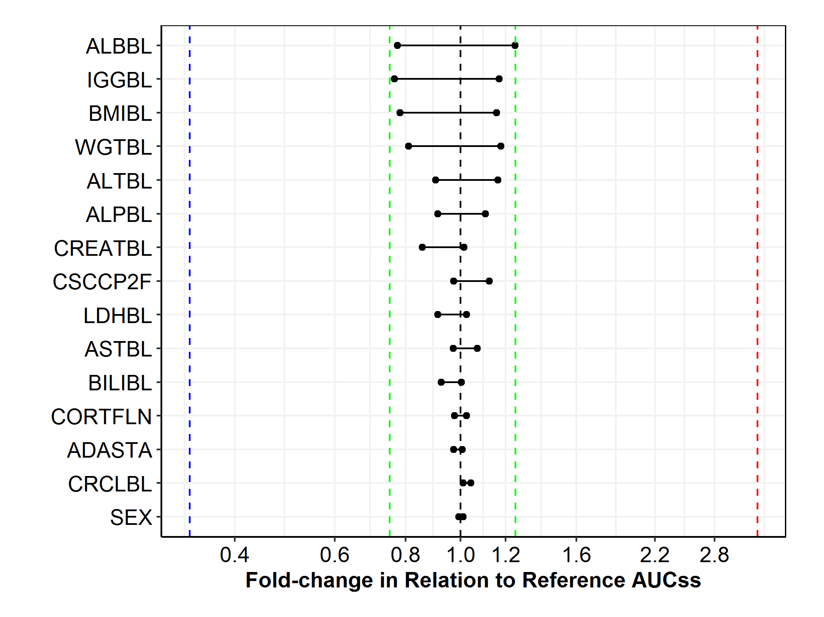

Note:

1. The black dashed reference line represents the median steady-state AUC6wk (3,550 day*mg/L) at 3 mg/kg Q2W for a typical patient. Each solid black lines represents a relevant covariate, continuous variables or categorical variables; the black dots represent the relative exposure in certain sub-population (either the top 90% percentile or bottom 10% of the relevant covariates), if continuous variables, or sub-population indicated by categorical variables such as (Male vs Female, Negative vs. Positive in ADA status, etc.). The length of bar from the dashed reference line represents the fold change of AUC6wk,ss in relation to the reference exposure at 3 mg/kg Q2W. The blue line and red line represent the median exposures of 1,180 day*mg/L and 11,800 day*mg/L at 1 mg/kg Q2W and 10 mg/kg Q2W, respectively. The green lines represent the 75% or 125% of the reference exposure. Its tabular form of representation is presented in the next page.
2. A typical patient in this patient population is a 60-year-old white male weighing 75 kg with a baseline BMI of 26.5 kg/m2, albumin level (ALB) of 38 g/L, lactate dehydrogenase (LDH) of 250 IU/L, alkaline phosphatase (ALP) of 90 IU/L, alanine aminotransferase (ALT) of 21 IU/L, creatinine (CREAT) of 75 µmol/L, immunoglobulin G (IgG) of 9.7 g/L and body surface area (BSA) of 1.88 m2. ADASTA: ADA status, CORTFLN: Corticosteroid (yes or no), CSCCP2F: CSCC flag based on 1540 criteria.

Table 19: Summary Statistics of Post-hoc Steady-State AUC6wk, ss, by Relevant Covariates at 3 mg/kg Q2W

| **Covariate** | **Top 90% or  Bottom 10% or Category** | **Value** | **N** | **Mean** | **SD** | **SE** | **Median (CI95)** |
| --- | --- | --- | --- | --- | --- | --- | --- |
| Sex | F | F | 208 | 3670 | 1380 | 95.5 | 3520(1550-7090) |
| M | M | 296 | 3750 | 1300 | 75.6 | 3580(1490-6850) |
| Creatinine  Clearance (mL/min) | 10% | [24.9,51.6] | 51 | 3590 | 1430 | 200 | 3590(1490-7410) |
| 90% | (139,420] | 50 | 3800 | 1340 | 189 | 3700(1590-6730) |
| ADA status  Treatment emergent | Negative | Negative | 499 | 3720 | 1330 | 59.7 | 3570(1550-6900) |
| Positive | Positive | 5 | 2980 | 1150 | 514 | 3450(1330-4120) |
| Corticosteroid | 0 | 0 | 269 | 3640 | 1270 | 77.7 | 3460(1760-6780) |
| 1 | 1 | 235 | 3800 | 1390 | 90.8 | 3630(1390-7290) |
| Total Bilirubin (µmol/L) | 10% | [0.35,5] | 56 | 3780 | 1530 | 205 | 3560(1790-7500) |
| 90% | (13.7,44.5] | 49 | 3530 | 1290 | 184 | 3280(1870-6630) |
| AST (IU/L) | 10% | [6,14] | 70 | 3830 | 1640 | 196 | 3440(1590-7600) |
| 90% | (54,179] | 50 | 3850 | 1220 | 173 | 3800(1870-6350) |
| LDH (IU/L) | 10% | [80,146] | 51 | 3780 | 1150 | 162 | 3630(1840-6400) |
| 90% | (587,3.12e+03] | 50 | 3430 | 1390 | 196 | 3240(1550-6850) |
| CSCCP2F  (CSCC flag, 1540) | N | N | 369 | 3580 | 1310 | 68.0 | 3450(1400-6780) |
| Y | Y | 135 | 4090 | 1330 | 115 | 3980(2030-7370) |
| Creatinine (µmol/L) | 10% | [33.6,53] | 63 | 3250 | 1330 | 168 | 3040(1260-6850) |
| 90% | (115,201] | 49 | 3790 | 1170 | 167 | 3590(1920-5980) |
| ALP (IU/L) | 10% | [32,57] | 52 | 4090 | 1360 | 188 | 3920(2110-7410) |
| 90% | (188,673] | 50 | 3270 | 1190 | 169 | 3230(1320-5540) |
| ALT (IU/L) | 10% | [5,10] | 56 | 3300 | 1290 | 173 | 3210(1170-6400) |
| 90% | (44,196] | 48 | 4240 | 1410 | 204 | 4120(1870-7140) |
| Weight  (kg) | 10% | [30.9,56] | 52 | 2830 | 1080 | 150 | 2870(1140-5020) |
| 90% | (101,156] | 50 | 4360 | 1410 | 199 | 4180(2520-6570) |
| BMI (kg/m2) | 10% | [14.8,21] | 51 | 2810 | 1150 | 160 | 2770(1140-5050) |
| 90% | (34.3,56.3] | 50 | 4310 | 1140 | 162 | 4100(2520-6730) |
| IgG (g/L) | 10% | [1.29,6.34] | 51 | 4370 | 1560 | 218 | 4150(1860-7500) |
| 90% | (14.6,27.9] | 48 | 2720 | 954 | 138 | 2710(1140-4110) |
| Albumin (g/L) | 10% | [22,32] | 77 | 2900 | 1160 | 133 | 2750(1260-5940) |
| 90% | (43,48] | 42 | 4570 | 1180 | 182 | 4420(2590-7370) |

Note: This table corresponds to Figure 15.

A typical patient in this patient population is a 60-year-old white male weighing 75 kg with a baseline BMI of 26.5 kg/m2, albumin level (ALB) of 38 g/L, lactate dehydrogenase (LDH) of 250 IU/L, alkaline phosphatase (ALP) of 90 IU/L, alanine aminotransferase (ALT) of 21 IU/L, creatinine (CREAT) of 75 µmol/L, immunoglobulin G (IgG) of 9.7 g/L and body surface area (BSA) of 1.88 m2. ADASTA: ADA status, CORTFLN: Corticosteroid (yes or no), CSCCP2F: CSCC flag based on 1540 criteria.

Figure 16: Tornado Plot of Post-hoc Steady-State Ctrough by Relevant Covariates at 3 mg/kg Q2W

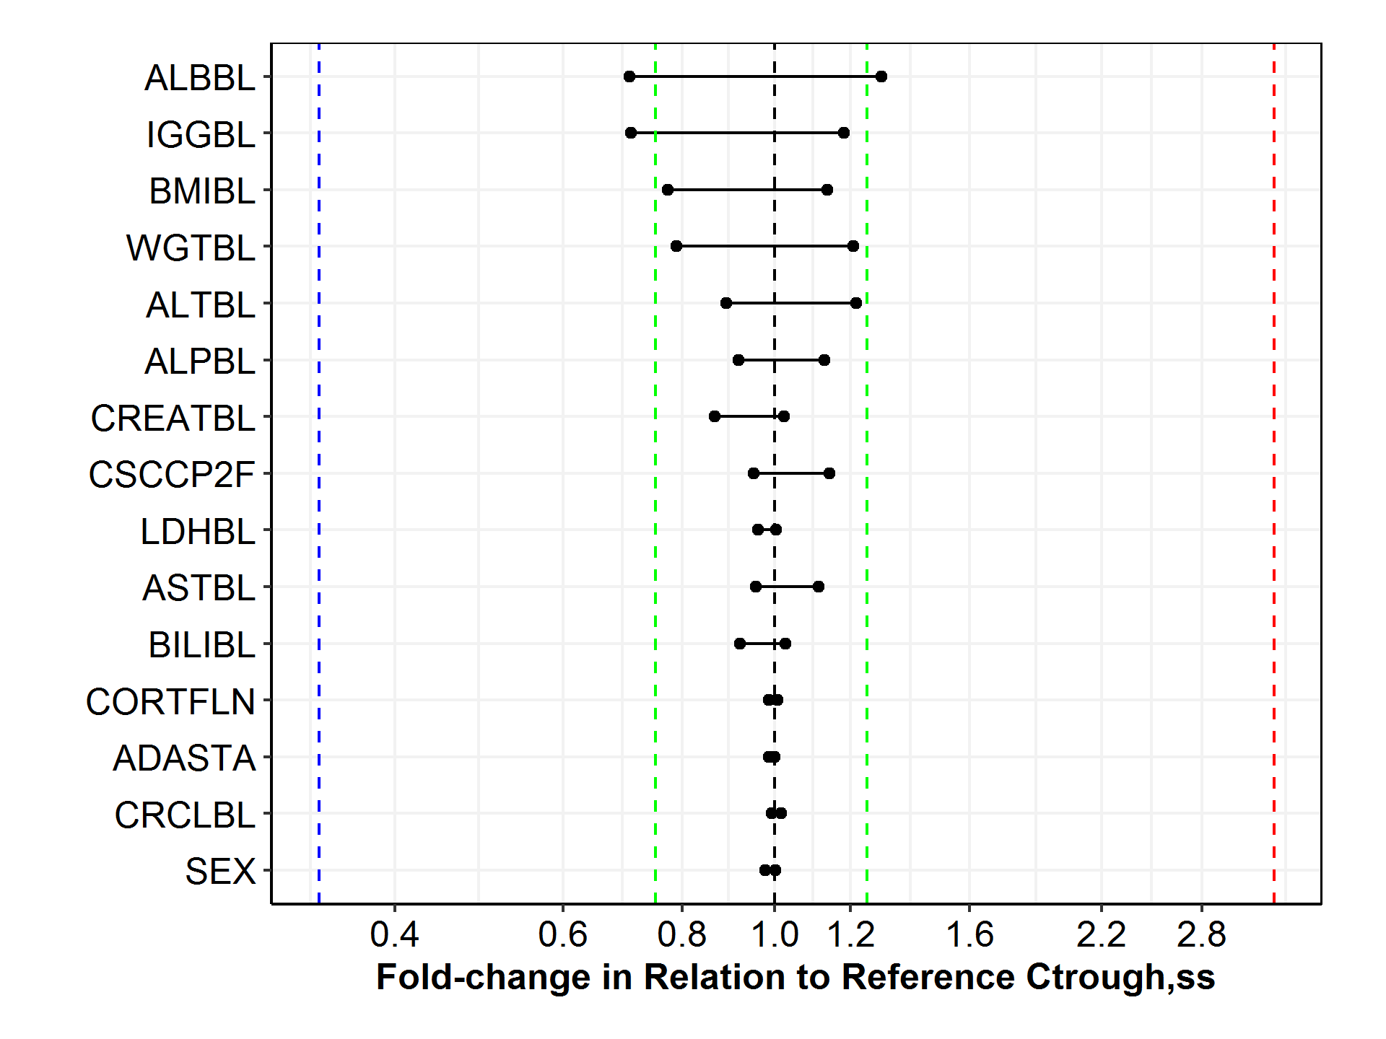

Note:

1. The black dashed reference line represents the median steady-state Ctrough (62.0 mg/L) at 3 mg/kg Q2W for a typical patient in this studied patient population. Each solid black lines represents a relevant covariate, continuous variables or categorical variables; the black dots represent the relative exposure in certain sub-population (either the top 90% percentile or bottom 10% of the relevant covariates), if continuous variables, or the sub-population indicated by categorical variables such as (Male vs Female, Negative vs. Positive in ADA status, etc.). The length of bar from the dashed reference line represents the fold change in relation to the reference Ctrough at 3 mg/kg Q2W (62.0 mg/L). The blue line and red line represent the median Ctrough of 20.7 mg/L and 207 mg/L at 1 mg/kg Q2W and 10 mg/kg Q2W, respectively. The green lines represent the 75% or 125% of the reference Ctrough.
2. A typical patient in this patient population is a 60-year-old white male weighing 75 kg with a baseline BMI of 26.5 kg/m2, albumin level (ALB) of 38 g/L, lactate dehydrogenase (LDH) of 250 IU/L, alkaline phosphatase (ALP) of 90 IU/L, alanine aminotransferase (ALT) of 21 IU/L, creatinine (CREAT) of 75 µmol/L, immunoglobulin G (IgG) of 9.7 g/L and body surface area (BSA) of 1.88 m2. ADASTA: ADA status, CORTFLN: Corticosteroid (yes or no), CSCCP2F: CSCC flag based on 1540 criteria.

Table 20: Summary Statistics of Post-hoc Steady-State Ctrough, by Relevant Covariates at 3 mg/kg Q2W

| **Covariate** | **Top 90% or  Bottom 10% or Category** | **Value** | **N** | **Mean** | **SD** | **SE** | **Median (CI95)** |
| --- | --- | --- | --- | --- | --- | --- | --- |
| ADA status  Treatment emergent | Negative | Negative | 499 | 65.9 | 28.1 | 1.26 | 62.0(22.0-134) |
| Positive | Positive | 5 | 49.7 | 21.4 | 9.56 | 61.1(15.6-67.1) |
| Corticosteroid | 0 | 0 | 269 | 64.1 | 26.6 | 1.62 | 61.1(25.0-128) |
| 1 | 1 | 235 | 67.5 | 29.6 | 1.93 | 62.3(18.1-141) |
| Creatinine  Clearance (mL/min) | 10% | [24.9,51.6] | 51 | 63.7 | 30.4 | 4.26 | 62.9(21.4-151) |
| 90% | (139,420] | 50 | 66.3 | 28.8 | 4.07 | 61.5(22.9-133) |
| Sex | F | F | 208 | 64.4 | 28.4 | 1.97 | 60.6(23.5-134) |
| M | M | 296 | 66.6 | 27.8 | 1.62 | 62.0(21.5-133) |
| LDH (IU/L) | 10% | [80,146] | 51 | 66.4 | 24.2 | 3.38 | 62.2(26.4-122) |
| 90% | (587,3.12e+03] | 50 | 60.6 | 28.9 | 4.08 | 59.5(21.5-133) |
| Total Bilirubin (µmol/L) | 10% | [0.35,5] | 56 | 67.3 | 33.9 | 4.53 | 63.6(25.0-153) |
| 90% | (13.7,44.5] | 49 | 62.7 | 27.9 | 3.98 | 57.0(27.4-135) |
| AST (IU/L) | 10% | [6,14] | 70 | 67.5 | 35.1 | 4.19 | 59.2(22.9-153) |
| 90% | (54,179] | 50 | 69.0 | 26.1 | 3.69 | 68.9(25.8-113) |
| Creatinine (µmol/L) | 10% | [33.6,53] | 63 | 56.4 | 28.1 | 3.55 | 53.6(18.1-133) |
| 90% | (115,201] | 49 | 66.7 | 24.0 | 3.43 | 63.4(29.3-118) |
| CSCCP2F  (CSCC flag, 1540) | N | N | 369 | 62.7 | 27.0 | 1.40 | 58.9(18.9-132) |
| Y | Y | 135 | 73.9 | 29.5 | 2.54 | 70.7(31.1-151) |
| ALP (IU/L) | 10% | [32,57] | 52 | 72.7 | 28.9 | 4.01 | 69.9(34.6-151) |
| 90% | (188,673] | 50 | 57.6 | 26.1 | 3.70 | 56.8(13.6-109) |
| ALT (IU/L) | 10% | [5,10] | 56 | 56.9 | 26.7 | 3.57 | 55.1(13.6-122) |
| 90% | (44,196] | 48 | 77.4 | 29.8 | 4.30 | 75.4(31.6-143) |
| BMI (kg/m2) | 10% | [14.8,21] | 51 | 49.2 | 24.4 | 3.42 | 47.9(13.2-102) |
| 90% | (34.3,56.3] | 50 | 74.8 | 24.5 | 3.46 | 70.3(36.7-127) |

Table 20: Summary Statistics of Post-hoc Steady-State Ctrough, by Relevant Covariates at 3 mg/kg Q2W – Continued

| **Covariate** | **Top 90% or  Bottom 10% or Category** | **Value** | **N** | **Mean** | **SD** | **SE** | **Median (CI95)** |
| --- | --- | --- | --- | --- | --- | --- | --- |
| Weight  (kg) | 10% | [30.9,56] | 52 | 49.3 | 23.0 | 3.18 | 48.9(13.2-102) |
| 90% | (101,156] | 50 | 76.8 | 31.7 | 4.49 | 74.9(36.7-118) |
| IgG (g/L) | 10% | [1.29,6.34] | 51 | 80.1 | 33.3 | 4.67 | 73.2(28.5-153) |
| 90% | (14.6,27.9] | 48 | 44.6 | 19.4 | 2.80 | 43.8(13.2-81.8) |
| Albumin (g/L) | 10% | [22,32] | 77 | 48.2 | 24.0 | 2.73 | 43.7(13.6-108) |
| 90% | (43,48] | 42 | 84.2 | 25.4 | 3.91 | 80.2(44.8-151) |

Note: This table corresponds to Figure 16.

A typical patient in this patient population is a 60-year-old white male weighing 75 kg with a baseline BMI (BMI) of 26.5 kg/m2, albumin level (ALB) of 38 g/L, lactate dehydrogenase (LDH) of 250 IU/L, alkaline phosphatase (ALP) of 90 IU/L, alanine aminotransferase (ALT) of 21 IU/L, creatinine (CREAT) of 75 µmol/L, immunoglobulin G (IgG) of 9.7 g/L and body surface area (BSA) of 1.88 m2. ADASTA: ADA status, CORTFLN: Corticosteroid (yes or no), CSCCP2F: CSCC flag based on 1540 criteria.

Table : Summary (Mean±SD) of Individual Post-Hoc Estimates of Exposure at Steady State (AUC6wk,ss and Ctrough) of Cemiplimab for the 3 mg/kg Q2W and 350 mg Q3WRegimens by Covariate or Other Patient Factors

| **Covariate** | **Value** | **N** | **3 mg/kg Q2W** | | **350 mg Q3W** | |
| --- | --- | --- | --- | --- | --- | --- |
| **AUC6wk,ss (day*mg/L)** | **Ctrough,ss (mg/L)** | **AUC6wk,ss (day*mg/L)** | **Ctrough,ss (mg/L)** |
| Reference Exposure* (Median) | | 505 | 3550 | 62.0 | 3580 | 54.9 |
| Study | 1423 | 396 | 3590(±1300) | 63.0(±27.0) | 3730(±1400) | 56.9(±27.2) |
| 1540 | 109 | 4170(±1350) | 75.3(±29.9) | 4080(±1430) | 65.0(±29.9) |
| Phase | NA | 109 | 4170(±1350) | 75.3(±29.9) | 4080(±1430) | 65.0(±29.9) |
| Escalation | 60 | 3680(±1240) | 65.3(±25.6) | 3620(±1410) | 56.4(±27.4) |
| Expansion | 336 | 3570(±1310) | 62.6(±27.3) | 3750(±1400) | 57.0(±27.2) |
| CSCC flag (Efficacy) | 0 | 398 | 3620(±1310) | 63.8(±27.1) | 3750(±1400) | 57.4(±27.3) |
| 1 | 107 | 4040(±1370) | 72.7(±30.5) | 4010(±1440) | 63.6(±30.0) |
| CSCC flag  (1540) | 0 | 370 | 3570(±1310) | 62.7(±27.0) | 3720(±1410) | 56.6(±27.4) |
| 1 | 135 | 4090(±1330) | 73.9(±29.5) | 4040(±1390) | 64.2(±29.0) |
| Efficacy  Responder flag | 0 | 56 | 3750(±1230) | 65.5(±25.8) | 3780(±1540) | 57.7(±30.5) |
| 1 | 51 | 4350(±1460) | 80.6(±33.4) | 4270(±1280) | 70.0(±28.3) |
| NA | 398 | 3620(±1310) | 63.8(±27.1) | 3750(±1400) | 57.4(±27.3) |
| Monotherapy flag | 0 | 267 | 3560(±1370) | 62.2(±28.2) | 3710(±1430) | 56.2(±27.9) |
| 1 | 238 | 3880(±1270) | 69.6(±27.5) | 3910(±1380) | 61.5(±27.8) |
| Sex | F | 209 | 3660(±1380) | 64.3(±28.4) | 4150(±1510) | 63.3(±30.0) |
| M | 296 | 3750(±1300) | 66.6(±27.8) | 3560(±1280) | 55.4(±26.0) |
| Race | Asia | 8 | 3820(±1650) | 67.5(±34.6) | 4490(±2120) | 69.3(±41.1) |
| Black | 20 | 3850(±1040) | 67.2(±19.1) | 3810(±867) | 57.4(±14.8) |
| Others | 21 | 3330(±1030) | 57.7(±20.4) | 3370(±898) | 50.3(±17.0) |
| White | 456 | 3720(±1350) | 65.9(±28.6) | 3810(±1440) | 58.9(±28.5) |
| Ethnicity | Hispanic or Latino | 38 | 3520(±1480) | 61.3(±30.5) | 3670(±1430) | 55.3(±28.2) |
| Missing | 16 | 3220(±1070) | 56.5(±20.5) | 3400(±769) | 51.6(±14.6) |
| Not Hispanic or Latino | 451 | 3750(±1330) | 66.4(±28.1) | 3830(±1430) | 59.2(±28.3) |
| Age group (year) | <65 | 250 | 3750(±1350) | 66.3(±28.3) | 3850(±1490) | 59.5(±29.4) |
| >=65 to <75 | 162 | 3590(±1250) | 63.2(±26.5) | 3660(±1270) | 55.9(±24.8) |
| >=75 | 93 | 3820(±1420) | 68.2(±30.1) | 3930(±1420) | 61.2(±29.0) |
| Country | Australia | 31 | 4430(±1660) | 81.0(±38.5) | 4200(±1420) | 68.0(±32.2) |
| Germany | 11 | 4340(±1530) | 80.4(±33.9) | 4520(±1780) | 74.4(±36.2) |
| Spain | 104 | 3420(±1390) | 60.2(±28.8) | 3740(±1490) | 57.1(±29.8) |
| US | 359 | 3710(±1250) | 65.5(±26.1) | 3770(±1370) | 57.8(±26.6) |
| ADA status  Treatment emergent | NA | 1 | 2110 | 32.6 | 2890 | 36.0 |
| Negative | 499 | 3720(±1330) | 65.9(±28.1) | 3810(±1410) | 58.9(±28.0) |
| Positive | 5 | 2980(±1150) | 49.7(±21.4) | 3050(±1400) | 42.4(±22.3) |
| Neutralized  AB status | NA | 495 | 3730(±1340) | 66.0(±28.2) | 3820(±1420) | 59.0(±28.1) |
| Negative | 10 | 2900(±913) | 48.8(±16.5) | 2990(±959) | 42.5(±15.4) |
| Tumor type 1 | CSCC** | 135 | 4090(±1330) | 73.9(±29.5) | 4040(±1390) | 64.2(±29.0) |
| NSCLC | 71 | 3440(±1250) | 59.5(±26.5) | 3590(±1320) | 53.5(±26.5) |
| Others | 299 | 3600(±1320) | 63.4(±27.1) | 3750(±1440) | 57.4(±27.5) |
| Tumor type 2 | laCSCC | 60 | 4130(±1200) | 74.9(±25.6) | 4260(±1420) | 68.4(±28.9) |
| mCSCC | 75 | 4070(±1430) | 73.1(±32.4) | 3850(±1350) | 60.9(±28.8) |
| NSCLC | 71 | 3440(±1250) | 59.5(±26.5) | 3590(±1320) | 53.5(±26.5) |

Table 21: Summary (Mean±SD) of Individual Post-Hoc Estimates of Exposure at Steady State (AUC6wk,ss and Ctrough) of Cemiplimab for the 3 mg/kg Q2W and 350 mg Q3WRegimens by Covariate or Other Patient Factors - Continued

| **Covariate** | **Value** | **N** | **3 mg/kg Q2W** | | **350 mg Q3W** | |
| --- | --- | --- | --- | --- | --- | --- |
| **AUC6wk,ss (day*mg/L)** | **Ctrough,ss (mg/L)** | **AUC6wk,ss (day*mg/L)** | **Ctrough,ss (mg/L)** |
| Reference Exposure* (Median) | | 505 | 3550 | 62.0 | 3580 | 54.9 |
|  | Others | 299 | 3600(±1320) | 63.4(±27.1) | 3750(±1440) | 57.4(±27.5) |
| Baseline ECOG | NA | 2 | 3780(±1590) | 66.1(±31.3) | 2790(±1050) | 42.3(±19.2) |
| 0 | 196 | 3950(±1220) | 71.1(±26.2) | 4040(±1490) | 64.0(±29.6) |
| 1 | 307 | 3560(±1380) | 62.2(±28.8) | 3660(±1350) | 55.4(±26.4) |
| Metastasis Status | NA | 430 | 3650(±1310) | 64.4(±27.1) | 3800(±1430) | 58.3(±27.8) |
| Distant | 52 | 4150(±1520) | 74.4(±34.3) | 3900(±1320) | 61.3(±28.9) |
| Nodal Only | 23 | 3880(±1240) | 70.3(±28.1) | 3740(±1420) | 60.0(±29.2) |
| Corticosteroid | 0 | 270 | 3640(±1280) | 64.0(±26.7) | 3750(±1380) | 57.4(±26.9) |
| 1 | 235 | 3800(±1390) | 67.5(±29.6) | 3870(±1460) | 60.2(±29.1) |
| Weight Quantile (kg) | [30.9,65.3] | 127 | 3110(±1180) | 54.4(±24.7) | 4280(±1610) | 65.0(±32.0) |
| (65.3,76.1] | 126 | 3730(±1340) | 66.4(±28.6) | 4070(±1450) | 63.6(±29.4) |
| (76.1,88.9] | 126 | 3880(±1220) | 69.1(±26.4) | 3690(±1190) | 57.6(±24.5) |
| (88.9,156] | 126 | 4140(±1370) | 72.8(±29.3) | 3160(±1090) | 48.4(±22.0) |
| Albumin (g/L) | <30 | 34 | 2790(±1120) | 45.3(±23.9) | 2740(±857) | 36.3(±17.5) |
| (30,35] | 132 | 3240(±1220) | 56.0(±24.9) | 3340(±1210) | 49.5(±23.1) |
| >35 | 339 | 3990(±1300) | 71.5(±27.7) | 4090(±1430) | 64.5(±28.5) |
| IgG (g/L) | [1.29,7.95] | 127 | 4070(±1370) | 73.8(±28.7) | 4240(±1530) | 68.0(±30.4) |
| (7.95,9.63] | 127 | 3830(±1270) | 67.9(±26.4) | 3960(±1350) | 61.4(±26.8) |
| (9.63,11.9] | 126 | 3670(±1350) | 64.7(±29.0) | 3670(±1400) | 56.3(±27.4) |
| (11.9,27.9] | 125 | 3270(±1220) | 56.0(±25.4) | 3340(±1210) | 48.8(±23.5) |
| Creatinine  Clearance (mL/min) | <30 | 4 | 2460(±617) | 39.6(±10.5) | 3780(±1470) | 50.3(±21.3) |
| (30,60] | 83 | 3590(±1280) | 64.0(±27.1) | 4390(±1660) | 68.3(±32.7) |
| (60,89] | 177 | 3740(±1310) | 66.4(±27.2) | 3880(±1340) | 60.2(±26.8) |
| >89 | 241 | 3750(±1370) | 66.1(±29.1) | 3540(±1310) | 54.4(±26.3) |
| Total Bilirubin (µmol/L) | <3 | 11 | 4150(±1480) | 75.1(±33.2) | 4500(±1730) | 71.4(±35.5) |
| (3,25] | 488 | 3700(±1330) | 65.4(±28.0) | 3790(±1410) | 58.5(±27.9) |
| (25,38] | 5 | 3870(±1260) | 69.4(±26.9) | 3230(±1030) | 50.8(±20.6) |
| >38 | 1 | 3870 | 69.4 | 3510 | 55.2 |
| AST (IU/L) | <10 | 11 | 3760(±1330) | 66.8(±27.3) | 3920(±1760) | 60.8(±29.9) |
| (10,40] | 418 | 3690(±1340) | 65.1(±28.2) | 3770(±1380) | 57.9(±27.3) |
| (40,60] | 35 | 3710(±1360) | 66.6(±28.5) | 3770(±1440) | 59.6(±29.0) |
| >60 | 41 | 3890(±1270) | 69.9(±26.9) | 4090(±1650) | 65.1(±33.2) |
| ALT (IU/L) | <7 | 13 | 3020(±1050) | 51.0(±21.4) | 3590(±1500) | 51.6(±26.1) |
| (7,56] | 457 | 3700(±1340) | 65.5(±28.3) | 3770(±1400) | 58.0(±27.6) |
| (56,84] | 18 | 4060(±1170) | 73.1(±23.1) | 4310(±1230) | 68.5(±22.3) |
| >84 | 17 | 4070(±1260) | 74.1(±28.6) | 4350(±1870) | 71.0(±40.0) |

Note: “NA” represents ‘not applicable’ or ‘missing’. BMI: body mass index, BSA: body surface area, ALB: albumin (g/L), ALP: alkaline phosphatase (IU/L), ALT: alanine aminotransferase (IU/L), AST: Aspartate Aminotransferase (IU/L), IgG: immunoglobulin G (g/L), LDH: lactate dehydrogenase (IU/L). *A typical patient in this patient population is a 60-year-old white male weighing 75 kg with a baseline BMI (BMI) of 26.5 kg/m2, albumin level (ALB) of 38 g/L, lactate dehydrogenase (LDH) of 250 IU/L, alkaline phosphatase (ALP) of 90 IU/L, alanine aminotransferase (ALT) of 21 IU/L, creatinine (CREAT) of 75 µmol/L, immunoglobulin G (IgG) of 9.7 g/L and body surface area (BSA) of 1.88 m2. ADASTA: ADA status, CORTFLN: Corticosteroid (yes or no), CSCCP2F: CSCC flag based on 1540 criteria. ** Patients with CSCC combined from Study 1423 and Study 1540.

* + - 1. Intrinsic Factors

*Body weight*

Typical of monoclonal antibodies and other large protein therapeutic agents for which the central compartment largely comprises the systemic volume, drug exposure is correlated with body-weight and body mass index (BMI). Consistent with these findings, the population PK model analysis identified weight as the major covariate, with significant effect on the observed PK of cemiplimab, although not clinically relevant.

Scatterplots of predicted steady-state AUC over 6 weeks in patients with body weight in the range of 30.9 – 156 kg receiving 3 mg/kg Q2W and 350 mg Q3W IV, are shown in Figure 40 and Figure 41, respectively. The relationship of exposure and body weight was evaluated by simulating exposure metrics (Ctrough,ss and AUCss) at steady-state for the 3 mg/kg Q2W dosing regimen for individual patients and presenting cemiplimab exposure by increasing quartiles of baseline body weight, as shown in Figure 42 and Figure 44 (AUC6wk,ss), Figure 43 and Figure 45 (Ctrough,ss). The results of this analysis indicate that when cemiplimab is administered with body weight‑based doses (eg, 3 mg/kg Q2W) patients with higher body weight shows a trend of higher exposure, while for fixed dosing (eg, 350 mg Q3W) the trend is reversed. However, these trends are considered small and likely not clinically important.

The overall comparison of body weight-adjusted dosing strategy (3 mg/kg Q2W) and fixed dose at 350 mg Q3W resulted in the following:

1. The suitability of fixed dosing was confirmed by the similar variability observed in steady state AUC over a wide body weight range. The overall distribution of exposure across the whole population is very similar irrespective of dosing paradigm of fixed dosing (350 mg Q3W) and weight-normalized dosing (3 mg/kg Q2W), as shown in the histogram plot (See Figure 17).
2. Patients with high body weight (top quantile, greater than 88.9 kg) receiving a fixed 350 mg Q3W dose experience similar exposure as patients with low body weight (the lowest quantile, i.e. within [30.9, 65.3] kg) dosed at 3 mg/kg Q2W, as shown in Table 21. Such observation indicates that similar efficacy would be expected in both dosing paradigms.
3. The magnitude of increasing/decreasing exposure associated with high/low body weight is relatively small, typically within 75% - 125% of the typical exposure at 3 mg/kg Q2W.
4. Based on allometric principles, the least variability in exposure would be achieved with fixed dosing when CL is not affected by body weight (allometric exponent α = 0), and conversely with body-weight–based dosing when CL varies with body weight (α = 1). An intermediate exponent value (α = 0.5) would therefore indicate no apparent advantage of weight-based dosing over fixed dose. The Pop PK analysis revealed an allometric exponent (α) of 0.454 (95% CI, 0.300–0.609) for the clearance parameters and 0.935 (95% CI, 0.779–1.08) for the volumes of distribution in the final model developed. In the final base model (LN014) in which baseline BMI was removed from the covariate list, both allometric exponents on CL/Q and Vss were found to be close to 0.5, indicating there is no apparent advantage of weight-based dosing over the fixed dose.

In particular, the following tables, Table 22, Table 23, and Table 24, show the summary statistics of AUC6wk,ss and related covariates by responder or others in the efficacy population (107 patients), by quantile of body weight, or by categorized weight group, respectively.

Figure : Histogram Plots of Post-hoc Steady-state AUC6wk at the Dose Regimens of 3 mg/kg Q2W and 350 mg Q3W

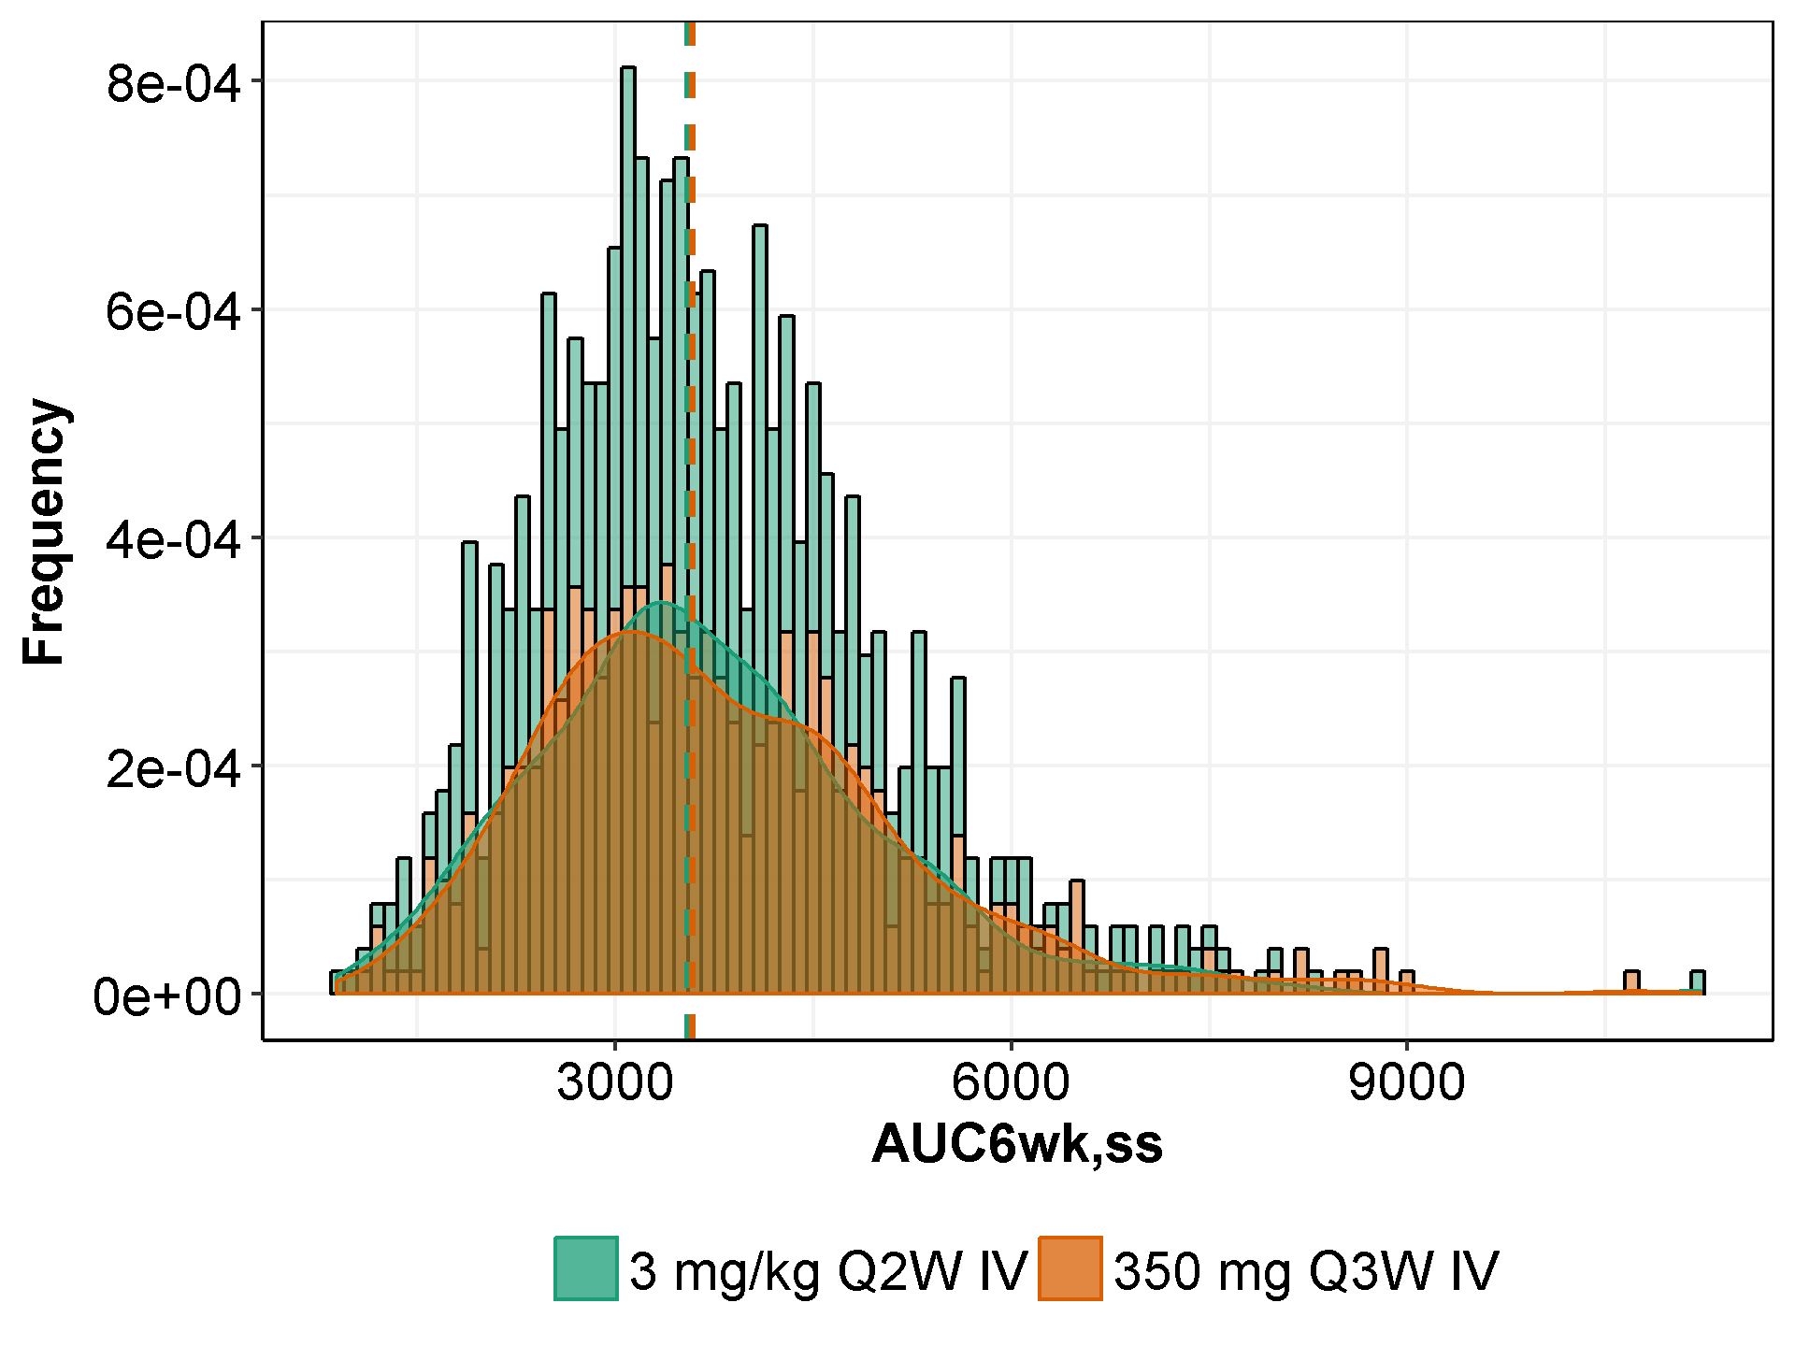

Note: The shaded areas represented density of the histogram; the dashed lines represent the medians of the distributions

Table : Summary Statistics (Mean, SD) of Post-hoc AUC6wk,ss by Responders or All Others and Relevant Covariates at 3 mg/kg Q2W

| **Responder\*** | **N** | **AUC**  **(day*mg/L)** | **WGT**  **(kg)** | **ALB**  **(g/L)** | **IgG**  **(g/L)** | **CRCL**  **(mg/min)** | **ALP**  **(IU/L)** |
| --- | --- | --- | --- | --- | --- | --- | --- |
| 0 | 56 | 3750(1230) | 80.8(18.0) | 38.1(4.44) | 10.5(3.71) | 83.1(34.1) | 82.8(32.4) |
| 1 | 51 | 4350(1460) | 80.4(16.3) | 38.8(3.74) | 9.93(2.81) | 82.1(26.2) | 99.4(63.0) |
| NA | 398 | 3620(1310) | 77.4(18.7) | 37.1(4.68) | 10.3(3.94) | 95.7(40.1) | 117(82.7) |

*: A total of 107 patients in the efficacy population.

Table : Summary Statistics (Mean, SD) of Post-hoc AUC6wk,ss by Quantile of Body Weight and Categorized Body Weight at 3 mg/kg Q2W and Relevant Covariates

| **Quantile** | **Weight (kg)** | **N** | **AUC6wk,ss (day*mg/L)** | **WGT**  **(kg)** | **ALB**  **(g/L)** | **IgG**  **(g/L)** | **CRCL**  **(mg/min)** | **ALP**  **(IU/L)** |
| --- | --- | --- | --- | --- | --- | --- | --- | --- |
| Q1 | [30.9,65.3] | 127 | 3110(1180) | 56.7(6.54) | 37.0(4.75) | 10.3(3.66) | 74.3(29.5) | 121(88.8) |
| Q2 | (65.3,76.1] | 126 | 3730(1340) | 71.1(3.23) | 37.3(4.66) | 10.2(4.10) | 87.9(29.6) | 120(89.8) |
| Q3 | (76.1,88.9] | 126 | 3880(1220) | 81.9(3.62) | 38.4(3.92) | 9.96(3.00) | 93.9(30.5) | 96.1(64.5) |
| Q4 | (88.9,156] | 126 | 4140(1370) | 103(12.6) | 36.8(4.86) | 10.7(4.36) | 116(49.3) | 108(60.7) |
|  |  |  |  |  |  |  |  |  |
|  | <60 | 85 | 2910(1050) | 53.5(5.60) | 36.5(4.87) | 10.6(3.79) | 70.8(30.0) | 125(84.9) |
|  | (60,100] | 367 | 3810(1300) | 78.7(10.7) | 37.7(4.39) | 10.2(3.84) | 91.3(30.0) | 108(76.5) |
|  | (100,125] | 44 | 4290(1470) | 108(5.81) | 36.6(5.48) | 10.1(3.38) | 130(45.3) | 110(72.6) |
|  | >125 | 9 | 4470(1080) | 138(9.51) | 34.2(2.86) | 11.6(4.88) | 185(99.6) | 110(71.6) |

Table : Summary Statistics (Mean, SD) of Post-hoc AUC6wk,ss by Quantile of Body Weight and Categorized Body Weight at 350 mg Q3W and Relevant Covariates

| **Quantile** | **Weight (kg)** | **N** | **AUC6wk,ss (day*mg/L)** | **WGT**  **(kg)** | **ALB**  **(g/L)** | **IgG**  **(g/L)** | **CRCL**  **(mg/min)** | **ALP**  **(IU/L)** |
| --- | --- | --- | --- | --- | --- | --- | --- | --- |
| Q1 | [30.9,65.3] | 127 | 4280(1610) | 56.7(6.54) | 37.0(4.75) | 10.3(3.66) | 74.3(29.5) | 121(88.8) |
| Q2 | (65.3,76.1] | 126 | 4070(1450) | 71.1(3.23) | 37.3(4.66) | 10.2(4.10) | 87.9(29.6) | 120(89.8) |
| Q3 | (76.1,88.9] | 126 | 3690(1190) | 81.9(3.62) | 38.4(3.92) | 9.96(3.00) | 93.9(30.5) | 96.1(64.5) |
| Q4 | (88.9,156] | 126 | 3160(1090) | 103(12.6) | 36.8(4.86) | 10.7(4.36) | 116(49.3) | 108(60.7) |
|  |  |  |  |  |  |  |  |  |
|  | <60 | 85 | 4270(1620) | 53.5(5.60) | 36.5(4.87) | 10.6(3.79) | 70.8(30.0) | 125(84.9) |
|  | (60,100] | 367 | 3810(1360) | 78.7(10.7) | 37.7(4.39) | 10.2(3.84) | 91.3(30.0) | 108(76.5) |
|  | (100,125] | 44 | 3100(1120) | 108(5.81) | 36.6(5.48) | 10.1(3.38) | 130(45.3) | 110(72.6) |
|  | >125 | 9 | 2520(544) | 138(9.51) | 34.2(2.86) | 11.6(4.88) | 185(99.6) | 110(71.6) |

*Renal Impairment*

Overall, given the molecular weight and hydrodynamic size of monoclonal antibodies, they are also not subject to renal elimination; therefore, renal insufficiency was not expected to significantly impact cemiplimab clearance exposure.

The effect of renal impairment on the exposure of cemiplimab was evaluated in patients with mild (CLcr 60 to 89 mL/min; n=177), moderate (CLcr 30 to <60 mL/min; n=83), or severe (CLcr <30 mL/min; n=4) renal impairment.

The effect size of baseline creatinine clearance or creatinine concentration was small (<20%), indicating that renal impairment has no relevant effect on cemiplimab exposure between patients with renal impairment and patients with normal renal function. However, in the 4 patients with severe renal impairment (CLcr <30 mL/min), the AUC6wk,ss at 3 mg/kg Q2W is approximately 30% lower than the median AUC6wk,ss of 3550 day*mg/L. This observation is mostly explained by an imbalance in the other known statistical covariates, eg, low body weight, high IgG, and low albumin levels relative to patients with normal or mild/moderate renal impairment, as show in Table 25.

Table : Summary Statistics (Mean, SD) of Post-hoc AUC6wk,ss Categorized by Creatinine Clearance and Relevant Covariates at 3 mg/kg Q2W

| **CRCL**  **(mL/min)** | **N** | **AUC6wk,ss (day*mg/L)** | **WGT**  **(kg)** | **ALB**  **(g/L)** | **IgG**  **(g/L)** | **CRCL**  **(mg/min)** | **ALP**  **(IU/L)** |
| --- | --- | --- | --- | --- | --- | --- | --- |
| <30 | 4 | 2460(617) | 52.6(7.77) | 32.8(2.22) | 14.4(2.63) | 27.0(2.13) | 140(94.7) |
| (30,60] | 83 | 3590(1280) | 65.2(13.3) | 37.6(4.23) | 9.96(3.29) | 49.2(7.37) | 98.8(53.1) |
| (60,89] | 177 | 3740(1310) | 76.0(14.8) | 37.1(4.81) | 10.3(3.70) | 74.5(8.41) | 111(81.4) |
| >89 | 241 | 3750(1370) | 84.4(19.4) | 37.5(4.56) | 10.3(4.04) | 123(34.6) | 115(81.4) |

*Hepatic impairment*

The effect of hepatic impairment on the exposure of cemiplimab was evaluated and the results are presented in Table 21 and Table 26. In patients (n=5) with mild hepatic impairment (total bilirubin greater than 1.0 to 1.5 times the upper limit of normal [ULN] and any AST) and one patients with moderate (>1.5 ULN of total bilirubin) hepatic impairment, no differences in the exposure of cemiplimab were found between patients with mild/moderate hepatic impairment and patients with normal hepatic function.

Table : Summary Statistics (Mean, SD) of Post-hoc AUC6wk,ss Categorized by Total Bilirubin (µmol/L) and Relevant Covariates at 3 mg/kg Q2W

| **Total Bilirubin  (**µ**mol/L)** | **N** | **AUC6wk,ss (day*mg/L)** | **WGT**  **(kg)** | **ALB**  **(g/L)** | **IgG**  **(g/L)** | **CRCL**  **(mg/min)** | **ALP**  **(IU/L)** |
| --- | --- | --- | --- | --- | --- | --- | --- |
| <3 | 11 | 4150(1480) | 74.1(15.6) | 36.8(4.42) | 9.91(3.29) | 79.8(32.8) | 77.1(29.0) |
| (3,25] | 488 | 3700(1330) | 78.0(18.4) | 37.4(4.56) | 10.3(3.84) | 92.8(38.2) | 112(78.6) |
| (25,38] | 5 | 3870(1260) | 94.8(20.7) | 33.4(6.77) | 10.4(2.54) | 131(70.0) | 112(34.3) |
| >38 | 1 | 3870 | 85.7 | 32.0 | 14.2 | 96.1 | 160 |

*Baseline albumin*

The covariate analysis showed that baseline albumin (ALBBL) has a significant effect on CL with a magnitude of the effect size of 1, indicating a linear relationship. In other words, cemiplimab CL was greater in patients with lower ALB levels (Figure 46), consistent with the findings in many PD1 inhibitors on the market. Cemiplimab exposures (steady-state AUC6wk) in patients with lower than normal albumin were lower than in patients with normal albumin levels (Figure 47). However, the magnitude of increasing/decreasing exposure associated with high/low albumin level are approximately within the range of 75% - 125% relative to the typical exposure at 3 mg/kg Q2W, as shown in two tornado plots of Figure 15 and Figure 16, and boxplot of Figure 47. The other relevant covariates for the categorized albumin levels are presented in the following table (Table 27).

Table : Summary Statistics (Mean, SD) of Post-hoc AUC6wk,ss Categorized by Albumin (g/L) and Relevant Covariates at 3 mg/kg Q2W

| **Albumin  (g/L)** | **N** | **AUC6wk,ss (day*mg/L)** | **WGT**  **(kg)** | **ALB**  **(g/L)** | **IgG**  **(g/L)** | **CRCL**  **(mg/min)** | **ALP**  **(IU/L)** |
| --- | --- | --- | --- | --- | --- | --- | --- |
| <30 | 34 | 2790(1120) | 80.1(21.5) | 27.9(2.48) | 11.8(5.05) | 99.2(52.2) | 150(120) |
| (30,35] | 132 | 3240(1220) | 77.4(21.0) | 33.3(1.33) | 10.1(4.31) | 93.3(43.8) | 122(81.9) |
| >35 | 339 | 3990(1300) | 78.1(16.9) | 39.9(2.87) | 10.2(3.43) | 92.1(34.8) | 103(68.6) |

*Baseline Immunoglobulin (IgG) level*

The covariate analysis showed that baseline IgG is a statistically significant covariate on CL with a magnitude of the effect size of 0.18 (final model LN900). Cemiplimab CL was greater in patients with higher IgG levels. As shown in Table 28, patients with higher baseline IgG levels (Q4, 11.9-27.9 g/L), tend to have slightly lower cemiplimab exposures (steady-state AUC6wk), comparing to the median exposure (3,550 day*mg/L) at 3 mg/kg Q2W (see Table 18).

Table : Summary Statistics (Mean, SD) of Post-hoc AUC6wk,ss Categorized by Quantile of Baseline IgG (g/L) and Relevant Covariates at 3 mg/kg Q2W

| **Quantile** | **IgG  (g/L)** | **N** | **AUC6wk,ss (day*mg/L)** | **WGT**  **(kg)** | **ALB**  **(g/L)** | **IgG**  **(g/L)** | **CRCL**  **(mg/min)** | **ALP**  **(IU/L)** |
| --- | --- | --- | --- | --- | --- | --- | --- | --- |
| Q1 | [1.29,7.95] | 127 | 4070(1370) | 77.1(18.2) | 37.7(4.49) | 6.29(1.46) | 92.7(35.2) | 107(74.7) |
| Q2 | (7.95,9.63] | 127 | 3830(1270) | 77.4(18.5) | 37.2(4.66) | 8.90(0.515) | 90.1(32.2) | 109(81.6) |
| Q3 | (9.63,11.9] | 126 | 3670(1350) | 80.3(18.1) | 37.9(4.45) | 10.7(0.685) | 94.0(37.5) | 111(69.0) |
| Q4 | (11.9,27.9] | 125 | 3270(1220) | 77.5(18.7) | 36.7(4.73) | 15.3(3.51) | 94.9(48.1) | 118(84.7) |

*Lactate Dehydrogenase*

The covariate effect of baseline lactate dehydrogenase (LDH) on CL was small (7.96%).

*Disease-related factors tumor type, disease status,*

Disease-related factors were found to have no significant effects (<20%) on cemiplimab pharmacokinetics, including solid tumor types (CSCC, NSCLC, and Others), baseline Eastern Cooperative Oncology Group (ECOG) status, and local advanced vs. metastasis.

*Age*

Based on the population PK analysis, age did not affect the PK of cemiplimab. The patients’ ages in Study 1423 and 1540 ranged from 27 years to 96 years, with a median age of 65 years.

*Ethnicity*

Based on the population PK analysis, ethnicity did not affect the PK of cemiplimab.

*Race*

In the small number of Asian patients in the overall population (n=8, 1 with CSCC), there was no evidence for a difference in cemiplimab pharmacokinetics.

In the small number of Black patients in the overall population (n=20, 1 with CSCC), maximum reduction in time-dependent clearance is achieved more slowly than White patients (T50 of ~75 days vs ~30 days), as shown in two forest plots inFigure 7 and Figure 11. However, no difference in their corresponding steady-state exposures was observed (see Table 21).

*Sex*

There is no apparent difference (<20%) of exposure (AUC6wk,ss or Ctrough,ss) between female and male patients in the population studied.

*Country*

There is no apparent difference (<20%) of exposure (AUC6wk,ss or Ctrough,ss) between countries in which studies 1423 and 1540 were performed.

*Treatment-Emergent Anti-Drug Antibodies (ADA)*

The incidence of treatment-emergent ADA is low (<1%, 5/505) and the presence of treatment-emergent ADA did not appear to have a clinically meaningful effect (elevated clearance) on cemiplimab concentrations.

* + - 1. Extrinsic factors

When tested by covariate analysis or by post-hoc analysis, neither study (1423 vs. 1540), nor cohort (escalation vs. expansion), or mono-therapy vs. combination therapy, were identified as a statistically significant covariate. Similarly, the use of corticosteroid treatments in combination with cemiplimab did not affect the PK of cemiplimab.

*Summary*

Taken together, the results of the covariate analysis indicate that cemiplimab exposure is not significantly affected by intrinsic, extrinsic and disease-related factors (effect sizes <20%), with the exception of body weight, BMI and baseline serum albumin. However, the magnitude of increasing/decreasing exposure associated with high/low albumin, BMI and IgG are approximately within the range of 75%-125% of the exposure for a typical patient in the patient population studied.

* + 1. Comparison of Post-hoc Exposure and Simulated Time-Profile in Two Dose Regimens

As previously presented in Table 18 and the histogram plot (see Figure 17) of the distribution of post-hoc AUC6wk,ss at both regimens of 3 mg/kg Q2W and 350 mg Q3W, the results indicated that weight-base dosing does not reduce between-patient variability in cemiplimab exposure; both regimens produced not only similar overall exposure but also similar distribution across a wide range of patient’s body weight (30.9-156 kg). These similarities in exposure were observed in both the overall population as well as the CSCC population, as shown in Table 21.

The simulated concentration-time profiles of both regimens were presented in Figure 18 (3 mg/kg Q2W, semilog scale), Figure 19 (3 mg/kg Q2W, linear scale), Figure 20 (350 mg Q3W, semilog scale), and Figure 21 (350 mg Q3W, linear scale). The results show that concentration time profiles for 350 mg Q3W are largely within the distribution of that from the 3 mg/kg Q2W treatment regimen.

In addition, given that exponent (α) estimates were close to 0.5 for clearance and volume of distribution (in final base model LN014), no advantage of weight-based dosing over fixed dosing is expected, and both weight-based and fixed dosing should provide adequate and similar control of PK variability, as discussed in Section 4.6.2.

Figure : Simulated Concentration-Time Profile (Semi-log Scale) of Cemiplimab at 3 mg/kg Q2W (with 95%CI) in Patients with Solid Tumors (2,000 Simulated Patients)

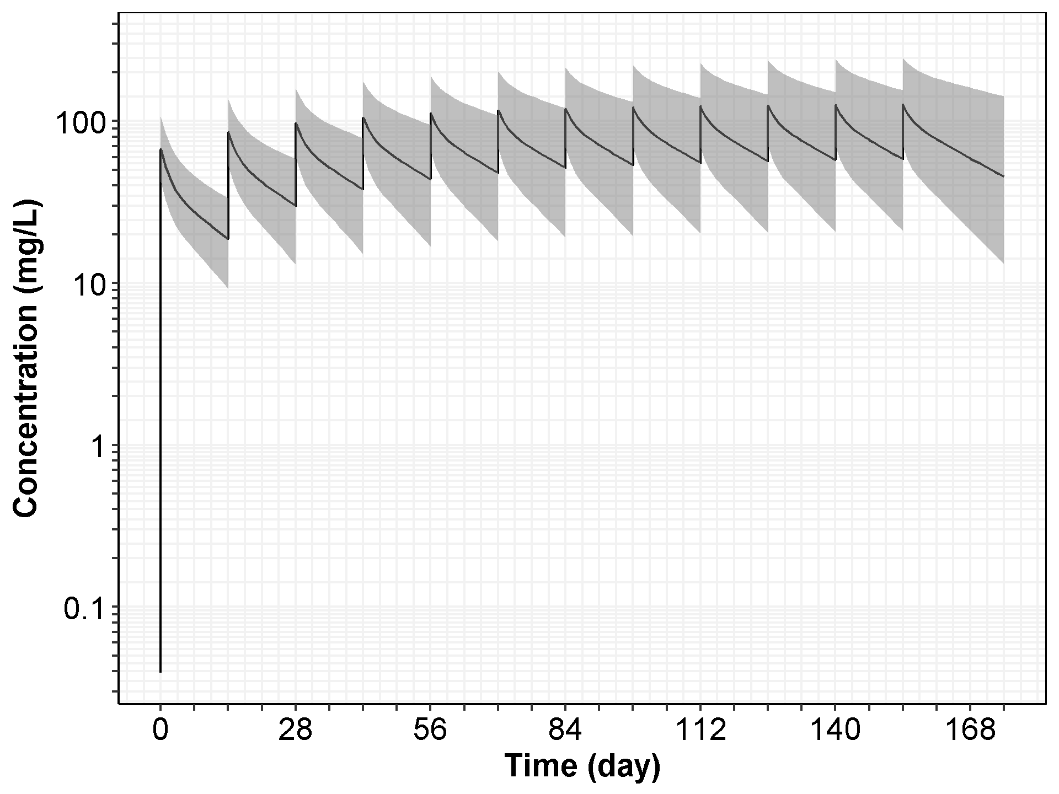

Note: The black solid line represents the median of the simulated concentration-time profiles, and the gray area shows the 95% CI with 2.5 percentile and 97.5 percentile of the simulated profiles.

Figure : Simulated Concentration-Time Profile (Linear Scale) of Cemiplimab at 3 mg/kg Q2W (with 95%CI) in Patients with Solid Tumors (2,000 Simulated Patients)

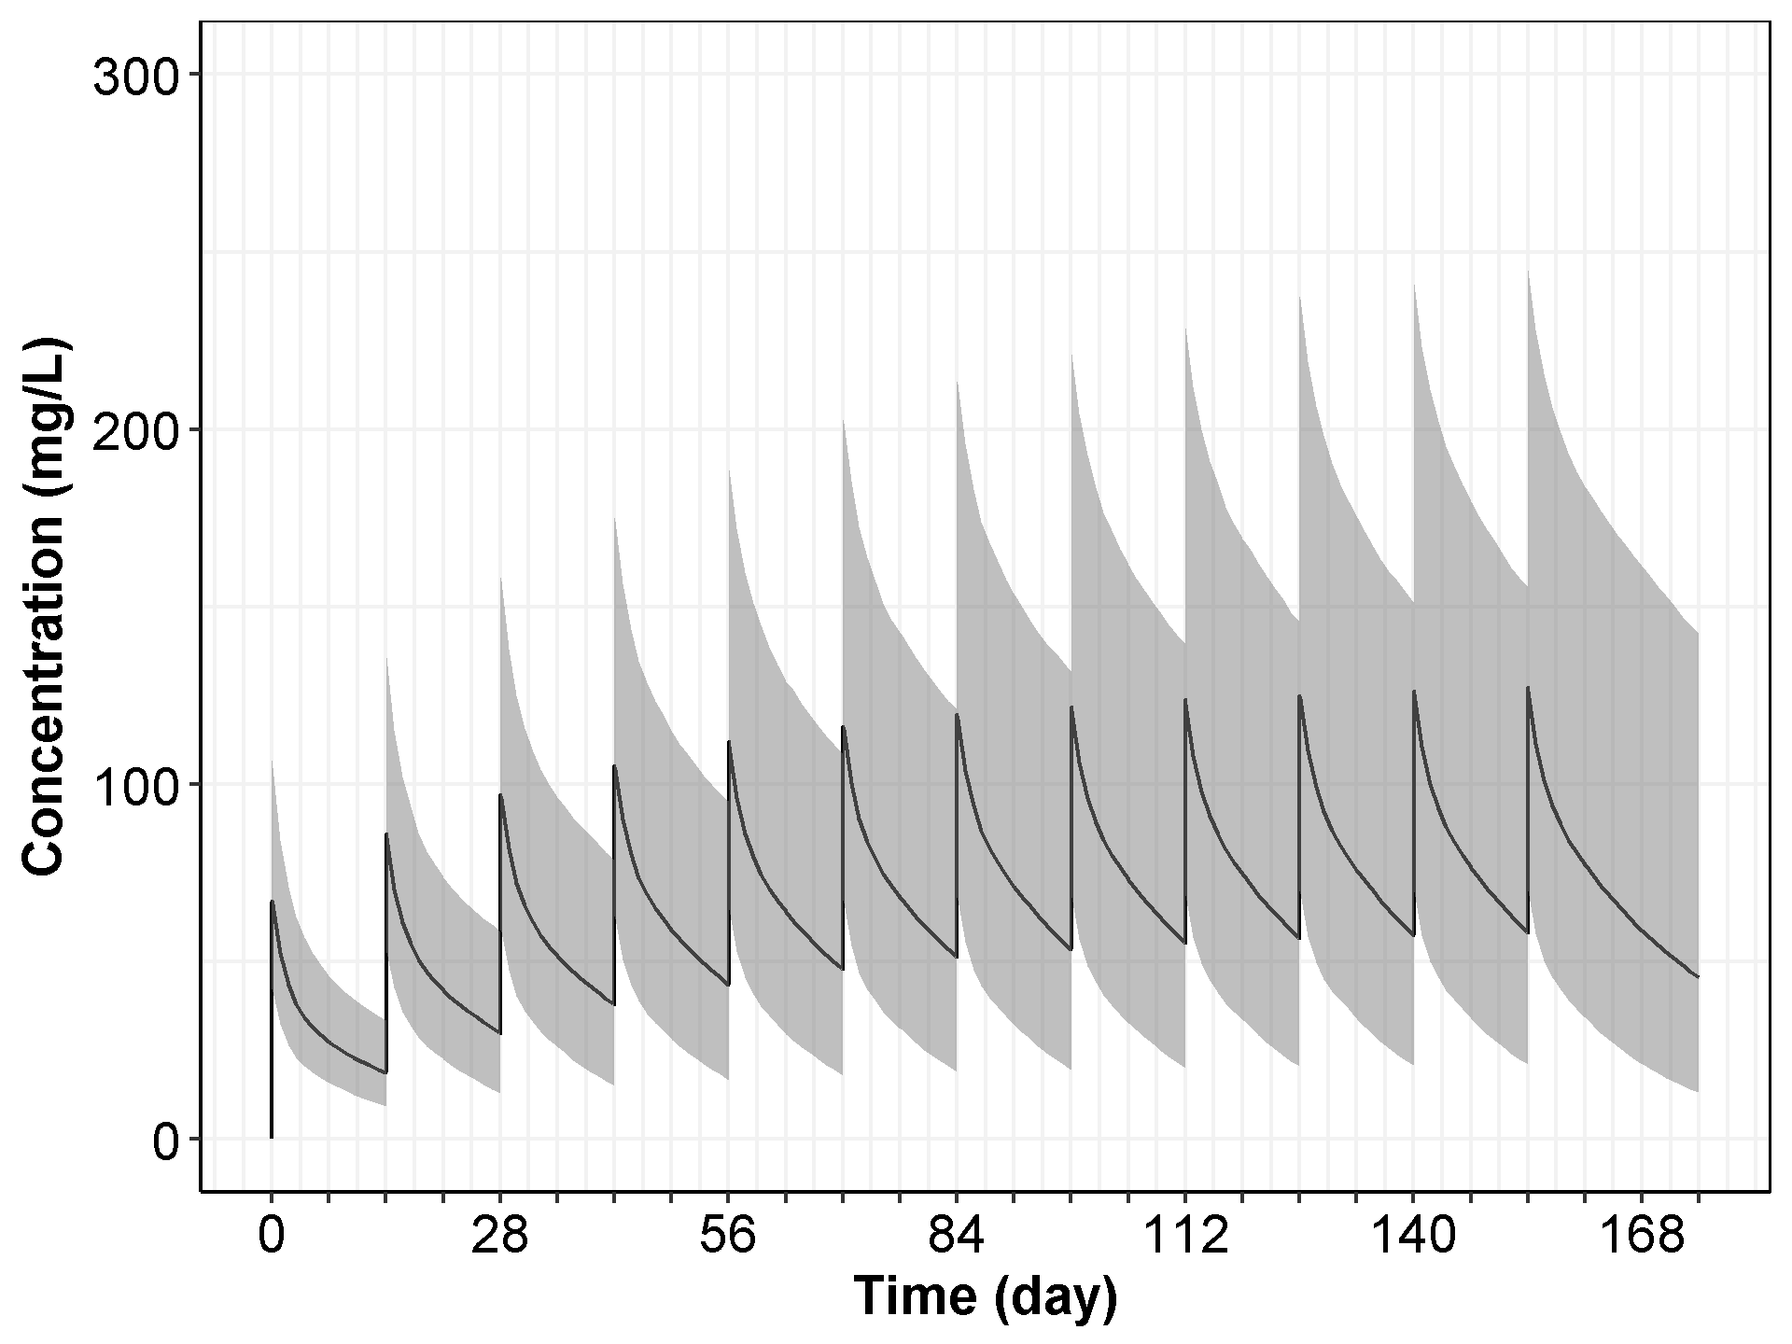

Note: The black solid line represents the median of the simulated concentration-time profiles, and the gray area shows the 95% CI with 2.5 percentile and 97.5 percentile of the simulated profiles.

Figure : Simulated Concentration-Time Profile of Cemiplimab at 350 mg Q3W (with 95%CI) in Patients with Solid Tumors (2,000 Simulated Patients)

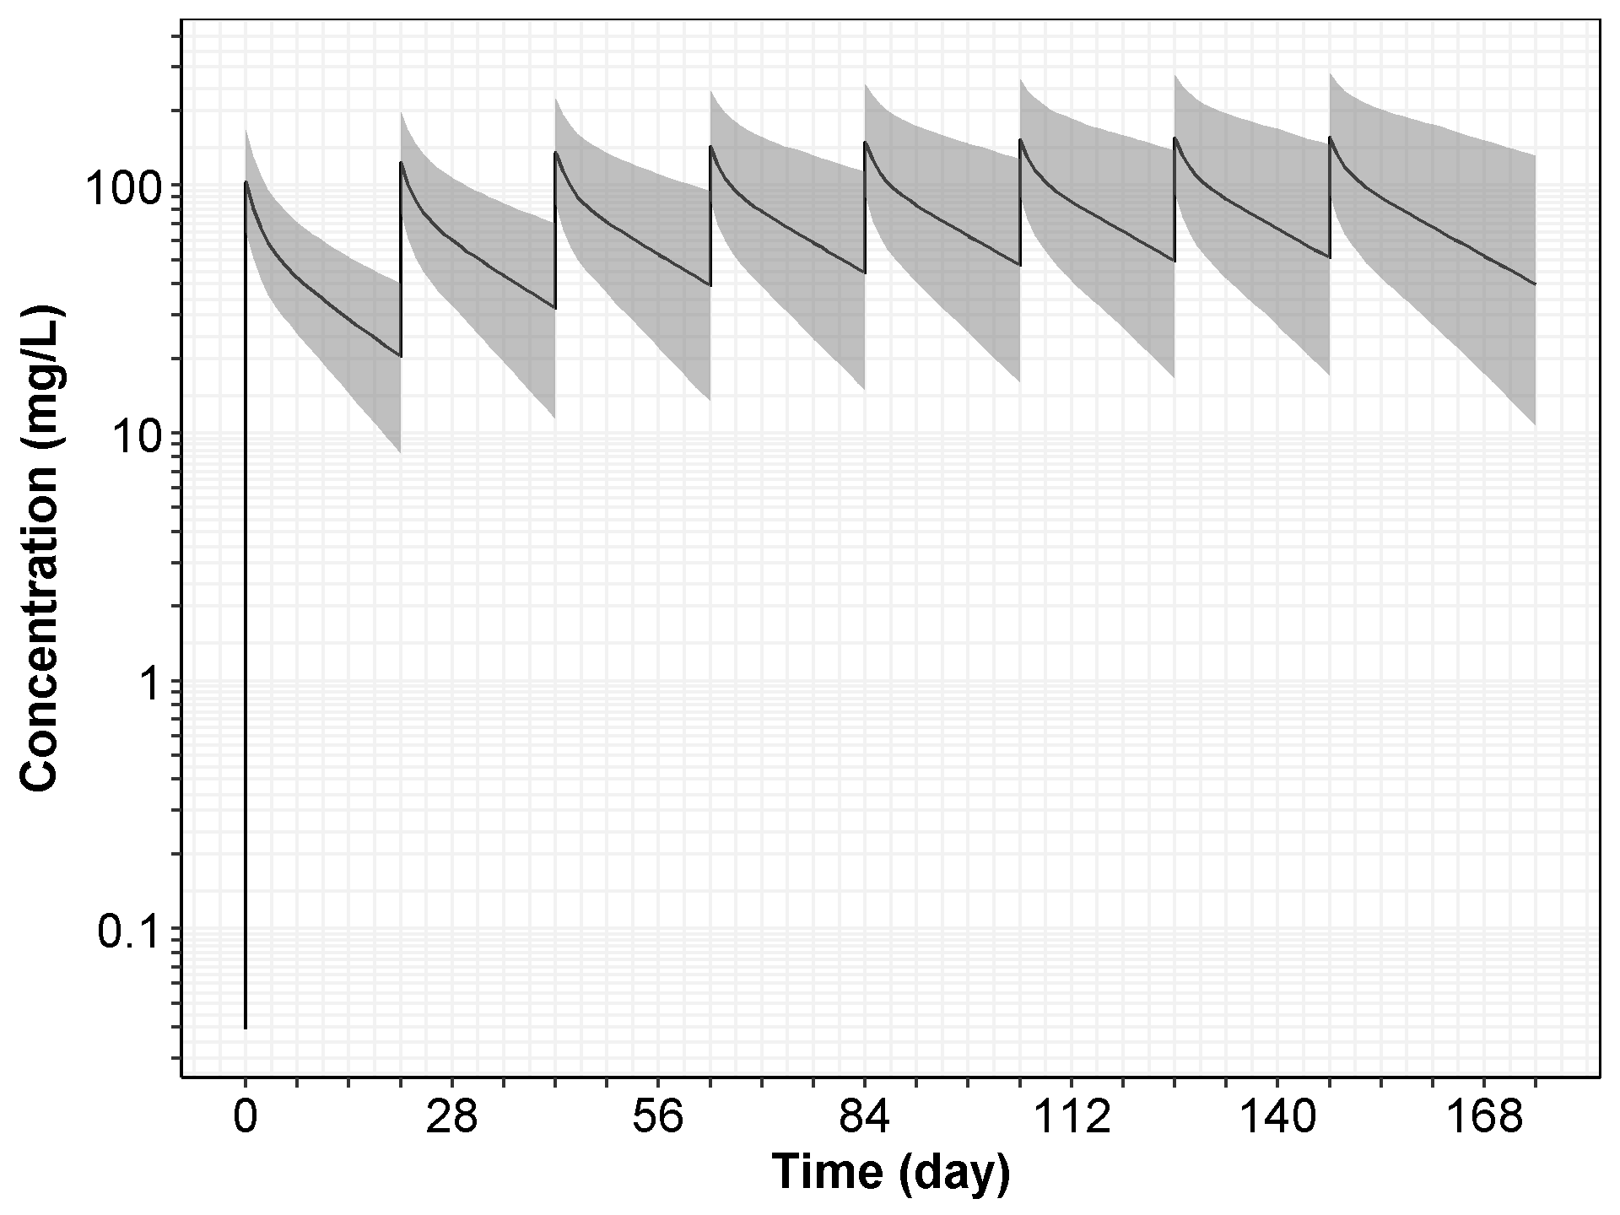

Note: The black solid line represents the median of the simulated concentration-time profiles, and the gray area shows the 95% CI with 2.5 percentile and 97.5 percentile of the simulated profiles.

Figure : Simulated Concentration-Time Profile (Linear Scale) of Cemiplimab at 3 mg/kg Q2W (with 95%CI) in Patients with Solid Tumors (2,000 Simulated Patients)

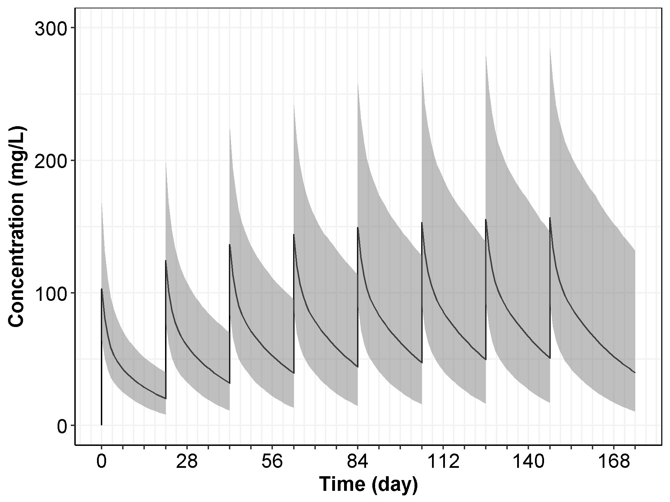

Note: The black solid line represents the median of the simulated concentration-time profiles, and the gray area shows the 95% CI with 2.5 percentile and 97.5 percentile of the simulated profiles.

1. DISCUSSION

As cemiplimab is a monoclonal antibody directed against PD-1, a cell membrane target, there is a body of data suggesting an underlying saturable, target-mediated elimination pathway may be the predominant route of elimination at low doses/concentrations, leading to non-linear pharmacokinetics. However, in Study 1423 and 1540, over the dose range studied, 1 mg/kg to 10 mg/kg, the pharmacokinetics of cemiplimab were generally observed to be linear and dose-proportional over the 2-week dosing interval.

Mean cemiplimab clearance after the first dose is estimated to be 0.325 L/day. Based on population PK analysis of the overall population, total clearance decreased by about 34.6% over the first 3 to 4 months to 0.211 L/day. This decrease is larger (39.5%) in patients with CSCC who were classified as responders, although the decrease in CL is not considered clinically relevant. The within dosing interval half-life of cemiplimab at steady state is 19.2 days in the overall population, but is slightly longer (22.7 days) in patients with CSCC classified as responders. Based on the population PK model, mean cemiplimab concentrations at steady-state range between 166 mg/L (Cmax) and 58.7 mg/L (Ctrough) for the 350 mg Q3W dose regimen. Based on the population PK model, steady state exposure is achieved after approximately 16 weeks (4 months) of cemiplimab treatment. Following multiple dosing with cemiplimab 350mg Q3W or 3mg/kg Q2W, the accumulation ratio is approximately 2-fold.

The main identified sources of intrinsic PK variability using population PK analysis were body weight or BMI, albumin and IgG levels. However, the effect of these covariates on exposure was small and not clinically important. None of the other demographic characteristics (eg, age, race, or gender) was found to have an effect on the steady state PK of cemiplimab. The PK and exposure of cemiplimab are consistent between monotherapy and in combination with other anti-cancer treatments. The PK of cemiplimab are unaffected by tumor-type; the PK of cemiplimab are similar between patients with any solid tumor type, patients with CSCC, and patients with either mCSCC or laCSCC.

Consistent with other mAbs, cemiplimab is not subject to elimination through the renal or hepatic pathways; no difference in cemiplimab exposure due to renal impairment or mild hepatic impairment was identified. In summary, although some covariates were identified to be statistically significant in the model, none of them had a meaningful effect on the post-hoc estimates of exposure.

Based on simulations from the population PK model, cemiplimab exposure is consistent between the 3 mg/kg Q2W and proposed 350 mg Q3W dose regimens. A high degree of overlap between the simulated concentration-time profiles for these 2 treatment regimens was also observed.

1. References

Bajaj G, Wang X, Agrawal S, Gupta M, Roy A, Feng Y. Model‐based population pharmacokinetic analysis of nivolumab in patients with solid tumors. CPT: Pharmacometrics Syst Pharmacol. 2017 Jan; 6(1): 58–66. doi: 10.1002/psp4.12143.

Bergstrand M, Karlsson MO. Handling data below the limit of quantification in mixed effect models. AAPS J. 2009 Jun;11(2):371-80. doi: 10.1208/s12248-009-9112-5.

Bioanalytical Report R2810-ONC-1423-BA-01V1: Determination of functional REGN2810 levels and anti-REGN2810 antibodies in samples from clinical study R2810-ONC-1423. Regeneron Pharmaceuticals, Inc. 2017.

Bioanalytical Report R2810-ONC-1540-BA-01V1: Determination of functional REGN2810 levels and anti-REGN2810 antibodies in samples from clinical study R2810-ONC-1540. Regeneron Pharmaceuticals, Inc. 2017.

Cockcroft DW, Gault MH. Prediction of creatinine clearance from serum creatinine. Nephron. 1976. 16(1):31-41.

Elassaiss-Schaap J, Rossenu S, Lindauer A, Kang S, de Greef R, Sachs, J, et al. Using model-based “learn and confirm” to reveal the pharmacokinetics-pharmacodynamics relationship of pembrolizumab in the KEYNOTE-001 trial. CPT Pharmacometrics Syst Pharmacol. 2017 Jan; 6(1): 21–28. doi: 10.1002/psp4.12132.

Feng Y, Masson E, Dai D, Parker SM, Berman D, Roy A, Model-based clinical pharmacology profiling of ipilimumab in patients with advanced melanoma. Br J Clin Pharmacol. 2014 Jul; 78(1): 106–117. doi: 10.1111/bcp.12323.

Freshwater T, Kondic A, Ahamadi M, Li CH, de Greef R, de Alwis D, et al. Evaluation of dosing strategy for pembrolizumab for oncology indications. J Immunother Cancer. 2017 May 16;5:43. doi: 10.1186/s40425-017-0242-5.

Gastonguay M. Full covariate models as an alternative to methods relying on statistical significance for inferences about covariate effects: a review of methodology and 42 case studies. PAGE Conference, June 2011, Athens, Greece. Available at http://www.page-meeting.org/?abstract=2229.

Gibiansky L, Gibiansky E, Kakkar T, Ma P. Approximations of the target-mediated drug disposition model and identifiability of model parameters. J Pharmacokinet Pharmacodyn 2008; 35: 573–91.

Gowda S, Desai PB, Hull VV, Math AAK, Vernekar SN, Kulkarni SS. A review on laboratory liver function tests. Pan Afr Med J 2009; 3:17.

Harrell FE, Jr. Regression Modeling strategies: with applications to linear models, logistic regression, and survival analysis. New York: Springer; 2010.

Keizer RJ, Huitema AD, Schellens JH, Beijnen JH. Clinical pharmacokinetics of therapeutic monoclonal antibodies. Clin Pharmacokinet 2010; 49: 493–507.

Levey AS, Bosch JP, Lewis JB, Greene T, Rogers N, Roth D. A more accurate method to estimate glomerular filtration rate from serum creatinine: a new prediction equation. Modification of diet in renal disease study group. Ann Intern Med 1999; 130: 461–70.

Li H, Yu J, Liu C, Liu J, Subramaniam S, Zhao H, et al. Time dependent pharmacokinetics of pembrolizumab in patients with solid tumor and its correlation with best overall response. J Pharmacokinet Pharmacodyn (2017) 44: 403. https://doi.org/10.1007/s10928-017-9528-y.

Mager DE, Jusko WJ. General pharmacokinetic model for drugs exhibiting target-mediated drug disposition. Pharmacokinet Pharmacodyn 2001; 28: 507–32.

Mould DR, Green B. Pharmacokinetics and pharmacodynamics of monoclonal antibodies: concepts andlessons for drug development. BioDrugs 2010; 24: 23–39.

Preclinical Pharmacokinetics Scaling Report REGN2810-MX-14136-SR-01V1: Population pharmacokinetic analysis of REGN2810 in cynomolgus monkeys and prediction of exposure in humans using allometric scaling. Regeneron Pharmaceuticals, Inc. 2014.

Ramalingam SS, Kummar S, Sarantopoulos J, Shibata S, LoRusso P, Yerk M, et al. Phase I study of vorinostat in patients with advanced solid tumors and hepatic dysfunction: a National Cancer Institute Organ Dysfunction Working Group study. J Clin Oncol 2010; 28: 4507–12.

Okazaki T, Honjo T. PD-1 and PD-1 ligands: from discovery to clinical application. Int Immunol. 2007 Jul;19(7):813-24. doi: 10.1093/intimm/dxm057.

Topalian SL, Hodi, FS, Brahmer JR, et al. Safety, activity, and immune correlates of anti–PD-1 antibody in cancer. N Engl J Med. 2012; 366(26): 2443–54.

Wang X, Feng Y, Bajaj G, Gupta M, Agrawal S, Yang A, et al. Quantitative characterization of the exposure–response relationship for cancer immunotherapy: a case study of nivolumab in patients with advanced melanoma. CPT Pharmacometrics Syst Pharmacol. 2017 Jan;6(1):40-48. doi: 10.1002/psp4.12133.

1. Monkey Model

Table : Summary of Preclinical PK Studies Conducted in Cynomolgus Monkeys

|  |  |  |  |  |  |  |
| --- | --- | --- | --- | --- | --- | --- |
| **Study** | **Study Type** | **Preclinical Species** | **Dose Route** | **Dose Regimen** | **Dose Level** | **Number of Patients** |
| REGN2810-PK-14065 | Non-GLP PK | Cynomolgus monkeys | IV infusion | Single dose | 1.0, 5.0 and 15.0 mg/kg | 5F per group |
| REGN2810-TX-14059 | GLP Tox | Cynomolgus monkeys | IV infusion | 4 x QW + 8-week Rec Phase | 2, 10 and 50 mg/kg; control article | 5M + 5F per group |
| REGN2810-PK-14152 | Non-GLP PK | Cynomolgus monkeys | SC | Single dose | 1, 5, 15 mg/kg | 5F per group |

Note: F: female, M: male

Table : Population Pharmacokinetic Parameters of REGN2810 in Monkey Serum

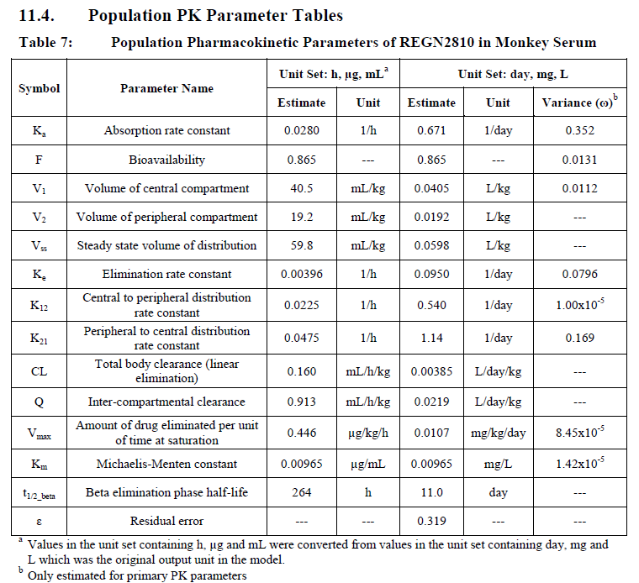

Note: See Table 7 in preclinical pharmacokinetics scaling report, REGN2810-MX-14136-SR-01V1.

Figure : Observed Concentration-Time Profiles from Three Preclinical PK/TX Studies (ADA Impacted Samples Removed)

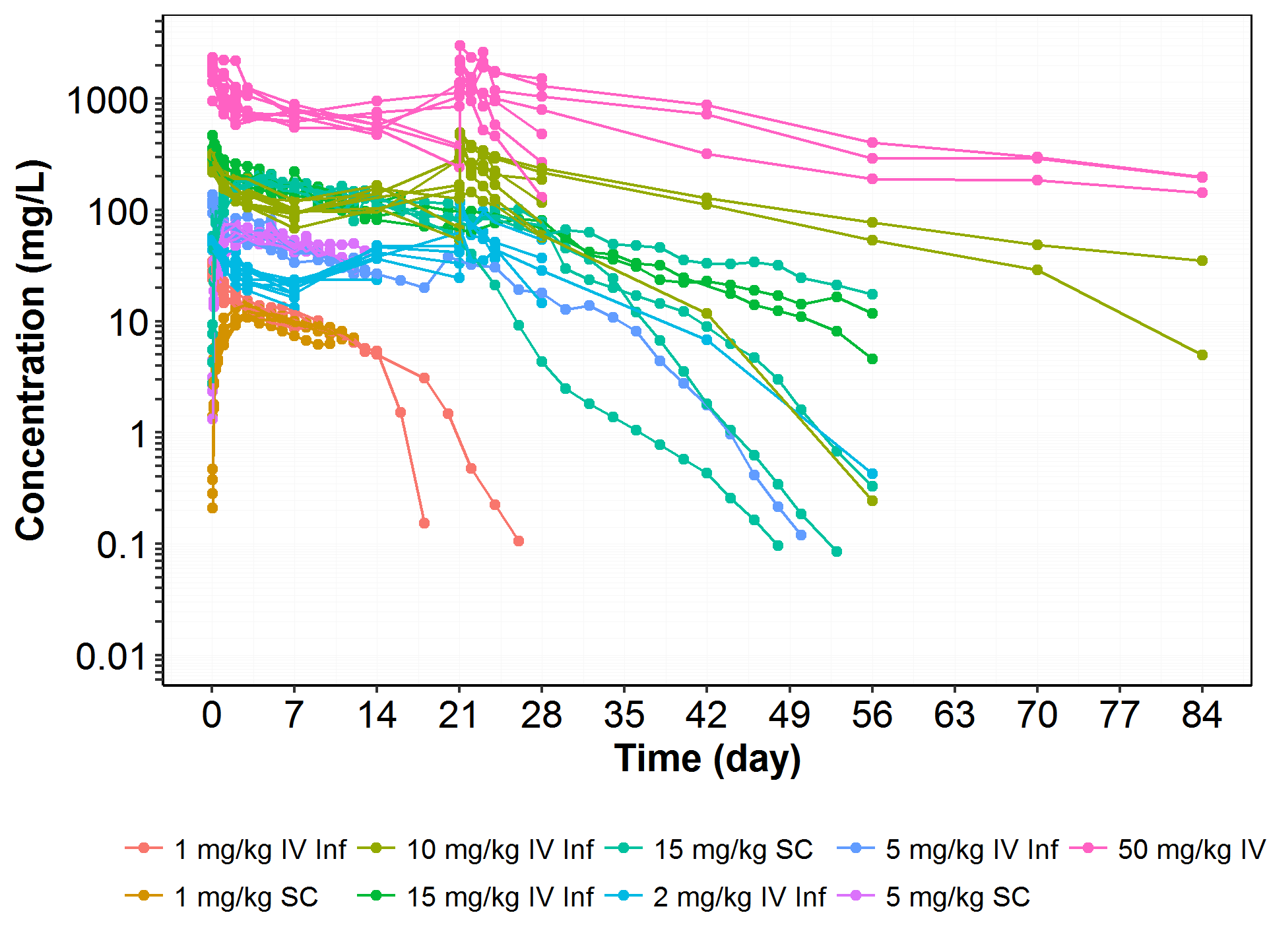

Note: there are 5 more PK samples added to the original dataset compiled in the preclinical pharmacokinetics scaling report, REGN2810-MX-14136-SR-01V1, by re-assessing the ADA-impacted concentration measurements.

1. Base Model

Figure : Dose-Normalized Concentration vs TAD (Time after the Previous Dose) in Both Studies of 1423 and 1540

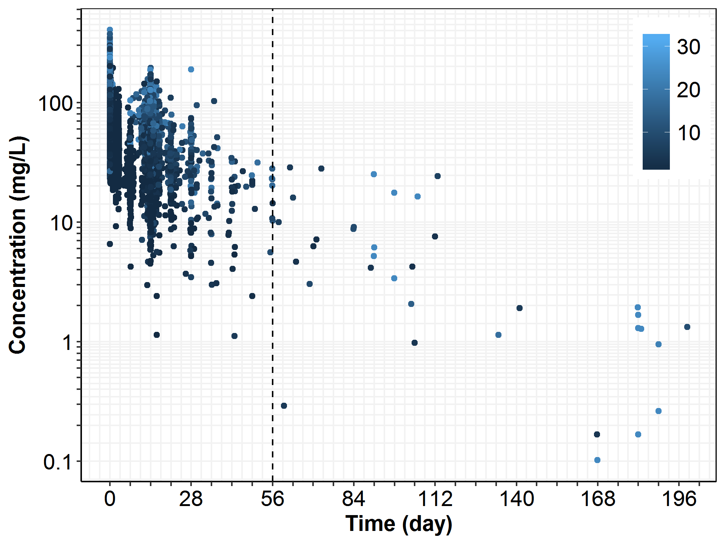

Note: dose was normalized to 3 mg/kg Q2W; PK samples from 3 mg/kg Q3W were excluded. Color legend shows the dosing sequence number. In the dose group of 10 mg/kg Q2W in Study-1423, one patient (R2810-ONC-1423-840004-006) who received the wrong dose (1 mg/kg) on Day 1 was excluded in the plot.

Figure 24: Goodness of Fit (PRED vs DV) for the Samples Collected After 56 Days from Previous Dose (Final Basel Model LN014)

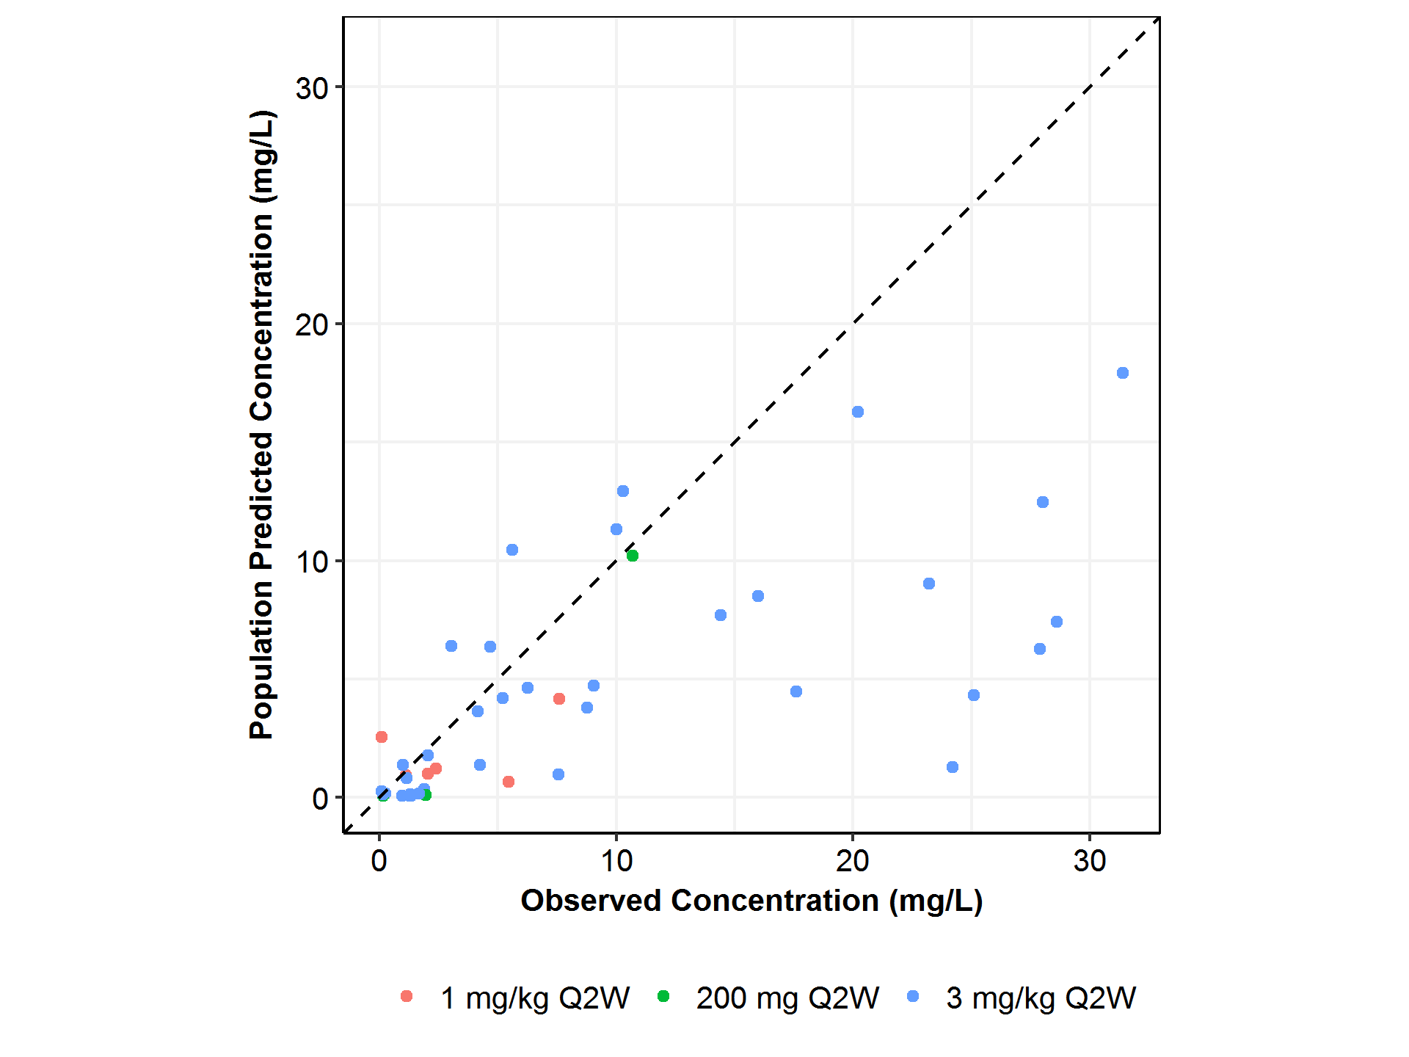

Note: The dashed line is the unity line.

Figure : Diagnostic Plots from the Final Base Model

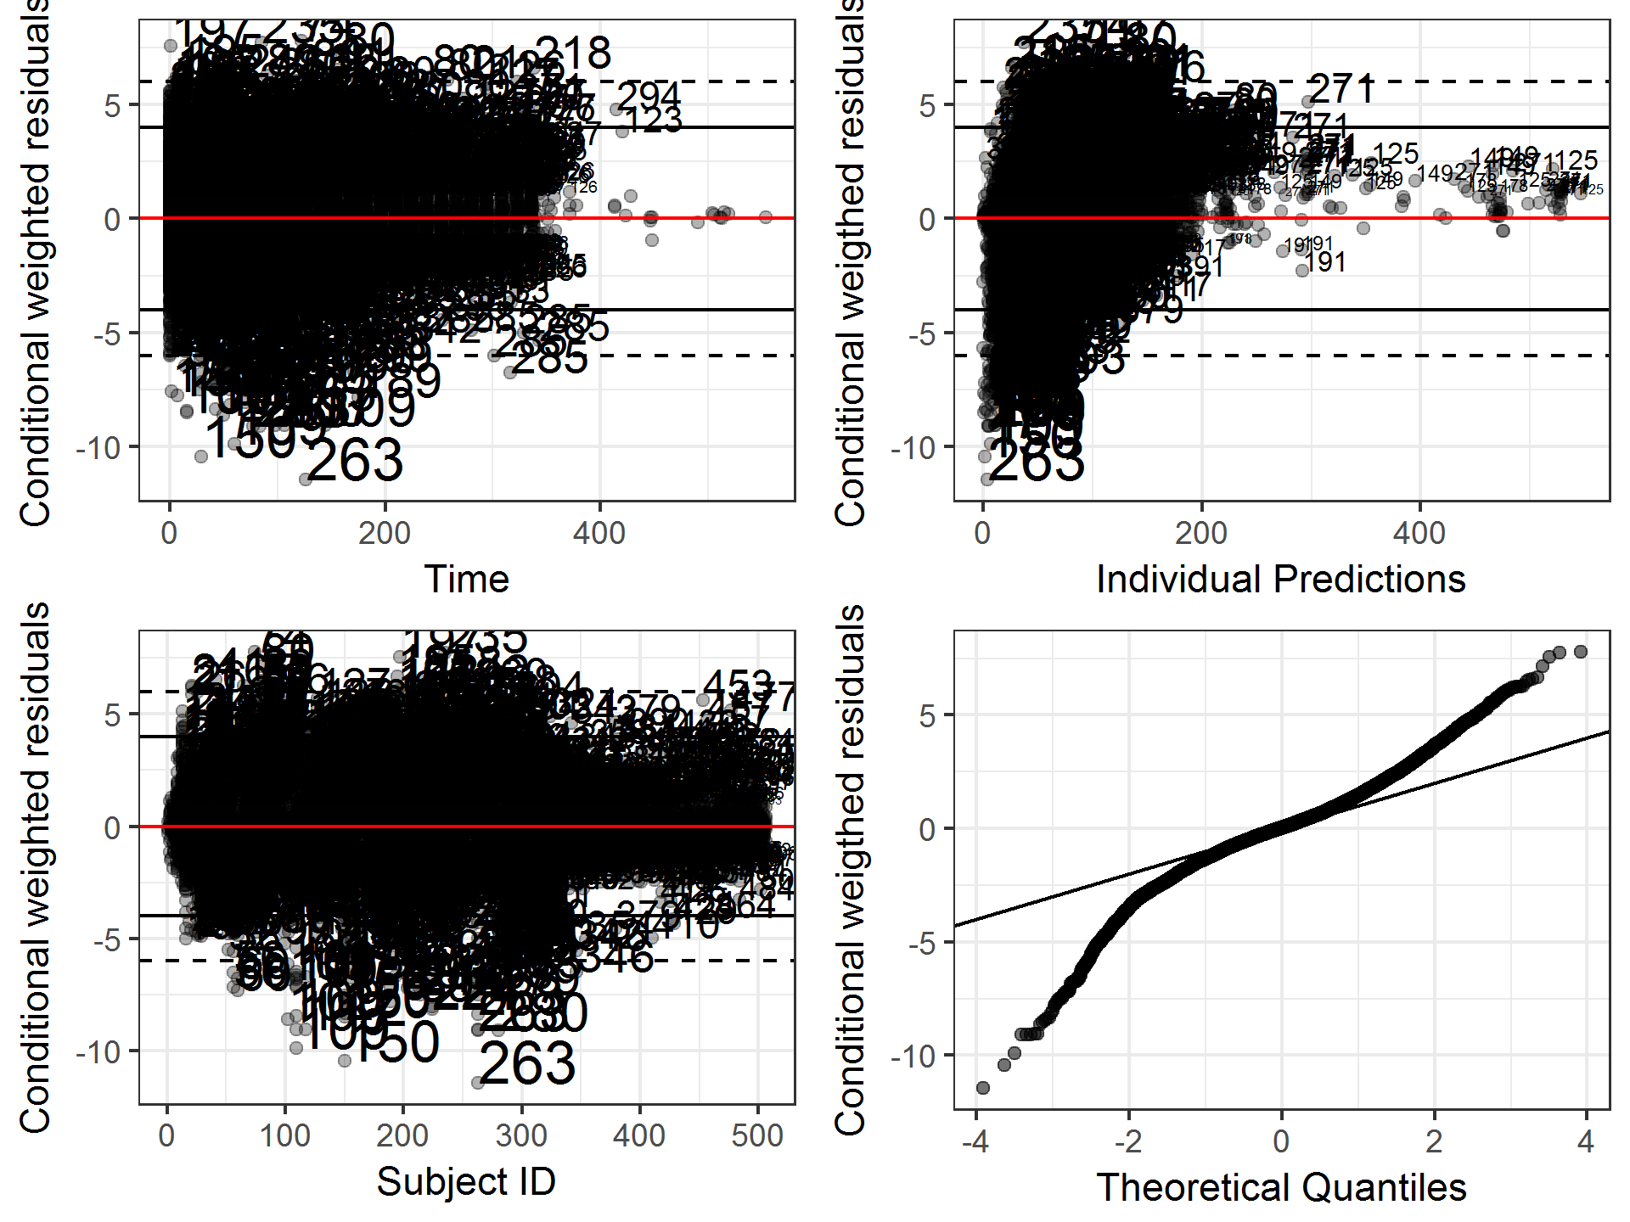

Table : Representative Model Fitting of Predicted Concentration-time Profiles vs Observed Profiles in Study 1423 and 1540 [Final Base Model]

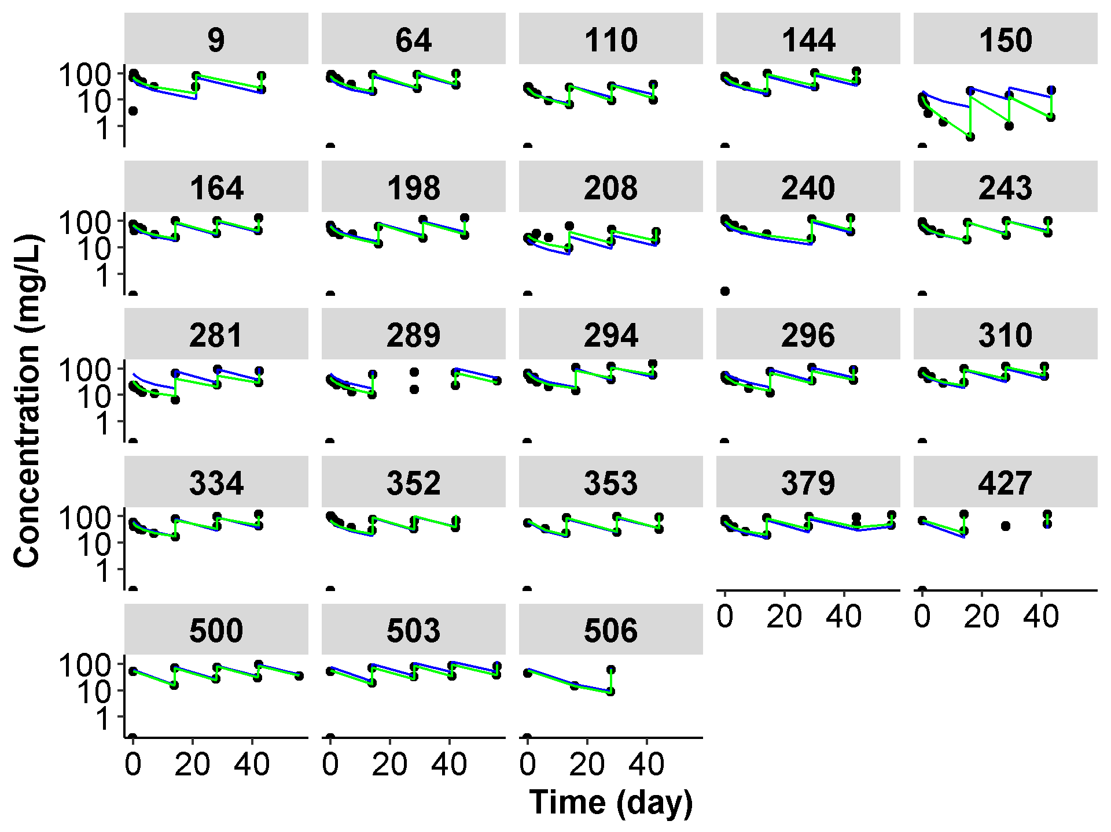

Note: Patients were randomly selected from the overall population. Each black dot represents the observe data; blue line represents the population mean prediction; the green line represents the individual prediction.

1. Final Model

Figure : Diagnostic Plots from the Final Model

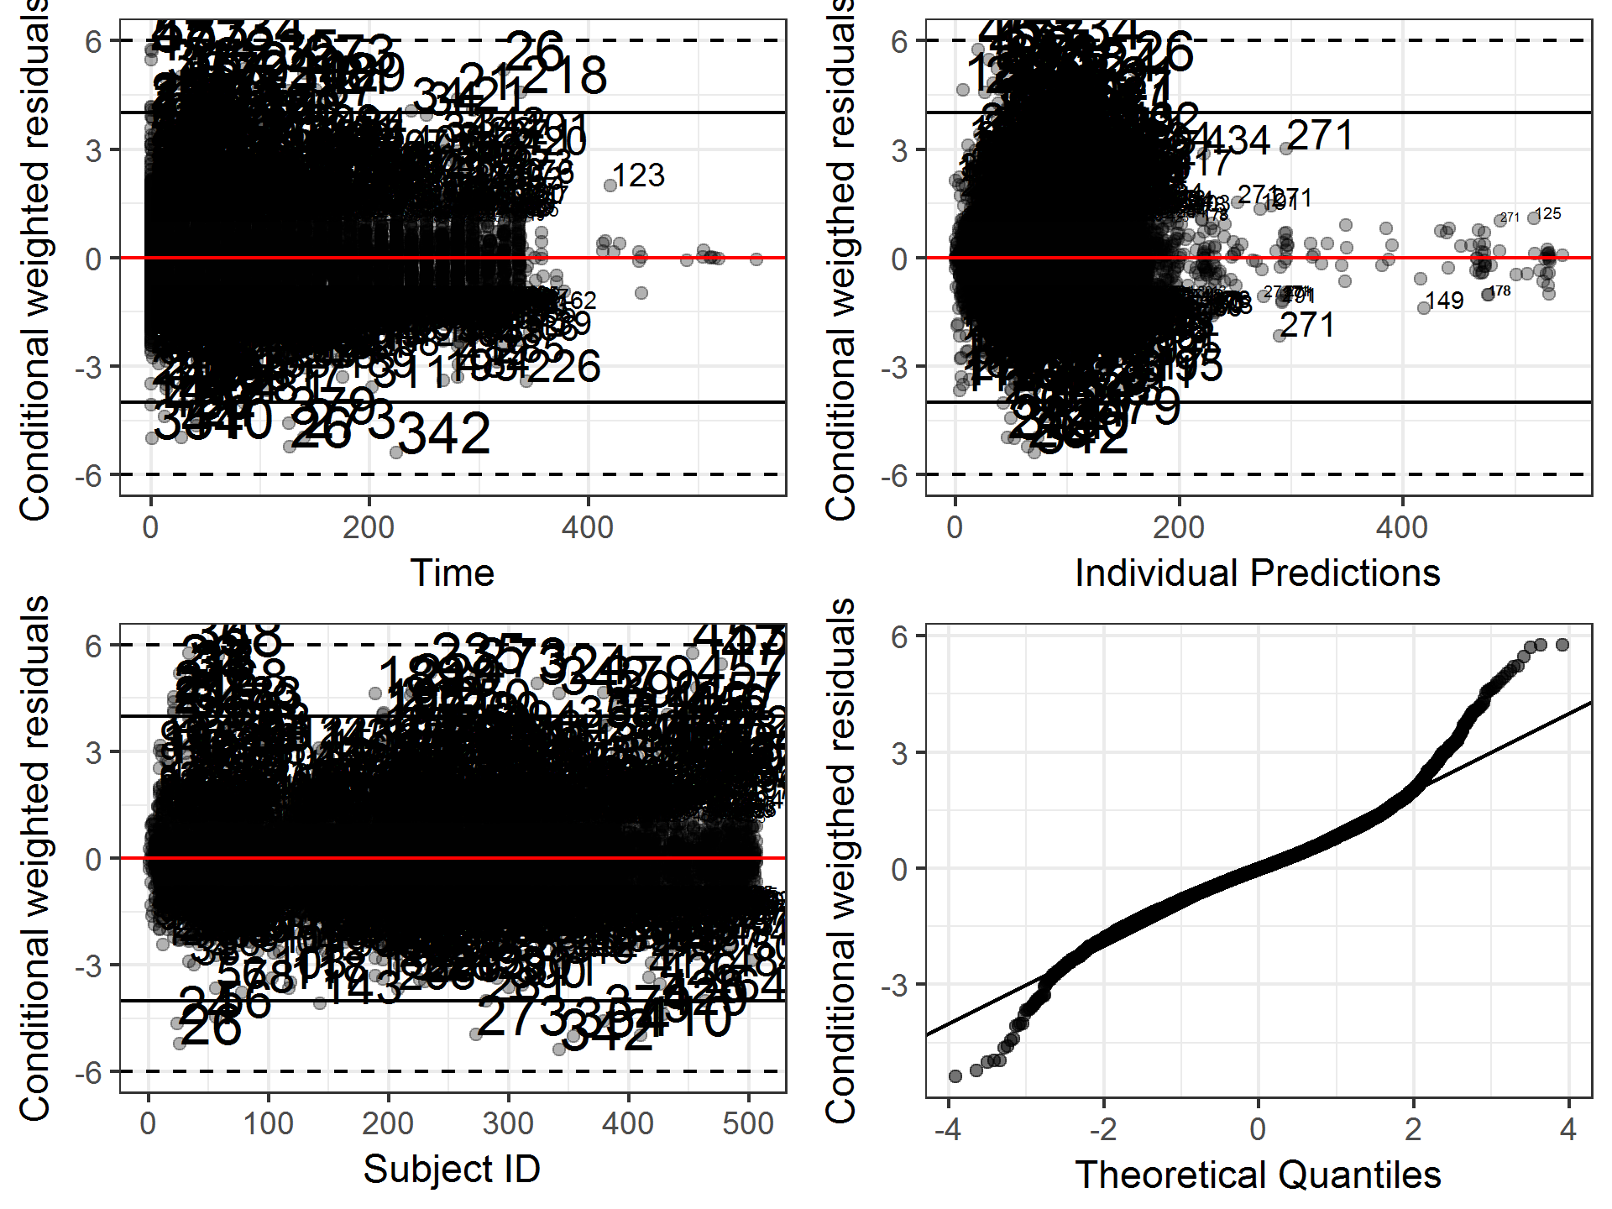

Figure : Representative Model Fitting of Predicted Concentration-time Profiles vs Observed Profiles in Study 1423 and 1540 [Using the Final Model]

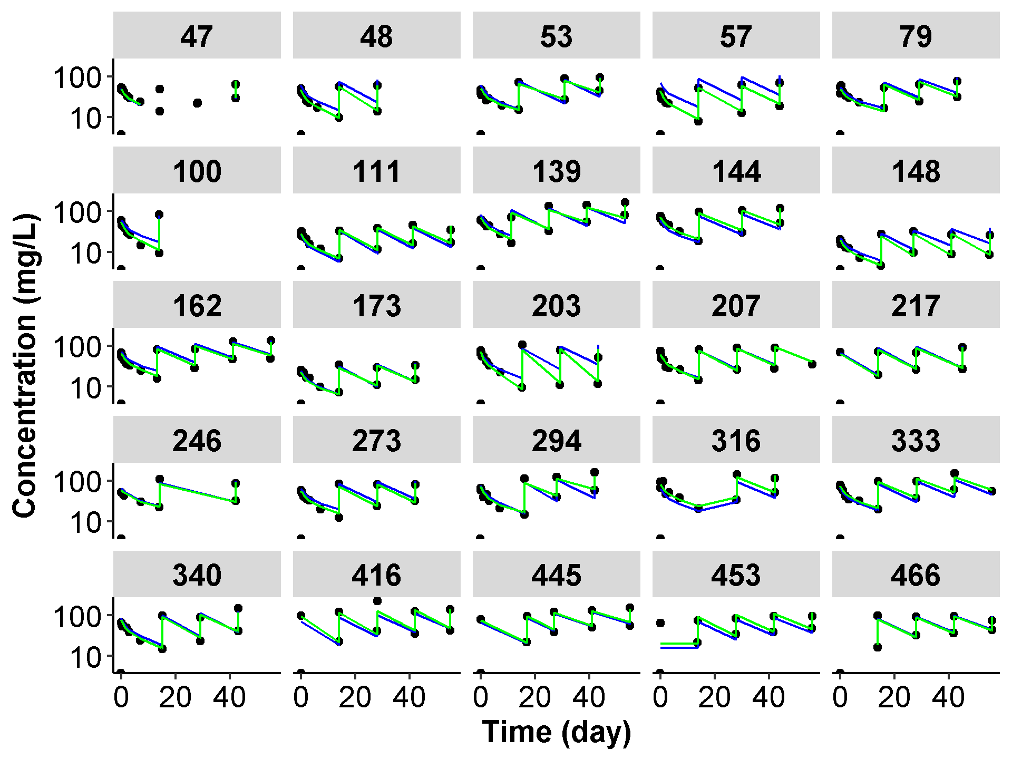

Note: Patients were randomly selected from the overall population. Each black dot represents the observe data; blue line represents the population mean prediction; the green line represents the individual prediction.

Figure : Age as Covariate Impacting on Model Parameters in the Final Model

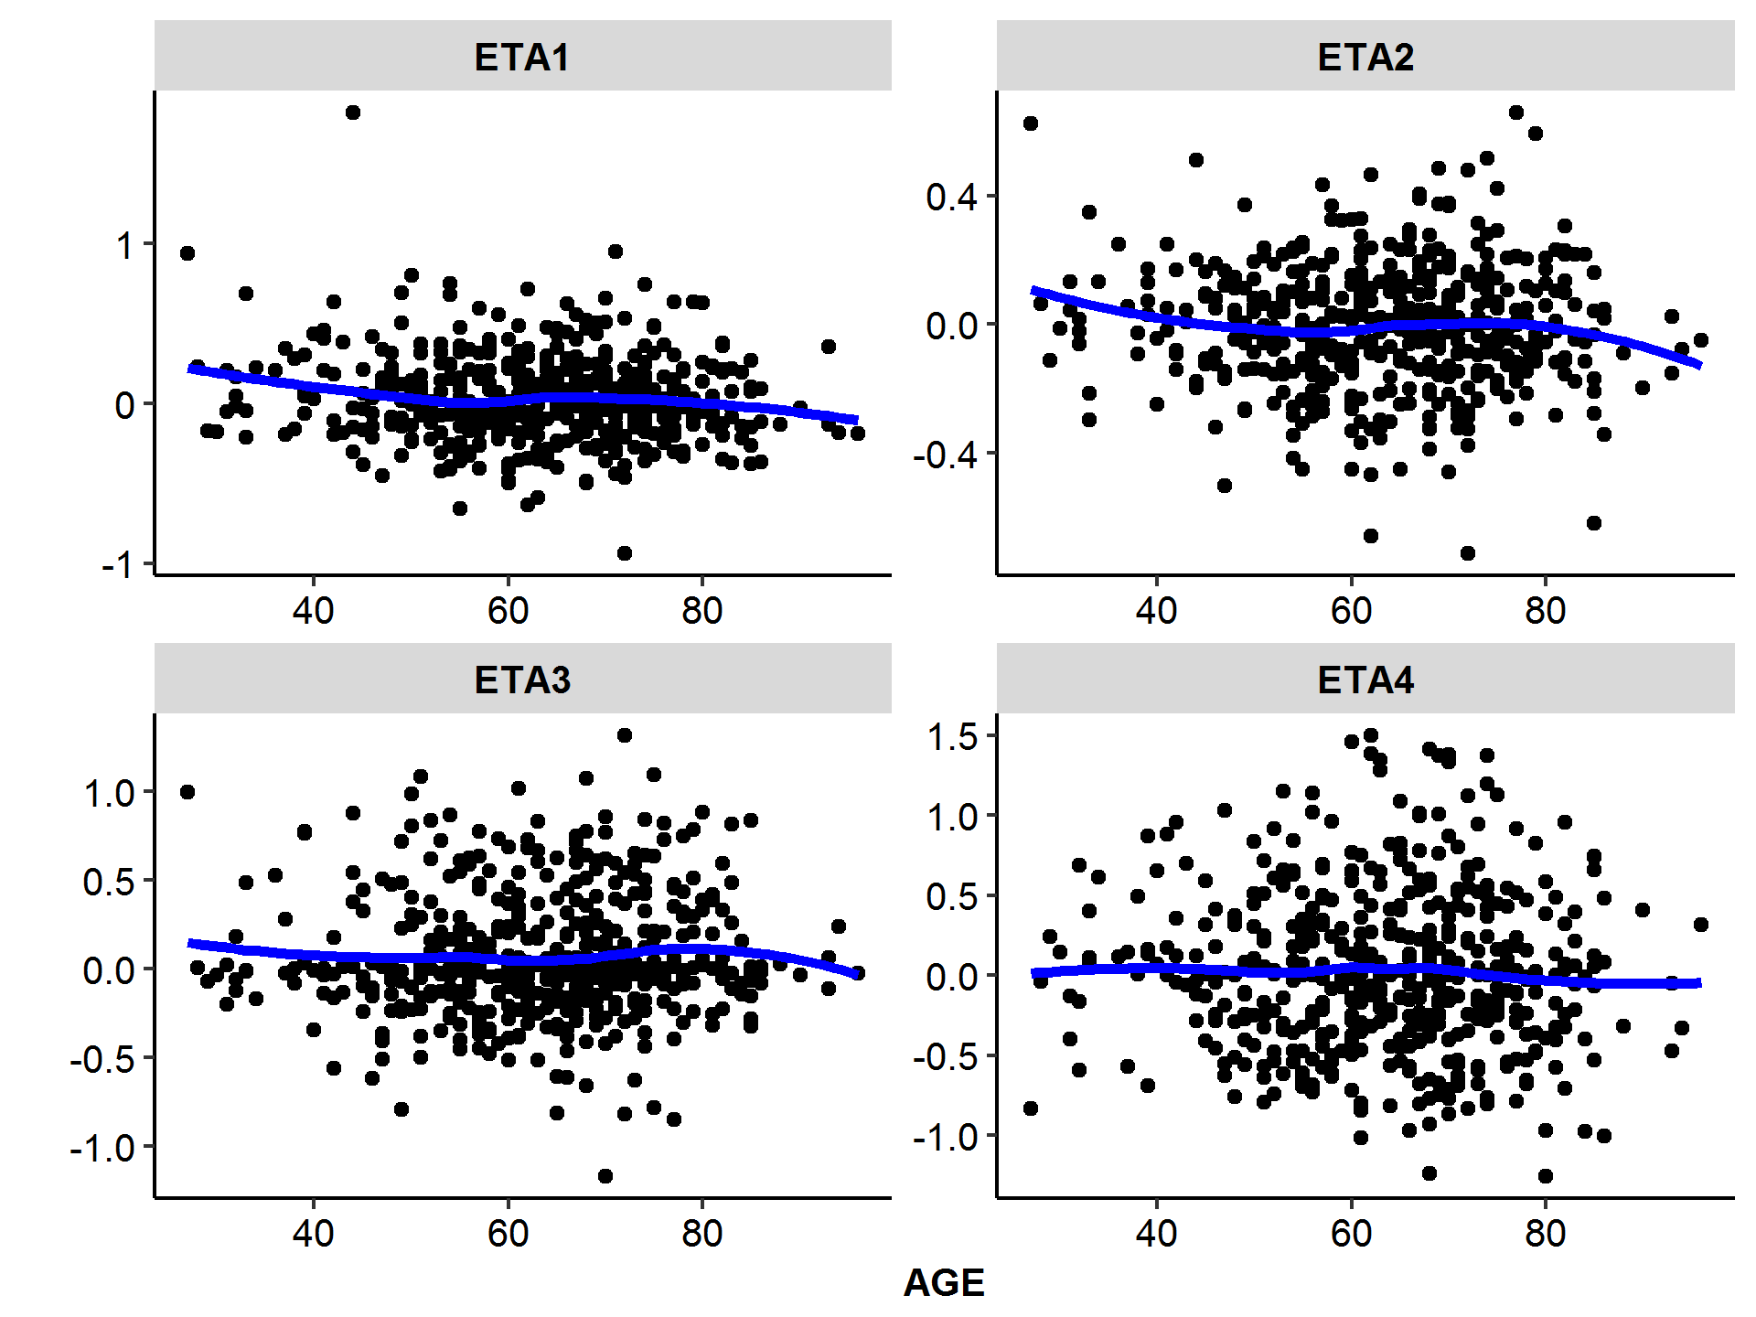

Note: the blue line represents the loess fit. ETA1, ETA2, ETA3 and ETA4 represents IIV of model parameters of CL/Q, V2/V3, EMAX, and T50.

Figure : Baseline Body Weight as Covariate Impacting on Model Parameters in the Final Model

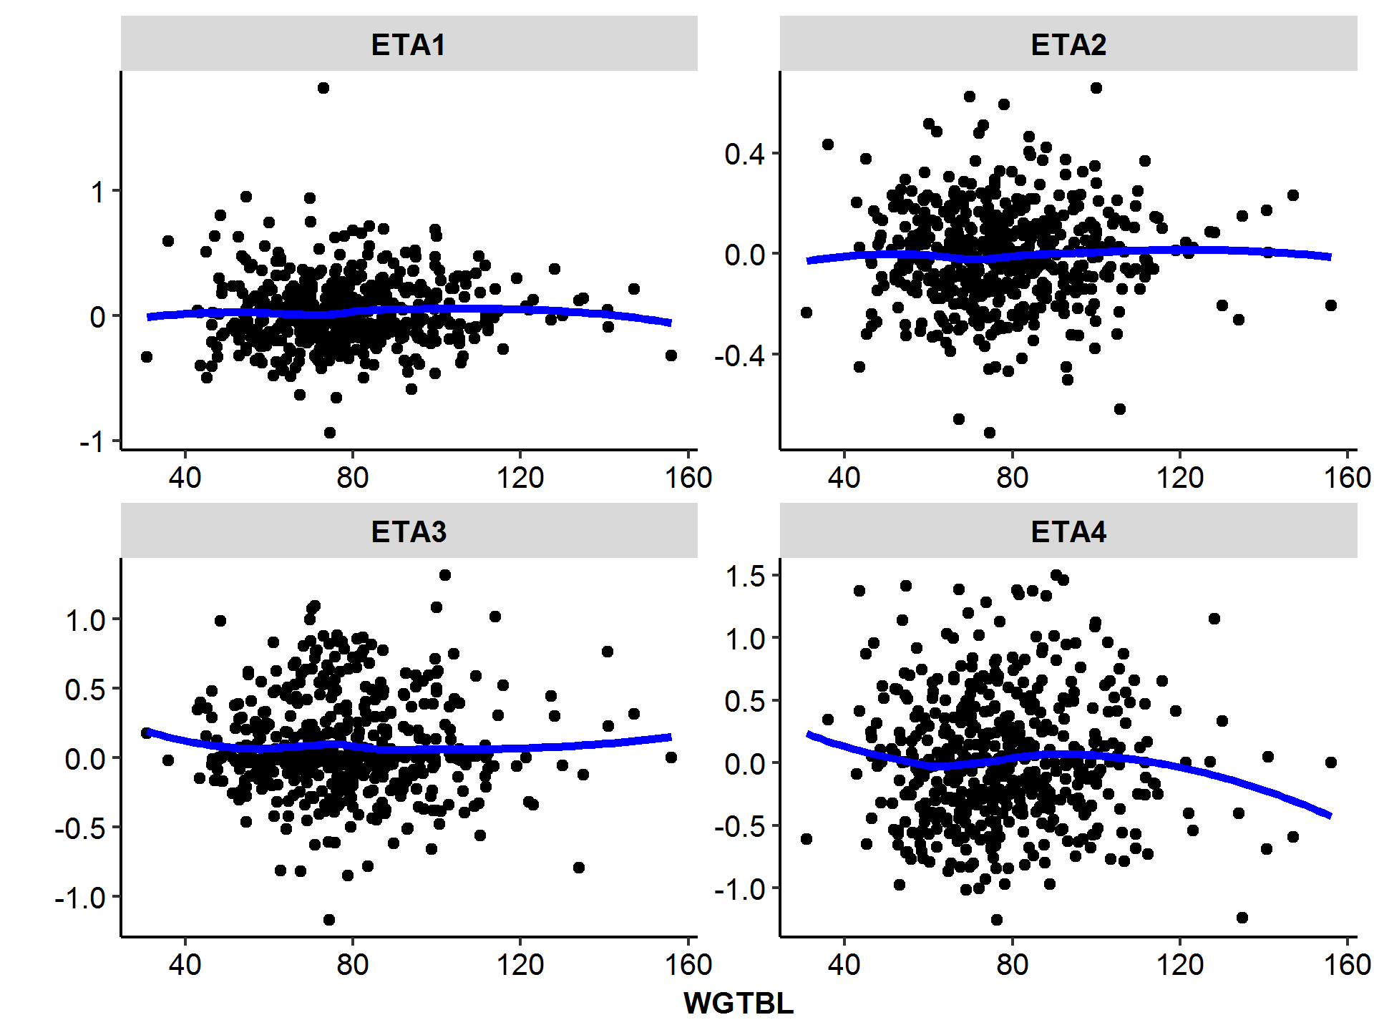

Note: the blue line represents the loess fit. ETA1, ETA2, ETA3 and ETA4 represents IIV of model parameters of CL/Q, V2/V3, EMAX, and T50.

Figure : Baseline Albumin as Covariate Impacting on Model Parameters in the Final Model

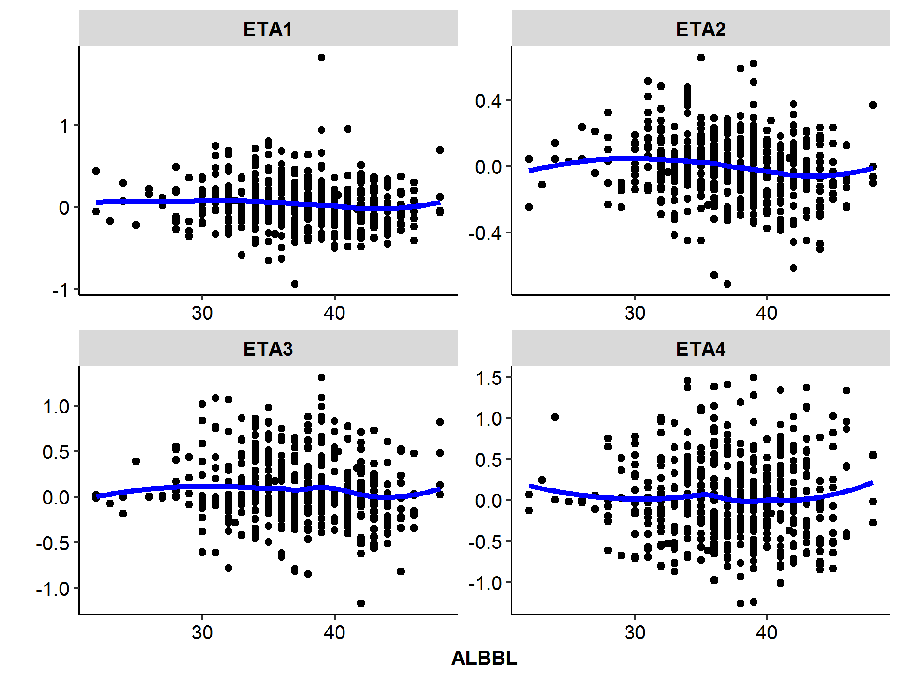

Note: the blue line represents the loess fit. ETA1, ETA2, ETA3 and ETA4 represents IIV of model parameters of CL/Q, V2/V3, EMAX, and T50.

Figure : Baseline IGG level as Covariate Impacting on Model Parameters in the Final Model

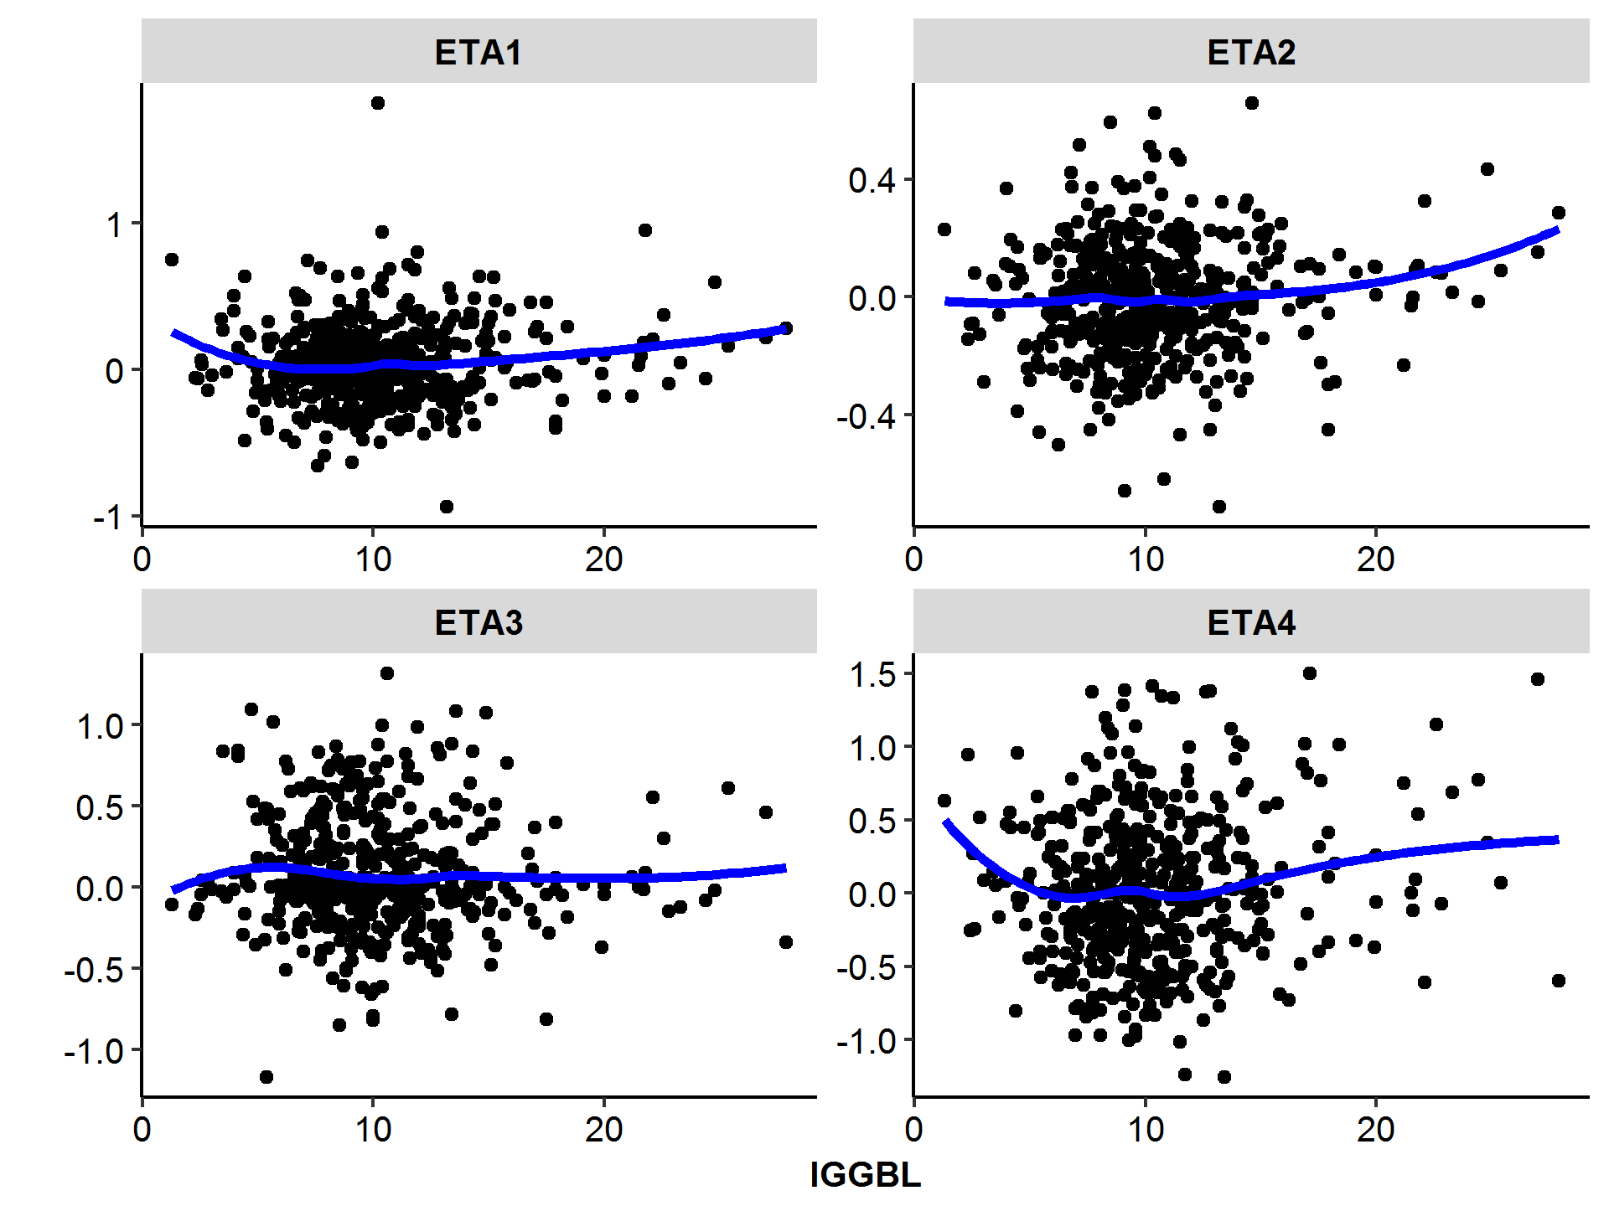

Note: the blue line represents the loess fit. ETA1, ETA2, ETA3 and ETA4 represents IIV of model parameters of CL/Q, V2/V3, EMAX, and T50.

Figure : Body Weight vs Time in Both Study 1423 and 1540

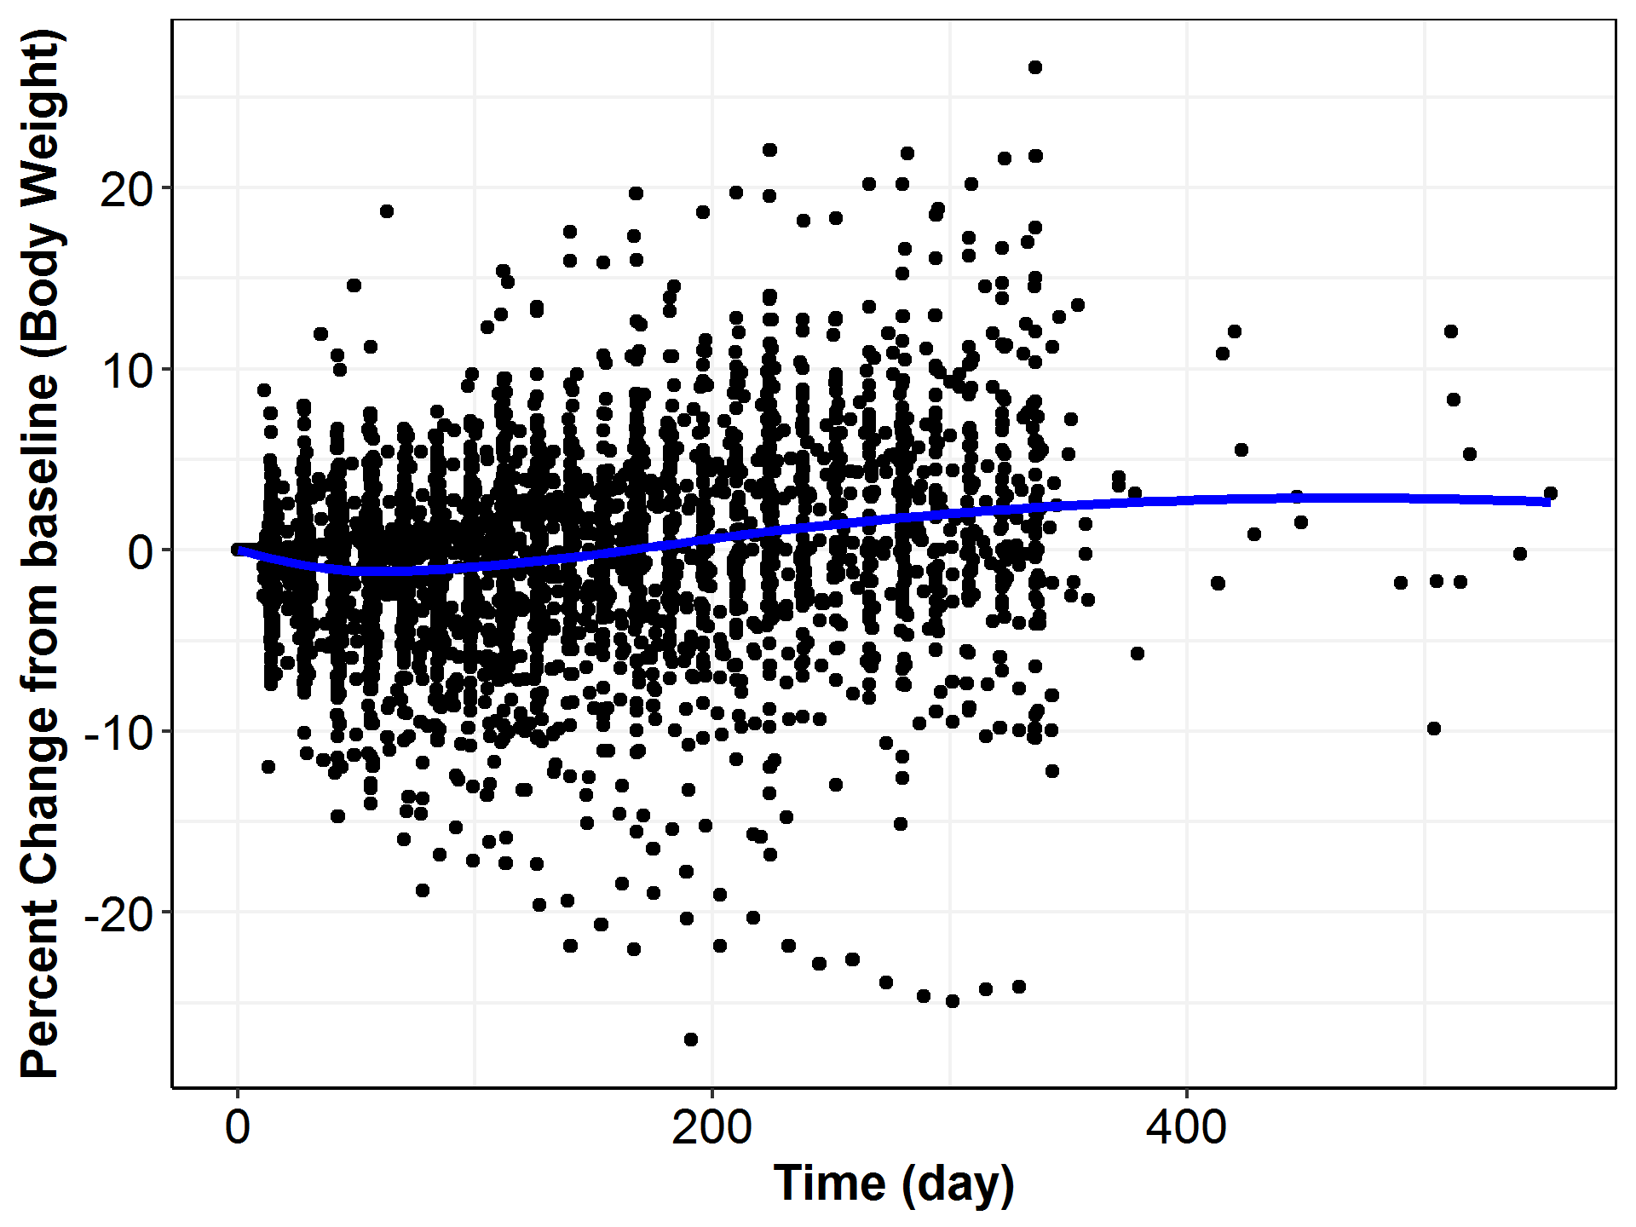

Note: the blue line represents the loess fit.

Figure : Albumin vs Time in Both Study 1423 and 1540

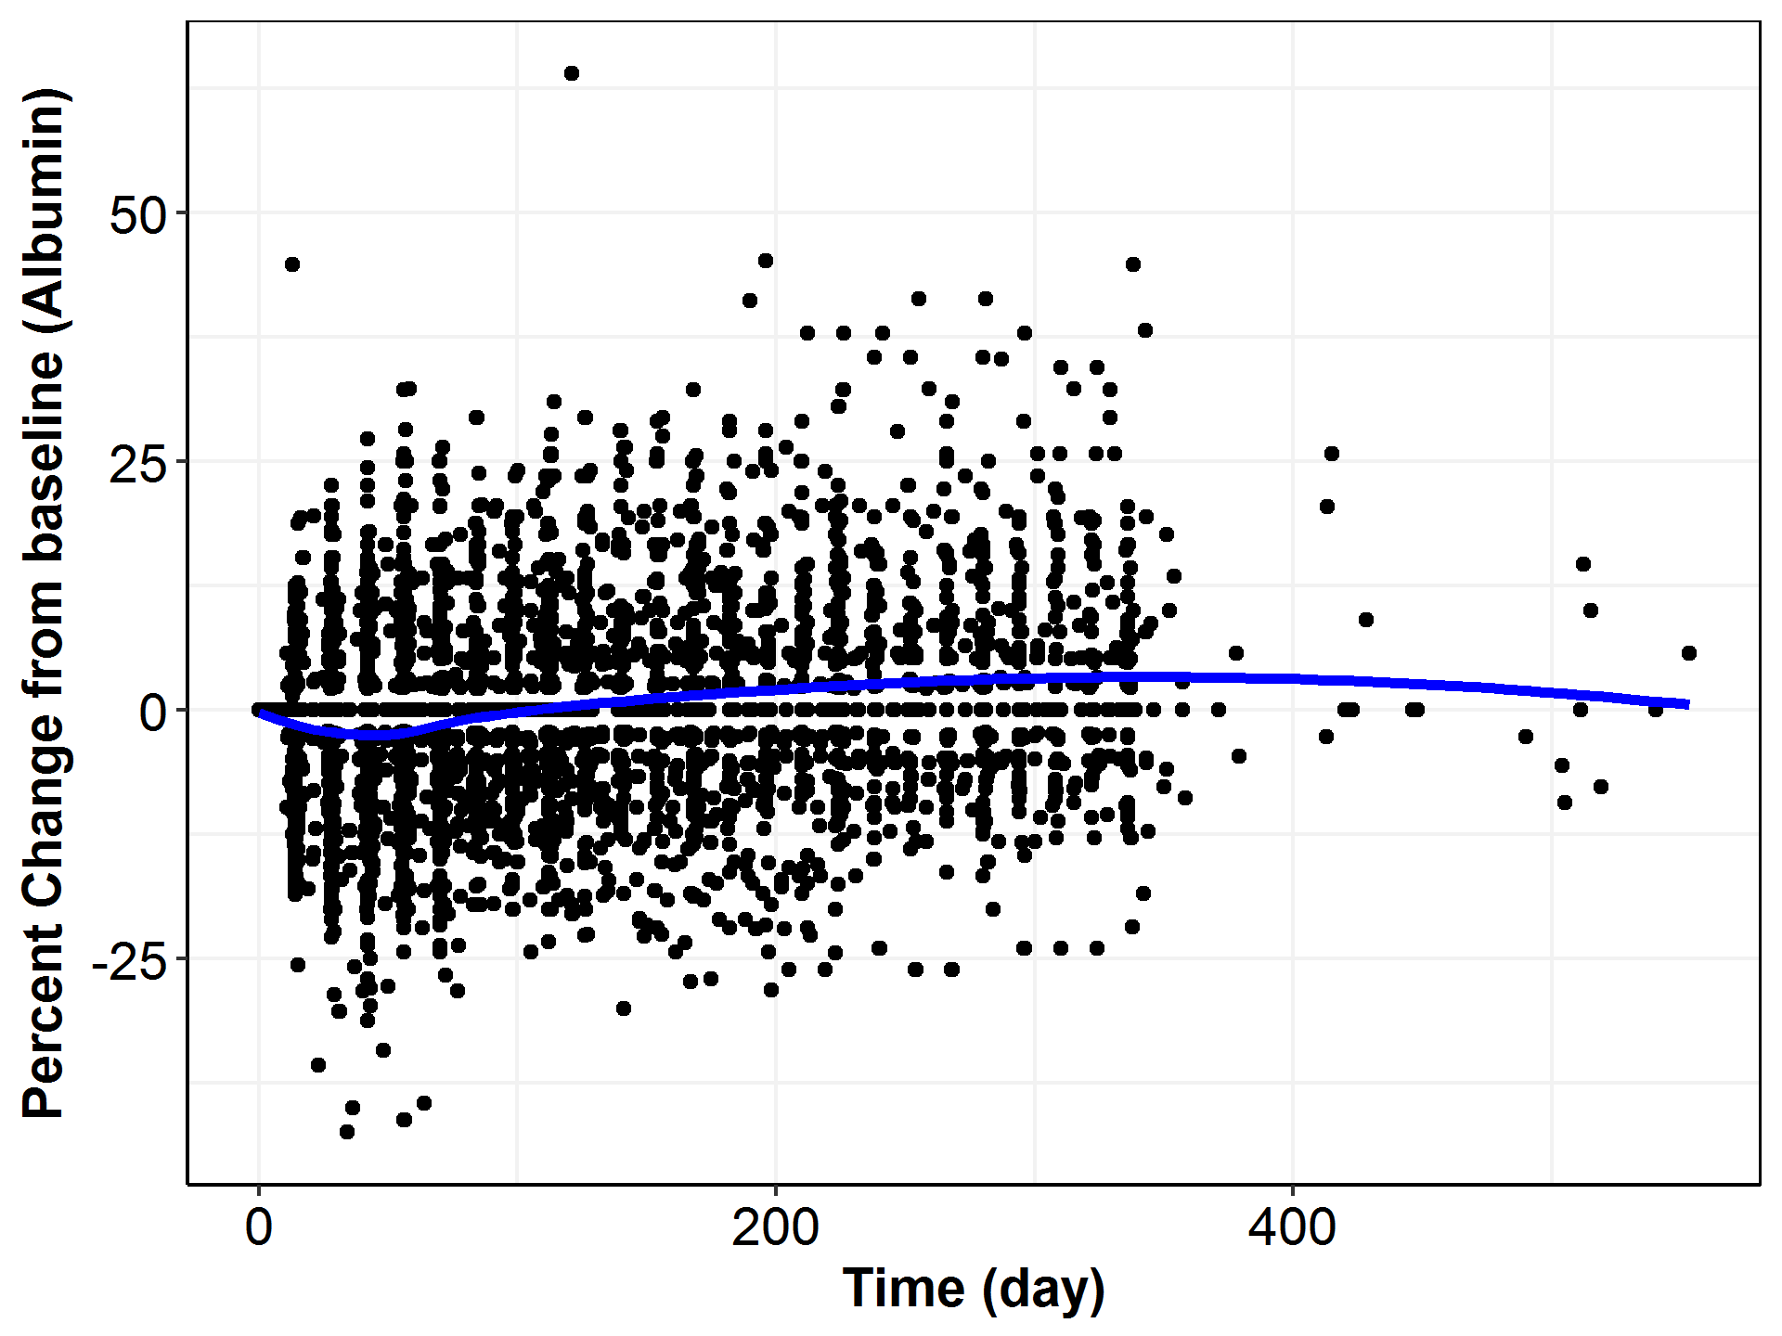

Note: the blue line represents the loess fit.

Figure : LDH vs Time in Both Study-1423 and Study-1540

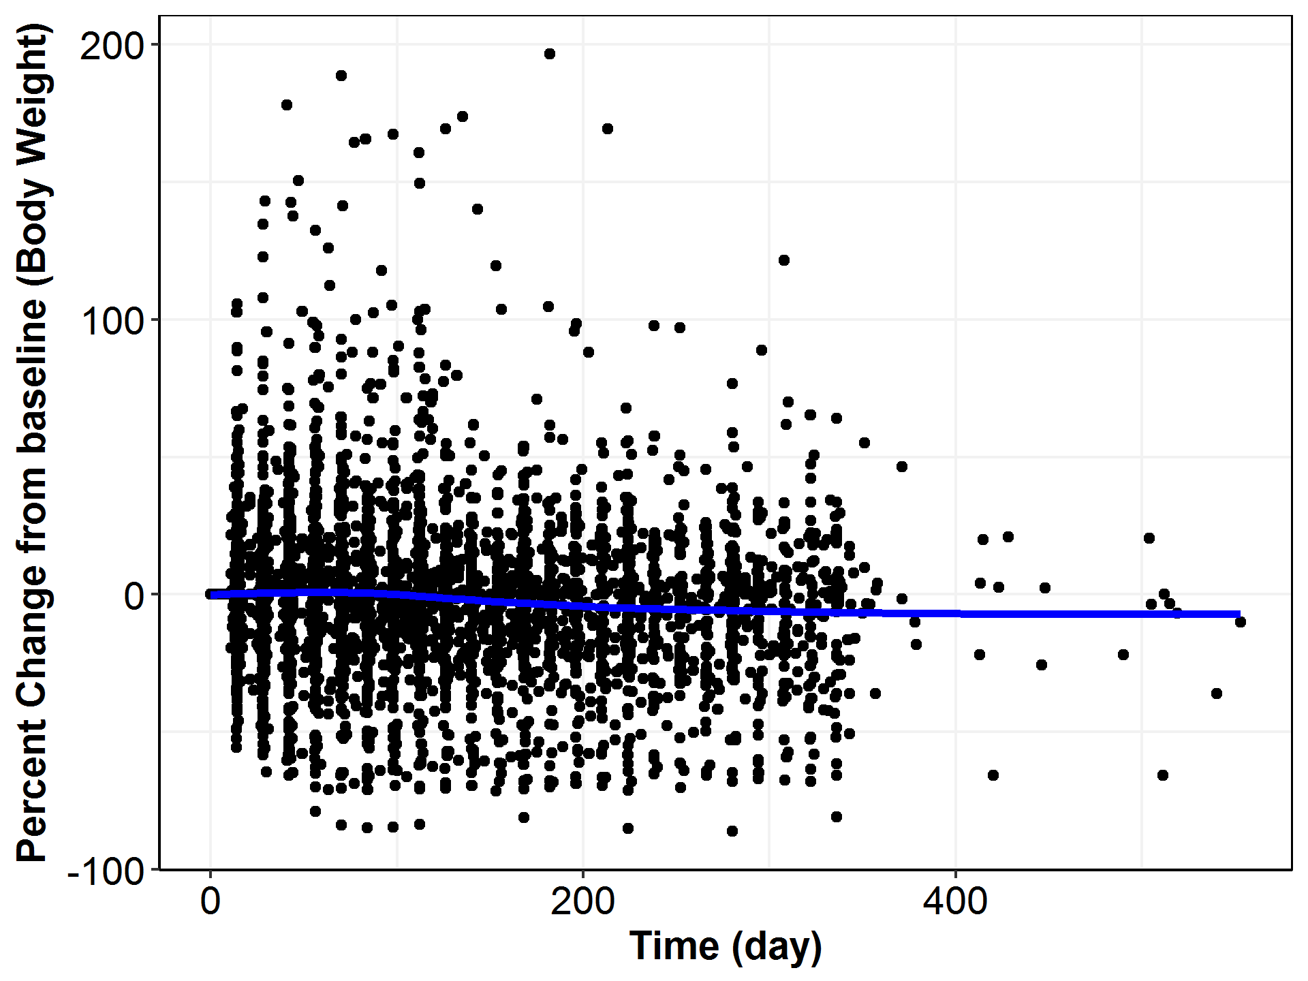

Note: the blue line represents the loess fit.

Figure 35: Histograms of the Minimum Objective Function Values across the 1,000 Bootstrap Runs

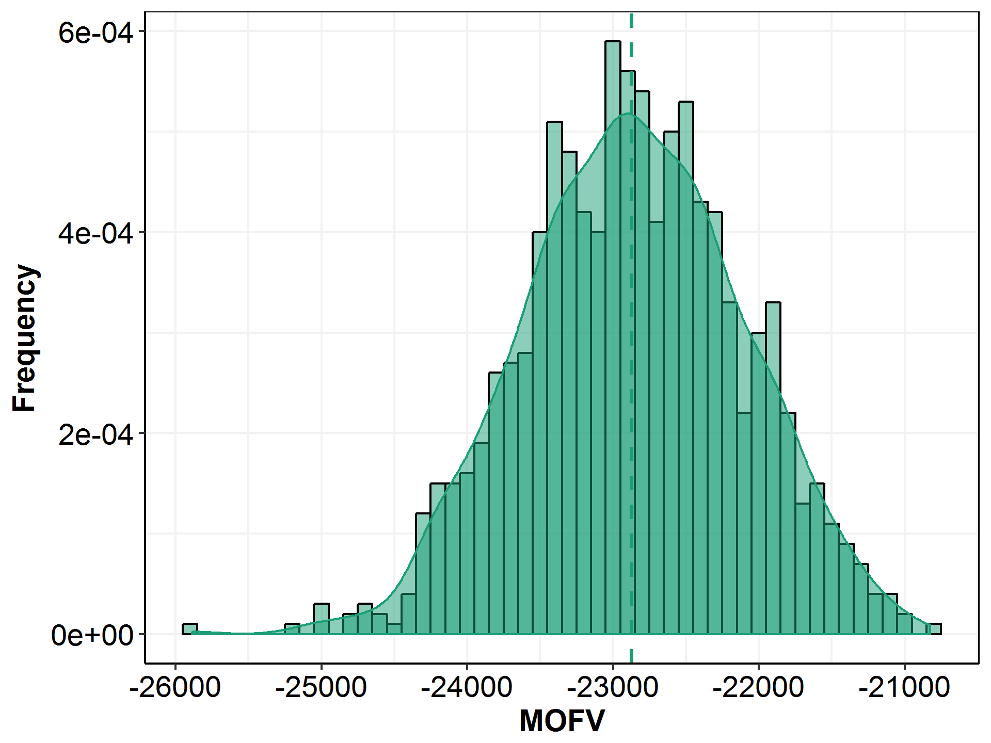

Note: the dashed line represents the median of the distribution.

Figure : Histogram of Parameter Estimates (CL) across 1,000 Bootstrap Runs

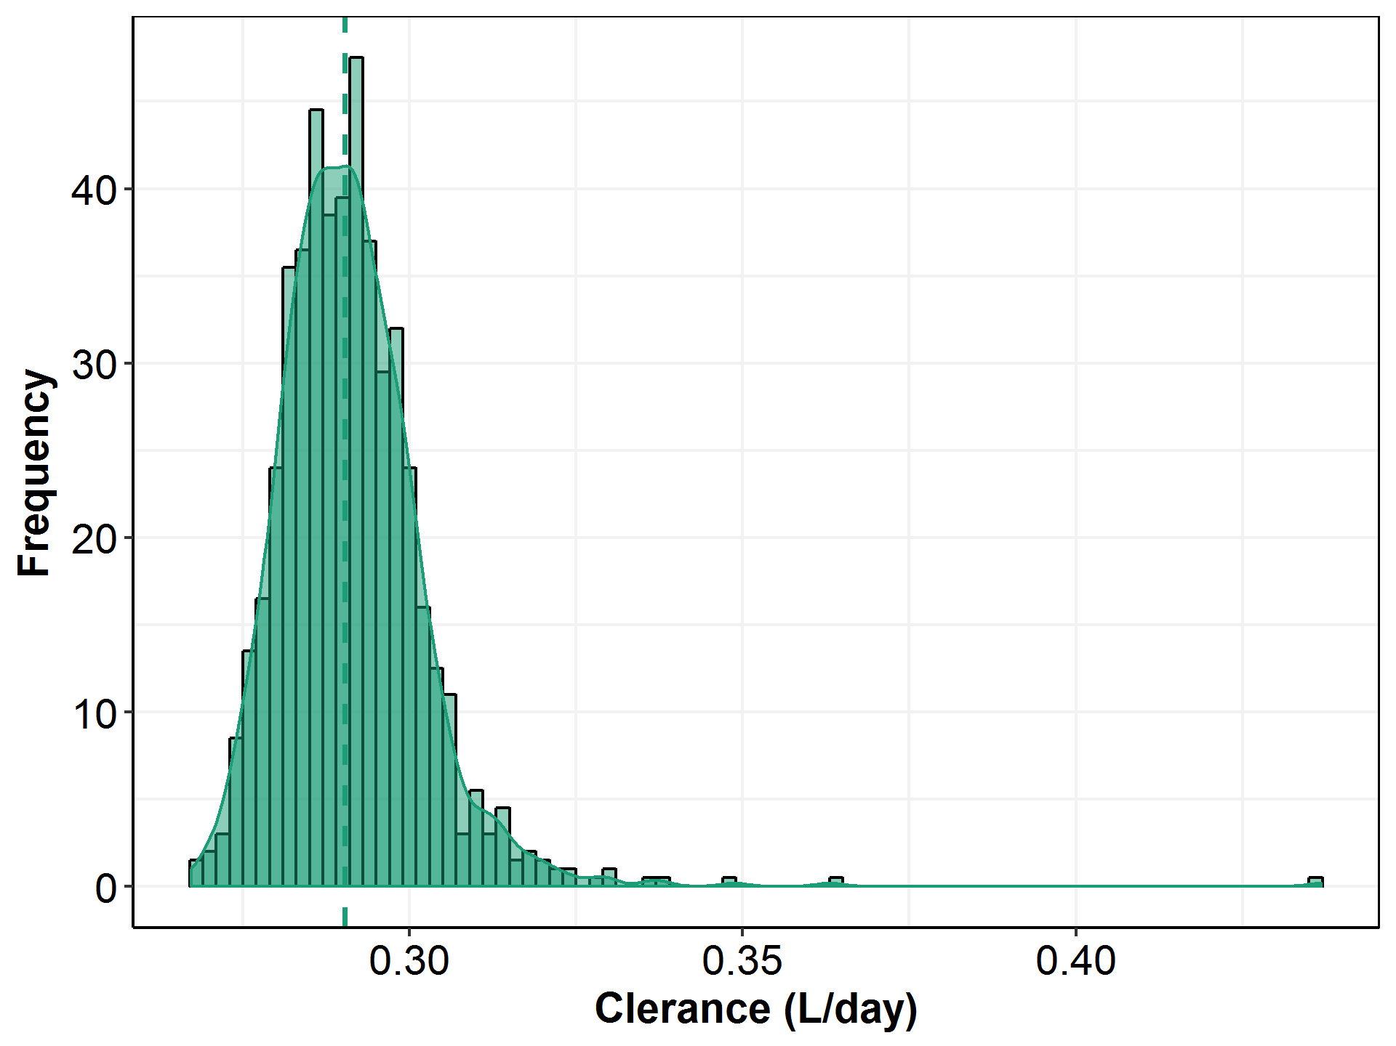

Note: the dashed line represents the median of the distribution.

Figure : Histogram of Parameter Estimates (V2) across 1,000 Bootstrap Runs

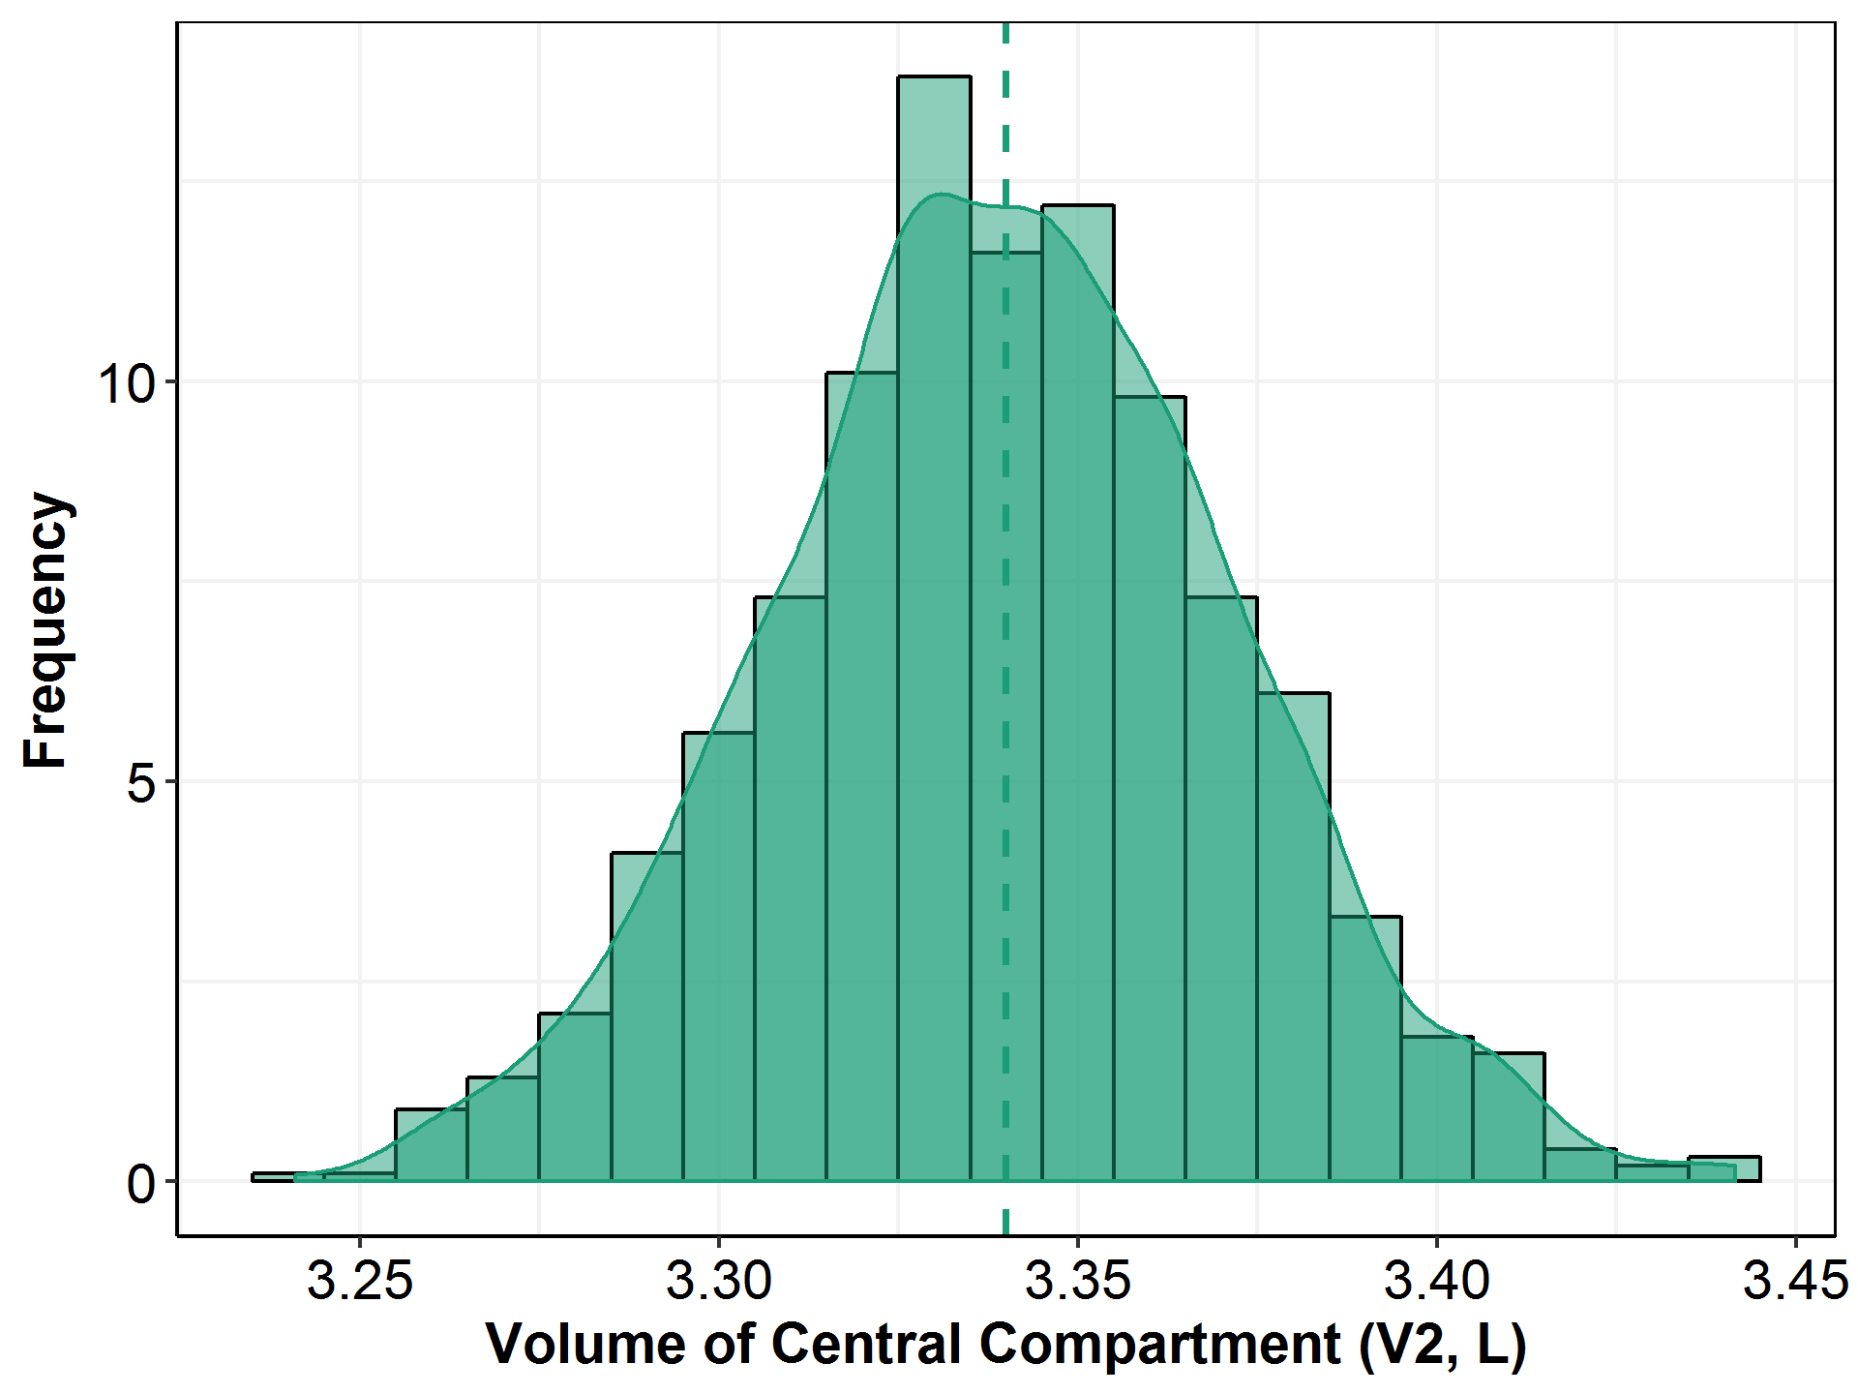

Note: the dashed line represents the median of the distribution.

Figure : Histogram of Parameter Estimates (Emax) across 1,000 Bootstrap Runs

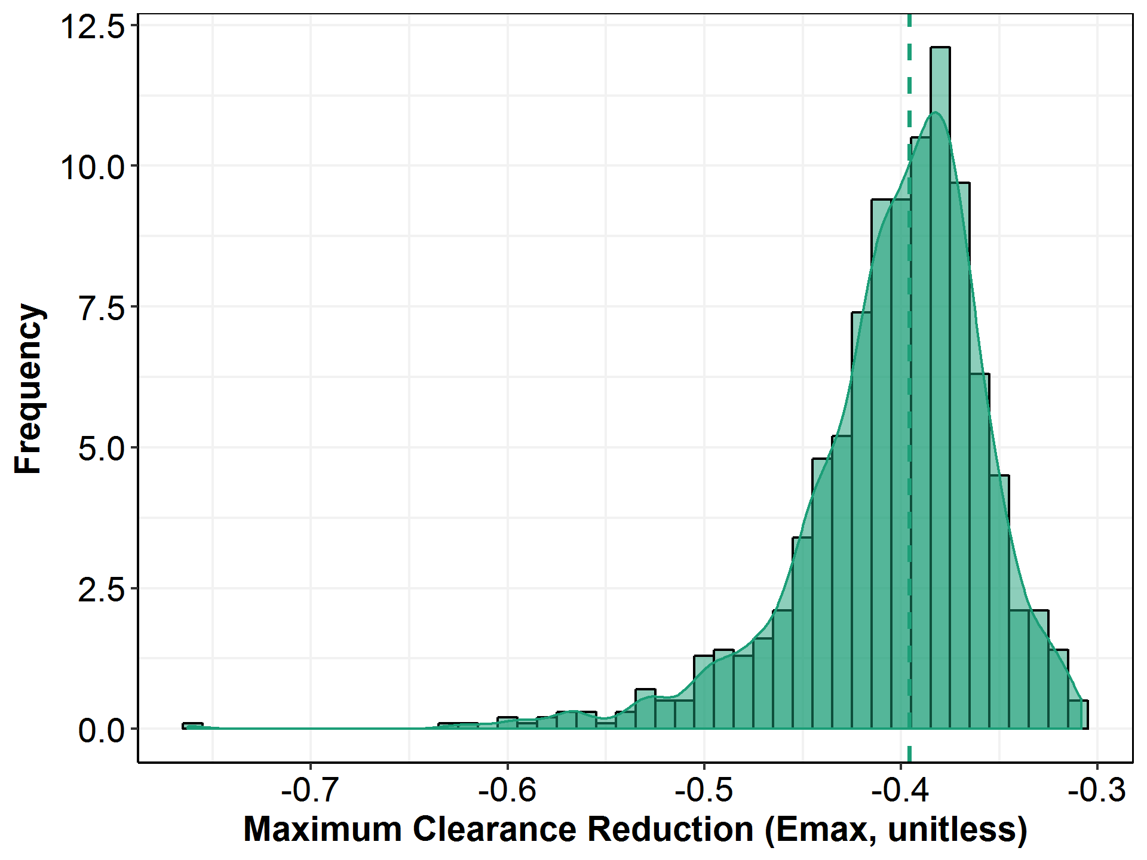

Note: the dashed line represents the median of the distribution.

Figure : Histogram of Parameter Estimates (T50) across 1,000 Bootstrap Runs

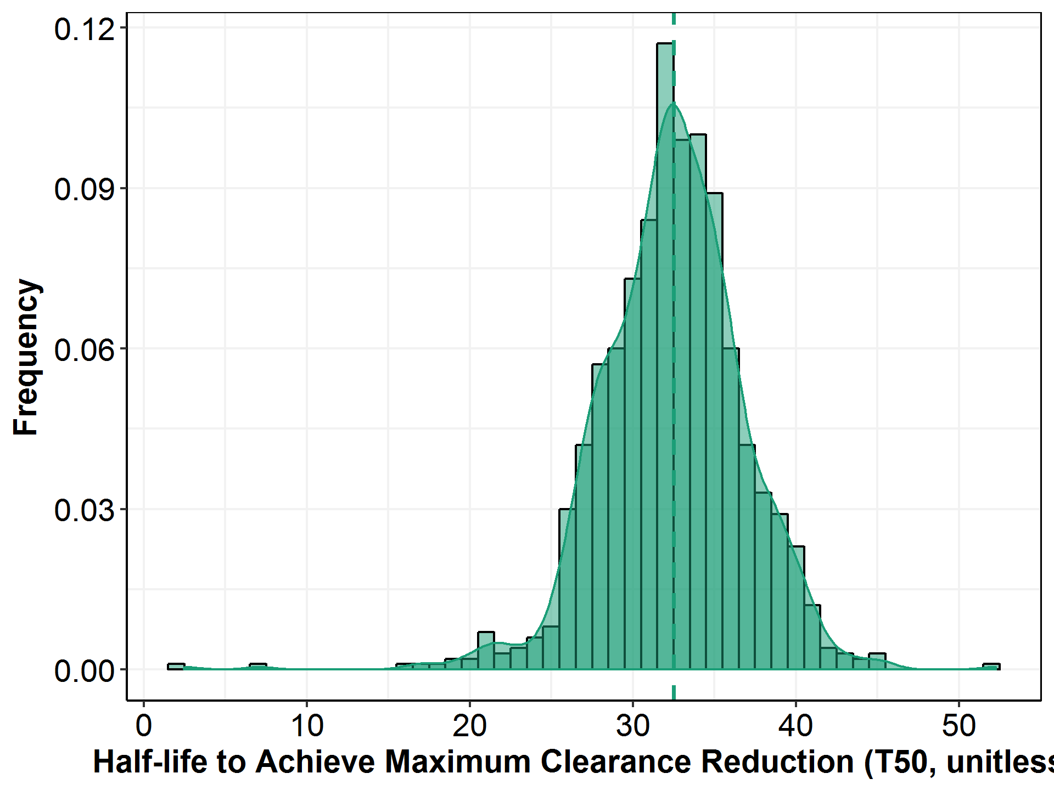

Note: the dashed line represents the median of the distribution.

1. Model Application
   1. Post-Hoc Exposure Metrics of Cemiplimab

Table 32: Descriptive Statistics for Post-hoc Cemiplimab PK Parameters in Patients with Solid Tumors Using the Final PK Population Model, Estimated at 3 mg/kg Q2W Regimen

| **Parameter** | **N** | **Mean(CV)** | **SE** | **SD** | **Median(CI95)** | **GEOmean(SD)** |
| --- | --- | --- | --- | --- | --- | --- |
| t1/2,beta,0-2wk (day) | 505 | 12.5(22.4%) | 0.124 | 2.79 | 12.6(7.19-17.8) | 12.1(9.55-15.4) |
| t1/2,beta,ss (day) | 505 | 19.2(29.5%) | 0.253 | 5.68 | 18.6(10.3-34.2) | 18.4(13.8-24.7) |
| Baseline Clearance (L/day) | 505 | 0.325(40.0%) | 0.00578 | 0.130 | 0.303(0.163-0.636) | 0.305(0.215-0.432) |
| Clearance at ss (L/day) | 505 | 0.211(39.5%) | 0.00370 | 0.0832 | 0.195(0.0939-0.428) | 0.197(0.136-0.284) |
| Percent of reduction in CL | 505 | 34.6(28.5%) | 0.439 | 9.87 | 31.8(20.2-58.6) | 33.3(25.4-43.7) |
| Volume of distribution (L) | 505 | 5.20(24.3%) | 0.0561 | 1.26 | 5.10(3.08-8.14) | 5.05(3.98-6.42) |
|  |  |  |  |  |  |  |
| Cmax,0-2wk (mg/L) | 505 | 69.5(23.2%) | 0.717 | 16.1 | 67.8(42.1-108) | 67.7(53.9-85.1) |
| Cmax.ss (mg/L) | 505 | 135(28.4%) | 1.71 | 38.4 | 132(71.3-229) | 130(97.5-173) |
| Ctrough,0-2wk (mg/L) | 505 | 18.9(30.3%) | 0.255 | 5.73 | 18.7(8.48-31.1) | 17.9(12.8-25.2) |
| Ctrough,ss (mg/L) | 505 | 65.7(42.8%) | 1.25 | 28.1 | 62.0(21.5-134) | 59.8(38.1-93.8) |
| Cavg0-6wk (mg/L) | 505 | 44.9(27.6%) | 0.551 | 12.4 | 44.5(22.8-71.6) | 43.1(32.2-57.7) |
| Cavg6wk,ss (mg/L) | 505 | 88.4(35.9%) | 1.41 | 31.7 | 84.5(35.4-164) | 82.8(57.2-120) |
| AUC0-6wk (mg*day*/L) | 505 | 1880(27.6%) | 23.1 | 520 | 1870(959-3010) | 1810(1350-2420) |
| AUC6wk,ss (mg*day*/L) | 505 | 3710(35.9%) | 59.3 | 1330 | 3550(1490-6900) | 3480(2400-5030) |
| Accumulation index  in AUC6wk | 505 | 1.95(20.0%) | 0.0174 | 0.391 | 1.88(1.47-2.92) | 1.92(1.61-2.30) |
| Percentage of SS  during (42,56] days | 505 | 74.6(13.4%) | 0.446 | 10.0 | 75.6(50.1-91.5) | 73.8(63.7-85.7) |
| Percentage of SS  during (56,70] days | 505 | 81.2(11.9%) | 0.432 | 9.71 | 82.9(57.0-95.6) | 80.6(70.6-92.0) |
| Percentage of SS  during (70,84] days | 505 | 86.2(10.4%) | 0.399 | 8.97 | 88.5(63.0-97.7) | 85.6(76.3-96.1) |
| Percentage of SS  during (84,98] days | 505 | 89.8(8.94%) | 0.357 | 8.03 | 92.3(69.2-98.8) | 89.4(80.9-98.7) |
| Percentage of SS  during (98,112] days | 505 | 92.4(7.59%) | 0.312 | 7.02 | 94.8(72.4-99.4) | 92.1(84.7-100) |

Note: GEOmean represents geometric mean.

Table : Descriptive Statistics for Post-hoc Cemiplimab PK Parameters in Patients with Solid Tumors Using the Final PK Population Model, Estimated at 350 mg Q3W Regimen

| **Parameter** | **N** | **Mean(CV)** | **SE** | **SD** | **Median(CI95)** | **GEOmean(SD)** |
| --- | --- | --- | --- | --- | --- | --- |
| t1/2,beta,3wk (day) | 505 | 12.5(22.4%) | 0.124 | 2.79 | 12.6(7.19-17.8) | 12.1(9.55-15.4) |
| t1/2,beta,ss (day) | 505 | 19.2(29.5%) | 0.253 | 5.68 | 18.6(10.3-34.2) | 18.4(13.8-24.7) |
| Baseline Clearance (L/day) | 505 | 0.325(40.0%) | 0.00578 | 0.130 | 0.303(0.163-0.636) | 0.305(0.215-0.432) |
| Clearance at ss (L/day) | 505 | 0.211(39.5%) | 0.00370 | 0.0832 | 0.195(0.0939-0.428) | 0.197(0.136-0.284) |
| Percent of   reduction in CL | 505 | 34.6(28.5%) | 0.439 | 9.87 | 31.8(20.2-58.6) | 33.3(25.4-43.7) |
| Volume of distribution (L) | 505 | 5.20(24.3%) | 0.0561 | 1.26 | 5.10(3.08-8.14) | 5.05(3.98-6.42) |
|  |  |  |  |  |  |  |
| Cmax,3wk  (mg/L) | 505 | 107(24.6%) | 1.17 | 26.3 | 103(64.6-171) | 104(81.9-132) |
| Cmax.ss  (mg/L) | 505 | 166(27.8%) | 2.05 | 46.1 | 160(92.5-281) | 160(122-209) |
| Ctrough,3wk (mg/L) | 505 | 20.4(37.4%) | 0.339 | 7.61 | 19.5(7.19-37.1) | 18.8(12.3-28.8) |
| Ctrough,ss (mg/L) | 505 | 58.7(47.7%) | 1.24 | 28.0 | 54.9(16.5-131) | 52.4(32.1-85.7) |
| Cavg0-6wk (mg/L) | 505 | 48.8(29.6%) | 0.642 | 14.4 | 47.5(25.9-81.7) | 46.8(34.7-63.0) |
| Cavg6wk,ss (mg/L) | 505 | 90.6(37.2%) | 1.50 | 33.7 | 85.3(39.1-178) | 84.8(58.7-122) |
| AUC0-6wk (mg*day/L) | 505 | 2050(29.6%) | 27.0 | 606 | 2000(1090-3430) | 1960(1460-2650) |
| AUC6wk,ss (mg*day*/L) | 505 | 3800(37.2%) | 62.9 | 1410 | 3580(1640-7460) | 3560(2470-5140) |
| Accumulation index  in AUC6wk,ss | 505 | 1.84(19.7%) | 0.0162 | 0.364 | 1.76(1.40-2.76) | 1.81(1.52-2.16) |
| Percentage of SS   during (42,63] days | 505 | 77.0(12.9%) | 0.443 | 9.95 | 78.1(52.5-93.3) | 76.3(66.1-88.0) |
| Percentage SS   during (63,84] days | 505 | 85.2(10.7%) | 0.406 | 9.13 | 87.6(62.0-97.3) | 84.7(75.2-95.4) |
| Percentage SS   during (84,105] days | 505 | 90.7(8.54%) | 0.344 | 7.74 | 93.2(70.4-99.0) | 90.3(82.1-99.2) |
| Percentage SS   during (105,126] days | 505 | 94.0(6.64%) | 0.278 | 6.24 | 96.3(76.1-99.6) | 93.8(87.2-101) |

Note: GEOmean represents geometric mean.

* 1. Covariate Effects on Cemiplimab Exposure
     1. Baseline Body Weight

Figure : Scatter Plot of Post-hoc Steady-state AUC6wk vs. Baseline Body Weight at 3 mg/kg Q2W

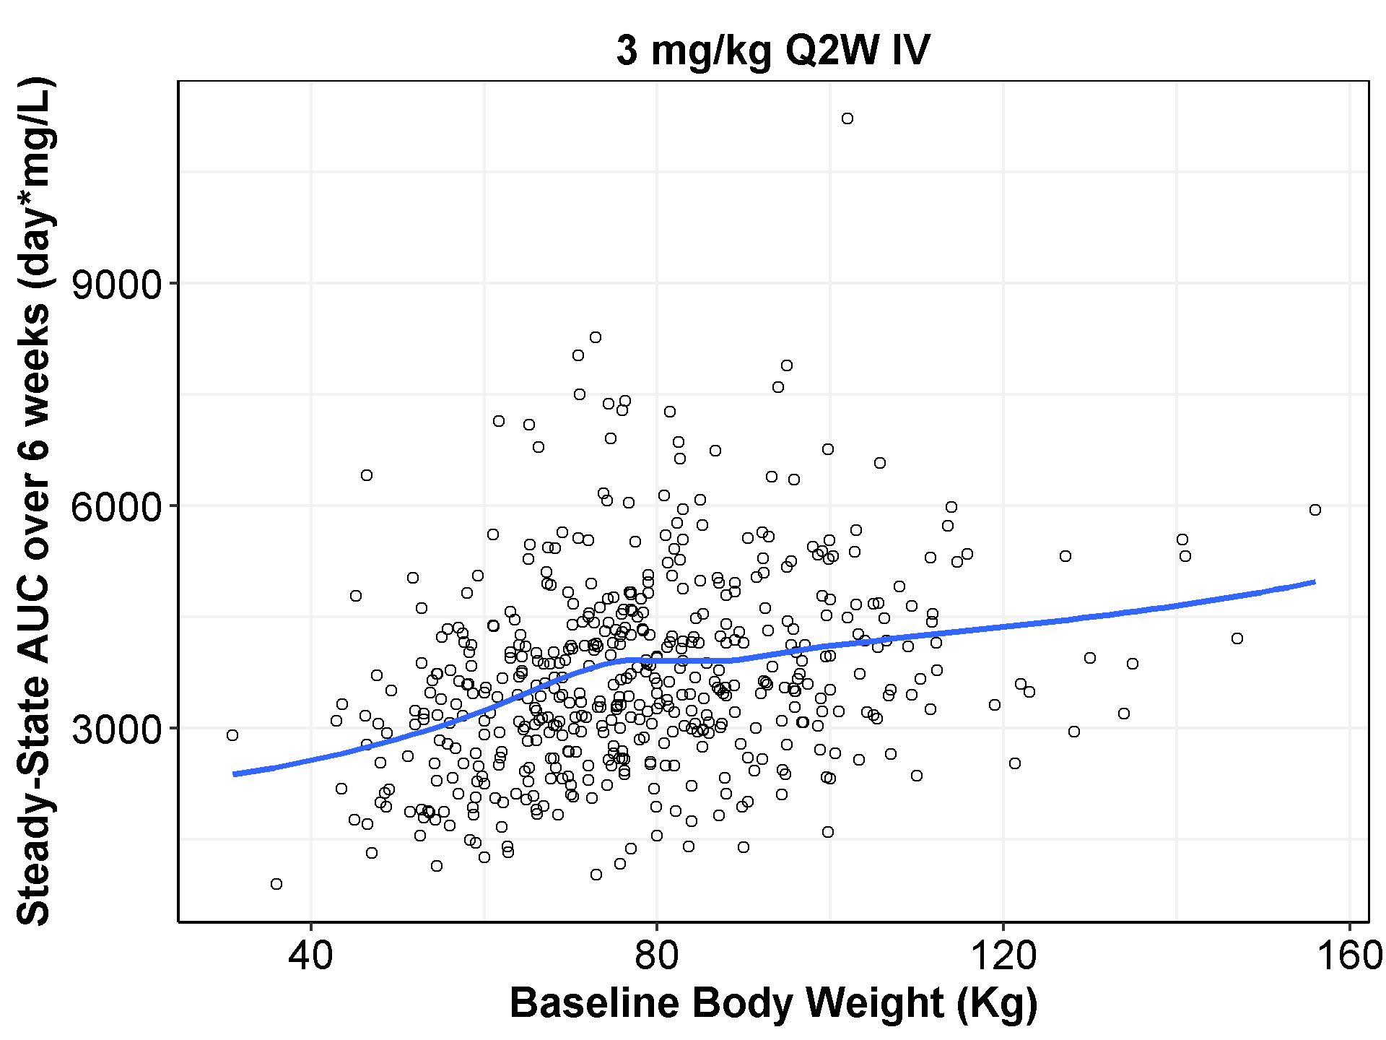

Note: Blue lines represent loess fits.

Figure : Scatter Plot of Post-hoc Steady-state AUC6wk vs. Baseline Body Weight at 350 mg Q3W

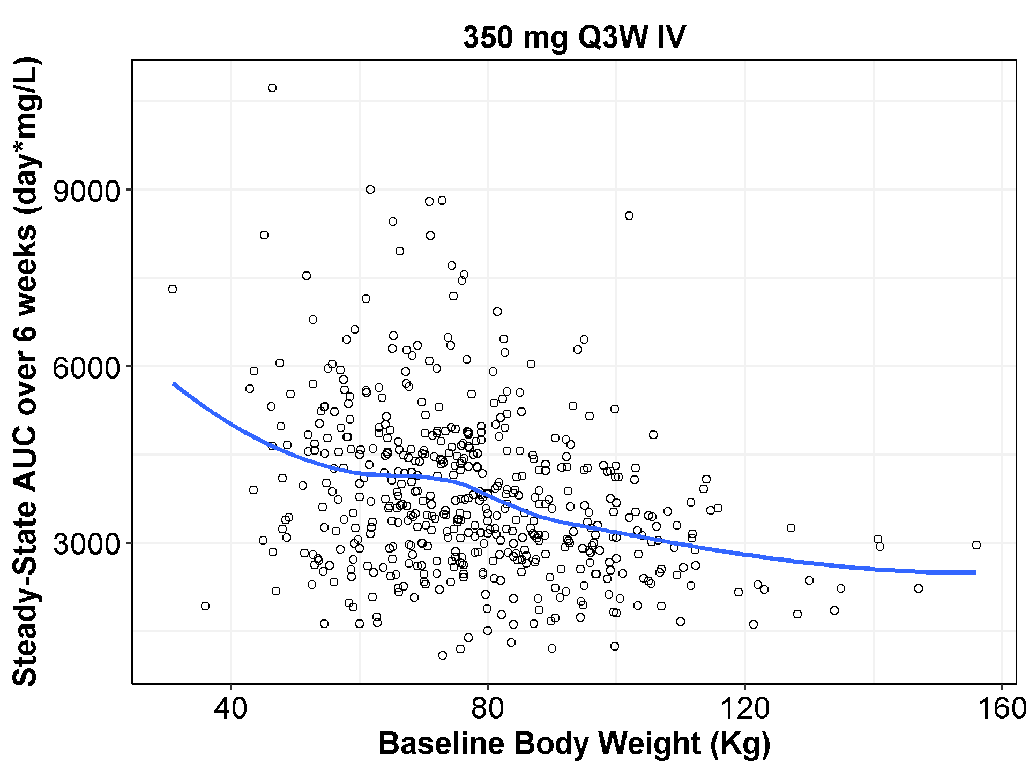

Note: Blue lines represent loess fits.

Figure : Boxplot of Post-hoc Individual Cemiplimab AUC6wk,ss by Quantiles of Baseline Body Weight at 3 mg/kg Q2W

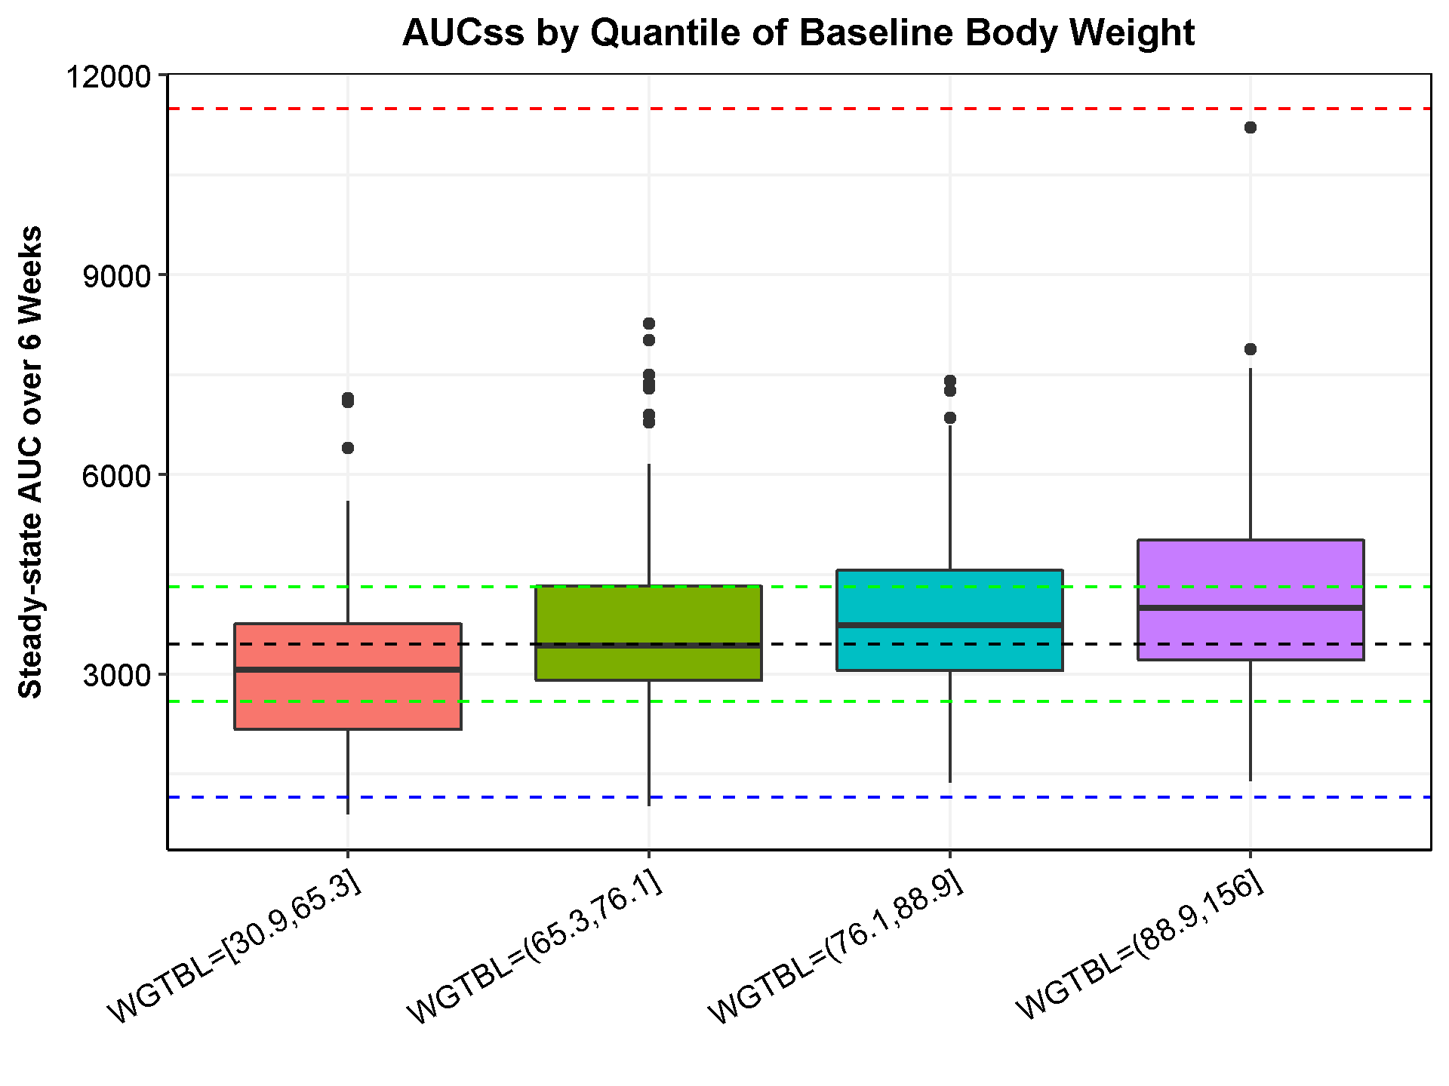

Note: The box plots represent median (bold line), 25th, and 75th percentiles of the AUC6wk,ss distribution. The whiskers represent 5th and 95th percentiles of the distribution. The black reference line represents the median AUC6wk,ss at 3 mg/kg Q2W (3,550 day*mg/L). The green lines represent the 75% or 125% of the reference exposure. The blue line and red line represent the median exposures of 1,180 day*mg/L and 11,800 day*mg/L at 1 mg/kg Q2W and 10 mg/kg Q2W, respectively.

Figure : Boxplot of Post-hoc Individual Cemiplimab Ctrough by Quantiles of Baseline Body Weight at 3 mg/kg Q2W

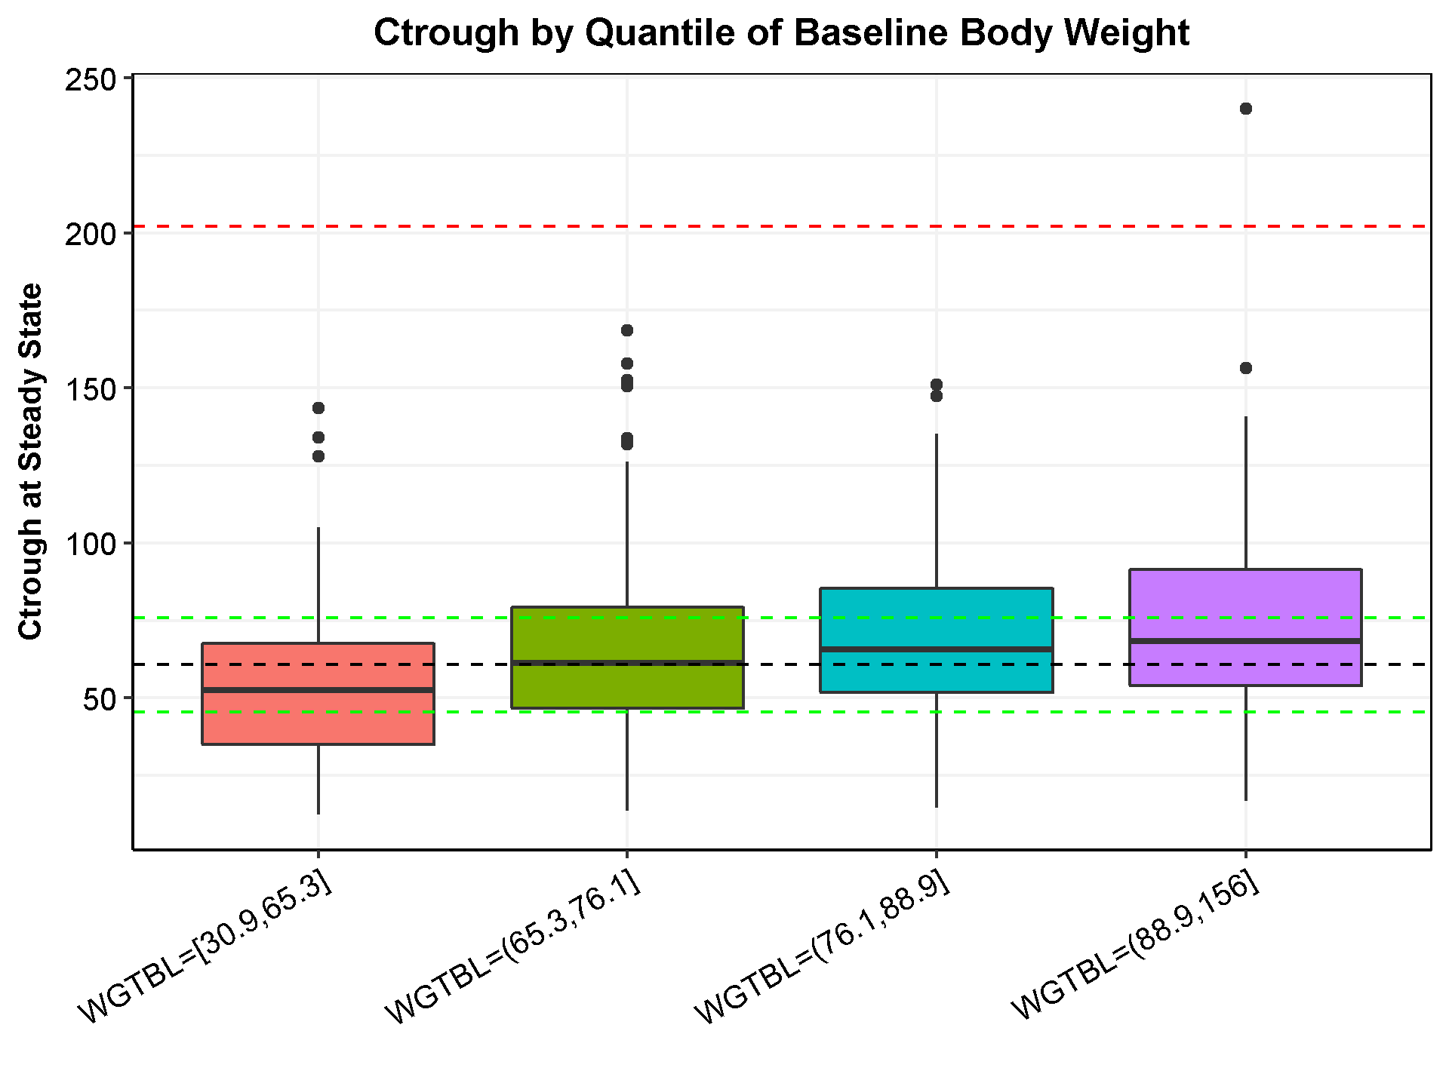

Note: The box plots represent median (bold line), 25th, and 75th percentiles of the Ctrough,ss distribution. The whiskers represent 5th and 95th percentiles of the distribution. The black reference line represents the median Ctrough,ss at 3 mg/kg Q2W (62.0 mg/L). The green lines represent the 75% or 125% of the reference exposure. The blue line and red line represent the median exposures of 20.7 mg/L and 207 mg/L at 1 mg/kg Q2W and 10 mg/kg Q2W, respectively.

Figure : Boxplot of Post-hoc Individual Cemiplimab AUC6wk,ss by Quantiles of Baseline Body Weight at 350 mg Q3W

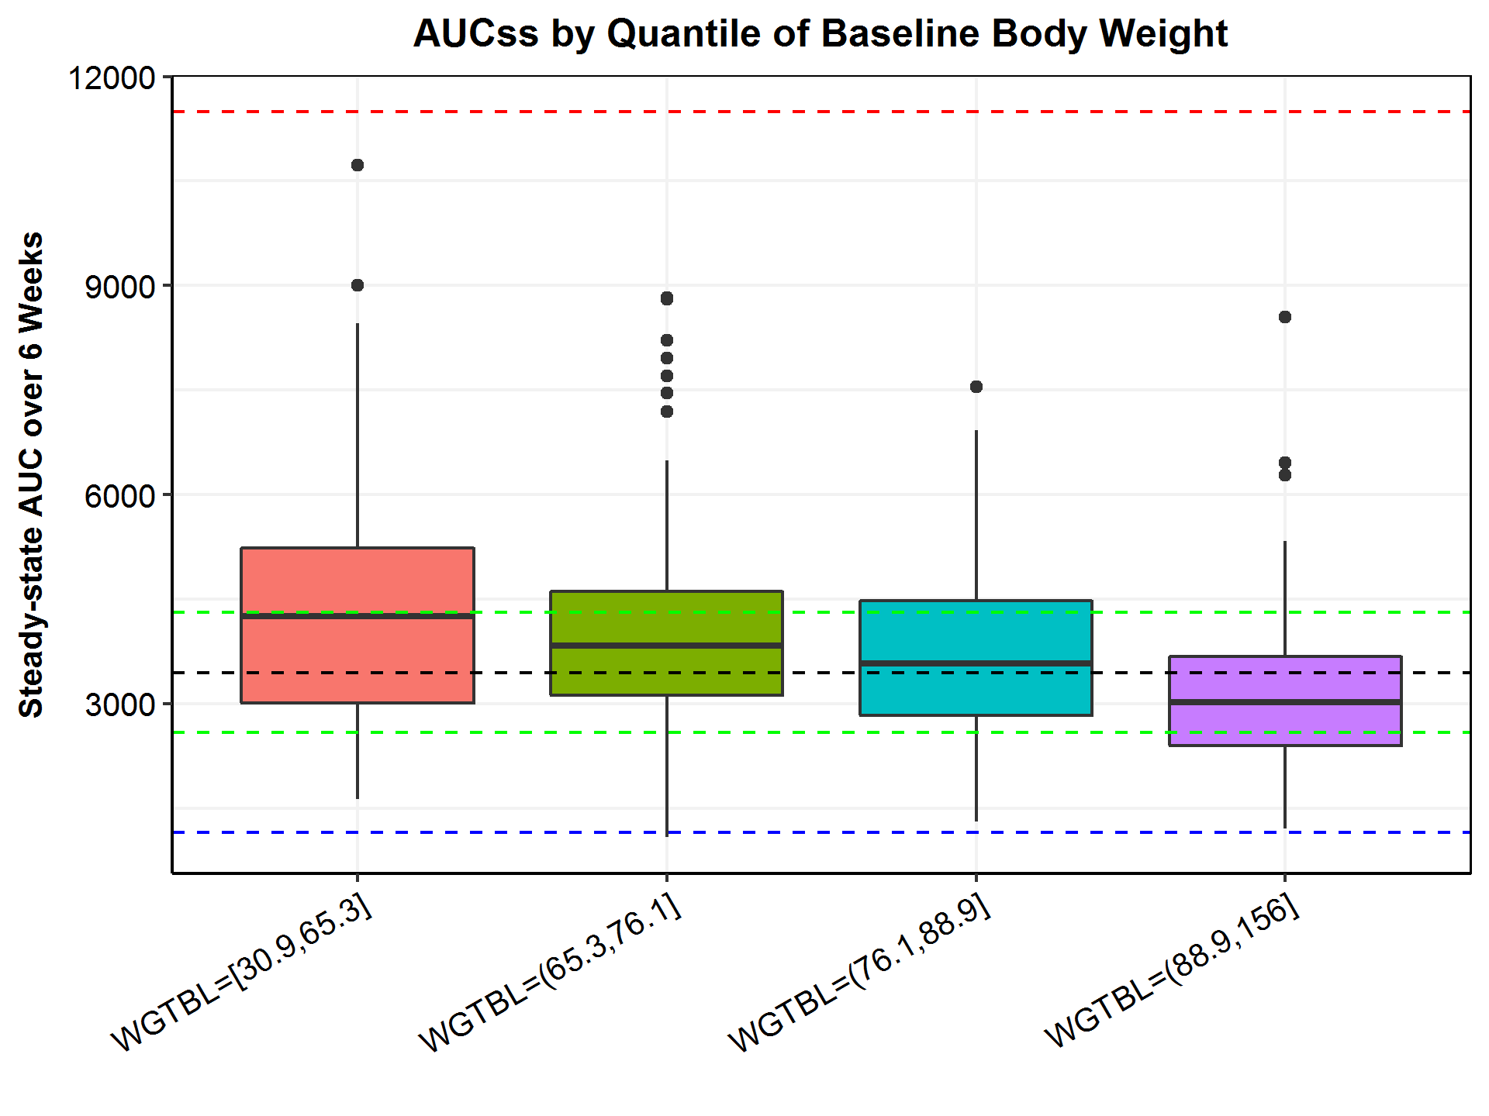

Note: The box plots represent median (bold line), 25th, and 75th percentiles of the AUC6wk,ss distribution. The whiskers represent 5th and 95th percentiles of the distribution. The black reference line represents the median AUC6wk,ss at 3 mg/kg Q2W (3,550 day*mg/L). The green lines represent the 75% or 125% of the reference exposure. The blue line and red line represent the median exposures of 1,180 day*mg/L and 11,800 day*mg/L at 1 mg/kg Q2W and 10 mg/kg Q2W, respectively.

Figure : Boxplot of Post-hoc Individual Cemiplimab Ctrough by Quantiles of Baseline Body Weight at 350 mg Q3W

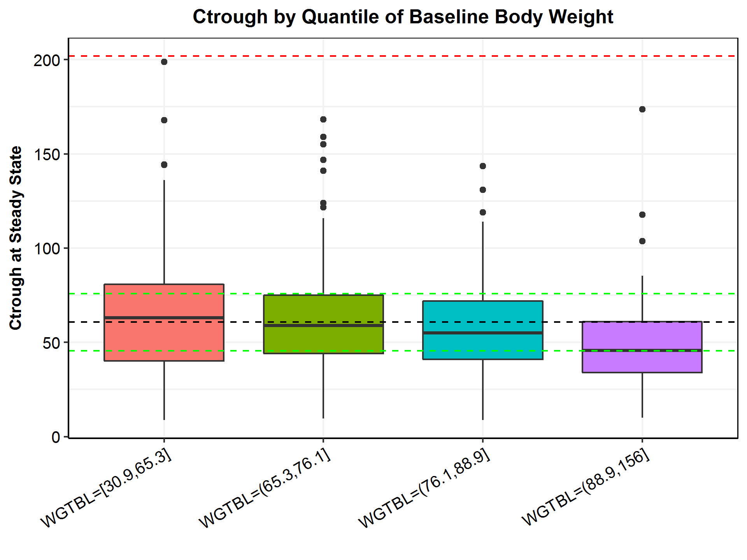

Note: The box plots represent median (bold line), 25th, and 75th percentiles of the Ctrough distribution. The whiskers represent 5th and 95th percentiles of the distribution. The black reference line represents the median Ctrough,ss at 3 mg/kg Q2W (62.0 mg/L). The green lines represent the 75% or 125% of the reference exposure. The blue line and red line represent the median exposures of 20.7 mg/L and 207 mg/L at 1 mg/kg Q2W and 10 mg/kg, Q2W, respectively.

* + 1. Baseline Albumin

Figure : Scatter Plot of Post-hoc Steady-state AUC6wk,ss vs. Baseline Albumin Level (g/L) at 3 mg/kg Q2W

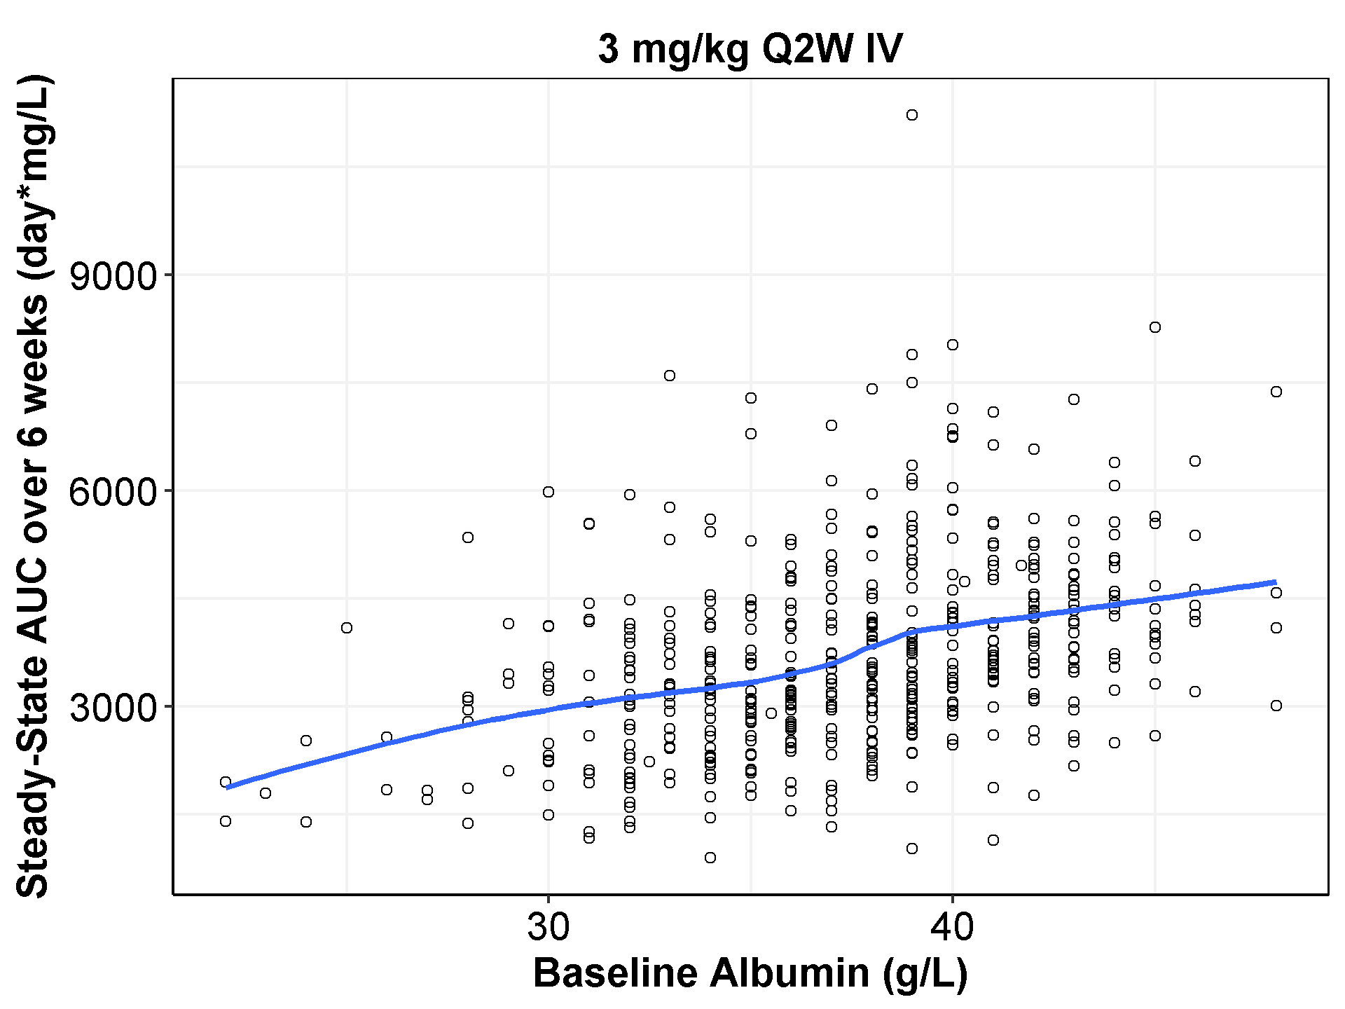

Note: Blue lines represent loess fits.

Figure : Boxplot of Post-hoc Steady-state AUC6wk by Quantiles of Baseline Albumin at 3 mg/kg Q2W

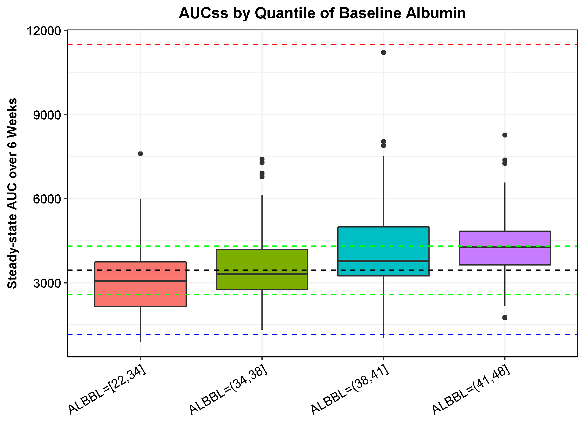

Note: The box plots represent median (bold line), 25th, and 75th percentiles of the AUC6wk,ss distribution. The whiskers represent 5th and 95th percentiles of the distribution. The black reference line represents the median AUC6wk,ss at 3 mg/kg Q2W (3,550 day*mg/L). The green lines represent the 75% or 125% of the reference exposure. The blue line and red line represent the median exposures of 1,180 day*mg/L and 11,800 day*mg/L at 1 mg/kg Q2W and 10 mg/kg Q2W, respectively.

* + 1. Baseline IgG

Figure : Scatter Plot of Post-hoc Steady-state AUC6wk,ss vs. Baseline IgG (g/L) at 3 mg/kg Q2W

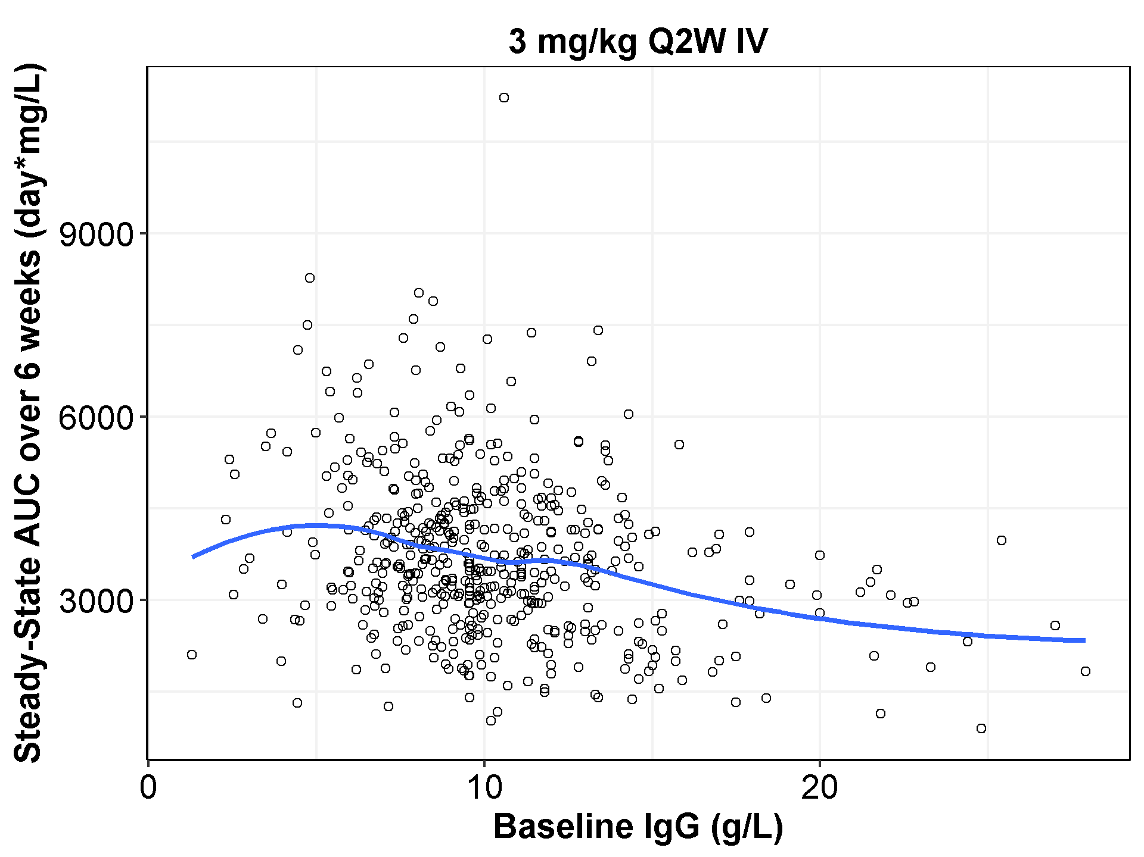

Note: Blue lines represent loess fits.

Figure : Boxplot of Post-hoc Steady-state AUC6wk,ss by Quantiles of Baseline IgG at 3 mg/kg Q2W

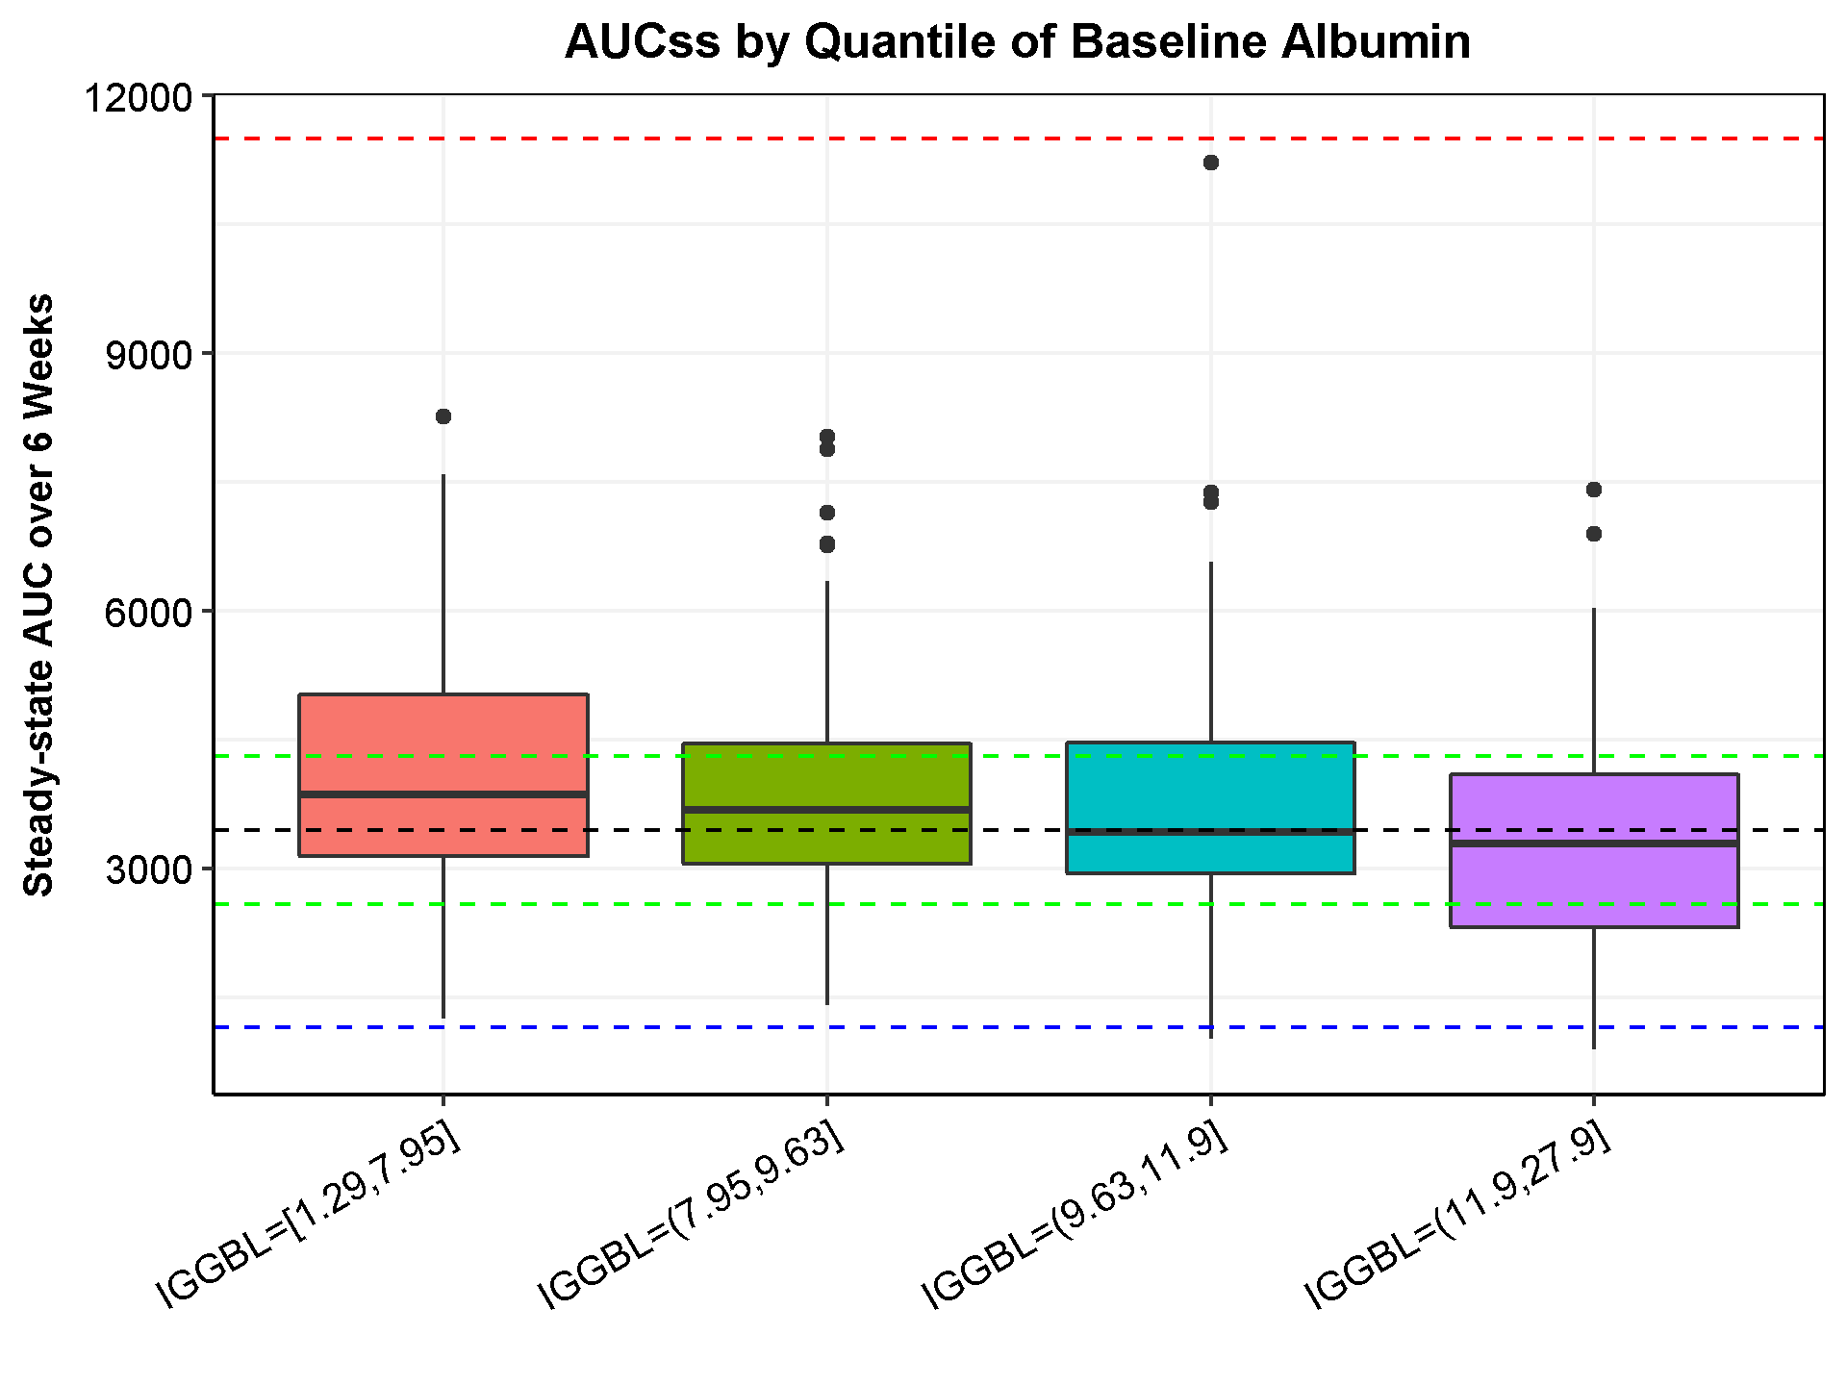

Note: The box plots represent median (bold line), 25th, and 75th percentiles of the AUC6wk,ss distribution. The whiskers represent 10th and 90th percentiles of the distribution. The black reference line represents the median AUC6wk,ss at 3 mg/kg Q2W (3,550 day*mg/L). The green lines represent the 75% or 125% of the reference exposure. The blue line and red line represent the median exposures of 1,180 day*mg/L and 11,800 day*mg/L at 1 mg/kg Q2W and 10 mg/kg Q2W, respectively.

* 1. Additional Simulated Time-Profiles of Cemiplimab

Figure : Simulated Time-Profile (Semi-log Scale) of Cemiplimab at 3 mg/kg Q2W (with 95%CI) in Patients with Solid Tumors (2,000 Simulated Patients, Weekly Axis)

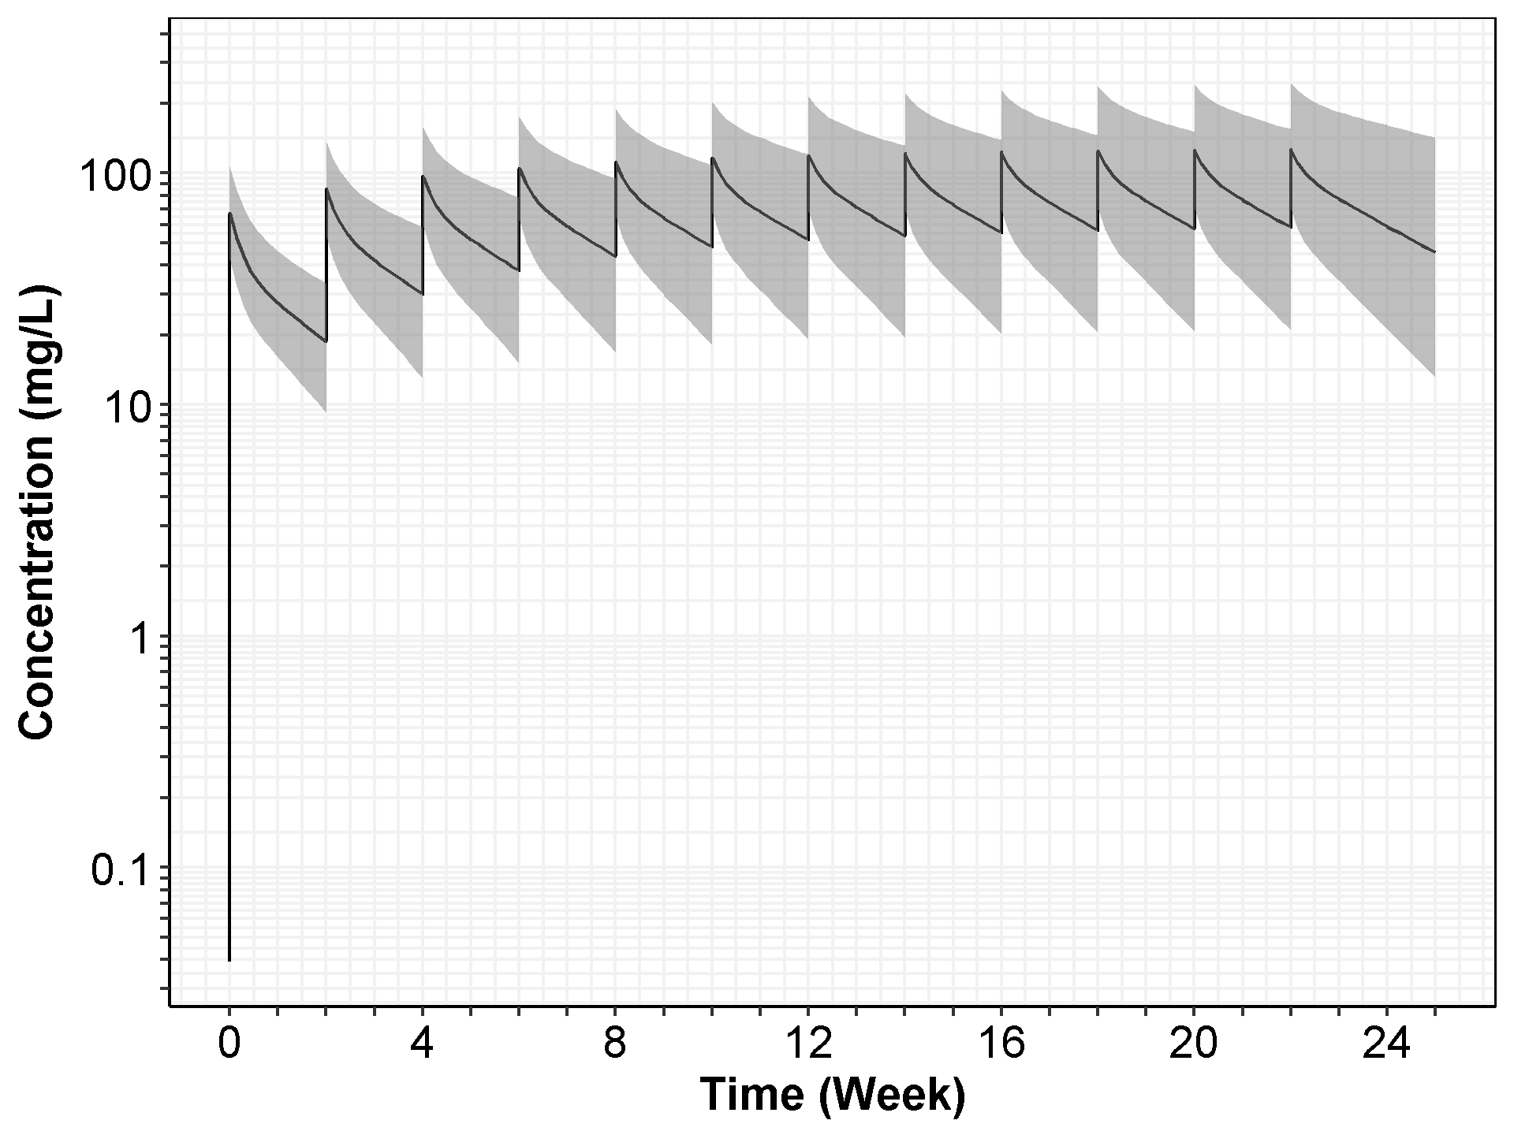

Note: The black solid line represents the median of the simulated concentration-time profiles, and the gray area shows the 95% CI with 2.5 percentile and 97.5 percentile of the simulated profiles.

Figure : Simulated Time-Profile (Linear Scale) of Cemiplimab at 3 mg/kg Q2W (with 95%CI) in Patients with Solid Tumors (2,000 Simulated Patients, Weekly Axis)

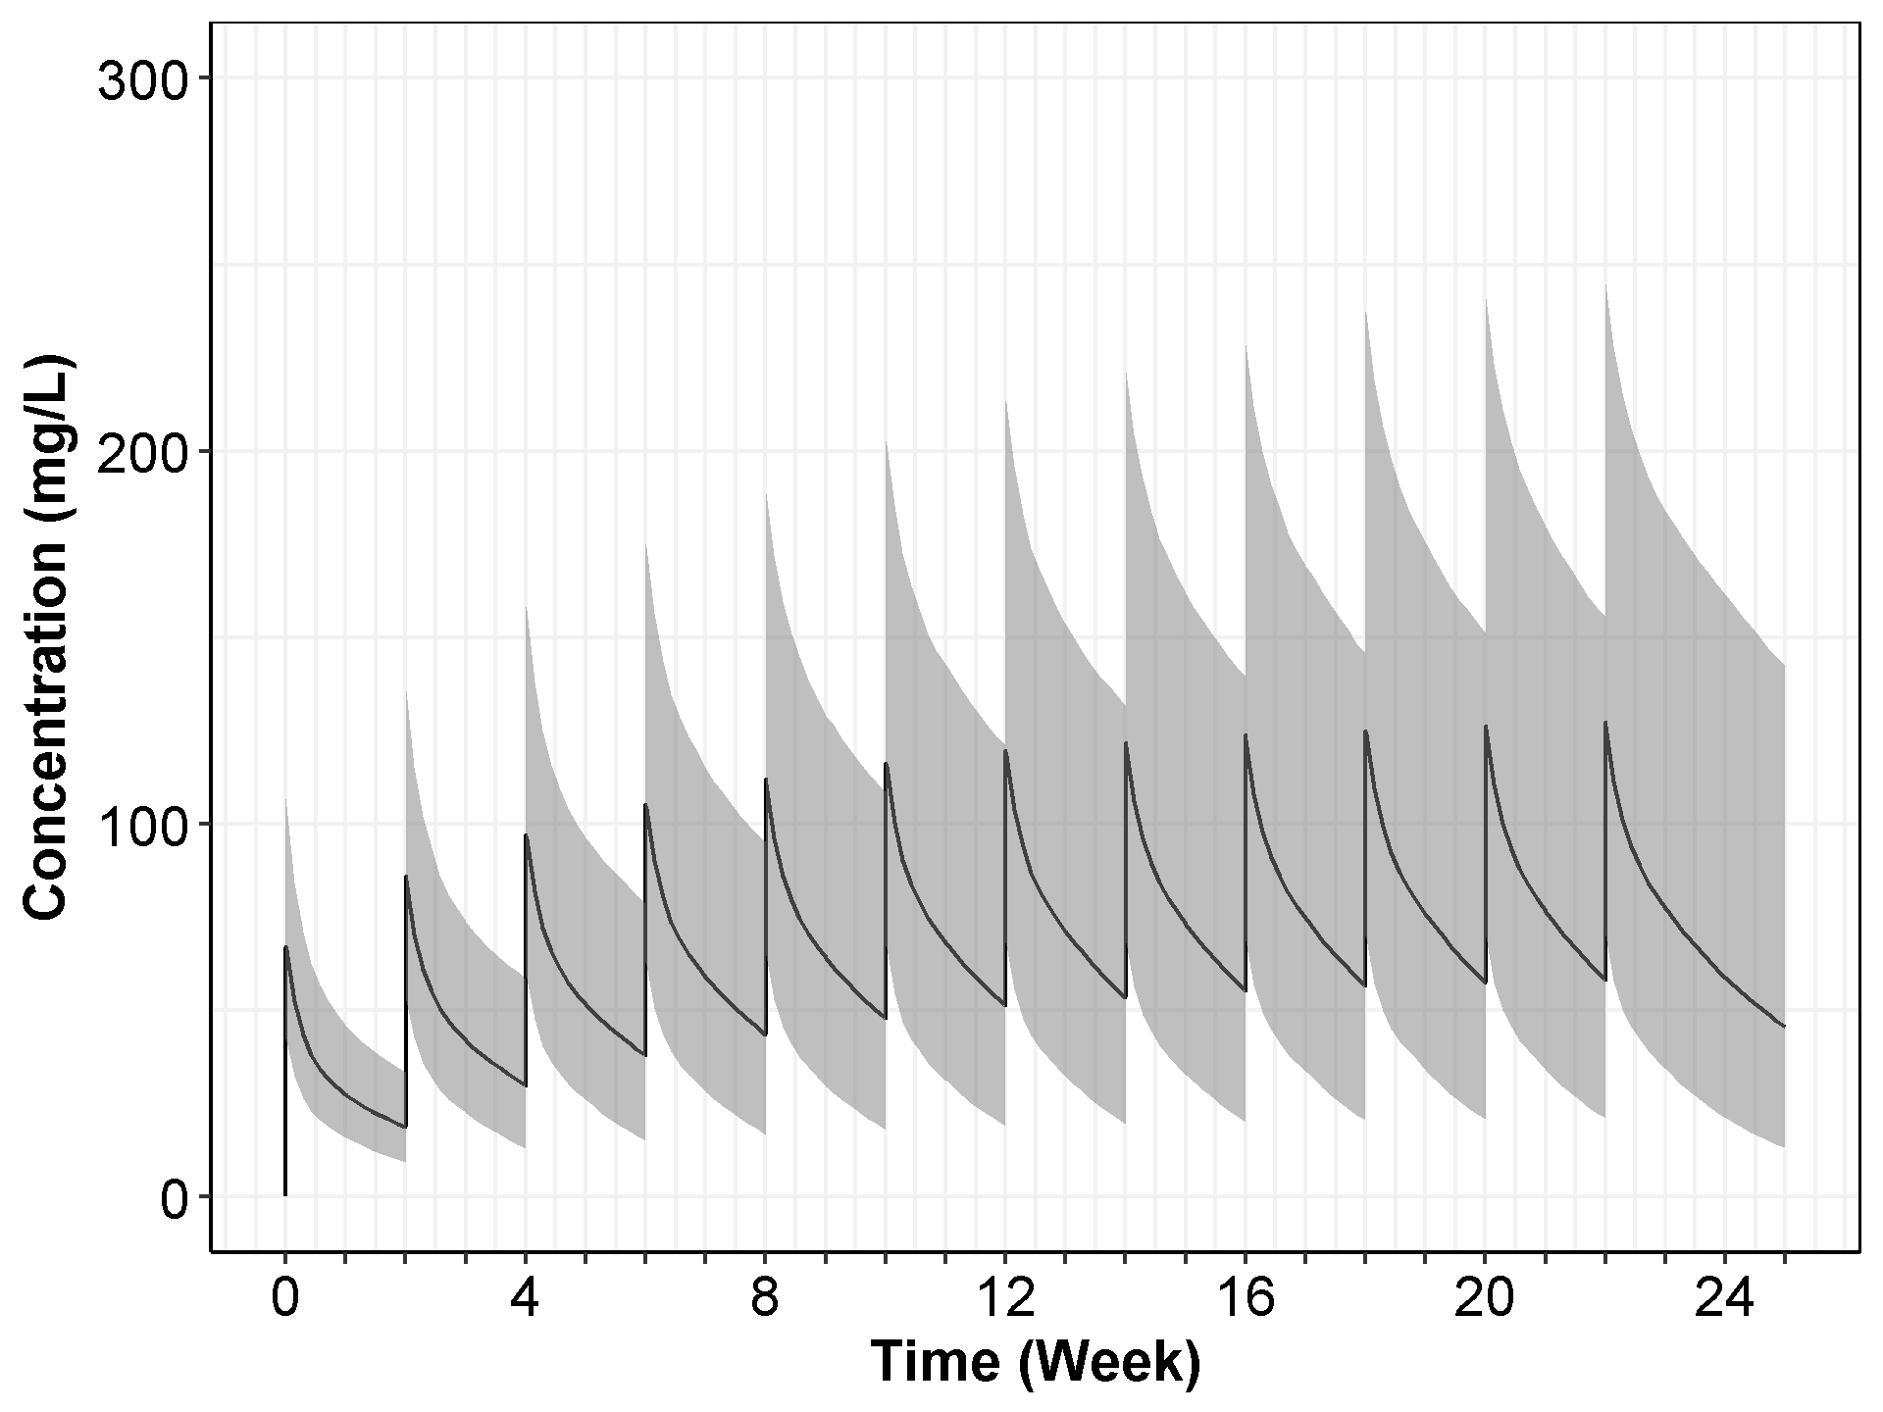

Note: The black solid line represents the median of the simulated concentration-time profiles, and the gray area shows the 95% CI with 2.5 percentile and 97.5 percentile of the simulated profiles.

Figure : Simulated Time-profile (Semi-log Scale) of Cemiplimab at 350 mg Q3W (with 95%CI) in Patients with Solid Tumors (2,000 Simulated Patients, Weekly Axis)

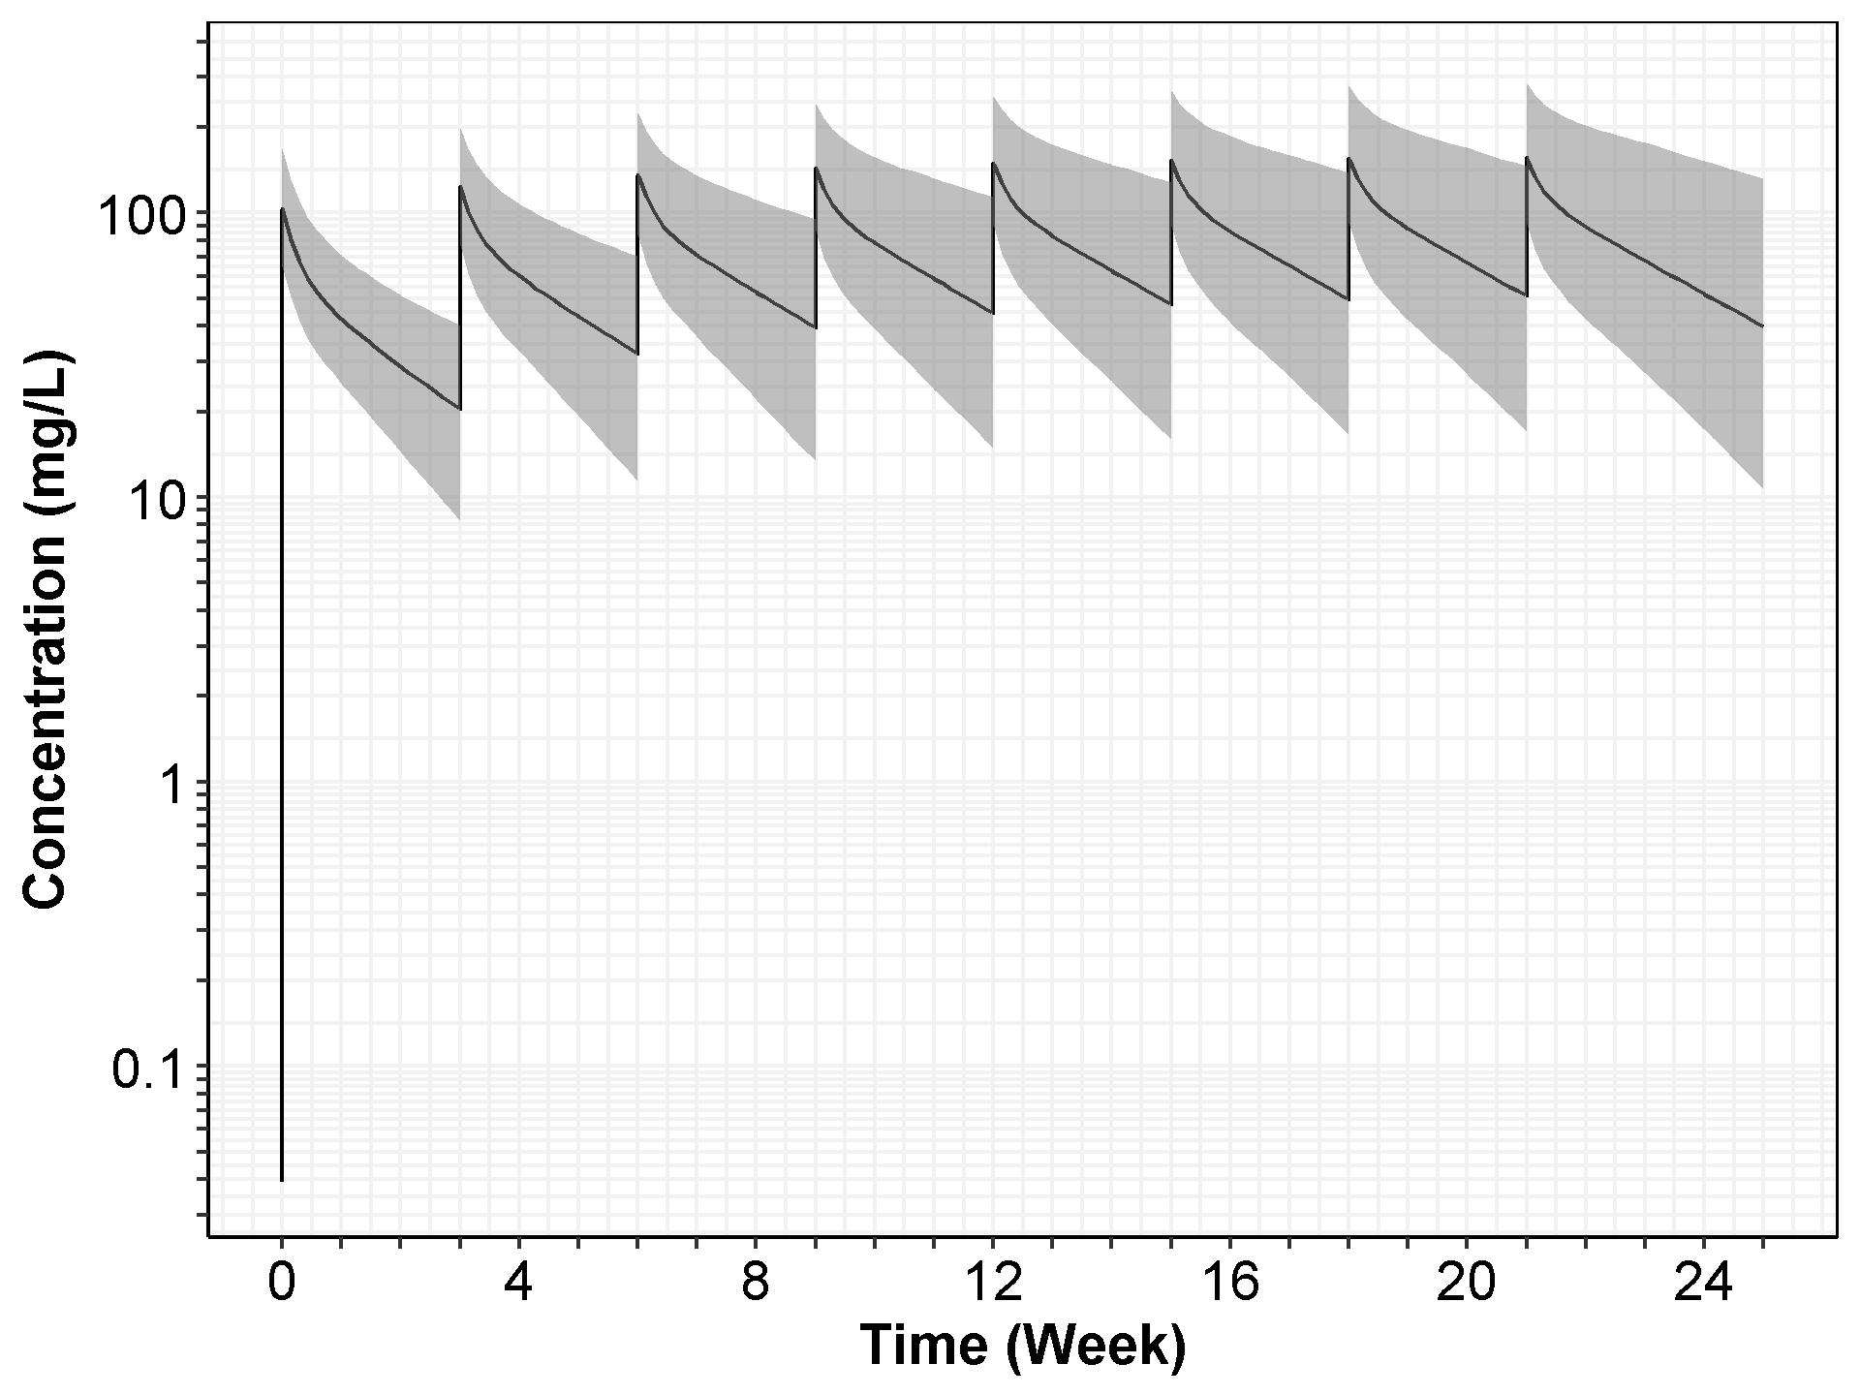

Note: The black solid line represents the median of the simulated concentration-time profiles, and the gray area shows the 95% CI with 2.5 percentile and 97.5 percentile of the simulated profiles.

Figure : Simulated Time-profile (Linear Scale) of Cemiplimab at 350 mg Q3W (with 95%CI) in Patients with Solid Tumors (2,000 Simulated Patients, Weekly Axis)

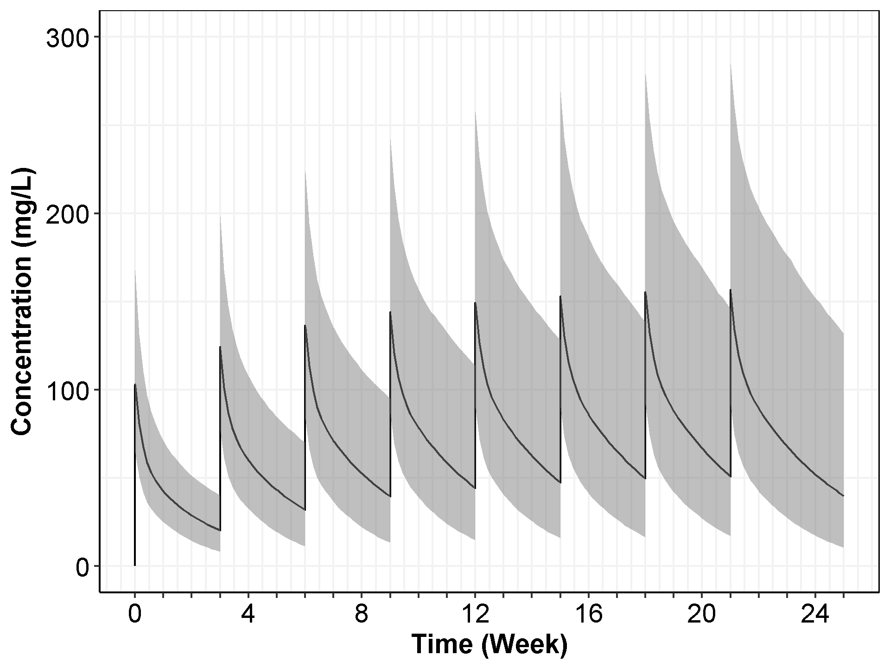

Note: The black solid line represents the median of the simulated concentration-time profiles, and the gray area shows the 95% CI with 2.5 percentile and 97.5 percentile of the simulated profiles.

1. Exploratory PKPD Analyses

Limited data show responders tends to show more clearance reduction under repeated cemiplimab treatment. Figure 54 is a plot of the individual clearance estimates over the course of treatment in patients with CSCC, which illustrates the time-varying change in clearance that was accounted for in the population PK model by a sigmoid-Emax function. The mean percent of reduction in clearance was larger in patients who responded to cemiplimab, with 39.5% in responders vs. 33.5% in all others, as shown in Table 17. Consequently, patients with CSCC who responded to cemiplimab treatment exhibit longer elimination half-life at steady state than all other patients (mean 22.7 days vs mean 18.7 days). However, this decrease in CL is not considered clinically relevant.

Figure 54: Post-hoc Individual Estimates of the Clearance of Cemiplimab Over Time by Treatment Response in Patients with CSCC

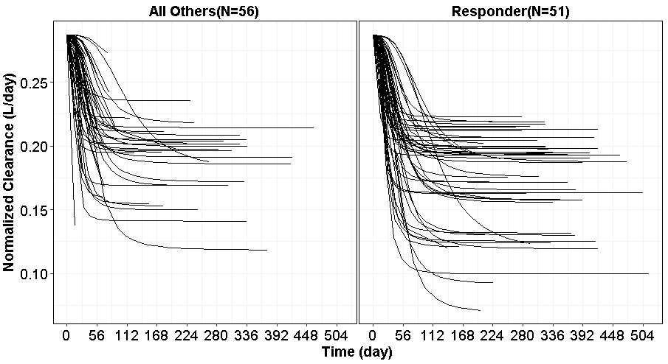

Note:

1. A total of 107 patients with CSCC (51 patients considered to be responders, 56 “all others”) were inlcuded in the efficacy population.
2. Except for 1 patient considered a responder (R2810-ONC-1423-840004-003) who received cemiplimab at 1 mg/kg Q2W, the other patients with CSCC received cemiplimab 3 mg/kg Q2W.
3. Control Stream of NONMEM Models

**NONMEM Control Stream for Final Base Model (LN014)**

$PROB 001 model with linear elimination (concentration only)

$INPUT C CFLAG=DROP ROWID STDY USUBJID=DROP ARMA=DROP ARMAN ID NTIM TAD TIME TEST=DROP

DVOR DV MDV CMT AMT RATE EVID EXSEQ WGTBL HGTBL BMIBL BSABL AGE SEXN RACEN ETHNICN

MONOTFLN CSCCP2FN FASCSFLN CREATBL CRCLBL ALTBL ASTBL BILIBL ALBBL IGGBL LDHBL ALPBL STDYARMA

$DATA ../../data/nmdat.csv IGNORE = C

;IGNORE=@

;IGNORE=(FLAG.NE.0)

;IGNORE=(NOPK.EQ.1)

$SUBROUTINE ADVAN4 TRANS4

$PK

IF (NEWIND.EQ.0) THEN

LLOQ1 = 0.078 ; mg/L

ENDIF

TVCL = THETA(1) ; POPULATION CLEARANCE (L/DAY)

TVV2 = THETA(2) ; POPULATION CENTRAL VOLUME (L)

TVQ = THETA(3) ; POPULATION INTERCOMPARTMENTAL CLEARANCE (L/DAY)

TVV3 = THETA(4) ; POPULATION PERIPHERAL COMPARTMENT VOLUME (L)

LF1 = THETA(5) ; POPULATION BIOAVAIBILITY

TVKA = THETA(6) ; POPULATION ABSORPTION RATE CONSTANT (1/DAY)

RUVCV = THETA(7) ; PROPORTIONAL ERROR

RUVSD = THETA(8) ; ADDITIVE ERROR

TVEMAX = THETA(9)

TVT50 = THETA(10)

HILL = THETA(11)

; COVARIATE MODEL

WGT_ON_CLQ = THETA(12)

WGT_ON_VSS = THETA(13)

M_WGT = 75 ; kg

COVCLQ = WGT_ON_CLQ *(LOG(WGTBL)-LOG(M_WGT))

COVVSS = WGT_ON_VSS *(LOG(WGTBL)-LOG(M_WGT))

CL = TVCL*EXP(ETA(1)+COVCLQ) ; CL, INDIVIDUAL CLEARANCE (L/DAY)

Q = TVQ *EXP(ETA(1)+COVCLQ) ; Q, INDIVIDUAL INTERCOMPARTMENTAL CLEARANCE (L/DAY)

V2 = TVV2*EXP(ETA(2)+COVVSS) ; V2, INDIVIDUAL CENTRAL VOLUME (L)

V3 = TVV3*EXP(ETA(2)+COVVSS) ; V3, INDIVIDUAL PERIPHERAL VOLUME (L)

KA = TVKA ; INDIVIDUAL ABSORPTION RATE CONSTANT (1/DAY)

;CL IS TIME-DEPENDENT VARIABLE

EMAX = TVEMAX*EXP(ETA(3)) ; INDIVIDUAL EMAX

T50 = TVT50*EXP(ETA(4)) ; INDIVIDUAL T50

CL = CL*EXP(EMAX*TIME**HILL/(T50**HILL+TIME**HILL)) ; Sigmoid Emax model

;DERIVED PARAMETERS

K = CL/V2

K23 = Q/V2

K32 = Q/V3

S2 = V2 ; dose = mg, conc = mg/L

F1 = LF1 ; Or EXP(LF1)/(1+EXP(LF1))

;CALCULATE TIME AFTER DOSE

;IF(NEWIND.NE.2) TDOS=0

;IF(AMT.GT.0) TDOS=TIME

;TAD=TIME-TDOS ; TIME RELATIVE TO DOSE

$ERROR (OBSERVATION ONLY)

CALLFL = 0

EPS0 = 1E-3

CONC = A(2)/S2

IF (CONC.LE.EPS0) CONC = EPS0

PROP=RUVCV ; proportional part

ADD= RUVSD ; additive part

SD=SQRT(PROP*PROP+ADD*ADD/CONC**2) ; log-transformed

;SD=SQRT(ADD*ADD+PROP*PROP*CONC**2) ; untransformed scale

BLOQ1 = 0

IF (BLOQ1.EQ.0) THEN

F_FLAG = 0

Y = LOG(CONC) + SD*ERR(1)

ELSE

F_FLAG = 1

Y = PHI((LOG(LLOQ1)-LOG(CONC))/SD)

ENDIF

DEL = 0

IF (F.EQ.0) DEL = 1

IPRED = Y

TY = 0

IF(IPRED.GT.0) TY = EXP(IPRED)

IRES=DV-IPRED ; INDIVIDUAL RESIDUAL

W = F ; PROPORTIONAL WSV

IWRES=IRES/(W+DEL) ; INDIVIDUAL WEIGHTED RESIDUAL

$THETA

(0,0.30) ;TVCL

(0,3.40) ;TVV2

(0,0.60) ;TVQ

(0,1.50) ;TVV3

0.7 FIX ;TVF1

0.4 FIX ;TVKA

(0, 0.1) ;RUVCV

(0, 0.1) ;RUVSD

(-0.50) ;EMAX

(0,30.0) ;T50

(0, 2.0) ;HILL

(0,0.75) ;WGT_ON_CLQ

(0, 1) ;WGT_ON_VSS

$OMEGA BLOCK(2)

0.1341 ;IIV_CLQ

0.0159127 0.0417008 ;IIV_VSS

$OMEGA

0.1 ;IIV_EMAX

0.1 ;IIV_T50

$SIGMA

1 FIXED ;SIGMA_1

$EST MAXEVAL=9999 NSIG=3 SIGL=9 METHOD=1 PRINT=10 NOABORT POSTHOC MSFO=001.MSF NOTHETABOUNDTEST NOOMEGABOUNDTEST NOSIGMABOUNDTEST

$COV PRINT=E UNCONDITIONAL MATRIX=S SIGL=12

;************************************************************

;**** TABLES ****

;************************************************************

;The 'standard' parameters, including IWRE, IPRE, TIME, and the NONMEM default items (DV, PRED, RES and WRES)

$TABLE ROWID ID TIME TAD IPRED PRED DV TY CL MDV IWRES CWRES RES WRES NOAPPEND NOPRINT ONEHEADER FORMAT=S1PE17.9E2 FILE=sdtab001

;The empirical Bayes estimates of individual model parameter values, or posthoc estimates.

$TABLE ID CL V2 Q V3 F1 KA EMAX T50 HILL RUVCV RUVSD WGT_ON_CLQ WGT_ON_VSS ETA1 ETA2 ETA3 ETA4 FIRSTONLY NOAPPEND NOPRINT ONEHEADER FORMAT=S1PE17.9E2 FILE=patab001

**NONMEM Control Stream for Final Base Model (LN900)**

$PROB 001 model with linear elimination (concentration only)

; NOTE:

; 1) BASED ON NOT-QCed PK DATA CUT OFF SEP, 29, 2017

; 2) SOME OUTLIERS NOT YET REMOVED.

$INPUT C CFLAG=DROP ROWID STDY USUBJID=DROP TR01PG4=DROP TR01PG4N ID NTIM TAD TIME PCTEST=DROP

DVOR DV MDV CMT AMT RATE EVID EXSEQ WGTBL HGTBL BMIBL BSABL AGE SEXN RACEN ETHNICN

MONOTFLN CSCCP2FN FASCSFLN CREATBL CRCLBL IALTBL ASTBL IBILIBL IALBBL IIGGBL ILDHBL ALPBL STDYARMA

$DATA ../../data/nmdat.csv IGNORE = C

;IGNORE=@

;IGNORE=(FLAG.NE.0)

;IGNORE=(NOPK.EQ.1)

$SUBROUTINE ADVAN4 TRANS4

$PK

IF (NEWIND.EQ.0) THEN

LLOQ1 = 0.078 ; mg/L

ENDIF

TVCL = THETA(1) ; POPULATION CLEARANCE (L/DAY)

TVV2 = THETA(2) ; POPULATION CENTRAL VOLUME (L)

TVQ = THETA(3) ; POPULATION INTERCOMPARTMENTAL CLEARANCE (L/DAY)

TVV3 = THETA(4) ; POPULATION PERIPHERAL COMPARTMENT VOLUME (L)

LF1 = THETA(5) ; POPULATION BIOAVAIBILITY

TVKA = THETA(6) ; POPULATION ABSORPTION RATE CONSTANT (1/DAY)

RUVCV = THETA(7) ; PROPORTIONAL ERROR

RUVSD = THETA(8) ; ADDITIVE ERROR

TVEMAX = THETA(9)

TVT50 = THETA(10)

HILL = THETA(11)

WGT_ON_CLQ = THETA(12)

WGT_ON_VSS = THETA(13)

; COVARIATE MODEL

ALT_ON_CLQ = THETA(14)

ALB_ON_CLQ = THETA(15)

IGG_ON_CLQ = THETA(16)

BMI_ON_VSS = THETA(17)

BLK_ON_T50 = THETA(18)

M_WGT=75 ; kg

M_AGE=60 ; YEAR

M_HGTBL=170; cm

M_BMIBL=26.5

M_BSABL=1.88

M_CREATBL=75

M_CRCLBL=88

M_IALTBL=21

M_ASTBL=24

M_IBILIBL=8.2

M_IALBBL=38

M_IIGGBL=9.7

M_ILDHBL=250

M_ALPBL=90

; SEX

; adpx %>% distinct(SEX, .keep_all=TRUE) %>% select(SEX, SEXN)

; ---------

; SEXN = 2 for FEMALE,

; SEXN = 1 for MALE

SEX = 0

IF (SEXN.EQ.1) SEX = 1

IF (SEXN.EQ.2) SEX = 0

; ETHNICN

; adpx %>% distinct(ETHNIC, .keep_all=TRUE) %>% select(ETHNIC, ETHNICN)

; as.matrix(table(adsl$ETHNIC))

; ---------

; NOT HISPANIC OR LATINO 1

; HISPANIC OR LATINO 2

; NOT REPORTED 3

HISPANIC = 3

IF (ETHNICN.EQ.1) HISPANIC = 0

IF (ETHNICN.EQ.2) HISPANIC = 1

; RACEN

; adpx %>% distinct(RACEN, .keep_all=TRUE) %>% select(RACE, RACEN)

; as.matrix(table(adsl$RACE))

; ---------

; WHITE 1

; BLACK OR AFRICAN AMERICAN 2

; ASIAN 3

; AMERICAN INDIAN OR ALASKA NATIVE 4

; OTHER 6

; UNKNOWN 7

; NOT REPORTED 8

BLK = 0

IF (RACEN.EQ.2) BLK = 1

ASIA = 0

IF (RACEN.EQ.3) ASIA = 1

OTHER = 0

IF (RACEN.NE.1 .AND. RACEN.NE.2 .AND. RACEN.NE.3) OTHER = 1

COVCLQ=WGT_ON_CLQ *(LOG(WGTBL)-LOG(M_WGT)) + ALT_ON_CLQ*(LOG(IALTBL)-LOG(M_IALTBL)) + ALB_ON_CLQ*(LOG(IALBBL)-LOG(M_IALBBL)) + IGG_ON_CLQ*(LOG(IIGGBL)-LOG(M_IIGGBL))

COVVSS=WGT_ON_VSS *(LOG(WGTBL)-LOG(M_WGT)) + BMI_ON_VSS*(LOG(BMIBL)-LOG(M_BMIBL))

COVEMAX=0

COVT50=BLK_ON_T50*BLK

CL = TVCL*EXP(ETA(1)+COVCLQ) ; CL, INDIVIDUAL CLEARANCE (L/DAY)

Q = TVQ *EXP(ETA(1)+COVCLQ) ; Q, INDIVIDUAL INTERCOMPARTMENTAL CLEARANCE (L/DAY)

V2 = TVV2*EXP(ETA(2)+COVVSS) ; V2, INDIVIDUAL CENTRAL VOLUME (L)

V3 = TVV3*EXP(ETA(2)+COVVSS) ; V3, INDIVIDUAL PERIPHERAL VOLUME (L)

KA = TVKA ; INDIVIDUAL ABSORPTION RATE CONSTANT (1/DAY)

;CL IS TIME-DEPENDENT

EMAX = TVEMAX*EXP(ETA(3)+COVEMAX) ; INDIVIDUAL EMAX

T50 = TVT50*EXP(ETA(4)+COVT50) ; INDIVIDUAL T50

CL = CL*EXP(EMAX*TIME**HILL/(T50**HILL+TIME**HILL)) ; Sigmoid Emax model

;DERIVED PARAMETERS

K = CL/V2

K23 = Q/V2

K32 = Q/V3

S2 = V2 ; dose = mg, conc = mg/L

F1 = LF1 ; Or EXP(LF1)/(1+EXP(LF1))

;CALCULATE TIME AFTER DOSE

;IF(NEWIND.NE.2) TDOS=0

;IF(AMT.GT.0) TDOS=TIME

;TAD=TIME-TDOS ; TIME RELATIVE TO DOSE

$ERROR (OBSERVATION ONLY)

CALLFL = 0

EPS0 = 1E-3

CONC = A(2)/S2

IF (CONC.LE.EPS0) CONC = EPS0

PROP=RUVCV ; proportional part

ADD= RUVSD ; additive part

SD=SQRT(PROP*PROP+ADD*ADD/CONC**2) ; log-transformed

;SD=SQRT(ADD*ADD+PROP*PROP*CONC**2) ; untransformed scale

BLOQ1 = 0

IF (BLOQ1.EQ.0) THEN

F_FLAG = 0

Y = LOG(CONC) + SD*ERR(1)

ELSE

F_FLAG = 1

Y = PHI((LOG(LLOQ1)-LOG(CONC))/SD)

ENDIF

DEL = 0

IF (F.EQ.0) DEL = 1

IPRED = Y

TY = 0

IF(IPRED.GT.0) TY = EXP(IPRED)

IRES=DV-IPRED ; INDIVIDUAL RESIDUAL

W = F ; PROPORTIONAL WSV

IWRES=IRES/(W+DEL) ; INDIVIDUAL WEIGHTED RESIDUAL

$THETA

(0,0.30) ;TVCL

(0,3.40) ;TVV2

(0,0.60) ;TVQ

(0,1.50) ;TVV3

0.7 FIX ;TVF1

0.4 FIX ;TVKA

(0, 0.1) ;RUVCV

(0, 0.1) ;RUVSD

(-0.50) ;EMAX

(0,30.0) ;T50

(0, 2.0) ;HILL

(0,0.75) ;WGT_ON_CLQ

(0, 1) ;WGT_ON_VSS

0.01 ;ALT_ON_CLQ

0.01 ;ALB_ON_CLQ

0.01 ;IGG_ON_CLQ

0.01 ;BMI_ON_VSS

0.01 ;BLK_ON_T50

$OMEGA BLOCK(2)

0.17685 ; IIV_CLQ

0.0378813 0.0524382 ; IIV_VSS

$OMEGA

0.1 ;IIV_EMAX

0.1 ;IIV_T50

$SIGMA

1 FIXED ;SIGMA_1

$EST MAXEVAL=9999 NSIG=3 SIGL=9 METHOD=1 PRINT=10 NOABORT POSTHOC MSFO=001.MSF NOTHETABOUNDTEST NOOMEGABOUNDTEST NOSIGMABOUNDTEST

$COV PRINT=E UNCONDITIONAL MATRIX=S SIGL=12

;$SIMULATION (20102) (330333 UNIFORM) ONLYSIM SUBPROBLEMS=1

;$EST METHOD=ITS INTERACTION LAPLACIAN NITER=100 NSIG=3 SIGL=9 CTYPE=2 CINTERVAL=50 NOABORT PRINT=5 GRD=TS(7) NOCOV=1 FILE=blq.ext

;$EST METHOD=SAEM INTERACTION LAPLACIAN NBURN=10000 NITER=1000 CTYPE=2 PRINT=50 NOCOV=1 CINTERVAL=50 ISAMPLE=2 GRD=TS(7) FILE=blq_saem.ext

;$EST METHOD=IMP INTERACTION LAPLACIAN ISAMPLE=2000 NITER=10 EONLY=1 PRINT=1 MAPITER=0 NOCOV=0 GRD=TS(7) DF=0

;$COV MATRIX=R COMPRESS UNCOND PRINT=E

;The 'standard' parameters, including IWRE, IPRE, TIME, and the NONMEM default items (DV, PRED, RES and WRES)

$TABLE ROWID ID TIME TAD IPRED PRED DV TY CL MDV IWRES CWRES RES WRES NOAPPEND NOPRINT ONEHEADER FORMAT=S1PE17.9E2 FILE=sdtab001

;The empirical Bayes estimates of individual model parameter values, or posthoc estimates.

$TABLE ID CL V2 Q V3 F1 KA EMAX T50 HILL RUVCV RUVSD WGT_ON_CLQ WGT_ON_VSS ALT_ON_CLQ ALB_ON_CLQ IGG_ON_CLQ BMI_ON_VSS BLK_ON_T50 ETA1 ETA2 ETA3 ETA4 FIRSTONLY NOAPPEND NOPRINT ONEHEADER FORMAT=S1PE17.9E2 FILE=patab001

1. Numerical Difference Observed in Analysis Set Used in this PopPK Report and the Final Dataset

In the Analysis Set (‘nmdat.xpt’) defined in the Section 4.1, there are 8 patients whose baseline values from blood chemistry panel was initially assumed to be taken at study day one, ie, baseline, but later it was found that the investigator answered the question of “if at dosing visit, was the sample collected prior to dosing” as “Not applicable”. Given such facts, the baseline blood chemistry values for these 8 patients was set as “missing” and then imputed accordingly in the final dataset (‘nmdatfnl.xpt’). Note one patient (1540-036002-007) was not in the PK analysis set, therefore not included in Analysis Set of this pop PK analysis.

Considering the Analysis Set for this Pop PK analysis has been locked before the updated final dataset (‘nmdatfnl.xpt’) arrived, this section is to evaluate the potential impacts of substituting the final dataset (‘nmdatfnl.xpt’) with Analysis Set (‘nmdat.xpt’). If only slight numerical changes in the overall population and the model parameter estimation are observed, we assume that both datasets would produce the similar finding as presented in this Pop PK analysis.

While Table 34 presents the relevant baseline values from blood chemistry panel for those 7 (8-1) patients in the Analysis Set (‘nmdat.xpt’), Table 35 shows the corresponding imputed values from the final dataset (‘nmdatfnl.xpt’). Certain difference was observed for those 7 patients. However, no meaningful changes in the distribution of overall patient population (505 patients) were observed, as illustrated in the Table 36 (final dataset) vs. Table 2 (Analysis Set). Similar conclusion can be drawn for patients with CSCC, as shown in Table 37 (final dataset) vs. Table 3 (Analysis Set).

Furthermore, the final model (LN900) was relatively stable (with 3 significant digits, see Table 38) in terms of the key model parameters (CL, V2, V3 and Q), although some small numerical changes were observed in the parameters for covariate estimation. The outputs from PsN run from the final model (LN900) using Analysis Set (nmdat.xpt) and final dataset (nmdatfnl.xpt) was also presented in Table 39. The minor changes observed are not expected to result in the corresponding changes in the covariate selection or estimation. Therefore, the conclusions made based on this Pop PK analysis is not expected to be impacted.

Table : Baseline Laboratory Variables of 8* Patients in the Analysis Set (‘nmdat.xpt’) in Study 1423 and 1540

| **Study** | **Patient ID** | **CSCCP2FN**  **(CSCC Flag)** | **Responder or not** | **IALBBL** | **ILDHBL** | **IALTBL** | **IBILIBL** | **ASTBL** | **CREATBL** | **CRCLBL** | **ALPBL** |
| --- | --- | --- | --- | --- | --- | --- | --- | --- | --- | --- | --- |
| R2810-ONC-1423 | 724001-021 | 0 |  | 43 | 233.5 | 12.0 | 4 | 13.8 | 106 | 80.162 | 67.9 |
| 724006-001 | 0 |  | 44 | 486 | 41 | 5.13 | 25 | 70.72 | 116.276 | 90 |
| 724006-015 | 0 |  | 37 | 924 | 19 | 5.13 | 26 | 79.56 | 87.983 | 138 |
| 724006-018 | 0 |  | 41 | 521 | 38 | 10.26 | 34 | 97.24 | 40.368 | 90 |
| R2810-ONC-1540 | 036001-002 | 1 | 1 | 35 | 452 | 15 | 5 | 36 | 67 | 73.298 | 90 |
| 036001-009 | 1 | 1 | 39 | 292 | 17 | 5 | 13 | 73 | 116.682 | 85 |
| 840002-003 | 1 | 0 | 36 | 139 | 16 | 3.42 | 17 | 107.848 | 72.284 | 103 |

Table : Baseline Laboratory Variables of 8* Patients in the Final Dataset (‘nmdatfnl.xpt’) in Study 1423 and 1540

| **Study** | **Patient ID** | **CSCCP2FN**  **(CSCC Flag)** | **Responder or not** | **IALBBL** | **ILDHBL** | **IALTBL** | **IBILIBL** | **IASTBL** | **ICREATBL** | **ICRCLBL** | **IALPBL** |
| --- | --- | --- | --- | --- | --- | --- | --- | --- | --- | --- | --- |
| R2810-ONC-1423 | 724001-021 | 0 |  | 37 | 284.0 | 22 | 8.208 | 24 | 73.372 | 91.241 | 90.6 |
| 724006-001 | 0 |  | 37 | 284.0 | 22 | 8.208 | 24 | 73.372 | 91.241 | 90.6 |
| 724006-015 | 0 |  | 37 | 284.0 | 22 | 8.208 | 24 | 73.372 | 91.241 | 90.6 |
| 724006-018 | 0 |  | 37 | 284.0 | 22 | 8.208 | 24 | 73.372 | 91.241 | 90.6 |
| R2810-ONC-1540 | 036001-002 | 1 | 1 | 40 | 191.5 | 16 | 8.55 | 20.5 | 81 | 76.3022 | 83.0 |
| 036001-009 | 1 | 1 | 40 | 191.5 | 16 | 8.55 | 20.5 | 81 | 76.3022 | 83.0 |
| 840002-003 | 1 | 0 | 40 | 191.5 | 16 | 8.55 | 20.5 | 81 | 76.3022 | 83.0 |

* Note patient 036002-007 in study 1540 was not within PK analysis set; therefore not included in Analysis Set. IGGBL was not impacted.

Table : Summary of Baseline Demographic Characteristics, Laboratory and Disease Status Variables in All Patients with Solid Tumors in Study 1423 and 1540 [in the ‘nmdatfnl.xpt’]

| **Covariate** | **Statistics** | **Study 1423** | **Study 1540** | **Overall** |
| --- | --- | --- | --- | --- |
| Creatinine (μmol/L) | N | 396 | 109 | 505 |
| Mean | 78.1 | 87.7 | 80.1 |
| SD | 24.0 | 25.2 | 24.5 |
| SE | 1.20 | 2.42 | 1.09 |
| Median(range) | 73.4(33.6-186) | 81.0(46.0-201) | 76.0(33.6-201) |
| Creatinine  Clearance (mL/min) | N | 396 | 109 | 505 |
| Mean | 96.0 | 82.1 | 93.0 |
| SD | 40.3 | 30.2 | 38.8 |
| SE | 2.03 | 2.89 | 1.72 |
| Median(range) | 91.2(24.9-419) | 76.3(29.7-177) | 87.5(24.9-419) |
| ALT (IU/L) | N | 396 | 109 | 505 |
| Mean | 27.9 | 20.3 | 26.3 |
| SD | 24.5 | 14.6 | 23.0 |
| SE | 1.23 | 1.40 | 1.02 |
| Median(range) | 22.0(5.00-196) | 16.0(6.00-92.0) | 21.0(5.00-196) |
| AST (IU/L) | N | 396 | 109 | 505 |
| Mean | 32.1 | 22.8 | 30.1 |
| SD | 25.6 | 10.7 | 23.5 |
| SE | 1.29 | 1.02 | 1.05 |
| Median(range) | 24.0(6.00-179) | 20.5(9.00-69.0) | 23.0(6.00-179) |
| Bilirubin (μmol/L) | N | 396 | 109 | 505 |
| Mean | 9.04 | 9.01 | 9.04 |
| SD | 5.05 | 4.08 | 4.86 |
| SE | 0.254 | 0.391 | 0.216 |
| Median(range) | 8.21(0.350-44.5) | 8.55(1.71-20.5) | 8.21(0.350-44.5) |
| Albumin (g/L) | N | 396 | 109 | 505 |
| Mean | 36.7 | 39.6 | 37.3 |
| SD | 4.47 | 4.28 | 4.58 |
| SE | 0.225 | 0.410 | 0.204 |
| Median(range) | 37.0(22.0-48.0) | 40.0(28.0-48.0) | 38.0(22.0-48.0) |
| IGG (g/L) | N | 396 | 109 | 505 |
| Mean | 10.3 | 10.4 | 10.3 |
| SD | 3.96 | 3.24 | 3.81 |
| SE | 0.199 | 0.310 | 0.170 |
| Median(range) | 9.57(1.29-27.9) | 10.3(4.13-21.6) | 9.63(1.29-27.9) |
| LDH (IU/L) | N | 396 | 109 | 505 |
| Mean | 380 | 224 | 346 |
| SD | 344 | 108 | 315 |
| SE | 17.3 | 10.3 | 14.0 |
| Median(range) | 284(80.0-3120) | 192(89.0-635) | 238(80.0-3120) |
| ALP (IU/L) | N | 396 | 109 | 505 |
| Mean | 117 | 92.8 | 111 |
| SD | 83.5 | 49.6 | 78.1 |
| SE | 4.19 | 4.75 | 3.47 |
| Median(range) | 90.3(32.0-673) | 83.0(46.0-485) | 88.0(32.0-673) |

Table 37: Summary of Baseline Demographic Characteristics, Laboratory and Disease Status Variables in Patients with Advanced CSCC in Study 1423 and 1540 [in the ‘nmdatfnl.xpt’]

| **Covariate** | **Statistics** | **Study 1423** | **Study 1540** | **Overall** |
| --- | --- | --- | --- | --- |
| Creatinine (μmol/L) | N | 26 | 109 | 135 |
| Mean | 83.3 | 87.7 | 86.8 |
| SD | 21.1 | 25.2 | 24.5 |
| SE | 4.13 | 2.42 | 2.10 |
| Median(range) | 78.2(52.2-130) | 81.0(46.0-201) | 79.8(46.0-201) |
| Creatinine  Clearance (mL/min) | N | 26 | 109 | 135 |
| Mean | 81.3 | 82.1 | 82.0 |
| SD | 32.1 | 30.2 | 30.4 |
| SE | 6.29 | 2.89 | 2.62 |
| Median(range) | 76.5(27.7-179) | 76.3(29.7-177) | 76.3(27.7-179) |
| ALT (IU/L) | N | 26 | 109 | 135 |
| Mean | 19.1 | 20.3 | 20.1 |
| SD | 8.33 | 14.6 | 13.6 |
| SE | 1.63 | 1.40 | 1.17 |
| Median(range) | 17.0(8.00-38.0) | 16.0(6.00-92.0) | 16.0(6.00-92.0) |
| AST (IU/L) | N | 26 | 109 | 135 |
| Mean | 21.4 | 22.8 | 22.6 |
| SD | 9.20 | 10.7 | 10.4 |
| SE | 1.80 | 1.02 | 0.893 |
| Median(range) | 19.5(7.00-50.0) | 20.5(9.00-69.0) | 20.0(7.00-69.0) |
| BILI (μmol/L) | N | 26 | 109 | 135 |
| Mean | 8.85 | 9.01 | 8.98 |
| SD | 3.74 | 4.08 | 4.00 |
| SE | 0.733 | 0.391 | 0.344 |
| Median(range) | 8.55(1.71-17.1) | 8.55(1.71-20.5) | 8.55(1.71-20.5) |
| Albumin (g/L) | N | 26 | 109 | 135 |
| Mean | 36.4 | 39.6 | 39.0 |
| SD | 2.89 | 4.28 | 4.23 |
| SE | 0.566 | 0.410 | 0.364 |
| Median(range) | 36.5(30.0-42.0) | 40.0(28.0-48.0) | 39.0(28.0-48.0) |
| IGG (g/L) | N | 26 | 109 | 135 |
| Mean | 9.70 | 10.4 | 10.2 |
| SD | 2.89 | 3.24 | 3.18 |
| SE | 0.567 | 0.310 | 0.273 |
| Median(range) | 9.65(3.50-16.2) | 10.3(4.13-21.6) | 10.2(3.50-21.6) |
| LDH (IU/L) | N | 26 | 109 | 135 |
| Mean | 273 | 224 | 233 |
| SD | 203 | 108 | 132 |
| SE | 39.8 | 10.3 | 11.4 |
| Median(range) | 178(80.0-805) | 192(89.0-635) | 190(80.0-805) |
| ALP (IU/L) | N | 26 | 109 | 135 |
| Mean | 82.8 | 92.8 | 90.9 |
| SD | 32.5 | 49.6 | 46.8 |
| SE | 6.37 | 4.75 | 4.03 |
| Median(range) | 70.5(40.0-158) | 83.0(46.0-485) | 81.5(40.0-485) |

Table : Numerical Difference Observed in Population PK Parameters of Cemiplimab Obtained from the Final Model (LN900)

| **Name** | **Description** | **Unit** | **Estimate(RSE)**  **In Analysis Set (“**nmdat.xpt**”)** | **Estimate(RSE)**  **In Final Dataset (“**nmdatfnl.xpt**”)** |
| --- | --- | --- | --- | --- |
| TVCL | clearance | L/day | 0.287(2.15%) | 0.287(2.15%) |
| TVV2 | central volume   of distribution | L | 3.34(1.11%) | 3.34(1.11%) |
| TVQ | inter-compartmental   clearance | L/day | 0.647(4.50%) | 0.647(4.50%) |
| TVV3 | peripheral volume   of distribution | L | 1.69(3.06%) | 1.69(3.06%) |
| RUVCV | proportional error |  | 0.180(0.360%) | 0.180(0.360%) |
| RUVSD | additive error | mg/L | 1.34(5.25%) | 1.34(5.25%) |
| EMAX | maximum effect   in sigmoid model |  | -0.382(5.53%) | -0.383(5.51%) |
| T50 | half-life to achieve   half of the maximum effect | day | 32.1(6.16%) | 32.0(6.17%) |
| HILL | hill exponent   in Sigmoid model |  | 3.17(9.08%) | 3.16(9.12%) |
| WGT_ON_CLQ | Weight on CL/Q |  | 0.454(13.3%) | 0.457(13.0%) |
| WGT_ON_VSS | Weight on Vss |  | 0.935(8.36%) | 0.936(8.39%) |
| ALT_ON_CLQ | ALT on CL/Q |  | -0.0818(25.0%) | -0.0874(23.4%) |
| ALB_ON_CLQ | Albumin on CL/Q |  | -1.00(8.72%) | -1.02(8.73%) |
| IGG_ON_CLQ | IGG on CL/Q |  | 0.182(15.4%) | 0.177(16.1%) |
| BMI_ON_VSS | BMI on Vss |  | -0.553(16.1%) | -0.554(16.2%) |
| BLK_ON_T50 | Black on T50 |  | 0.946(30.0%) | 0.951(29.9%) |
| IIV_CLQ | IIV on CL/Q |  | 0.0893(5.52%) | 0.0880(5.48%) |
| IIV_VSS | IIV of Vss |  | 0.0412(6.38%) | 0.0413(6.38%) |
| IIV_EMAX | IIV of Emax |  | 0.260(15.3%) | 0.258(15.3%) |
| IIV_T50 | IIV on T50 |  | 0.583(16.9%) | 0.586(16.8%) |
| OMEGA.2.1. | IIV between   CLQ and VSS |  | 0.0403(8.57%) | 0.0402(8.54%) |

Note: values colored as green and underlined, show small numerical difference between Analysis Set (“nmdat.xpt”) and Final Dataset (“nmdatfnl.xpt”).

Table : Comparison of PsN Output from the Final Model (LN900) Using Analysis Set (nmdat.xpt) and Final Dataset (nmdatfnl.xpt)

|  |  |  |  |  |  |  |  |  |  |  |  |
| --- | --- | --- | --- | --- | --- | --- | --- | --- | --- | --- | --- |
|  | **Significant digits** | **Cond Num** | **methods** | **Run time** | **Subprob est_time** | **Subprob**  **cov_time** | **ofv** | **TVCL** | **TVV2** | **TVQ** | **TVV3** |
| **nmdat.xpt** | 3.5 | 37.8685 | FOCE | 0:10:41 | 569.45 | 59.69 | -22814.6 | 0.28693 | 3.33857 | 0.647261 | 1.68879 |
| **nmdatfnl.xpt** | 3.4 | 37.3552 | FOCE | 0:10:59 | 588.48 | 59.49 | -22818.7 | 0.286842 | 3.33879 | 0.646693 | 1.68857 |
|  |  |  |  |  |  |  |  |  |  |  |  |
|  | **TVF1** | **TVKA** | **RUVCV** | **RUVSD** | **EMAX** | **T50** | **HILL** | **WGT**  **ON_CLQ** | **WGT**  **ON_VSS** | **ALT**  **ON_CLQ** | **ALB**  **ON_CLQ** |
| **nmdat.xpt** | 0.7 | 0.4 | 0.179543 | 1.33522 | -0.38242 | 32.0746 | 3.16533 | 0.45423 | 0.935131 | -0.08178 | -1.00381 |
| **nmdatfnl.xpt** | 0.7 | 0.4 | 0.179553 | 1.33696 | -0.38308 | 32.0382 | 3.16494 | 0.456949 | 0.935746 | -0.08737 | -1.01815 |
|  |  |  |  |  |  |  |  |  |  |  |  |
|  | **IGG**  **ON_CLQ** | **BMI**  **ON_VSS** | **BLK**  **ON_T50** | **IIV**  **CLQ** | **OMEGA**  **(2,1)** | **IIV**  **VSS** | **IIV**  **EMAX** | **IIV**  **T50** | **SIGMA_1** |  |  |
| **nmdat.xpt** | 0.182303 | -0.55281 | 0.946409 | 0.089275 | 0.040323 | 0.041245 | 0.260328 | 0.583401 | 1 |  |  |
| **nmdatfnl.xpt** | 0.177345 | -0.55389 | 0.950845 | 0.088043 | 0.040166 | 0.041256 | 0.258406 | 0.586017 | 1 |  |  |